CENG4480 Embedded System Development and Applications
Computer Science and Engineering Department
The Chinese University of Hong Kong
Laboratory 5: Audio Recorder
October, 2020
Introduction
In this lab session you will construct an audio recorder which make up of (1) Microphone amplifier, (2) Arduino, (3) SD card module and (4) Speaker amplifier.
The recording steps of the signal are as follows:
- Capture the audio signal by a microphone.
- Amplify the signal by an operation amplifier (Op-am).
- Feed the amplified signal to the Analog-to-digital input (A0) of the Arduino microcontroller.
- The Arduino performs Analog to Digital conversion and then store the data in the SD card.
The playing steps of the signal are as follows:
- The Arduino read data from SD card and performs Digital to Analog conversion and feed the signal to speaker amplifier.
- The speaker amplifier filter out the high frequency noise and amplify the audio signal to drive the speaker.
Objectives
- To learn how to interface an analogue signal to digital systems
- To learn how to use SD card to store audio signals in an embedded system.
Introduction to hardware part
The following diagram shows the hardware system.

SD card module
SPI
ADC
Arduino ADC input and DAC output
Mic. Amp.

DAC
Speaker Amp.

The audio signal input from the microphone is amplified by a Mic. Amp. Then the amplified signal (0 – 5V) is fed to the ADC input of the Arduino board (A0). The audio signal is then converted into digital data and saved in the SD card. In playing mode, the Arduino read data from SD card and convert to PWM analog signal and output to speaker amp. In the speaker amp a low pass filter remove the high frequency noise and amplify the audio signal to drive the speaker. The power of the board is provided by 4 x 3.2V battery pack and regulated to 5V by 7805 regulator.

Introduction to software part
The given example program Lab5.ino
The example program is using the Arduino TMRpcm library to record and play the audio signal. For detail operation you can refer to the TMRpcm library wiki :

https://github.com/TMRh20/TMRpcm/wiki

NOTICE:

- To use the TMRpcm library you have to install the library (TMRpcm-master.zip) on the Arduino IDE.

Download the TMRpcm-master.zip from here:

https://github.com/TMRh20/TMRpcm/archive/master.zip

- You have to uncomment 3 lines inside the pcmConfig.h file.

- #define buffSize 128,
- #define ENABLE_RECORDING and
- #define BLOCK_COUNT 10000UL

The pcmConfig.h is located in

C:\Users\XXX\Documents\Arduino\libraries\TMRpcm-master

(XXX – username of your PC)

Exercise 1. Connect the SD card module to Arduino board
Connect the SD card module to Arduino board by following the steps below:
- Connect CS (blue) to Arduino pins 4
- Connect SCK (yellow) to Arduino pins 13
- Connect MOSI (violet) to Arduino pins 11
- Connect MISO (green) to Arduino pins 12
- Connect VCC (red) to Arduino 5V
- Connect GND (black) to Arduino GND

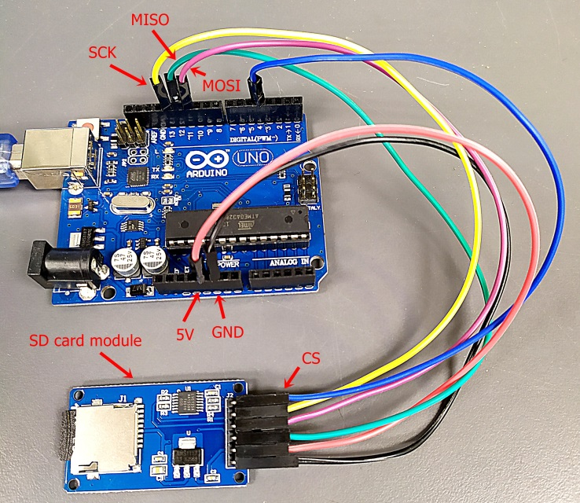
Figure 2. Connection between SD card module to Arduino

Exercise 2. Connect the Mic amp module and Speaker module to Arduino
Connect Mic amp module to Arduino by following the steps below:
- Connect AO (yellow) on the Mic amp module to Arduino A0
- Connect G (black) on the Mic amp module to Arduino GND
- Connect + (red) on the Mic amp module to Arduino 5V
Connect Speaker amp module to Arduino by following the steps below:
- Connect VCC (red) on Speaker amp module to Arduino VIN
- Connect IN (orange) on the Speaker amp module to Arduino pin 9
- Connect GND (black) on the Speaker amp module to Arduino GND

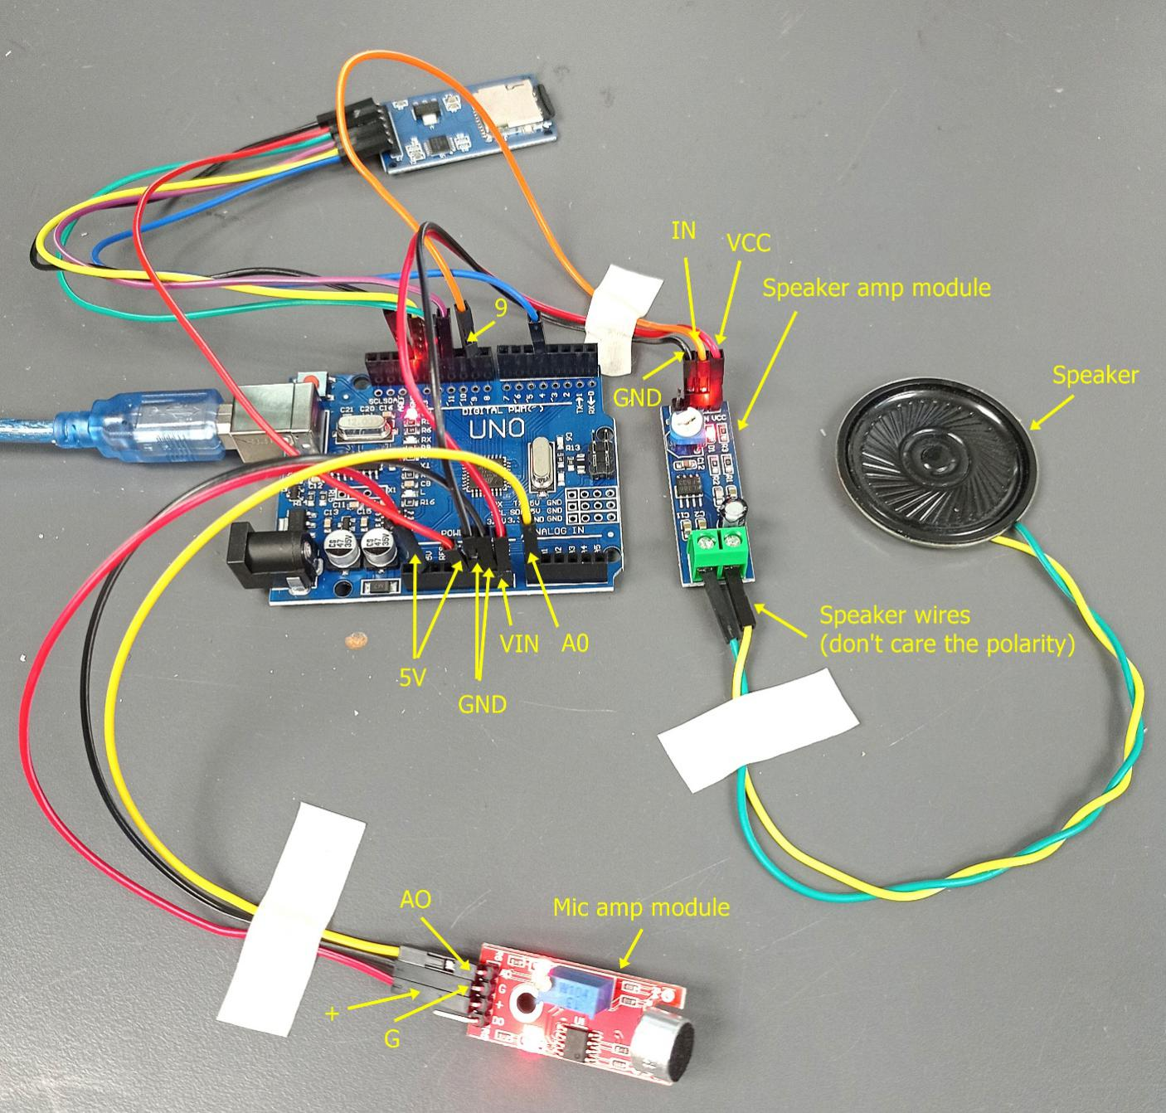
Figure 3. Connection of the Mic amp module and the Speaker module

Notice: The output of recorded sound is very weak. It is because the amplification of the Mic amp module is not large enough to drive the ADC of the Arduino. However, you can still hear the sound if you put the speaker close to your ear.

Exercise 3. Programming and testing the audio recorder

- Connect the USB cable of Arduino to PC. Download the given Lab5.ino program to Arduino.

- Open RealTerm terminal program and configure the Baudrate(115200) and Port number. Reset the Arduino, you should see the SD OK message (as shown in Figure 5.).

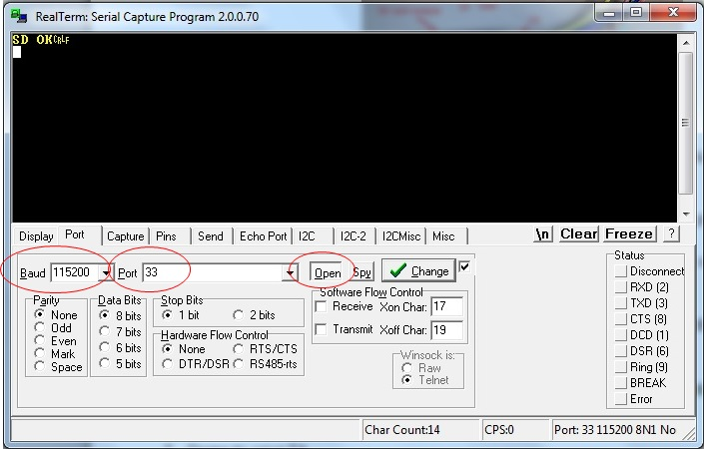
Figure 5. Configure Baud rate and Port number

- Start to record some voice by sending “r” on RealTerm and stop recording by sending “s” on RealTerm.

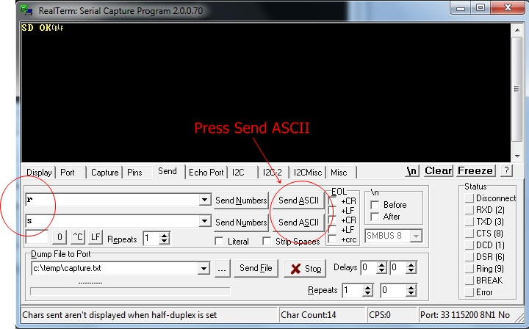

Figure 6. Send “r” to record and “”s” to stop

- Play the recorded voice by sending “p” on RealTerm. You should heard the voice on the speaker. To stop playing send “S”.

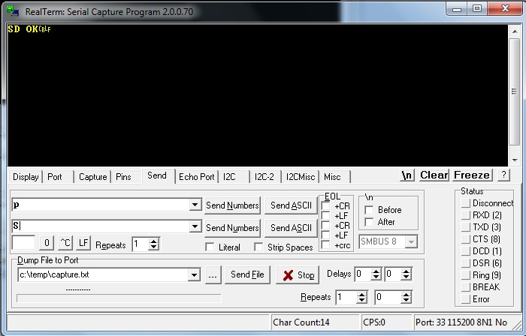

- Send your demo video and your report with the answer of the questions to TA before deadline.

END

Lab 5 Questions
Q1. What type is the op. amp. circuit used in the mic. amplifier ?
Q2. What is the gain of the mic. amplifier ?
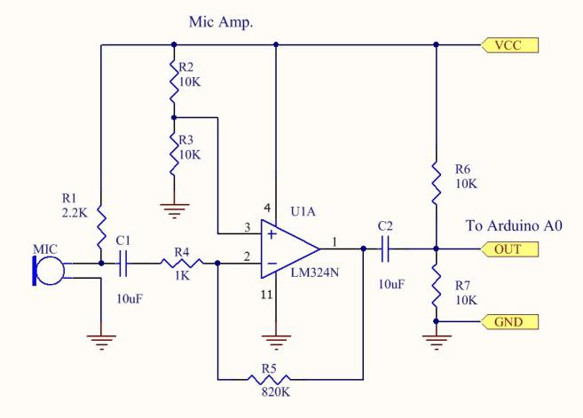

Appendix
Lab5.ino
#include <SD.h>
#include <SPI.h>
#include <TMRpcm.h>

//#define SD_ChipSelectPin 53 //example uses hardware SS pin 53 on Mega2560
#define SD_ChipSelectPin 4 //using digital pin 4 on arduino nano 328, can use other pins

TMRpcm audio; // create an object for use in this sketch

void setup() {

// audio.speakerPin = 11; //5,6,11 or 46 on Mega, 9 on Uno, Nano, etc
// pinMode(12,OUTPUT); //Pin pairs: 9,10 Mega: 5-2,6-7,11-12,46-45

audio.speakerPin = 9; //5,6,11 or 46 on Mega, 9 on Uno, Nano, etc
pinMode(10,OUTPUT); //Pin pairs: 9,10 Mega: 5-2,6-7,11-12,46-45

Serial.begin(115200);

if (!SD.begin(SD_ChipSelectPin)) {
return;
}else{
Serial.println("SD OK");
}
// The audio library needs to know which CS pin to use for recording
audio.CSPin = SD_ChipSelectPin;
}

void loop() {

if(Serial.available()){ //Send commands over serial to play
switch(Serial.read()){
case 'r': audio.startRecording("test.wav",16000,A0); break; //Record at 16khz sample rate on pin A0
case 'R': audio.startRecording("test.wav",16000,A0,1); break; //Record, but with passthrough to speaker.
case 't': audio.startRecording("test.wav",16000,A0,2); break; //Do not record. Output direct to speaker
//Note: If samples are dropped before writing, it
// will not be heard in passthrough mode
case 's': audio.stopRecording("test.wav"); break; //Stop recording
case 'p': audio.play("test.wav"); break; //Play the recording
case '=': audio.volume(1); break; //Increase volume by 1. Does not affect recording
case '-': audio.volume(0); break; //Decrease volume by 1. Does not affect recording
case 'S': audio.stopPlayback(); break; //Stop all playback

}
}
}

