Quantum Computing (Fall 2013) Instructor: Shengyu Zhang.

Lecture 2 Factoring and Abelian HSP

Factoring problem
Historical importance: one of the oldest computational problems.
Average-case hardness: not only hard on worst-case inputs, but also on average-case inputs.
Relation to RSA: If Factoring is easy, then RSA is insecure.
Best classical algorithms: $2^{O\left(\sqrt{n\log{n}}\right)}$ for $n$-bit numbers.
Shor’s quantum algorithm: $O(n^{3})$.

Quantum Fourier Transform (QFT)
Definition of QFT. In next class, we will define Fourier transform on general groups. Today, we’ll only focus on a cyclic group: $Z_{N}$. (Sometimes it is written as $Z/NZ.$) Define $ω_{N}=e^{i2π/N}$, a primitive $N$-th root of unity. For each $x∈Z_{N}$, the QFT has the following effect on the basis vector $|x〉$:
$$|x〉→\frac{1}{\sqrt{N}}\sum_{y∈Z_{N}}{ω_{N}^{xy}|y〉}=\frac{1}{\sqrt{N}}\sum_{y∈Z_{N}}{e^{2πixy/N}|y〉}.$$
In other words, the QFT is the following operator. $F_{Z_{N}}=\frac{1}{\sqrt{N}}\sum_{x,y∈Z_{N}}{ω_{N}^{xy}|y〉〈x|}$. In matrix form, it is

Algorithm for QFT for $Z_{2^{n}}$. (Note: the group is the cyclic group $Z_{N}$ with $N=2^{n}$, but not ${\left(Z_{2}\right)}^{×n}$ ). Write both $x$ and $y$ by binary numbers, namely $x=\sum_{k=0}^{n-1}{2^{k}x_{k}}$ and $y=\sum_{j=0}^{n-1}{2^{j}y_{j}}$. Then
The QFT can be implemented by the following circuit, where we use some controlled-$R_{r}$, with $R_{r}=\left(\begin{matrix}1 & 0 \\ 0 & e^{2πi/2^{r}}\end{matrix}\right)$. (We’ve learned controlled-NOT in the last class; the general controlled-unitary operator is similar: Conditioned on the control bit being 1, do the unitary.)
We can see intuitively why this circuit works by verifying the first two qubits. For the top qubit, one Hadamard gates makes the output $|0〉+{\left(-1\right)}^{x_{0}}|1〉=|0〉+e^{2πix_{0}/2}|1〉=|z_{n-1}〉$. (Note that we used the fact that $e^{2πi2^{s}x_{k}}=1$ for all $s≥0$ and $x_{k}∈\{0,1\}$.) Now look at the second qubit. After the Hadamard gate, it is $|0〉+e^{2πix_{1}/2}|1〉$. The controlled-$R_{2}$ gate further puts a phase $e^{2πix_{0}/4}$ on $|1〉$, thus the final output on this qubit is $|0〉+e^{2πi\left(\frac{x_{1}}{2}+\frac{x_{0}}{4}\right)}|1〉=|z_{n-2}〉$. Using the same way one can verify the rest qubits.

Tool – Phase Estimation
One important application of QFT on $Z_{N}$ is Phase Estimation. Suppose that there is a unitary operation $U$ and we are given the ability of applying controlled-$U^{j}$ operations for $j=2, 2^{2}, 2^{3}, …$ We are also given an eigenstate $|u〉$, which corresponds to an eigenvalue $φ_{u}$. The task is to get an estimate of $φ_{u}$. (Recall the spectral decomposition of normal matrices.)
Here is a simple algorithm using QFT.
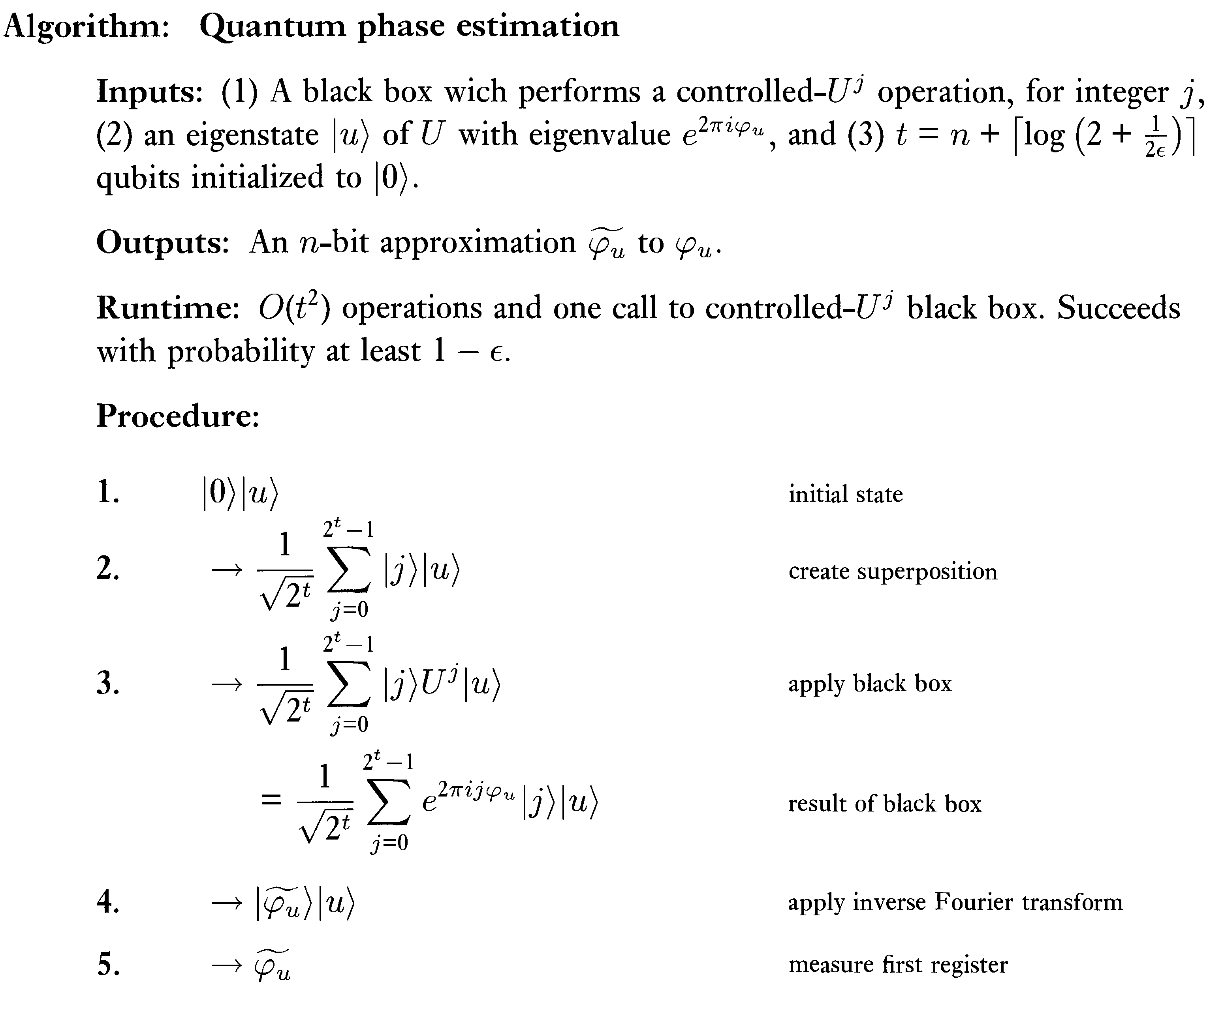
To get an intuition why the above algorithm is correct, consider the case that the eigenvalue has an $n$-bit binary representation. Then the inverse Fourier transform in Step 4 above will give exactly the eigenvalue $φ_{u}$. (Recall the definition of Fourier transform: $|φ〉→\sum_{y∈Z_{N}}{e^{2πiφj}|j〉}$.)

Quantum algorithm for Factoring
First, Factoring is known to be equivalent to another problem called Order Finding. In Order Finding, we are given two positive integers $x$ and $N$ that are co-prime to each other. We want to find the smallest $r$ s.t. $x^{r}=1 mod N$. For example, when $x=5$ and $N=21$, then it is not hard to verify that the powers of $x$ are 5, 4, 20, 16, 17, 1 (all mod 21), thus the order is 6.
Algorithm for Order Finding. Consider the unitary matrix $U|y〉=|xy mod N〉$for each $y∈[0,N-1]$. Note that for different $y$’s, $U|y〉$’s are also different. (Suppose ${xy}_{1}≡xy_{2}$, then $x\left(y_{1}-y_{2}\right)≡0$, impossible because $x$ is co-prime with $N$.) Thus $U$ is indeed a unitary matrix.
For each $s∈[0,r-1]$, consider state $|u_{s}〉=\frac{1}{\sqrt{r}}\sum_{k=0}^{r-1}{ω_{r}^{-sk}|x^{k} mod N〉}$. It is actually an eigenvector of $U$ with respect to eigenvalue $ω_{r}^{s}$:
$$U|u_{s}〉=\frac{1}{\sqrt{r}}\sum_{k=0}^{r-1}{ω_{r}^{-sk}|x^{k+1} mod N〉}=\frac{1}{\sqrt{r}}\sum_{k=0}^{r-1}{ω_{r}^{-s(k-1)}|x^{k} mod N〉}=ω_{r}^{s}|u_{s}〉.$$
Thus we can run the Phase Estimation algorithm on $|u_{s}〉$ and we’ll get $s/r$.
Some issues: We don’t have $|u_{s}〉$; after all it needs information of $r$. But note that
$$\frac{1}{\sqrt{r}}\sum_{s=0}^{r-1}{|u_{s}〉}=\frac{1}{\sqrt{r}}\sum_{s=0}^{r-1}{\frac{1}{\sqrt{r}}\sum_{k=0}^{r-1}{ω_{r}^{-sk}|x^{k} mod N〉}}=|1〉.$$
(For $k≠0$, $\sum_{s}{ω_{r}^{-sk}}=0$.) So if we prepare $|1〉$ and run the Phase Estimation algorithm, then we will get $\frac{1}{\sqrt{r}}\sum_{s=0}^{r-1}{|s/r〉|u_{s}〉}$. Measuring the first register gives $s/r$. Using a simple procedure called the continued fraction, one can get $s'$ and $r^{'}$ s.t. $\frac{s^{'}}{r^{'}}=\frac{s}{r}$. $r^{'}$ may not be $r$, but $r^{'}$ is at least a factor of $r$. Doing this a couple of times and get $r^{''}, r^{'''},$… and take the least common multiple of $r^{'}, r^{''}, r^{'''}, …$would give us $r$. (Actually, a careful analysis shows that most likely the least common multiple of $r^{'}$ and $r^{''}$ is already $r$.)
Another issue is that in Phase Estimation, we need controlled-$U^{2^{j}}$ operations.

Hidden Subgroup Problem (HSP)
Definition of HSP. Order Finding and many other problems fall into the framework of Hidden Subgroup Problem (HSP). In HSP, there is a function $f:G→S$ on a group $G$, which contains a subgroup $H$. $H$ partitions $G$ by (left) cosets. We have the promise that $f$ is constant on each coset, and distinct on different cosets. The goal is to identify $H$ efficiently. In quantum algorithms, we can access $f$ by controlled-$f$ gates. In particular, we can make the following transform: $|x〉|0〉→|x〉|f\left(x\right)〉$.
HSP for finite Abelian groups. Any finite Abelian group $G$ is isomorphic to $Z_{n_{1}}×⋯×Z_{n_{k}}$. For each element $a=(a_{1},…,a_{k})∈Z_{n_{1}}×⋯×Z_{n_{k}}$, define a character function $χ_{a}:G→C$ by $χ_{a}\left(x_{1}…x_{k}\right)=ω_{n_{1}}^{a_{1}x_{1}}…ω_{n_{k}}^{a_{k}x_{k}}|a_{1}…a_{k}〉$, and define the QFT by $|x〉→\frac{1}{\sqrt{\left|G\right|}}\sum_{a}{χ_{a}\left(x\right)|a〉}$. It is easily checked that each $χ_{a}$ is a homomorphism: $χ_{a}(xy)=χ_{a}\left(x\right)χ_{a}(y)$. The set of the $χ_{a}$’s is denoted by $\hat{G}$, which is isomorphic to $G$ itself. One property for $\hat{G}$ is that any two distinct characters are orthogonal. In particular, if $a≠(0,…,0)$, then $\sum_{x∈G}{χ_{a}(x)}=0$.
Algorithm.
$\frac{1}{\sqrt{\left|G\right|}}\sum_{x∈G}{|x〉}$ // prepare a uniform superposition
$\underset{→}{query f} \frac{1}{\sqrt{\left|G\right|}}\sum_{x∈G}{|x〉|f\left(x\right)〉}$
$\underset{→}{measure |f\left(x\right)〉} \frac{1}{\sqrt{\left|H\right|}}\sum_{y∈H}{|s+y〉}$ for an unknown and random $s∈G$
$\underset{→}{QFT} \frac{1}{\sqrt{\left|H\right||G|}}\sum_{χ∈\hat{G}}{\sum_{y∈H}{χ(s+y)|χ〉}}$
$\underset{→}{measure}$ a random $χ$ with $χ\left(y\right)=1$, $∀y∈H$.
Do this for $t=O(\log\left|G\right|)$ times, and obtain $χ_{1}, …, χ_{t}$. For a character $χ$, define its kernel as $\ker\left(χ\right)=\{g∈G:χ\left(g\right)=1\}$, and it is easily seen that kernel is a subgroup of $G$. Claim. For some $T=\log_{2}\left|G\right|$, it holds that $H=\bigcap_{i=1,…,T}{ker⁡(χ_{i})}$ with high probability. Proof. First, there is a fact that $H^{⊥}≝\left\{χ:χ\left(y\right)=1,∀y∈H\right\}=\{χ:H≤ker⁡(χ)\}$ is a group and it’s isomorphic to the quotient group $G/H$. Thus $\left|H^{⊥}\right|=|G|/|H|$. Similarly $\left|{K_{t}}^{⊥}\right|=|G|/|K_{t}|$. Suppose that after $t$ times, $K_{t}=⋂_{i=1 }^{t}ker⁡(χ_{i})$ is still strictly larger than $H$. The next iteration gives a random $χ∈H^{⊥}$. Since $K_{t+1}≤K_{t}$, we know that $\frac{\left|K_{t+1}\right|}{\left|K_{t}\right|}≤\frac{1}{2}$ unless $K_{t+1}=K_{t}$. Since $K_{t+1}=K_{t}∩ker⁡(χ)$, it suffices to show that $\underset{χ∈H^{⊥}}{Pr}\left[K_{t}⊆\ker\left(χ\right)\right]≤1/2$. Note that $K_{t}⊆\ker\left(χ\right)$ means $χ∈K_{t}^{⊥}$. Therefore, $\underset{χ∈H^{⊥}}{Pr}\left[K_{t}⊆\ker\left(χ\right)\right]=\frac{\left|K_{t}^{⊥}\right|}{\left|H^{⊥}\right|}=\frac{|G|/|K_{t} | }{\left|G\right|/\left|H\right|}=\left|H\right|/|K_{t}|$. This ratio is at most 1/2 since we assumed that $H$ is a proper subgroup of $K_{t}$.

Note
There are many explanations of Shor’s algorithm, see the wiki page. We basically followed [NC00], Chapter 5 and [CvD10] Section III.
For the Hidden Subgroup Problem part, see [CvD10], Section IV-C.

Reference
[NC00] Michael Nielsen and Isaac Chuang, Quantum Computation and Quantum Information, Cambridge University Press, 2000.
[CvD10] Andrew M. Childs and Wim van Dam, Quantum algorithms for algebraic problems, Reviews of Modern Physics, Volume 82, January–March 2010.

Exercise
- Verify that the QFT operator $F_{N}$ is unitary.
- Write down the QFT for $Z_{2}$, $Z_{3}$, $Z_{4}$, $Z_{5}$.
- Suppose $N=2^{n}$. We want a uniform superposition $\frac{1}{\sqrt{N}}\sum_{x=1}^{N}{|x〉}$. Prove that we can obtain it by simply preparing $n$ qubits all in state $|0〉$, and then applying a Hadamard gate on each qubit.

