Quantum Computing (Fall 2013) Instructor: Shengyu Zhang.

Lecture 10 Quantum information 2: entropy and mutual information

Review of classical information theory
Let’s first review some basic concepts in information theory.
Suppose that $X$ is a discrete random variable on the sample space X, and the probability distribution function is $p(x)=Pr⁡[X=x]$. Following the standard notation in information theory, we also use the capital letter $X$ to denote the distribution, and by writing $x←X$, we mean to draw a sample $x$ from the distribution $X$.
Entropy. The entropy $H(X)$ of a discrete random variable $X$ is defined by
$$H\left(X\right)=-\sum_{x∈\text{X}}{p\left(x\right)\log_{2}{p(x)}}.$$
Here we use the convention that $0\log_{2}{0}=0$.
One intuitive explanation about this definition is that entropy measures the amount of the uncertainty of a random variable. The more entropy $X$ has, the more uncertain it is. In particular, $H\left(X\right)=0$ iff $X$ is fixed/deterministic. At the other extreme, the maximum entropy for any random variable on X is $\log_{2}{|\text{X}|}$, achieved by the uniform distribution. The range of the entropy is
$$0≤H\left(X\right)≤\log_{2}\left|\text{X}\right|,$$
Another interpretation of entropy is the compression rate, which will be the subject of the next lecture.
A special case is binary entropy, when $X$ takes only 2 possible values. Suppose $\operatorname{Pr}\left[X=x\right]=p$, then the binary entropy is $H\left(p\right)=p\log{\frac{1}{p}}+\left(1-p\right)\log{\frac{1}{1-p}}$. How does this quantity vary with $p$? See the following figure.
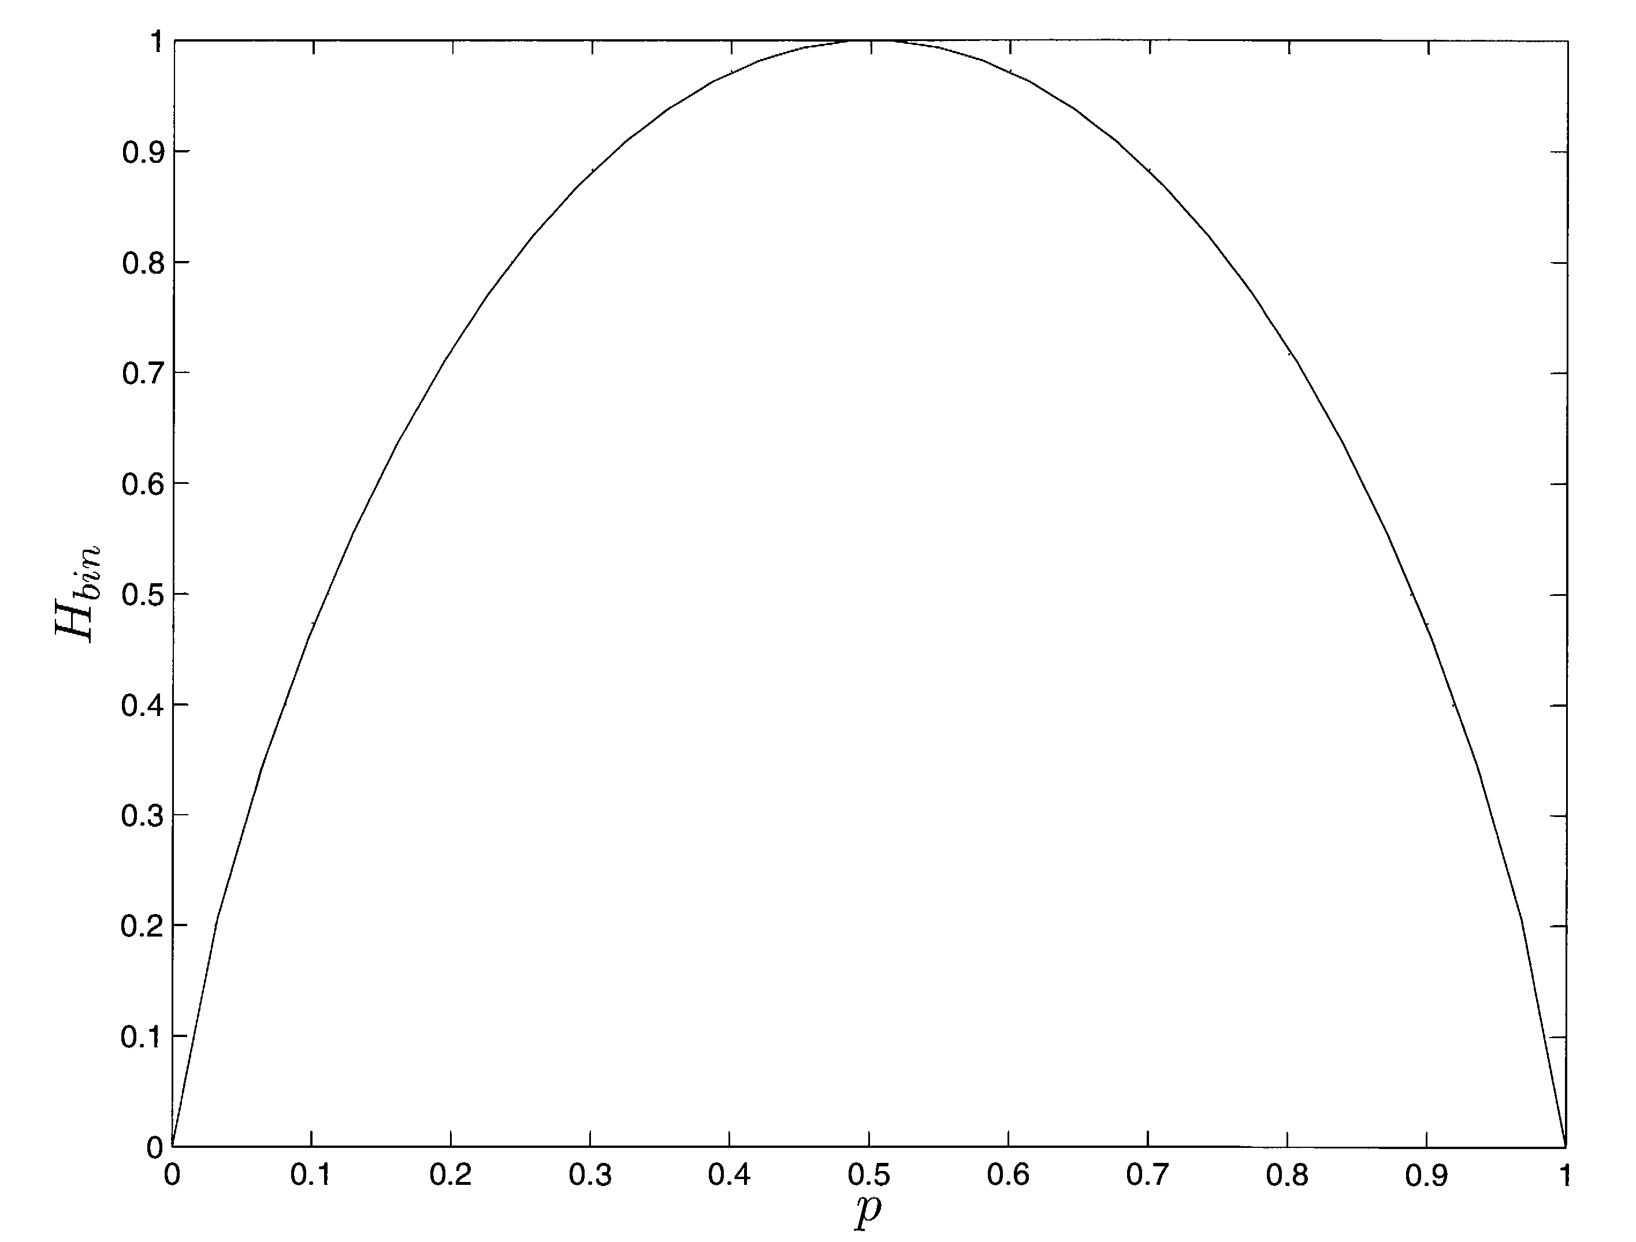
In particular, it reaches its maximum when $p=1/2$.

Joint distribution. Sometimes we have more than one random variable under the concern. If $(X, Y)$ is a pair of random variables on $\text{X}×\text{Y}$, distributed according to a joint distribution $p(x, y)$, then the total entropy is simply the following, treating $(X,Y)$ as one random variable in a bigger sample space $\text{X}×\text{Y}$:
$$H\left(X,Y\right)=-\sum_{x∈\text{X}\text{,} y∈\text{Y}}{p\left(x,y\right)\log_{2}{p(x,y)}}.$$
Marginal distribution and conditional distribution. The joint variable $(X, Y)$ has a marginal distribution $p\left(x\right)$over $\text{X}$ defined by $p\left(x\right)=\sum_{y}{p(x,y)}$. For any fixed $y∈\text{Y}$ with positive probability $p(x,y)$ for some $x$, there is a conditional distribution $X|(Y=y)$ defined by $p_{y}\left(x\right)=p(x,y)/p(x)$. The conditional entropy is defined as the average entropy of the conditional distribution:
$$H\left(X | Y\right)=E_{y←Y}\left[H\left(X | Y=y\right)\right],$$
From this definition, it is easily seen that $H\left(Y | X\right)≥0$.
In general, conditioning reduces entropy:
$$H\left(X | Y\right)≤H(X)$$
Knowing something else ($Y$) always helps you to knowing the target (X).
Chain rule. Another basic fact is the chain rule:
$$H\left(X,Y\right)=H\left(X\right)+H\left(Y | X\right).$$
Think of this as the following: The uncertainty of $H(X,Y)$ is that of one variable $X$, plus that of the other variable $Y$ after knowing $X$.
The chain rule also works with conditional entropy,
$$H\left(X,Y|Z\right)=H\left(X|Z\right)+H\left(Y | X,Z\right),$$
and with more variables:
$$H\left(X_{1},…{,X}_{n}|Z\right)=H\left(X_{1}|Z\right)+H\left(X_{2} | X_{1},Z\right)+…+H\left(X_{n} | X_{1},…,X_{n-1},Z\right)$$
$$≤H\left(X_{1}|Z\right)+H\left(X_{2} | Z\right)+…+H\left(X_{n} | Z\right),$$
where the inequality is usually referred to as the subadditivity of entropy.
Relative entropy. Another important concept is that of the relative entropy of two distributions $p$ and $q$.
$$H\left(p||q\right)=\sum_{x∈\text{X}}{p\left(x\right)\log_{2}{\frac{p\left(x\right)}{q\left(x\right)}}} .$$
Relative entropy can sometimes serve as a good measure as distance of two measures. A basic property is that it is nonnegative.
Fact. $H(p|\left|q\right)≥0$ with equality iff $p=q$.
Proof. Use the fact that $\log_{2}{x}=\frac{\ln{x}}{\ln{2}}≤\frac{x-1}{\ln{2}}$ in the definition of $H\left(p||q\right)$.
Mutual information. For a joint distribution $\left(X,Y\right)=p(x,y)$, the mutual information between $X$ and $Y$ is
$$I\left(X;Y\right)=D\left(p\left(x,y\right)||p\left(x\right)p\left(y\right)\right)=H\left(X\right)-H\left(X | Y\right)=H\left(X\right)+H\left(Y\right)-H(X,Y).$$
It is a good exercise to verify the above equalities. But the second one has a clear explanation: We mentioned earlier that conditioning always reduces the entropy. How much does it reduce? Exactly the mutual information. So the mutual information is the amount of uncertainty of $X$ minus that when $Y$ is known. In this way, it measures how much $Y$ contains the information of $X$. It is not hard to verify that it’s symmetric: $I\left(X;Y\right)=H\left(X\right)-H\left(X | Y\right)=H\left(Y\right)-H\left(Y | X\right)$, and we’ve implicitly said that it’s nonnegative:
$I\left(X;Y\right)≥0$, i.e. $I\left(X;Y\right)≤\min\left\{H\left(X\right),H\left(Y\right)\right\}$
One can also add conditioning on this. The conditional mutual information is defined by
$$I\left(X;Y|Z\right)=E_{z}[I\left(X;Y | (Z=z)\right)]$$
It is not hard to see that
$$I\left(X;Y|Z\right)≤\min\left\{H\left(X|Z\right),H\left(Y|Z\right)\right\}≤\log_{2}{|\text{X}|}$$
and
$$I\left(X;Y|Z\right)=H\left(X | Z\right)-H\left(X | YZ\right).$$

Data processing inequality. A sequence of random variables $X_{1}, X_{2},…$form a Markov Chain, denoted by $X_{1}→X_{2}→…$ if
$$\operatorname{Pr}\left[X_{n}=x|X_{n-1}=x_{n-1}\right]=\operatorname{Pr}\left[X_{n}=x|X_{1}=x_{1},…,X_{n-1}=x_{n-1}\right]$$
Namely, $X_{n}$ depends only on $X_{n-1}$, but not the “earlier history”.
Fact. If $X→Y→Z$, then $I\left(X;Z\right)≤I(X;Y)$.
Intuitively, it says that processing data always reduces the contained information.

Quantum entropy
We can extend the classical Shannon entropy to the quantum case. The von Newmann entropy of a quantum state $ρ$ is defined by
$$S\left(ρ\right)=-tr(ρ\log{ρ})$$
Equivalently, if the eigenvalues of $ρ$ are $λ=\left(λ_{1},…,λ_{n}\right)$, then $S\left(ρ\right)=H\left(λ\right)$. (Note that $tr\left(ρ\right)=1$ and $ρ≽0$, so $λ$ is a distribution.)
Similar to the classical case, the quantum entropy is a measure of uncertainty of the quantum states.
Fact. $S\left(ρ\right)≥0$, with equality iff $ρ$ is a pure state.

Relative entropy. The quantum relative entropy is defined by
$$S\left(ρ||σ\right)=tr(ρ\log{ρ}-ρ\log{σ})$$
Let’s first verify that this extends the classical relative entropy. When $ρ$ and $σ$ commute and they have eigenvalues $\left\{p_{i}\right\}$ and $\left\{q_{i}\right\}$, then
$$S\left(ρ||σ\right)=\sum_{i}{\left(p_{i}\log{p_{i}}-p_{i}\log{q_{i}}\right)}=\sum_{i}{p_{i}\log{\frac{p_{i}}{q_{i}}}}$$
consistent with the classical case.
The relative entropy can be viewed as a distance measure between states.
Theorem (Klein’s inequality). $S\left(ρ||σ\right)≥0$ with equality holding iff $ρ=σ$.
Another “distance” property is that taking partial trace reduces relative entropy.
Fact. $S\left(ρ_{A}||σ_{A}\right)≤S\left(ρ_{AB}||σ_{AB}\right)$.

The theorem can be used to prove the following result.
Fact. Projective measurements can only increase entropy. More precisely, suppose $\left\{P_{i}\right\}$ is a
complete set of orthogonal projectors and $ρ$ is a density operator. Then $S\left(\sum_{i}{P_{i}ρP_{i}}\right)≥S(ρ)$ with equality iff $P_{i}ρP_{i}=ρ$.

Conditional entropy. Suppose that a joint quantum system $\left(A,B\right)$ is in state $ρ_{AB}$. For convenience, we sometimes use $\left(A,B\right)$ to denote $ρ_{AB}$. We define the conditional entropy as
$$S\left(A | B\right)=S\left(A,B\right)-S(B)$$
Note that classically conditional entropy can also be defined as the average of $S(A|b)$, but we cannot do it for quantum entropy. Actually, different than the classical case, the quantum conditional entropy can be negative. For example, consider an EPR pair, $S\left(A | B\right)=0-1=1$, but the average definition won't give us this: A and B are in either 00 or 11.
On the other hand, the quantum conditional entropy cannot be too negative.
$$\left|S\left(A\right)-S\left(B\right)\right|≤S\left(A,B\right)≤S\left(A\right)+S(B)$$

Convexity. Suppose $ρ_{i}$’s are quantum states and $p_{i}$’s form a distribution.
$$\sum_{i}{p_{i}S(ρ_{i})}≤S\left(\sum_{i}{p_{i}ρ_{i}}\right)≤\sum_{i}{p_{i}S\left(ρ_{i}\right)}+H(p)$$
Mutual information.
$$S\left(A;B\right)=S\left(A\right)+S\left(B\right)-S\left(A,B\right)=S\left(A\right)-S\left(A | B\right)=S\left(B\right)-S(B|A)$$
Classically the mutual information is upper bounded by individual entropy, i.e. $I\left(A;B\right)≤\min\left\{H\left(A\right),H\left(B\right)\right\}$, but quantum mutual information isn’t… Well it still holds---up to a factor of 2:
$$I\left(A;B\right)≤\min\left\{2S\left(A\right),2S\left(B\right)\right\}$$

Strong subadditivity. $S\left(A,B,C\right)+S\left(B\right)≤S\left(A,B\right)+S(B,C)$.

Notes
The definitions and theorems in this lecture about classical information theory can be found in the standard textbook such as [CT06] (Chapter 1). The quantum part can be found in [NC00] (Chapter 11).

References
[CT06] Thomas Cover, Joy Thomas. Elements of Information Theory, Second Edition, Wiley InterScience, 2006.
[NC00] Michael Nielsen and Isaac Chuang, Quantum Computation and Quantum Information, Cambridge University Press, 2000.

Exercise
- What’s the von Newmann entropy of the following quantum states?
- $|ψ〉=|0〉$
- $|ψ〉=\frac{1}{\sqrt{2}}\left(|0〉+|1〉\right)$
- $ρ=\frac{1}{3}\left[\begin{matrix}2 & 1 \\ 1 & 1\end{matrix}\right]$.
- What’s the mutual information between the two parts of an EPR state?

