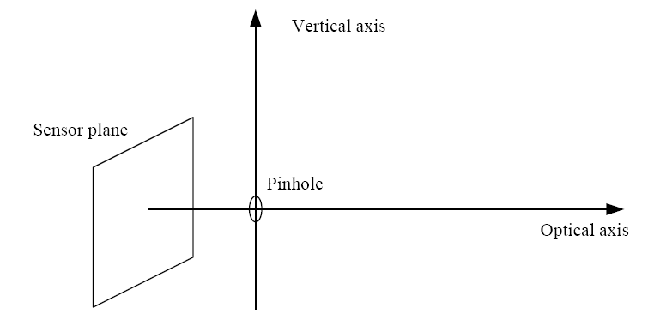
- If you photograph a wall as shown, with the sensor plane parallel to the brick wall, will the lines of the bricks be parallel or not in the resulted picture?
- We know that one image may have more than one projected vanishing points. How about vanishing line, is it possible that there is more than one vanishing lines in a single image? Why?
- List any 3 different cross ratio representations.
- What is the rough height of the person standing on the box?
1
2
3
4
5

