User Manual for
Building Construction System

You will need several pieces of software installed in order the system will operate. First download the Python program from the following URL (or latest version)

http://www.python.org/ftp/python/2.3.3/Python-2.3.3.exe

Also you have to install the Win32 extensions provided by Mark Hammond's win32all, a collection of Windows-specific extensions including COM support and Pythonwin.

Installed the above packages immediately afterwards.

Also download the RealityFactory development environment and install it:

Reality Factory is a free game development package which features an open source game engine using Genesis3D (another open source 3D engine) with all the necessary tools to build a game for any user at home. To use the package, we will first need to download the package from the Internet via the following URL:

http://www.realityfactory.ca

Currently the most updated version is 0.72A. Download and install the Reality Factory package (0.72A)

http://dhost.info/realityfactory/downloads.htm

or follow the download link inside http://www.realityfactory.ca

Choose the official release to download at the above page. Inside the page, choose RealityFactory072.exe for download for now.

Now unzip the building construction system zipfile into a directory, say “building”.
Sample walkthrough of the operation of the system

- bring up command prompt, and change directory into the “building” directory.
- The building construction system read a floorplan file in Microsoft Bitmap file format( 1bit monochrome format), and convert it into a 3D model file. So the system would expect you to have the data file (in bitmap format) being placed in the building directory. A sample is prepared for you, called “test_plan3.bmp”, which is placed at data folder of building directory. You may process this file now by typing the following command:
build test_plan3
or
build_external test_plan3
for building outlook generation. Note that you may supply a parameter after the command for external generation for the number of floors you want to generated. Check out the batch file for more detail.
The program will then execute automatically to generate the output model file.
- Bring up the world editor of RF package (rfEditpro.exe) in the tools folder of RF installed directory. After the world editor window displayed, choose “File\Open” and browse to the directory you just execute the build program. Open the file “test_plan3” which should now have extension “3dt”. The editor window should now similar to follow (you may need to change the directory path of the level file according to your own installed path):
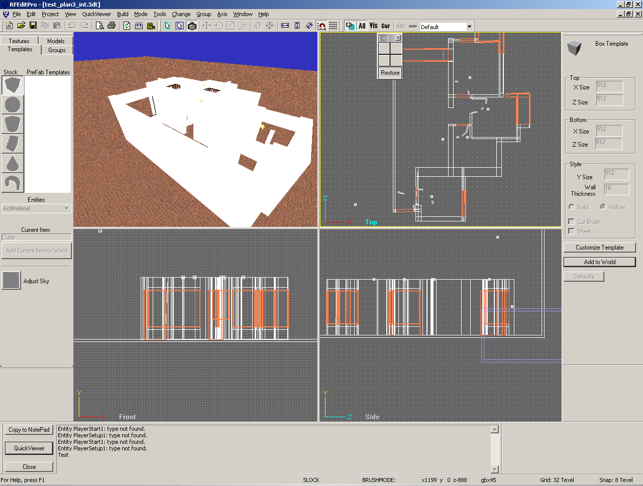

- To navigate around the level, simply compile the level to generate the required level file. Choose “tools\compile”” get the follow dialog box:
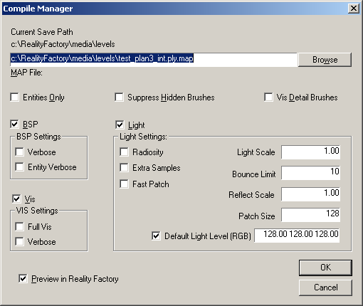
Note that the “MAP File” entry is “c:\RealityFactory\media\levels\filename.map”, that means it assume you have a directory called “c:\RealityFactory\media\levels”. In most of the case, you won’t have this directory. You are suggested to key in a new directory that exists, for example the “c:\building” directory that we created in the above. For the other entries just skip them will be okay.
- A dialog box like below will be displayed:
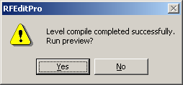
That means the level is compiled successfully. Press “Y” or enter to confirm it.
- Move around the level by using the “arrow” keys and mouse to adjust view point. A sample shot look like below:
