The Chinese University of Hong Kong
Department of Computer Science and Engineering

Final Year Project(2002/2003)
LYU0202
Advanced Audio Information Retrieval System

Supervised by: Prof. Michael Lyu
Group Members: Fok Ka Ling(00593524)
Ng Lai Sze (00571413)
Abstract

Nowadays, many applications such as video segmentation focus on the use of visual data. However, besides the use of visual data, the audio data can also help in many aspects. For the video segmentation, we can use the signal from the audio channel of the video to do the video segmentation. The time may be reduced by using audio data because there is always more visual data than audio data.

In this final year project, we focus on building a networked based AdvAIR system (Advanced audio information retrieval system) which provides different functions such as video segmentation, speaker recognition, language recognition, query by humming, pattern matching, real time audio streaming. Technique such as Bayesian Information Criterion, Gaussian mixture model is used to ensure the accuracy and reliability of the system. Video segmentation, speaker recognition, language recognition can be used for audio data mining. Pattern matching, query by humming can be used to retrieve information from a large set of audio data set. AdvAIR system provides a network based system so that you can search audio clips from the server and stream the audio clips in real-time.
Acknowledge
We would like to express our faithful gratitude to Professor Michael R. Lyu for his useful suggestion and kindly guidance towards our final year project.
We would also like to express our thanks to Jackie Chun Keung CHAU, who have helped us to plan for the project and give us lots of help on both theory and programming.

Chapter 1 Introduction 7
1.1 Project Background 7
1.2 Audio Mining 10
1.2.1 Introduction 10
1.2.2 The need of audio mining system 10
1.2.3 Application of Audio Mining 11
1.2.4 Automatic video scene change 12
1.2.5 Speaker Recognition 13
1.2.6 Language Recognition 13
1.2.7 How AdvAIR system related to audio mining? 14
1.3 Huge Video/Audio Data Set Searching 15
1.3.1 Introduction to Video/Audio Data Searching 15
1.3.2 Pattern Matching 16
1.3.3 Query by Humming 17
1.3.4 Audio Data Searching using AdvAIR system 17
1.4 System block diagram of AdvAIR system 18
1.5 How AdvAIR works 19
1.5.1 Feature extraction 19
1.5.2 Segmentation 19
1.5.3 Recognition 20
1.5.4 Pattern Matching 20
1.5.5 Query by Humming 20
1.6 Importance of Audio Segmentation 22
Chapter 2 Feature Extraction 25
2.1 Introduction to speech 25
2.2 Nature of sound features 26
2.3 Features Encoding and processing 27
2.4 MFCC model 29
2.4.1 Model introduction 29
2.4.2 Data rate compression 30
Chapter 3 Audio Scene Change 31
3.1 Introduction to audio scene change 31
3.2 Model Selection Criteria 33
3.3 Change Point Detection through BIC 35
3.3.1 Single Acoustic Change Point Detection 35
3.3.2 Multiple Acoustic Change Point Detection 40
3.4 Enhanced Implementation Algorithm 43
3.5 Hierarchical Clustering through BIC 45
Chapter 4 Recognition Engine 48
4.1 Introduction to Recognition Engine 48
4.1.1 Background information on Recognition Engine 48
4.1.3 Background knowledge about Gaussian Mixture Model 52
4.1.4 Description of Gaussian Mixture Model (GMM) 55
4.1.5 Training Procedure for Gaussian Mixture Model (GMM) 57
4.2 Speaker Recognition/Identification 61
4.2.1 Introduction to Speaker Recognition/Identification 61
4.2.2 Speaker Recognition Procedure 62
4.3 Language Recognition 63
4.3.1 Introduction to Language Recognition 63
4.3.2 Language Recognition Procedure 63
4.4 Gender Recognition 64
4.4.1 Introduction to Gender Recognition 64
4.4.2 Gender Recognition Procedure 64
4.5 Why speaker identification is more accurate than gender identification 65
Chapter 5 Direct Audio Search 66
5.1 Introduction 66
5.2 Algorithm overview 67
5.3 Performance enhancement 69
5.4 Conclusion 69
Chapter 6 Query by Humming 70
6.1 Introduction to Query by Humming 70
6.2 System Flow Chart 71
6.3 System Implementation 71
6.3.1 Pitch Tracking 71
6.3.2 Intermediate representation and similar tracking 72
6.4 Conclusion and limitations 73
Chapter 7 Network Implementation 75
7.1 Introduction 75
7.2 Network Flow Chart 76
7.2.1 Server Side Flow Chart 76
7.2.2 Client Side Flow Chart 77
7.2.3 Multipart Downloads Flow Chart 78
7.3 Data Structure and Format of packet 79
7.4 Features and security 81
Chapter 8 Experimental Result 82
8.1 The Environment for experiment 82
8.2 Segmentation 82
8.2.1 Parameter Setting 82
8.2.2 Result of the experiment on Segmentation engine 83
8.2.3 Comparison with the old proposed system 83
8.2.4 Analyze of the Experiment Result 84
8.3 Speaker Recognition 85
8.3.1 Training Stage 85
8.3.2 Testing Stage 86
8.3.3 Result of the experiment on Speaker Recognition engine 87
8.3.4 Analyze of the Experiment Result 89
8.4 Language Recognition 92
8.4.1 Training Stage 92
8.4.2 Testing Stage 92
8.4.3 Result of the experiment on Language Recognition engine 93
8.4.4 Analyze of the Experiment Result 93
8.5 Gender Recognition 94
8.5.1 Training Stage 94
8.5.2 Testing Stage 94
8.5.3 Result of the experiment on Gender Recognition engine 95
8.5.4 Analyze of the Experiment Result 95
8.6 Pattern Matching 97
8.6.1 Background of the experiment 97
8.6.2 Result of the experiment on Pattern Matching Engine 97
8.6.3 Analyze of the Experiment Result 98
8.7 Queries by Humming 99
8.7.1 Background of the experiment 99
8.7.2 Result of the experiment on Query by Humming engine 99
8.7.3 Analyze of the Experiment Result 99
Chapter 9 AdvAIR Advanced Audio Information Retrieval System 100
9.1 Introduction to AdvAIR system 100
9.2 Server and Client Graphical User Interface 101
9.2.1 Client Side Graphical User Interface 101
9.2.2 Server Side Graphical User Interface 103
9.3 Audio data mining 104
9.3.1 Introduction to Audio data mining 104
9.3.2 Segmentation engine 105
9.3.3 Recognition engine 108
9.3.4 Segmentation with Speaker Recognition engine 112
9.4 Audio Data Searching 114
9.4.1 Introduction to Audio Data Searching 114
9.4.2 Pattern Matching on local host 114
9.4.3 Pattern Matching on server side 116
9.4.4 Query by Humming on local host 117
Chapter 10 Contribution of Work 119
10.1 Alex’s contribution 119
10.1.1 Introduction 119
10.1.2 Preparation work 119
10.1.3 Implementation Detail 120
10.2 Shirley’s contribution 121
10.2.1 Introduction 121
10.2.2 Preparation Work 122
10.2.3 Implementation Details 123
Chapter 11 Conclusion 125
Reference 126

Chapter 1 Introduction
  - Project Background
With the honor of supervision by Professor Michael R. Lyu, whom is the Principal Investigator of VIEW lab, our project can be done in supportable and smooth fashion.

VIEW, Video over Internet and Wireless, is a project to develop a multilingual digital video content hub for culture exchange and commercial deployment. The project tries to delivers:
1. Multilingual video segmentation, categorization, indexing, searching, cashing, delivery, and presentation techniques.
2. Software enabling schemes for content creation, information summarization and dissemination, security authentication, and wireless access.
3. A multimedia content hub for distant learning, financial news, virtual Hong Kong tour, telemedicine, and culture exchange.

Our project is following the mother project of VIEW, tries to find out the possibility of using audio information as a potential source of data mining and data searching. With bringing the concept from professor Lyu, a network-based speech processing system – Advanced Audio Information Retrieval System (AdvAIR) have been developed in order to facilitate the multipurpose audio data searching, extraction and analysis.

Nowadays, many of the audiovisual data segmentation and indexing are focused on visual cues such as color histogram differences, motion vectors, and key frames [1][2][3]. Most of them didn’t make use of the audio information. However, the audio channel in a video can provide useful and complementary semantic cues. In TV news program, it is easy to segment the video into semantic scenes using visual information only but segmentation of general video program may not be so accurate. In the view of this, our system wants to make good use of the audio information to aid the retrieval of information of the audiovisual data.

Our Advanced Audio Information Retrieval System has two main functions, one is audio data mining and the other is audio data searching. Automatic segmentation, audio database indexing, and retrieval of audiovisual data has an important role in the real world as multimedia system and data become more and more common and more and more important. There are a lot of important applications in media production, audiovisual archive management, education and entertainment, and so on. Audio data mining and audio data searching helps a lot in these kinds of application.

Our system is also an N-to-N network-based system. It is a multi-client multi-server application. It allows clients to search and get information from a large data set in the server side. When the client has found the audio file he/she wanted, he/she can download the audio file and listen to it in the client side. Multimedia file such as audio file and video are both very large in size, especially the video file. Therefore our system do not download the file from one server only, the file is cut into many small parts, different part is download from different server at the same time to speed up the download process.

Section 1.2 describes audio data mining and how our system related to audio data mining. In section 1.3, we will mention about the audio data searching.
  - Audio Mining
    - Introduction
Audio mining is a way to turns information hidden in audio resource into archives that can be browsed, searched and mined. It is also an essential in the decade of Internet, which made the access of unlimited data storage capacity possible with the ease of clicking a mouse. As the result of blooming technology, even greater volume of data in the form of speech from television, radio, telephone calls can be captured and used for data mining and perform various analysis.

1.2.2 The need of audio mining system
Intuitive access to information in everyday environments is becoming a central concern of new information society technologies. An important question is how established and well functioning everyday environments can be enhanced rather than replaced by virtual environments. Augmented or enhanced reality technologies address this issue but have concentrated so far on the visual sense and have mainly been used in applications. [4]. Auditory augmentation of visually dominated everyday environments is a new and very promising approach in creating user-friendly information retrieval systems, which are accessible to everybody. The complementarily between the visual and auditory sense is the basis for the new type of multi-sensory content, which will become feasible thanks to anticipated advances in auditory rendering.

1.2.3 Application of Audio Mining
Application using audio Mining includes:
- Technical support centers.
A technical support manager responsible for providing feedback to a product development team can search a database of recorded technical support calls to determine the issues end users are contending with.
- Call centers.
A stockbroker or call center operator can gain access to specific recorded conversations to verify transaction information. Marketing executives can access customer requests and feedback from a company database to fine-tune marketing campaigns.

- Broadcast media.
A news editor at a TV or radio station can search archives of recorded broadcasts to retrieve information relevant to breaking news almost immediately. The technology can also be used to index live broadcasts.

- Corporate communications and public relations departments.
Communications and PR managers can index and search both live video feeds and archived broadcasts to track how their company or a competitor is being covered in the news.
- Conference managers.
A conference management organization can use audio mining to create index of key topics to help in preparing tapes of sessions. Such an index would allow material on CD-ROM to be directly accessible.
- Law enforcement and security operations.
Security personnel can obtain critical information from hours of recorded phone calls or radio transmissions much more rapidly than before. The technology also allows the indexing and searching of live broadcasts in order to monitor breaking events.

1.2.4 Automatic video scene change
Automatic video scene change detection is a fundamental but challenging task in audio mining. For instance, before doing speaker recognition or language recognition for a long video which consists of many speakers, audio scene change is definitely needed. Video is the combination of visual and audio. Using visual information alone often cannot provide a satisfactory solution. With the combination of audio and visual features, the checking of boundary and classification of video can be done with pleasing result.

1.2.5 Speaker Recognition
Video scene change is the basic unit for audio mining system but it is inadequate for audio mining system. Further processing is further applied after video scene change detection to extract meaningful information. The result of video scene change serve as input for further processing units such as the speaker recognition. By applying speaker recognition, speaker information in the audio can be retrieved. A database or data set of video or audio clips that consists of different speakers can be analyzed and mined using speaker recognition. You can know which clips are belong to a specific speaker, how long had the speaker spoken in the clips.

1.2.6 Language Recognition
Language Recognition is another process which can be used to extract information about video or audio. Audio data mining within a database or data set about the language spoke can be done by language recognition. Also, you can classify the audio clips by language using language recognition. Before applying translator or speech recognizer, you can also use language recognition so that the appropriate translator or speech recognizer can be used.

1.2.7 How AdvAIR system related to audio mining?
In the view of this, a system that performs various speech functions such as front-end features extraction, segmentation, back end process such as language identification, speaker identification should be developed. AdvAIR is a system for such usage. When designing such a system, one often faces two problems: first, devising a procedure efficient enough to be able to identify languages within a reasonable time; second, collecting and train the data needed. In principle, models for language, gender is often computed offline for the task of best fitting model determination.

  - Huge Video/Audio Data Set Searching

1.3.1 Introduction to Video/Audio Data Searching
Rapid increase in speed, capacity of computers and networks helps the development of multimedia system a lot. Multimedia is the combination of audio, visual material to provide computerized interaction of text, sound, graphics, images, animation & video to enhance communication and to enrich its presentation. Only using text is not enough to convey information. In the aid of image, sound and video, conveying and distributing information become easier. However, searching in multimedia system is not as easy as searching of textual documents.

Searching within data set of 10 audio or video clips is easy, you can play every audio or video to check if it is the one you want. However, most of the time, the number of audio or video clips in a multimedia system is over 100 or even more. In such a large set of data, it is quite difficult to search for a clip. It is impossible to search by playing every clip and check if it is the one you needed. Therefore we need to use some special technique for searching of a database or data set. Pattern matching and query by humming can be used for searching audio or video data base. Besides searching, pattern matching can also be used as audio indexing of database or data set.

1.3.2 Pattern Matching
Pattern Matching have two functions. It can be used as video/audio database indexing or video/audio file searching. For video/audio database indexing, the first step is to extract a meaningful part of video/audio from every video/audio in the database and store the index part in another directory or place, the purpose of this index audio is similar with the index of a table. When you want to find a particular entry in a table with index, you search the row you needed by the index number you have. Table used index number, video/audio database used the meaningful video/audio part as index instead.

For searching of video/audio, you can use the any part of the video/audio for search of the file in the database. Besides exact matching, it can also be used for searching a set of related, relevant video/audio in the video/audio database. The idea is the pattern matching actually is to compare the similarity of an audio file with another audio file and give them a score. Exact matching just choose the file with minimum score as the result, while for similarity matching, the set of file with the lowest score will be the result. Of course, a threshold is needed to distinguish whether the file is really match or not, because it is possible that the file with minimum score is not the matched file.

1.3.3 Query by Humming
Query by humming is another method for searching audio or video. When the audio or video clips you want to search is a song or music video, then you can use query by humming to search. You can sing one line in a song or music video out, then a similarity testing will be performed. As it is checking for similarity but not performing exact matching, so there may be some mismatching resulted. And background noise, how you sing the song will also affect the accuracy of the system.

1.3.4 Audio Data Searching using AdvAIR system
Our system has both the pattern matching and query by humming included. For both functions, what we need to consider about is the time need when searching. Of course, the time needed is proportional to the number of files in the database. However, we can increase the speed by doing a rough searching first and then performance a detailed search at later time.

1.4 System block diagram of AdvAIR system
Feature Extraction (using MFCC)
2 Main Functions
Segmentation alone
Recognition Engine
Segmentation with Speaker Recognition
Pattern Matching
Query by humming
Select an mpeg
(Audio Signal)
Select an mpeg
(Audio Signal)
Audio Scene Change by BIC Segmentation
Feature Extraction (using MFCC)
Select an mpeg
(Audio Signal)
Audio Scene Change by BIC Segmentation
Speaker Recognition
Select type of recognition and a time interval
Feature Extraction (using MFCC)
Compare with the models and calculate the score
Audio Data Mining
Audio Data Searching
Pitch Tracking
Intermediate representation matching
Similarity list of result
AHU Algorithm
List of similarity list of result
Select an mpeg
(Audio Signal)

Select a wav file and search folder

Select a wav file and search folder

1.5 How AdvAIR works
The required technology to produce accurate results in a processing operation that incorporates speech and language should contain at least six elements.

1.5.1 Feature extraction
For which to enhance speech back-end process and provide the fundamental part of speaker recognition, language recognition, gender recognition and segmentation. It also provides the data compression for which to reduce the data processing size. Chapter 2 will fully explain the feature extraction concept of computer processing.

1.5.2 Segmentation
Story segmentation is the process of turning continuous stream of source into units, each of which contains a coherent set of topic. The main difficulty of segmentation process is to locate the story boundaries and the definition of story segments. Speaker segmentation is the same as the story segmentation, which differs only by means of, locates the boundaries between speakers in the stream. The use of mathematical model provides a good means to identify and transcribe them; it often is the core of most of audio recognition system. The segmentation process will be described in chapter 3.

1.5.3 Recognition
To recognize the speakers, languages, genders which are known in prior often produce great interest to the field of data mining. Speakers of the speech, languages of the speech and the gender of the speakers of the speech are the most useful and important information people want to get from a speech. The training process and the open set speaker identification often contribute the greatest challenge. Our AdvAIR system has implemented the speaker recognition, language recognition and the gender recognition. Audio segmentation is also used to do the automatic speaker recognition. Various methods of identification will discuss in chapter 4.

1.5.4 Pattern Matching
Audio data searching become more and more important as there is more and more multimedia file such as audio file. In a large set of audio file, searching is difficult and time wasting. Therefore, our system implements the pattern matching technique to let user to do searching in an audio data set either locally or in the server side. Pattern Matching will be discussed in chapter 5.

1.5.5 Query by Humming
As mentioned above, data searching become more and more important nowadays. Pattern matching provides one way for searching. It can search for a file when the users have part of the file they want to search for. Query by Humming is another way to search for audio file. It allows you to search a song by humming out the melody of the song. Just like searching of song in internet. In internet searching, you use the name of the song for searching. Our engine uses the melody of the song for searching instead. It is very useful searching technique when you don’t know about the background of the song (e.g. the singer, the name of the song) and you don’t have part of the song for pattern matching. Query by Humming will be covered in chapter 6.

1.6 Importance of Audio Segmentation
In many speech recognition and speaker identification applications, it is often assumed that the speech from a particular individual is available for processing. When this isn’t the case, and the speech from the desired speaker is intermixed with the speech from other speakers. The speech must be segmented into speech from the individuals before the recognition or identification process can commence.

As mentioned before, the segmentation is also the main core of most speech recognition and audio mining system, it is important to know what the reason is. As the clustering, speaker modeling and identification is all relies on the part of audio segmentation, in order to provide the reliability and the robustness of the overall system, audio segmentation should be performed accurately. Moreover, as the rapid expansion of audio information, audio segmentation provides a good means of divide and conquer strategy towards the homogenous speaker, environment and channel condition. An AUTOMATIC segmentation system is intended to replace hang-segmentation system, which by commitment, will facilities the retrieve of information and interest of user. As the volume of the available material becomes huge, manual segmentation and indexing through computer processing based on content analysis is clearly the trend.

In our proposed AdvAIR system, BIC algorithm, a well-known model in statistic, is applied in an improved fashion, which provides a dramatically increase in performance without decrease in accuracy.
1.7 Implementing using BIC likelihood.
BIC, Bayesian Information Criterion, is a model selection criterion well known in the statistic literature. The BIC criterion can also be applied as a termination criterion in hierarchical method for clustering of audio segments: two nodes can be merged only if the merging increases the BIC value. [5].
By experiments, it shows that BIC maximum likelihood approach for acoustic change detection can achieve a high success rate; the overtraining and some other problem can also be avoided. Let’s take a look on Figure 1, it shows a block diagram of typical segmentation system.
Speech Input
Speech Segmentation Criteria

Threshold
Optimality
Accept

Reject

Speaker Change
Fig. 1 System block diagram of speech segmentation system
As we can see, the attribute Threshold, Optimality is the criteria for deciding a change point is whether exists or not. By measurement, BIC provides robust, threshold-free and optimal converging features, so the choice of BIC is a crystal clear selection.
1.8 Importance of Audiovisual Data Analysis and summary
While current approaches for audiovisual data are mostly focused on visual cues, audio signal may actually play a more important role in content for much application. Audio signal from TV can be segmented and classified into various types; clustering the segment can do speaker tracking. Moreover, simple audio features including energy function, average zero-crossing rate, and spectral peak tracks are extracted to ensure the feasibility of real time processing [6].

In this project, we focused on the building of AdvAIR system using various algorithms for component implementation, understanding of the segmentation system, speech recognition system, pattern matching system, query by humming system and its application, the following chapters that guide you through the road for building up the AdvAIR system. Here you will enjoy the journey of understanding of the AdvAIR system.

Chapter 2 Feature Extraction

2.1 Introduction to speech
Speech sounds are created by vibration of human vocal tract. Speech is transmitted through media like air, liquid and solid where take on the form of radiating waves.
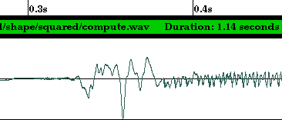
Fig. 2 Sample waveform of human voice
As we see the wave is in an analog format, it should be digitized into the form where computer readable. The need of transforming a speech waveform into a sequence of parameters vectors is now be highlighted.

2.2 Nature of sound features
Speech exhibits significant variation from instance to instance the same speaker and text. From the point of view of text-independent speaker identification, a speaker produces a stream of speech features (features will be discussed in greater detail below). These features characterize both the speech as well as the speaker. For a reasonable period of speech (i.e. several seconds), we expect the features to fill features space in a way that depends primarily on the speaker.

An important step in speaker identification process is to extract sufficient information for good discrimination, at the same time, to capture the information in a form and size that is efficiency to be modeled.
The generic features of sound include loudness, pitch period and bandwidth of an audio signal, different object have different signature, which produces a particular sound. For example, musical instrument has its own “impulse response” when struck. Storing these signatures and analyzing can identify particular object, which made the sound. [7]. In general, when classifying an audio sequence, one can first find some low-level acoustic characteristics associated with each short audio clip, and then compare it with those pre-calculated for different class of audio.

2.3 Features Encoding and processing
The overall process of feature extraction is to convert the waveform into a sequence of parameter blocks, which we call it vectors. Continuous waveform is first discrete into bits representation (i.e. 16 bit, 32 bit) with higher bits represent higher quality and then the bits vector is encoded into parameter vectors; the number of sample collected in one second is called a sampling rate.

A frame is a collection of sample vectors with a constant frame window size. Frame is overlapping with another frame; clip-level features are computed based on frame-level features.
Window Size
Fig. 3 Concept of overlapping and window frames

There is lots of features model to use to characterize audio signals. Volume Contour which use the root mean square (RMS) of the signal magnitude within each frame to approximate the volume of the frame, to detect frame that are silent, the comparison of volume and zero crossing rate of each frame to some preset thresholds. [6].
Harmonicity distinguishes between harmonic spectra (such as musical sounds and vowels), inharmonic spectra (such as metallic sounds) and noise. It is computed by measuring the deviation of the sound’s line spectrum for a perfectly harmonic spectrum. [8].

Pitch is the period of an audio waveform, and also it is important parameter for analysis and synthesis of speech signals. AMDF, average magnitude difference function is one of the common models to determine the pitch of each frame.

Spectral Centroid is the “balancing point” of the spectral power distribution. Many kinds of music involve percussive sounds, which, by including high-frequency noise, push the spectral mean higher. [6]. In addition, excitation energies can be higher for music than for speech, where pitch stays in a low range. This feature can give different results for voiced and unvoiced speech.

Zero-Crossing Rate is the number of time-domain zero crossing with a speech frame. This can determinate the silent point.

With so many important features can be derived in sound, a systemic way to modeling the sound should be introduced for elegant, efficiency audio system to be built on it.

2.4 MFCC model

2.4.1 Model introduction
Mel-frequency cepstral coefficients (MFCC) is a model of homomorphic type processing which allows us to separate the broad spectral characteristic of sound form pitch and voicing information. [9].
MFCC is computed by re-sampling a conventional magnitude spectrogram to match critical bands as measured by auditory perception experiments. The representation is inverted to generate a smooth spectrogram for the sound. As MFCC is an industrial standard of performing feature extraction, we choose it as well as other system as our base-line extraction mechanism. Figure 4 shows a MFCC conceptual graph.
Frequency
Energy in each band
Fig. 4 MFCC conceptual graph

2.4.2 Data rate compression
We have mentioned use of features vector can reduce the number of data process. Here we can show that use of MFCC can reduce the data rate at a scale of half.
Let’s the sampling rate of 16 bits 22050 Hz
That is 22050 samples are taken by each second.
So, for each second, the computer should handle
16 * 22050 = 352800 bits, which is 44100 bytes = 43 Kbytes
If MFCC feature extraction is used with window size 400 and 24 features vector dimension and stepping size 128 (each feature uses 16 bits for representation)
Then for each second there is only
22050/128 *24 *16 bits = 66150 bits, that is 8268.75 byes needed to handle.

Chapter 3 Audio Scene Change

3.1 Introduction to audio scene change
Speech segmentation is the location of boundaries between speakers in the audio stream. There are a lot of models available for detecting audio scene change. For examples, decoder-guided segmentation, model-based segmentation, metric-based segmentation, Bayesian Information Criterion techniques. Some segmentation techniques such as decoder-guided segmentation only segmented the audio stream at the silence locations and regard it as the change point. However, the segmented result will be a set of segmented sentences which don’t have meaning always. The data is not useful and meaningful when divided into too small and discrete pieces. Since most of the time, only data long enough to give some statistics or information is needed. For instances, in a news TV program or in a recorded conference, there are a lot of people speaking interleavingly. We believe that paragraphs of speech speaked by speakers are more useful than a huge set of single sentences from the audio streams. While for the model-based segmentation, metric-based segmentation, a threshold is needed for segmentation. Different from the others, Bayesian Information Criterion requires no threshold. Also, Bayesian Information Criterion can divided audio streams into output streams that is long enough to provide useful information. Other advantages are no need to do model training and no prior knowledge concerning acoustic conditions are required.

Bayesian Information Criterion is robust, threshold free and generalizes well to unseen acoustic conditions. The input audio stream can be modeled as Gaussian process. A maximum likelihood approach is used to detect turns in Gaussian process. The decision of a turn is based on the Bayesian Information Criterion which is a model selection criterion in the statistics literature. Besides the use in segmentation, BIC can also be used as termination criterion in hiearchical clustering. Two different clusters can be merged if the merging increases the BIC value. In other words, if BIC value increased after merging two clusters, then both nodes can be seen as belong to the same speaker. BIC criterion can detect acoustic changes accurately and produce clusters with high purity in hierarchical clustering, so we have choosen the BIC criterion for both segmentation and hierarchical clustering of the input audio stream in our Advanced Audio Information Retrievel System(AdvAIR).

Automatic audio scene change detection is important and essential because it is the fundamental part for data mining. You can’t analyse the data when it has too much data mixed together. So you need to segment the audio stream according to the audio scence change in order to retrievel useful and meaningful informatino. Segmentation is needed to provide pure and sufficient information to drive automatic speaker identification or classification program. It can be also be used to extract parts needed from an input stream.

3.2 Model Selection Criteria
Model selection means that we choose a model among a set of different models to describe the given data set. We need to choose the model carefully so that it can represent our data set. Different models are associated with different number of parameters. When the number of parameters in a model increased, the likelihood of the data also increased. However, when the number of parameters is more than needed, overtraining may occur. As a result, there are several criteria for selection of models, ranging from non-parametric methods such as cross-validation, to parametric methods such as the Bayesian Information Criterion(BIC) [7, 14]. In order words, models with too many parameters are not general and result in over-fitting, while those with too few parameters are not accurate and result in under-fitting.

BIC is a likelihood criterion which is penalized by the large number of parameters in the model. There is a trade-off in the number of parameter and the accuracy of the model estimation.
X = {x_{i} : i = 1,2,….,N} is the data set we are modeling.
M = {m_{i}: i = 1,2,….,K} is the candidates of desired parametric models.
Let L(X, m) be the likelihood function for model M. We maximize the likelihood function.
Let Num(m) be the number of parameters in the model M.
BIC criterion is defined as:
BIC (m) = log L(X,m) - $\frac{1}{2}$*λ*Num(m) *log(N) ……………………… (1)
Where penalty weight λ = 1
BIC procedure is to choose the model such that BIC criterion is maximized. This procedure can be derived as a large-sample version of Bayes procedures for the case of independent, identically distributed observations and linear models [10].

BIC criterion is widely used for model identification in statistical modeling such as time series [11], linear regression [12]. It is also used in the engineering literature such as for speaker adaptation [13]. λ which is the penalty weight in equation (1) can be assigned different value, but only λ = 1 represents BIC.

3.3 Change Point Detection through BIC
As mentioned Section 3.1 in this report, BIC can be used for both audio stream change point detection and hiearchical clustering. In section 3.3.1, we are going to give the alogrithm used for single change point detection. In section 3.3.2, we will give the alogrithm for multiple change point detection. Hiearchical clustering will be mentioned in section 3.4.

Let us find define some notations for detection of acoustic change in audio stream using BIC criterion:
d is the number of feature used to model each frame of the audio stream.
N is the number of frame in the audio stream.
X = {x_{i} Є R^{d} , i = 1,2,…,N} is the set of feature vectors representing the entire audio stream. (x₁ is the first feature vector, x_{i} is the i-th feature vector)
Assume X is drawn from an independent multivariate Gaussian process:
X ~ N( μ , Σ ) where the μ is the mean vector and Σ is the full covariance matrix which describe the Gaussian process.

3.3.1 Single Acoustic Change Point Detection
Let’s look into the algorithm for detecting single change point first. Assume that the change point occur at time i. Assume our data set is { X₁ … X_{N} }. We can view H₀ and H₁ as two different models which describe the data in different way. What we want to do is to find a model which models the audio stream better. H₀ is a model which models the data as one Gaussian distribution. H₁ is another model which models the data as two Gaussians distribution.
H₀: X₁ … X_{N} ~ N( μ , Σ )
H₁: X₁ … X_{i} ~ N( μ₁ , Σ₁ ) ;
X_{i+1} …X_{N} ~ N( μ₂ , Σ₂ ) …………………………… (2)

The maximum likelihood ratio statistics is:
R(i) = N log | Σ | - N₁ log | Σ₁ | - N₂ log | Σ₂ |
where Σ, Σ_{1,} Σ₂ are the sample covariance matrices from data { X₁ … X_{N} }, { X₁ … X_{i} } and from { X_{i+1} …X_{N} } respectively.
By the maximum likelihood estimate, the changing point is located at time t:
t = arg(max_{i} R(i))

BIC values can be expressed as:
BIC(i) = R(i) -λ* P …………………………… (3)
where P is the penalty, λ is the penalty weight
λ= 1
P = $\frac{1}{2}$(d +$\frac{1}{2}$d(d+1)) log N where d is the dimension of the space or the number of feature use to model the audio stream

If BIC(i) is positive, then model the data as two Gaussians(H₁) is better than model the data as one Gaussian(H₀). The i that maximizes the BIC(i) is the time of change point. That means i that make {max_{i} BIC(i)} > 0 is the change point.

Therefore maximum likelihood estimate of the changing point can be expressed as:
t = arg(max_{i} BIC(i))

Algorithm for detecting single acoustic change point:
Assume the data is { X₁ … X_{N} }, i is the position we are testing, max_BIC is the current maximum value of BIC(i), max_i is the position with max_BIC
Step 1: Initial i = 1, max_i = -1, max_BIC = 0, the data is viewed as two set { X₁,X₂ }, { X₃ … X_{N} }
Step 2: Test if position i is change point by calculating BIC(i), if BIC(i) is positive and larger than current max_BIC, then set max_i = i, max_BIC = BIC(i)
Step 3: If i = N-1 then goto Step 4,
Otherwise increase i by 1, that means set i = i + 1, go back to step 2
Step 4: If max_i = -1, that means all BIC(i) is negative, then there is no change point, otherwise i is the position of change point

BIC segmentation method has the following advantage comparing to the metric-based segmentation methods, there are experiment done on single point detection by some expert to show these.

- BIC is more robust because it use all the samples on either the left hand side of change point i and the samples on right hand side of change point i. In contrast, the metric-based segmentation methods use only a pre-defined number of samples on the left hand side and right hand side of the chagne point.
The distance between the first sample and last sample used in metric-based segmentation methods can be log likelihood ratio distance [14] or the Kullback-Liebler distances (KL distance). Probably only a few samples are used (for examples only two seconds samples). As a result, the measurement is not robust and is noise. The experiment is done using a speech signal of 77 seconds which contain two speakers measured using log likelihood ratio distance(i.e. the Gish distance), KL distance.

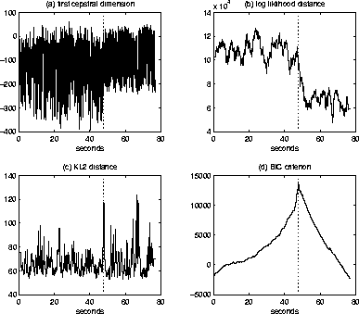

Fig. 5 Fig. 6

Fig. 7 Fig. 8
The above diagram is the result of the experiment. Figure 5 above shows how the sound wave used in the experiment look like, it is clear that the change point is between 40 and 50 seconds. Figure 6 show the result of log likelihood ratio distance. It is clear that at the change point, there is a local maximum occur, but there are many other maxima which does not correspond to any change point. So it can’t give a clear idea about where the change point locates. Figure 7 show the result of KL distance. It also obtain a local maximum at the change point and there exist some other maxima which does not correspond to any change point. The problem is the same as log likelihood ratio distance. Figure 8 show that the result of BIC criterion can accurately locate the change point and it is clearly show that only one sharp global maximum occur which corresponding to the change point.

- BIC is threshold free. Both log likelihood ratio distance and KL distance rely on the threshold to detect the change point, while BIC doesn’t need a threshold. Finding a suitable threshold is really a difficult problem. If a wrong threshold is used, then change point may not be able to locate accurately. So finding threshold makes log likelihood ratio distance and KL distance more complex.

- BIC has optimality. Change point can be located accurately as the sample size increases. When the sample size is too small, the result may not be accurate enough. However, when the sample size is large enough, then optimality can be guaranteed.

3.3.2 Multiple Acoustic Change Point Detection
Algorithm for detecting multiple acoustic change point is similar to that for detecting single change point. It’s only the extension of the algorithm for detecting single acoustic change point.

Below is the algorithm for detecting multiple acoustic change point.
[a, b] is the interval we investigate. Checking is done to see if single change point appears within that interval.
Step 1: Initialize the interval [a,b]. Set a = 1, b = 2
Step 2: Detect if there is a changing point in the interval [a,b] through BIC single change point detection algorithm
Step 3: If there is no change point in interval [a,b],
then set b = b+1
else let t be the changing point detected, record down the change point, set a = t+1, b = t+2
Step 4: Stop when all samples are processed. Otherwise go to Step (2)

For example,
Start Pos. Frame 0
Change point
Frame 2000
Change point
Frame 1000
End Pos.
Frame 3000
Fig. 9 Audio stream with change points
Figure 9 shows an audio stream which has two change points (at frame 1000, frame 2000), Step to compute the change point is:

- First set a=1, b=2
- Use single point detection algorithm to detect change point between [1,2]. As there is no change point within [1,2], so continue to detect the interval [1,3], [1,4], [1,5], … ,[1,1000], [1,1001], …
As there is no change point between frame 1 and frame 1000, so we increase b until we detect a change point, probably b is increased until a value between 1000 and 3000 which allow us to detect the change point at frame 1000, let’s assume we detect the change point when b = b’
- Then we set a = 1001, b = 1002 and repeat step (2) to step (4) of the multiple acoustic change point detection algorithm
We investigate the interval [1001,1002], [1001,1003], [1001,1004], … ,[1001,2000], …
Similarly, we stop when b equal to a value between frame 2000 and 3000 which allow us to detect the change point at frame 2000, let’s assume we detect the change point when b = b’’
- Then we set a = 2001, b = 2002 and repeat step (2) to step (4)
We investigate the interval [2001,2002], [2001,2003], [2001,2004], … , [2001,3000] and then we can stop. As there is no change point between frame 2001 and 3000, we only repeat to increase b until b reach the end (frame 3000). Then our detection of multiple change point will be ended.

3.4 Enhanced Implementation Algorithm
The multiple change point detection algorithm mentioned in section 3.3.2 starts by detecting change point within 2 frames. Next the investigation interval is increased by 1 through increasing b by 1 when no change point is detected within the interval. However, it is very slow if we process also the small interval such as 2 frames because there are a lot of frame in an audio stream. We have implemented our engine using this implementation but it run very slowly, we need to wait for around 30 minutes for detecting change point for a 15 seconds mpeg file. We need to wait a long time for segmenting such a short mpeg, so if we use it for a long mpeg, we may need to wait for a long time. A system that needs unreasonable time for running is not so useful in the real world.

As a result, in order to achieve a higher speed, our engine use implementation that based on the multiple change point detection algorithm but a larger processing interval is used. The minimum processing interval used in our engine is 100 frames. In one second, they’re around 170 frames. So frame i and frame i+100 is only difference by less than one second and error in detecting the change point is acceptable and is not very large when we use interval of 100 frames rather than 2 frames.

We start the processing by setting a = 1, b = 100, then we will increase the interval by 100 frames every time we can’t find the change point. The new implementation is faster then the old implementation for around than 100 times. For a 15 seconds mpeg file, we can detect the change point at around 15 seconds. However, the trade-off is that the change point we detect is not so accurate. To compensate this, we have a recalculation after detecting a change point. After we have detecting a change point using the 100 frame interval implementation, we investigate on the frames before that change point and the frame after that change point with interval incremented by 1 every time to locate a more accurate change point. By doing this, we can locate the change point quite accurately without using too much time.

3.5 Hierarchical Clustering through BIC
As mentioned in the beginning of Chapter 3, BIC can also be used for clustering besides segmentation. Clustering is a useful technique that groups together audio segments come from the same speaker. When we have a lot of segments in which there are different speakers, each speaker has several segments in the data set, we can do clustering to group all the segments belong to the same speaker together in order to provide more organized and meaningful information. For example, in a recorded conference, we may want to get all the segments that belong to the president of the company so as to follow the instruction he given.

Another use is to compensate the miscalculate of the segmentation algorithm. Sometimes the segmentation algorithm is not so accurate, it may cut two consecutive speeches, which belong to the same people into two different parts. So by using clustering we can group them together to correct the segmentation result.

Now we are going to give the algorithm for clustering:
Let’s define some notations first:
S = {s₁,…,s_{k}} is a set of clusters or nodes
Suppose s₁,s₂ are belong to the same speaker, let s be the new node if we merge s₁ and s₂.
Let S’ = {s,…,s_{k}} be the set of clusters after merging s₁ and s₂.
We model each node s_{i} as a multivariate Gaussian distribution N( μ_{i} , Σ_{i} ).

Then we compare S and S’ to see which has a higher BIC value.
Modeling s2
Modeling s1
Modeling s
Fig. 10 Gaussian Mixture Model Graph

In figure 10, one Gaussian distribution is the modeling s and the other two Gaussian distributions model s1 and s2. We compare the modeling of S and S’ as a Gaussian distribution to see which is more likely to represent the data set. We check if one Gaussian distribution modeling s as a node of combining s1 and s2 is better or two Gaussian models which model s1, s2 separately is better. The idea is shown on the above diagram.

The equation we used is the same as that for segmentation:
BIC = N log | Σ | - N₁ log | Σ₁ | - N₂ log | Σ₂ | - λ*P ………………………… (4)
where P is the penalty,
P = $\frac{1}{2}$(d +$\frac{1}{2}$d(d+1)) log N where d is the dimension of the space or the number of feature use to model the audio stream
λ= 1 is the penalty weight,
N = N1+N2 is the sample size of the merged node s,
Σ is the sample covariance matrix of the merged node.

Two nodes should be merged if equation (4) is negative. If equation (4) gives a positive value, by segmentation algorithm described in Section 3.3.1, there is a change point, which means that the two nodes are belong to different speaker. Therefore, when equation (4) gives a negative value that means those two nodes are belong to the same speaker.

Chapter 4 Recognition Engine

4.1 Introduction to Recognition Engine

4.1.1 Background information on Recognition Engine
Our Recognition Engine can perform three recognition, they are speaker recognition, language recognition and gender recognition. Recognition engine can be used in data mining because it give information about an input audio stream, for instance, the speaker of the speech, the language spoken and the gender of the speaker.

There are two type of recognition system: close set recognition system or open set recognition system
1. Close-set recognition system
  - The system can only recognize the speaker or language as one of the speaker or language inside the set of model that is being trained.
  - The input speech is assumed to be spoken by one of the speaker and is belong to one of the language inside the training set.
  - The system only need to check which speaker or language is the input speech belongs to within the training set.
  - If speech not belong to the training set is input, the system will just identify the speaker as the most similar speaker inside the training set and identify the language as the most similar language inside the training set.

2. Open-set recognition system
  - The system can recognize the speaker as outsider among the training set and language as unknown language.
  - When a speech belongs to speaker or language inside the training set, it can recognize it. Otherwise, it can identify the speaker or language as unknown.
  - The outsider or the unknown language can then be trained and put into the training set.
  - It is more complicated then close-set system. The system may have false alarm. (false positive: recognize outsider as speaker inside the training set, false negative: recognize the speaker inside the training set as outsider).

Our speech recognition system is an open-set recognition system. When the input speaker is not inside the set of speakers we have trained, we can identify that he/she is an unknown speaker. On the other hand, the language recognition system and the gender recognition system is a close-set recognition system. Language recognition system can identify language as unknown language when it is not one of the trained languages. Gender recognition system must be close-set because there are only two genders on the world, either male or female.
Section 4.2 is about speaker recognition system. Section 4.3 is language recognition system. Lastly, section 4.4 is about the gender recognition system.
4.1.2 Selection of model for our Recognition Engine
Vector Quantization Modeling, Neural Network and Gaussian Mixture Model are the most popular method for recognition. Vector Quantization Modeling [15] is a template modeling where the temporal information of the features is averaged out. A codebook is used to represent the features of the speech. The main idea is to average out the factors that influence the acoustic features and intra-speaker variation, only the speaker dependent component is left. However, the loophole is that the averaging process discards much speaker-dependent information and it requires long speech utterance (>20s) to derive stable long-term speech statistics.

Neural Network does not train the individual model separately. It is trained to model the decision function which best discriminates speakers within a known set. Time-delay Neural Network [16], Multilayer perceptrons [17] have been used in some speaker recognition tasks. The merits of Neural Network is that it require a small number of parameters and have better performance in recognition as compare to Vector Quantization. However, the drawback is that the complete network must be retained when a new speaker or language is added to the data set. This is very time consuming and inconvenient.

Gaussian Mixture Model is a statistical model that models the underlying sound of a person’s voice. Gaussian Mixture Model represents the broad acoustic classes which reflect general speaker-dependent vocal tract configurations. The vocal tract configuration of a person is unique, so can be used to model the speaker identity. The Gaussian mixture density provides a smooth approximation to the sample distribution of observations obtained from utterances by a given speaker. It is computationally efficient and only short utterances are needed, so we have chosen to use the Gaussian Mixture Model as our recognition model. We will discuss about the GMM model in the sections below.

4.1.3 Background knowledge about Gaussian Mixture Model
As different speakers and different languages have their own statistical density, so we can identify speakers, genders and languages by the statistical density. A Gaussian distribution is a normal distribution, which uses mean and variance to represent it. Gaussian Mixture Model is a type of density model that use to represent the speaker model. It strictly follows the probabilistic rules. Advantage of Gaussian mixture model is text independent, robust, computationally efficient and easy to implement.

GMM[18] is commonly used for language identification, gender identification and speaker identification. It is more accurate for identifying speaker than gender. We will explain the reason after we have talk about GMM.

Figure 11 shows a Gaussian distribution. A Gaussian distribution is represented by a mean and variance
mean

Fig. 11 Gaussian distribution

The model we used is a Gaussian mixture model instead of a Gaussian distribution. A Gaussian mixture model is modeled by many different Gaussian distributions. Each of the Gaussian distribution has its mean; variance and weighting in the Gaussian mixture model it modeling [19]. This is shown in figure 12. Figure 13 shows how a Gaussian mixture model is being model by the many Gaussian distributions. All of the Gaussian distribution in figure 12 combines to form the large Gaussian mixture model in figure 13.
Model i
…………………

Fig. 12 Variance, Weighting in GMM Model

Fig. 13 Construction of GMM

You may wonder why we need to use more than one Gaussian distribution to represent the model. Why don’t we use one Gaussian distribution to represent the speaker model?

This is because Gaussian distribution, which is a normal distribution, is symmetric about the middle. However, in real world, the distribution, which uses to represent a model, is not always symmetric. It may be irregular in shape, just look like figure 14. As a result, a symmetric Gaussian distribution cannot represent the model that is irregular in shape. Instead a Gaussian mixture model includes many small Gaussian distribution is used to represent a speaker model. So the Gaussian mixture model is represented by the sum of the small Gaussian distribution multiple by the weight for each of the Gaussian distribution. All the small Gaussian distribution contributes a point in the Gaussian mixture model.

Fig. 14 Irregular distribution

4.1.4 Description of Gaussian Mixture Model (GMM)
Assume M is the number of small Gaussian distribution used to model the Gaussian mixture model
Let us consider the simple case first, when there is only one-dimensional random vector:
The equation used to calculate the Gaussian Mixture Density for one-dimensional random vector is:
$p(x)=\sum_{i=1}^{M}{p_{i}b_{i}}(x)$
where i = 1, …. , M
$b_{i}(x)=\frac{1}{(2π)^{1/2}{\left|Σ_{i}\right|}^{1/2}}\text{exp}\left\{\left.−\frac{1}{2}(x−μ_{i})'Σ_{i}^{−1}(x−μ_{i})\right\}\right.$
x is the input one-dimensional random vector
$b_{i}$ is the score for Gaussian distribution i
$μ_{i}$is the mean for Gaussian distribution i
$Σ_{i}$is the covariance matrices for Gaussian distribution i
$p_{i}$is the weighting of the score for the Gaussian distribution i
$\sum_{i=1}^{M}{p_{i}}=1$, the sum of all the weight must be 1
We need $\sum_{i=1}^{M}{}$because we need to sum up all the score contributed by the M different Gaussian distribution.

The following equation is used to calculate the Gaussian Mixture Density for D-dimensional random vector:
$p(\vec{x})=\sum_{i=1}^{M}{p_{i}b_{i}}(\vec{x})$……………………….. (5)
where $\vec{x}$ D-dimensional random vector
i = 1, … , M
$b_{i}(\vec{x})=\frac{1}{(2π)^{D/2}{\left|Σ_{i}\right|}^{1/2}}\text{exp}\left\{\left.−\frac{1}{2}(\vec{x}−{\vec{μ}}_{i})'Σ_{i}^{−1}(\vec{x}−{\vec{μ}}_{i})\right\}\right.$

x is the input D-dimensional random vector
$b_{i}$ is the score for Gaussian distribution i
$μ_{i}$is the mean for Gaussian distribution i
$Σ_{i}$is the covariance matrices for Gaussian distribution i
$p_{i}$is the weighting of the score for the Gaussian distribution i
$\sum_{i=1}^{M}{p_{i}}=1$, the sum of all the weight must be 1
We need $\sum_{i=1}^{M}{}$because we need to sum up all the score contributed by the M different Gaussian distribution.

4.1.5 Training Procedure for Gaussian Mixture Model (GMM)
Before you can identify a speaker, language or gender, an important step must be done. That is training of the models. For every speaker, language or gender you want to identify, you need to collect clips that are long enough for training. After training, a set of parameters are obtained. They are the mean, variance and the weighting for the small Gaussian distribution. They are represented by
$λ=\left\{\left.p_{i},{\vec{μ}}_{i},Σ_{i}\right\}\right.$ in which $p_{i}$ represents the Gaussian mixture weights.${\vec{μ}}_{i}$ Represents the mean and $Σ_{i}$ represents the variance. A possible approach to do training is the Maximum Likelihood parameter estimation. The aim of the Maximum Likelihood parameter estimation is to find the model parameters which maximize the likelihood of the training data. Maximum Likelihood parameters can be estimated using a specialized version of expectation-maximization (EM) algorithm. The basic idea is that we first begin with an initial model, and then we estimate the new model such that the new model represents the data better. After training, we will obtain the mean, variance, and weighting of each Gaussian distribution ($λ$).

Steps for training:
- First collect a set of sound clips that is long enough for each speaker you want to identified
- Begin with an initial model λ
Then we calculate the $\bar{λ}$ (new mean, variance, weighting) for the model by using the following formula.
Gaussian mixture weights:
${\bar{p}}_{i}=\frac{1}{T}\sum_{t=1}^{T}{p(i|{\vec{x}}_{t},λ)}$

Means:
${\bar{\vec{μ}}}_{i}=\frac{\sum{p(i|{\vec{x}}_{t},λ){\vec{x}}_{t}}}{\sum{p(i|{\vec{x}}_{t},λ)}}$

Variances:
${\bar{σ}}_{i}^{2}=\frac{\sum{p(i|{\vec{x}}_{t},λ)x_{t}^{2}}}{\sum{p(i|{\vec{x}}_{t},λ)}}−{\bar{μ}}_{i}^{2}$

- Check if the newly calculated parameter is more suitable to model the speaker by using the following formula.
$p(i|{\vec{x}}_{t},λ)=\frac{p_{i}b_{i}({\vec{x}}_{t})}{\sum{p_{k}b_{k}({\vec{x}}_{t})}}$

We use part of the training data to test the parameter$\bar{λ}$. If the score $p(X|\bar{λ})$ is larger than the score$p(X|λ)$, then we will use the newly calculated parameter $\bar{λ}$ to do the training again.
We use the new parameter $\bar{λ}$ when the following equation is satisfied.
$p(X|\bar{λ})≥p(X|λ)$

- Continuous to do the training by repeating step (3) and step (4). It has been proven by some paper that this method is a convergent approach. In order words, when we repeat to train the parameter$\bar{λ}$, we will get the parameter which is more close to the actual parameter for modeling the speaker. The error between the actual parameter for the model and $λ$ become smaller and smaller through training. With more training data, the error will be smaller.

A critical factor in doing the training is that we need to do the initialization of the model parameters before applying the EM algorithm. Actually the EM algorithm can only guaranteed to find a local maximum likelihood model. However, the likelihood equation for the GMM may have several local maxima. As a result, different initialization model may lead to different local maxima. Several initialization methods have been compared in paper [23]. Although different initial models may converge to different local maxima of the likelihood function, the different between the final models is insignificant.

For both close set and open set model for speaker and language recognition, every speaker and language has its own GMM model. In addition, open set speaker recognition system has an extra GMM overall speaker model to decide whether to reject the input stream as outsider.

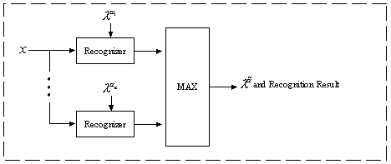 Fig. 15 System flow chart of recognition engine
In figure 15, X is the input audio stream, and each of the recognizer is to check the score of the audio stream against one of the GMM, which represent one speaker, language or gender. Then we can identify that the speaker, language or gender of the incoming audio stream is the speaker, language or gender that obtain the highest score.

Figure 15 shows the recognition for close set. For open set speaker recognition, we have an extra model which is the general model. The general model represents all other possible speakers. The score of each of the speaker model is normalized with the score of the general model. Also, a threshold is needed. The speaker model with the highest score that is smaller than the threshold is the speaker of the input audio stream. If all the score is larger than the threshold, then we consider the speaker of the input stream as outsider.

Our recognition engine is implemented using the GMM. As GMM is quite common and it is very tedious to implement all the things in GMM, so we have used some library to aid us to implement the engine.

4.2 Speaker Recognition/Identification

4.2.1 Introduction to Speaker Recognition/Identification
Speaker identification is an important part in real world. It is use to identify a speaker given an input stream. Segmentation and clustering is a support for doing speaker identification. For a speaker identification engine, segmentation and clustering is the front-end and the speaker identification part is the back-end. First, we need to segment a long input stream into a list of stream that belongs to different speakers. Next, we can choose to cluster the speech belong to the same person into a group. However, we only have different group of segments by doing segmentation and clustering. Finally, the speaker identification is done because it is one of the useful information a user needed. Sometimes the user may ask is the speech spoken by person X. That’s why speaker identification important. For examples, in security lock system using voice lock, the main idea is to verify whether the speaker is the authorized person to open the lock. In voice mail system, you may want to know who have leave you message too, this is speaker identification.

A speaker recognition system is a system, which can identify the speaker given an input audio stream. In order to be able to identify speaker, the recognition system must have some knowledge about whom the system want to identify first. Before the recognition system can work, it must do pre-processing -- training. Training is a process in which sound clips of a group of speaker need to be collected. It uses some model to train the group of speakers which the system want to identify and then store it in some understandable form to allow the system to use it afterwards.

4.2.2 Speaker Recognition Procedure
- Calculate the scores for each of the GMM model against the incoming audio streams using the following equation and the means and variances calculated during training. This is to compare the input feature vectors against the speaker model for the trained identity.
The following equation is derived from equation (5) in 4.1.4
$\text{ln}p(\vec{x})=\text{ln}\sum_{i=1}^{M}{p_{i}b_{i}}(\vec{x})$ where $\vec{x}$ is the random vector
i = 1, … , M where M is the number of mixture in the Gaussian Mixture Model.
$b_{i}(\vec{x})=\frac{1}{(2π)^{D/2}{\left|Σ_{i}\right|}^{1/2}}\text{exp}\left\{\left.−\frac{1}{2}(\vec{x}−{\vec{μ}}_{i})'Σ_{i}^{−1}(\vec{x}−{\vec{μ}}_{i})\right\}\right.$

However, we will take logarithm. You may wonder why we take logarithm. This is because the value b_{i}$(\vec{x})$ is always too small. If we do not take logarithm, then final result value may underflow.
- Divide the score of each of the speaker model by the score of the general model. The general model represents all other possible speakers.
- Select the speaker of the GMM model with maximum score and score less than the threshold as the result

4.3 Language Recognition

4.3.1 Introduction to Language Recognition
Language recognition is the process of automatically identifying the language of a spoken utterance. With the increase in the multi-lingual based speech system, language recognition becomes more important and useful.

Our Language Recognition system can be used to recognize three most common languages, Cantonese, Mandarin and English. It is a close set recognition system. It cannot identify the language of the input stream as unknown when it is not one of those three languages. The Training procedure is mentioned in section 4.1.5.

4.3.2 Language Recognition Procedure
- Calculate the scores for each of the language model against the incoming audio streams using the following equation and the means and variances calculated during training.
$\text{ln}p(\vec{x})=\text{ln}\sum_{i=1}^{M}{p_{i}b_{i}}(\vec{x})$
- Select the language of the model with maximum score as the result

4.4 Gender Recognition

4.4.1 Introduction to Gender Recognition
Gender Recognition is the process of automatically identifying the gender of a spoken utterance. It must be a close-set system because there are only two genders which are male and female in the world. By applying gender recognition, the search space can be divided into half. As a result, speech recognition can be facilitated.

4.4.2 Gender Recognition Procedure
- Calculate the scores for the male and female model against the incoming audio streams using the following equation and the means and variances calculated during training.
$\text{ln}p(\vec{x})=\text{ln}\sum_{i=1}^{M}{p_{i}b_{i}}(\vec{x})$
- Select the gender of the model with maximum score as the result

  - Why speaker identification is more accurate than gender identification
We have mentioned that identification for gender is not as accurate as speaker identification if both are close set recognition. The Gaussian mixture model for speaker will probably have little variance, the distribution is look like those in figure 16. While those for male or female will have a large variance, just like the distribution shown in figure 17. The variance for male and female is quite large, and overlapping occurs more easily when the variance is large. As a result, the overlapping part of male and female is also very large as compare to those of the speaker distribution. The region of error for gender is therefore larger than the region of error for the speaker identification. That’s why speaker identification is more accurate than gender identification.

Fig. 16 Speaker model distribution graph
Region of error

Fig. 17 Gender model distribution graph

Chapter 5 Direct Audio Search

5.1 Introduction
With the ever-increasing size and availability of audio databases, it is believed that necessary to have an accurate and efficient method to classify and to index data. It gives rise to the problem of audio searching and retrieving.

For some problems, most appropriate representation of audio is to use derived text transcription, while this method is called the Spoken Document Retrieval (SDR) by apply some text-based retrieval methods to documents produced by a large vocabulary systems used [24]. Another method should be work in the content-based audio retrieval by allowing some section of the audio which are similar to be retrieved from a database, much more similar to the “Select record from database which attribute like some others” in SQL language.

While the ability to recognize similar sounds is useful for audio retrieval, classification and segmentation, there are several applications where an exact match is also required. Naturally, similar techniques can be used, but the problem is simplifying to a binary choice of whether the cue-audio is present or absent within a particular audio sample.

We address the problem of find similar or exact match of audio segments in an efficient and accurate manner and the method can be applied to a wide range of applications. The technique is particularly useful in database searching which have a time critical issue and accuracy needed.

Specifically, music Pattern Matching is usually done by specifying some features to representation the audio and computing an average feature vectors over a whole sound clip. Given a cue-audio, a standard measurement is used to compare the clip with another to give the rank in similarity. Detailed algorithm will be described in following paragraph.

5.2 Algorithm overview
To be able the search the audio accurately and quickly, the data must first be sampled and a set of features which capable to describe the characteristics of the audio must be defined. As before, MFCC is used due to its great capability to capture characteristic. A single feature vector is calculated for each frame consists of 512 vectors and a 256 vectors shifting. A distance metric is required to calculate the similarity between segments. Metrics which used is the covariance-weighted Euclidean distance between the feature vectors. A covariance based comparison method using AHS distance was used for the audio search task. This method mainly compares the covariance matrix of the cue audio with those segments of data of the same size in the audio data to be searched.

First, the covariance matrix of a segment is calculated from it feature vectors. The AHS (arithmetic harmonic sphericity [25]) distance between segments is defined as:
D(X, Y) = log$\left[\text{tr}\left(\sum{y\sum{x^{−1}}}\right)⋅\text{tr}\left(\sum{x\sum{y^{−1}}}\right)\right]−2\text{log}\left(D\right)$
Where tr represents the trace of the matrix and D is the dimension of feature vectors. Using this AHS measures, the distance between identical segments should be zero. However, due to the asynchronous of cue-audio events, a small threshold is defined and distances less than the threshold used to indicate an exact match. For similarity check, the score calculated should be ranked from small to large to indicate the degree of similarity. When attempting the find a small piece of cue-audio in a long portion of target audio, the latter case is sliced into windows as the same length as the former. By the experiments reported in later section, it shows that when the cue-audio is longer than one-second, shift period can be half the window without affecting the accuracy in order to maintain the accuracy and performance.
Slice of target audio with the same size of given cue
Shift Size
Cue Audio
AHU comparison
Fig. 18 Conceptual graph of direct audio search

5.3 Performance enhancement
To speed up a search, threshold can be set so that the process can stop when a match is found; this can be done in the scenario of exact match. To enable this threshold to be robust, separation between the clips where cue-audio is absent and those where it is present should be high enough. By experiment, 6.6 second piece of cue-audio can be correctly defied every time it occurs, even when the windows shift size is large. As the covariance representation attempts to capture the generic properties of the audio, it is no longer necessary to shift the search by a single frame, and therefore the search speed is increased accordingly, the size of shift is depends on the length of cue-audio and the required trade-off between accuracy and performance.

5.4 Conclusion
An accurate and fast method of finding exact and similar matches in audio database using a MFCC feature vectors representation and AHU (arithmetic harmonic sphericity) distance measurement, it can effectively finding a small section of cue audio in a fast and accurate fashion. By adjusting the shift interval and cue audio size, an additional performance enhancement can be achieved.

Chapter 6 Query by Humming

6.1 Introduction to Query by Humming
New information retrieval methods are addressed due to the emergence of huge size of audio and video data, moreover these searching method should be optimized for the specific media to give user the maximally convenience. The most natural way of querying an audio database should be giving some examples; no matter by singing or giving, from the previous section, query by giving similarity cue-audio or exact audio direct search. In this section, we will bring you another, more natural way of querying the audio database, query by humming.

The new generation database will consists not only boring text, but also exciting multimedia information, as well as storing, indexing and quer7ying are also important event. For instance, the most natural way to describe a picture is by drawing, retrieve image based on images or sketches supplied as input. Similarly, a natural way to query audio is by singing (humming the song) the tune of the song. In fact, this type of system is already formed in commercial market product (provided by NTT Do-Co-Mo Japan), we just demonstrate it to show the idea will work practically.

  - System Flow Chart
Intermediate Representation database
Pitch Tracking Engine
Similarity tracking Engine
Ranked list of similarity
Hummed songs or played midi
Midi
Fig. 19 Flow chart of query by humming system

  - System Implementation

6.3.1 Pitch Tracking
The most important part of the whole system is the part of pitch tracking; the most proper way to say about pitch tracking is the estimation of the fundamental frequency of speech or musical notes in a given period of time. Algorithms which deal with frequency domain algorithms are generally more robust than time-domain algorithms, thus we chose an algorithm which is based on the well-known autocorrelation method with a number of modifications to prevent errors [26].

The fundamental frequency of a periodic signal is the inverse of its period; this definition applies only to a perfect periodic signal only. Since human voice is time varying function with pitch shifting. So, some applications give it a differently definition, for voiced speech, it is usually defined as the rate of vibration of the vocal folds. But the final destination of our algorithm is very simple, we want the pitch tracking engineering can determine one thing, tracking the trend of voiced sound, in the manner of “UP”, “Down” or “Same”. As we mentioned before, we use time domain autocorrelation function, ACF, to implement our core.

ACF is created from the equation
$φ_{t}\left(γ\right)=\sum_{j=t+1}^{t+W}{x_{j}x_{j+γ}}$ [24]
Where $φ_{t}\left(γ\right)$ is the autocorrelation function which lag $γ$calculated, and W be the integration window size. Because a periodic signal will have a strongly correlation with itself by the fundamental period, so picking the peak in the ACF function is done for reflecting the multiples of the period. In order to have a sequence of pitches, the melody is isolated and tracked, this can be done by energy level and zero crossing rate. The output is in the form of intermediate representation as below described.

6.3.2 Intermediate representation and similar tracking
For the aims of simplicity and easy be implemented, a simple but concise intermediate representation is defined. We use three symbols, ‘U’, ‘D’, ‘S’, for above, below and same as previous note. For Example, Beethoven’s 5th Symphony is begin with notes S,S,D,U,S,S,D [27]. Songs in our database is also represented by the same representation keyed in by human. With this representation, a pattern-matching can be done easily. The pattern-matching also need to use some method of search to allow error which is due to the humming error as well as the tone shifting. In fact, the method is the well-known largest substring matching problem. The problem consists of given input string X and Y; it is needed to find that at most k mismatches for each instance of P in Y. For a given query, the algorithm address above returns the list of song with sorted similarity. User predefined threshold of error should be set in order to anticipate the error key search. From the result list, users can then identify which is the song they desired.

  - Conclusion and limitations
Accuracy tracking on human voice is still a hard problem to be solved, till now, it really an important influence on system performance. If we can extract the pitch of human voice correctly, then the system becomes more accuracy. Due to the noise, false pitch value, and shifting of human voice, our system can not recognize human hummed melody accurately. However, we can show that our system works well with pure tone rather than human voice. As stated before, it is a commercial product, and it need vast of resources and time to develop the complete system, we have try our best to have the most accurate result, we wish have our system developed completely in the future. Content-based music retrieval is very challenging task, in the future, more and more database searching method will be appeared in the trend of multimedia database. Despite the accuracy, it shows the possibility of implementing such a system and we deeply believe that it will work well in a future time.

Chapter 7 Network Implementation

7.1 Introduction
In order to enhance the user interactivity, and with the consideration of further improvement of the system, network-based communication has been implemented. The network core is solely implemented by using windows socket programming including both UDP and TCP for fast and reliable transfer.
Our system is a multi-server multi-client system. It consists of download of request file using UDP, upload of file using TCP for audio data searching on server side. Downloading of file is a multipart download process. A file is divided into many different tiny pieces and download different pieces from different server in parallel. The client downloads each piece from a specified server, then stitches them together in order, and finally plays back the whole audio stream. Besides, there are communication control threads, each thread responds for its own task and communicates with each other to make whole system robust and effective.
Currently, the network based system can support downloading files, fault tolerance with bandwidth control, uploading file for searching on servers. We deeply believed that our system will work even better in future due to the development of network part making the nature of scalability becomes possible.

7.2 Network Flow Chart

7.2.1 Server Side Flow Chart
Timer and Resend
Stand By
Start Up
Analysis Packet

Receive Packet
Add Connection
Threading new Process
Initialize Connection
Download

Open Port and create new thread
Upload
A new thread to maintain communication
TCP thread for handling file transfer
UDP thread for multi-part download
Perform requested operation
Request operations
Thread for keeping alive message with client
Alive Message
Send back result
Fig. 20 Server side flow chart

7.2.2 Client Side Flow Chart
Login and Authentication
Ready
GUI thread for display and input
Network thread
Network related Message
Add connection
Download
Upload
Other operations
New Thread handling alive message with servers
Receiving Thread
Result
Alive Messages
Request files from servers and wait for packet
Packets of file slice
A new TCP thread for file transferring
Thread asynchronously
Re-send and wait for result
Fig. 21 Server side flow chart

7.2.3 Multipart Downloads Flow Chart
Fig. 22 N to N client, server flow chart
Audio Stream 1
Server 1
Audio Stream 2
1
2
3
4
5
1
2
3
4
Audio Stream 1
Server 2
Audio Stream 2
1
2
3
4
5
1
2
3
4
1
2
3
4
Download Audio Stream 2
I want Audio 2 part 1 and part 3

I want Audio 2 part 2 and part 4
Client 2

7.3 Data Structure and Format of packet
UDP packet format and packet type:
UDP Packet format for download

struct packet
{
int type; //type of packet
int payloadLen; //payload length
char buffer[BUFFER_LEN]; // buffer
int parentPort;
//an variable which represent the packet’s parent port
}packet;

UDP Packet Type for download

#define TYPE_CLIENT_HELLO 0
#define TYPE_CONNECT_FULL 1
#define TYPE_CLIENT_BYE 2
#define TYPE_SERVER_HELLO 3
#define TYPE_INITDOWNLOAD 50
#define TYPE_REPLYDOWNLOAD 51
#define TYPE_REQUESTBYTE 52
#define TYPE_REPLYBYTE 53
#define TYPE_KILL_DOWN_SUB 54
#define TYPE_STOP_DOWNLOAD 55
#define TYPE_CLIENT_ALIVE 99
#define TYPE_SERVER_ALIVE 98
#define TYPE_LIST_FILE 97
#define TYPE_REPLY_LIST 96
#define TYPE_KILL_ME 100
TCP packet format and packet type:
TCP Packet format for upload

struct ftppacket
{
int type;
int connect_index;
bool isEndFile;
long byteNeed;
int payloadLen;
char buffer[BUFFER_LEN];
char filename[100];
int filetype; //0: for pattern matching
int parentPort;
} ftppacket;

TCP Packet Type for upload

#define TYPE_PATTERN_FILE_NAME 0
#define TYPE_PATTERN_FILE_UPLOAD 1
#define TYPE_PATTERN_RESULT_FILE_NAME 2

7.4 Features and security
Both TCP and UDP have been implemented for reliable but fast transfer. UDP is used for download of file from server. TCP is used for uploading of file from client to server for pattern matching. We separate the download and upload of file so that only privileged users can use the upload of file for the pattern matching function.

For the UDP file download, fault tolerance is also achieved by retransmission of packets and pumping of alive messages. Also bandwidth control has been implemented to ensure client will not overwhelm the servers. Servers and clients can be added in at any time. If the server is heavy loaded, then more server can be added in and allow client to connect in the middle of the download process to speed up the download process.

Security is also an important issue, so authentication system is build on the client side. Client need to login in order to use the system. Besides, all the transmitted packets are encrypted using 64 bit symmetric keys. In original design already considers the scalability, so the data structure used has been developed to allow more servers and users during the long life span.

Chapter 8 Experimental Result
This chapter includes the experimental result of different engines in our system, i.e. audio segmentation, language identification, gender identification, speaker classification, pattern matching and query by humming of the AdvAIR system.

8.1 The Environment for experiment
- CPU: P4 1.7 GHz
- Memory: 512M DDR Ram

8.2 Segmentation

8.2.1 Parameter Setting
- Dimension: 24 (the number of features vector used)
- Sampling rate: 22050 Hz
- Number of Channel: 1
- Number of Filter Bank: 60
- Frame windows size: 400
- Frame stepping rate: 128
The overlapping area of neighbor frame is 400-128 = 272 samples.

8.2.2 Result of the experiment on Segmentation engine
Table 1 show the overall result of the experiment.
Test | Sound clip length | Actual Turing Pt | False Alarm | Missed Point | Time used
1 | 8 seconds | 1 | 0 | 0 | 2 seconds
2 | 14 seconds | 2 | 0 | 0 | 4 seconds
3 | 25 seconds | 3 | 0 | 0 | 8 seconds
4 | 165 seconds | 12 | 1 | 1 | 92seconds
5 | 586 seconds | 51 | 8 | 2 | 617 seconds

Table 1 Result of segmentation engine

8.2.3 Comparison with the old proposed system
In the beginning, we have implemented the segmentation system using the basic technique which processed all the frames. It is quite accurate. However, the time needed to process even a short audio file is unreasonably long (e.g. 1 whole day is needed for processing of audio file of length 586 seconds). Therefore, we have improved the system so that the accuracy doesn’t affect much but the time used for processing reduced a lot. The new system is implemented using the basic technique but some improvement has been done as mentioned in chapter 3.4. Table 2 shows the comparison of the performance of the old system with the new system.

Test | Method | Sound clip length | Actual Turning Point | False Alarm | Missed Point | Time used
1 | Old | 8 seconds | 1 | 0 | 0 | 10 seconds
1 | New | 8 seconds | 1 | 0 | 0 | 2 seconds
2 | Old | 14 seconds | 2 | 0 | 0 | 40 seconds
2 | New | 14 seconds | 2 | 0 | 0 | 4 seconds
3 | Old | 25 seconds | 3 | 0 | 0 | 1300 seconds
3 | New | 25 seconds | 3 | 0 | 0 | 8 seconds
4 | Old | 165 seconds | 12 | 1 | 0 | 1300 seconds
4 | New | 165 seconds | 12 | 1 | 1 | 92 seconds
5 | Old | 586 seconds | 51 | 7 | 2 | Over 1 days
5 | New | 586 seconds | 51 | 8 | 2 | 617 seconds
Table 2 comparison between old and new system

8.2.4 Analyze of the Experiment Result
From Table 1, we can see that the miss point is not too much, but the false alarm is a lot more than the miss point. The segmentation engine will falsely treat a point as change point if there is background noise or loss in quality in a particular part or non-nature stop of a speech by person.
As show in the result in Table 2, the new segmentation engine is a lot faster than the old engine, and the accuracy of the engine still doesn’t degrade much. Especially for a long audio file such as the 5th test case, the running time has been improved a lot.

8.3 Speaker Recognition

8.3.1 Training Stage
For the open-set recognition, we used five males and five females from TVB news for the training stage. About 20 minutes long sound clips of each speaker are used to train his/her own GMM model. There is an extra generic GMM model. The generic human speech GMM model is trained by using both male and female sound clips.

Parameters used in Experiment 1:
We trained three sets of GMM models using different parameters (number of mixture models) for modeling.
For extraction of feature for training is the same for all the three sets:
Sampling rate: 22050 Hz
Frame windows size: 220
Frame stepping rate: 220

Number of mixture models in Gaussian Mixture Model for modeling:
First set of GMM models: 128 mixtures
Second set of GMM models: 256 mixtures
Third set of GMM models: 512 mixtures

Parameters used in Experiment 2:
For extraction of feature for training:
Sampling rate: 22050 Hz
Frame windows size: 220
Frame stepping rate: 220

For modeling:
Number of mixtures models in Gaussian Mixture Model: 256

8.3.2 Testing Stage
We have two speaker recognition engines. One is speaker recognition engine alone, the other is segmentation with speaker recognition engine. The first engine is for recognition of a segment in the input audio file. Our engine only treats the segment as speech of one speaker only. The second engine, segmentation with speaker recognition engine, can automatically identify all the speakers in the input audiovisual data file. Two experiments have been done to investigate the accuracy of these two engines.

In the first experiment, we use three different training set of GMM models for testing of the speaker recognition engine. They are composed of different number of Gaussian mixture. This is to investigate on the accuracy of the engine when different number of Gaussian mixture used and also investigate to see what the suitable number of Gaussian mixture is. For each of the three set of training model and each of the four different lengths (3s, 5s, 10s, and 20s) of testing file, we used 50 file to test for the accuracy. Some of the speeches are spoken by speakers in our training set, some are not. The input audio is speech of one speaker only.
In the second experiment, we used the segmentation with speaker recognition engine for testing. We will see how our system performs when the input consists of one or more than one speaker. We have used five sound clips for testing. The sound clips used for testing is the News from TVB. Each sound clips consists of various length speech from different speaker. Some of these speakers are in our training set, some are not. From this we can investigate the accuracy of our segmentation with speaker recognition system.

8.3.3 Result of the experiment on Speaker Recognition engine
Experiment 1:
Below shows the accuracy of the speaker recognition engine when the number of Gaussian mixture used for training of the models is 128,256, and 512.
Number of Gaussian mixture used for training | Test Length
Number of Gaussian mixture used for training | 3 seconds | 5 seconds | 10 seconds | 20 seconds
128 mixtures | 58%/13seconds | 64%/21seconds | 72%/47seconds | 78%/88seconds
256 mixtures | 68%/18seconds | 80%/27seconds | 86%/66seconds | 90%/123seconds
512 mixtures | 72%/30seconds | 82%/61seconds | 88%/143seconds | 94%/298seconds
Table 3 experiment result of speaker recognition

Experiment 2:
Definition of the three false alarm type:
- False Alarm Type 1: Recognized the speech of outsiders as belong to someone inside the training set
- False Alarm Type 2: Recognized the speech of speaker inside our training set as belong to outsider
- False Alarm Type 3: Recognized the speech of speaker inside our training set as belong to another speaker which is also inside our training set

Test | Sound clip length | Num. of Segments | Correctly recognized | False Alarm |  |  | Time used
 |  |  |  | Type1 | Type2 | Type3 | Time used
1 | 8 seconds | 1 | 1 | 0 | 0 | 0 | 39 seconds
2 | 14 seconds | 2 | 2 | 0 | 0 | 0 | 69 seconds
3 | 25 seconds | 3 | 3 | 0 | 0 | 0 | 81 seconds
4 | 165 seconds | 12 | 8 | 4 | 0 | 0 | 593 seconds
5 | 586 seconds | 51 | 42 | 8 | 0 | 1 | 2419 seconds
Table 4 Testing result of recognition

8.3.4 Analyze of the Experiment Result
Experiment 1:
For 128 mixtures GMM models:
Average accuracy:
$\frac{\text{58\%}+\text{64\%}+\text{72\%}+\text{78\%}}{4}$
= 68%
Average running time:
$\frac{\text{13}+\text{21}+\text{47}+\text{88}}{4}$ seconds
= 42.25 seconds

For 256 mixtures GMM models:
Average accuracy:
$\frac{\text{68}\text{\%}+\text{80}\text{\%}+\text{86}\text{\%}+\text{90}\text{\%}}{4}$
= 81%
Average running time:
$\frac{\text{18}+\text{27}+\text{66}+\text{123}}{4}$ Seconds
= 58.5 seconds

For 512 mixtures GMM models:
Average accuracy for 128 mixture GMM models:
$\frac{\text{72\%}+\text{82}\text{\%}+\text{88\%}+\text{94\%}}{4}$
= 84%

Average running time:
$\frac{\text{30}+\text{61}+\text{143}+\text{298}}{4}$ Seconds
= 133 seconds

From result of experiment 1, you can see that different between the accuracy of engine using 512 mixtures GMM model and that using 256 mixtures GMM model is small but the different between the accuracy of engine using 128 mixtures GMM model and that using 256 mixtures GMM model is quite large. On the other hand, the average running time used by engine using 512 mixtures GMM model is too long. User need to wait for a long time before getting the result. Therefore the best number of mixtures in GMM model is 256, and our engine is using 256 mixtures in GMM models.

Experiment 2:
Accuracy of the system = percentage of correctly identified segments
=$\frac{\text{No}\text{.}\text{ of correctly identified segments}}{\text{Total number of segments}}x\text{100}\text{\%}$
=$\frac{\text{56}}{\text{69}}x\text{100}\text{\%}$
= 81.2 %
Error percentage of False Alarm type 1 =$\frac{\text{12}}{\text{69}}x\text{100}\text{\%}$
= 17.4%

Error percentage of False Alarm type 2 =$\frac{0}{\text{69}}x\text{100}\text{\%}$
= 0%
Error percentage of False Alarm type 3 =$\frac{1}{\text{69}}x\text{100}\text{\%}$
= 1.4%

From the error percentage, we can see that most of the system error is caused by wrongly recognized an outsider as one of the speaker belong to our training set.

8.4 Language Recognition

8.4.1 Training Stage
Cantonese, English and Mandarin are three most frequently used language in Hong Kong. Therefore, our language recognition system is designed to recognize these three languages. For each of these languages, we have collected 20 minutes of audio stream for training. After training, we got three GMM models.

Parameters used:
For extraction of feature for training:
Sampling rate: 22050 Hz
Frame windows size: 220
Frame stepping rate: 220
For modeling:
Number of mixture models in Gaussian Mixture Model: 256

8.4.2 Testing Stage
We investigate both the accuracy and the time needed to recognize the language of a speech. As the length of the speech increase, the accuracy of the recognition system increase. We have do experiment for sound clips of 4 different length. For each of the length of speech, we get 90 sound clips for testing where 30 sound clips for each language is used.

8.4.3 Result of the experiment on Language Recognition engine
Test | Sound clips length | Clips used | Average Time used | Correct %
1 | 3 seconds | 90 | 10 seconds | 86.7%
2 | 5 seconds | 90 | 17 seconds | 93.3%
3 | 8 seconds | 90 | 22 seconds | 95.5%
4 | 10 seconds | 90 | 23 seconds | 96.7%
5 | 15 seconds | 90 | 30 seconds | 97.8%
6 | 30 seconds | 90 | 50 seconds | 97.8%
Table 5 result of language recognition

8.4.4 Analyze of the Experiment Result
Average accuracy:
$\frac{\text{86}\text{.}7\text{\%}+\text{93}\text{.}3\text{\%}+\text{95}\text{.}5\text{\%}+\text{96}\text{.}7\text{\%}+\text{97}\text{.}8\text{\%}+\text{97}\text{.}8\text{\%}}{6}$
= 94.6%
Average run time:
$\frac{\text{10}+\text{17}+\text{22}+\text{23}+\text{30}+\text{50}}{6}$ Seconds
= 25.3 seconds

From the above result, we can see that if we take 15 or 30 seconds from the sound clips for recognition, the result is quite accurate. However if 30 seconds clips are used, the time taken to get the result is quite long. Background noise is one of the reasons which caused error. For recognition of language, 15 seconds long segment is enough.

8.5 Gender Recognition

8.5.1 Training Stage
We have collected sound clips of 20 minutes long in total for both male and female. Then we have used these to train the male GMM model and female GMM model.

Parameters used:
For extraction of feature for training:
Sampling rate: 22050 Hz
Frame windows size: 220
Frame stepping rate: 220
For modeling:
Number of mixture models in Gaussian Mixture Model: 256

8.5.2 Testing Stage
We have do four set of testing where sound clips of different length are tested. Sound Clips of length 3 seconds, 5 seconds, 10 seconds and 15 seconds are being tested. We have used 90 sound clips for each of these. Within the 90 sound clips, 45 belong to male and 45 belong to female.

8.5.3 Result of the experiment on Gender Recognition engine
Test | Sound clips length | Clips used | Average Time used | Correct %
1 | 3 seconds | 90 | 13 seconds | 86.7%
2 | 5 seconds | 90 | 15 seconds | 90.0%
3 | 8 seconds | 90 | 19 seconds | 92.2%
4 | 10 seconds | 90 | 22 seconds | 93.3%
5 | 15 seconds | 90 | 24 seconds | 94.4%
6 | 30 seconds | 90 | 39 seconds | 94.4%
Table 6 gender recognition result

8.5.4 Analyze of the Experiment Result
Average accuracy:
$\frac{\text{86}\text{.}7\text{\%}+\text{90}\text{.}0\text{\%}+\text{92}\text{.}2\text{\%}+\text{93}\text{.}3\text{\%}+\text{94}\text{.}4\text{\%}+\text{94}\text{.}4\text{\%}}{6}$
= 91.8%
Average run time:
$\frac{\text{13}+\text{15}+\text{19}+\text{22}+\text{24}+\text{39}}{6}$ Seconds
= 22 seconds

From the above result, we can see that if we take 15 or 30 seconds from the sound clips for recognition, the result is quite accurate. Background noise is one of the reasons which caused error. However, the problem for gender recognition is that we are not able to get 30 seconds long audio clips for gender recognition always. This is because the input audio file sometimes just consists of many short speeches from each of the people, the length of this speech is less than 30 seconds always. For instance, in the news report, most of the time the reporter speaks for less than 20 seconds.

8.6 Pattern Matching

8.6.1 Background of the experiment
We have done an experiment to find out the accuracy of the pattern matching engine and the time required to do the pattern matching. We have collected 50 different sound clips and use it to search a database of various sizes to check the accuracy of the engine. Some of the sound clips are part of the sound clips in the database, some are not. Below shows the overall result, and 8 of the experimental results.
Number of sound clips used for pattern matching | Number of Correct Result | Number of Incorrect Result
50 clips | 47 clips | 3 clips

8.6.2 Result of the experiment on Pattern Matching Engine
Test | Testing File Length | Target File length | Total length of search files | No. of search files | Result | Time Used
1 | 8 seconds | 1min 42sec | 3min 16sec | 2 | Correct | 12 seconds
2 | 10 seconds | 3min 34sec | 13min 47sec | 5 | Correct | 52 seconds
3 | 4 seconds | 4min41sec | 19min 28sec | 7 | Correct | 59 seconds
4 | 1 seconds | 5min20sec | 30min10sec | 6 | Correct | 70seconds
5 | 1min | 2min | 103min3sec | 20 | Correct | 200seconds
6 | 2min | 2min | 323min13sec | 50 | Correct | 650seconds
7 | 2 seconds | 3 min10sec | 24min43sec | 10 | Incorrect | 80seconds
Table 7 Pattern matching result
Table 8 another Pattern matching result

8.6.3 Analyze of the Experiment Result
From Table 7,
The average accuracy of pattern matching engine is:
= $\frac{\text{number of correct result}}{\text{total number of test case}}∗\text{100}\text{\%}$
= $\frac{\text{47}}{\text{50}}∗\text{100}\text{\%}$
= 94%

Table 8 shows 8 experimental results.
From the experimental result, we can see that the time used for pattern matching is a very little when compare to the length of the input audio for searching and the total length of all the audio file inside the database. For a database of over 30 minutes and searching input audio of 1 seconds, only 70 seconds is used for the pattern matching engine to locate the matched audio file. The total length of all the audio files in the database is 25 time larger than the searching time used. From the time used and the accuracy of the engine, we can see that the algorithm used for pattern matching is very effective and efficient.

8.7 Queries by Humming

8.7.1 Background of the experiment
Our database consists of 50 songs, which is downloaded from popular internet midi-base, which consists of both popular and classical music. The test is conducted by playing some notes to match against the database intermediate representation, the result will be ranked by the similarity.

8.7.2 Result of the experiment on Query by Humming engine
Queries can be found within the top five results, and if the notes played is a pure tone, then result can be found at 100% accurately. About 78% is within the first three matches, while over 88% is within the first five matches.

8.7.3 Analyze of the Experiment Result
It can be shown that our system is capable to identify the hummed songs; it can be achieved quite accurately. However, due to the misaligned pitch and human error, some false alarm is formed. The retrieval time is proportional to the number of songs in the database, although the run time is O(mn), it will requires a great amount of time if the database is too large, i.e. over 30000 songs. As a summary, it is a workable system which works independent with its own algorithm without the use of lyrics or similarity comparison (Direct Audio Search mentioned above).

Chapter 9 AdvAIR Advanced Audio Information Retrieval System

9.1 Introduction to AdvAIR system
Our Engine is called AdvAIR; it stands for Advanced Audio Information Retrieval System. The pronunciation of AdvAIR is similar with at air. What we mainly process is the audio stream or the audio channel in the video stream. In our world, air is the main channel for transmitting the sound wave signal, the speech of a person. Therefore, we use AdvAIR as the name of our system to let people have the idea that our system is related to air and related to audio when they hear the name AdvAIR.

Our system is a network based system consists of two main parts, audio data mining and audio data searching. Section 9.2 talks about the basic download function of our system. Section 9.3 talks about audio data mining function of our system. Section 9.4 talks about audio data searching of our system. Our system helps to extract different kinds of information from audio file.

9.2 Server and Client Graphical User Interface

9.2.1 Client Side Graphical User Interface
User Authentication
Audio data mining
Audio Data Searching
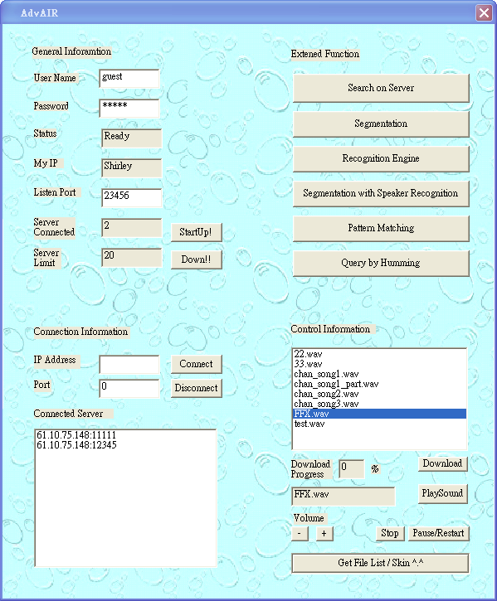
Fig. 23 Core GUI
Here shows the server connected
The list of file for download
File downloaded

Figure 23 shows the Client Graphical User Interface. The left top part shows the login and also the information of client. The left bottom part is for making connection to server and the information of the server connected is displayed below that. The right top part shows different function for audio data mining and audio data searching. The right bottom part shows the list of audio file for downloading from server.

Download of audio file is one of the functions of our network-based system. We include it because we believe that download of audio file is a basic and necessary function for a network-based audio information retrieval system. It allows clients to get the file they want or get the result audio file after performing audio data searching.

Our system allows users to change the skin of the client main graphical user interface to increase the user-friendliness.

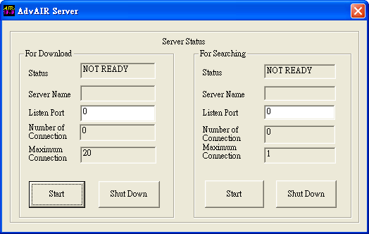
9.2.2 Server Side Graphical User Interface

For download of audio file
For upload of file and pattern matching

Fig. 24 Server GUI

Figure 24 shows the server side graphical user interface. The left part is used for download of audio file. The right part is used for upload and pattern matching for privileged users. Since it takes quite a lot of resources (memory) to perform the pattern matching, so the maximum connection for upload and pattern matching is one and only one user is allowed to do pattern matching at a time. The download of audio file allows 20 maximum connections because not many resources are taken for sending of a small part of audio file to clients at a time.

9.3 Audio data mining

9.3.1 Introduction to Audio data mining
Audio data mining means to get some information from audio file. In our system, we can do segmentation to segment a audio file into according to the acoustic change, identify the identity of the speaker of a speech, identify all the speaker inside an audio file, identify the language spoken and the gender of the speaker in a speech. All of this helps a lot in audio data mining because when handling a huge set of data, automatic process and analyze of audio data is needed, it is impossible to ask someone to do this manually as it used a lot of time and money.

We have separated the segmentation with speaker recognition engine into three engines. They are segmentation engine, speaker recognition engine and segmentation with speaker recognition engine. We write three separate engines because we think that all of the three engine useful and can be used separately in different aspect. Segmentation can be used to give a general idea about the input stream. After we segmented the audio stream, we can extract one of the segments needed for other used. It can also be used for building up a database of audio or video stream. The segmentation with speaker recognition engine can be used to automatically segment and recognized all of the speakers in the audio stream. It is useful for data mining of large set of data. While the speaker recognition engine alone is used to recognize the speaker of a specific segment in the input audio stream. The segmentation with speaker recognition engine is used to recognize the whole input audio file, you can’t choose to get information of a particular segment only. The speaker recognition engine alone is useful when user only want to get the speaker information about a part of a segment of audio file instead of the whole file.

9.3.2 Segmentation engine
Segmentation engine is used to segment the input audio file according to the acoustic change in the audio stream. In other words, we will segment an input audio file into different small segments belong to different speakers. Segmentation Engine takes an mpeg video in .mpeg format as input. A Mpeg player section is used to show the mpeg video. When we want to do the segmentation, the engine first converts the mpeg into a wave file to extract the audio channel information from the video stream. Next, the feature in every frame in the wave file is extracted and stored in feature vectors. BIC segmentation algorithm is used to calculate where in the audio stream we should segment. After segmentation, all the segments belong to the same speaker is grouped together.
Figure 25 shows the Graphical User Interface of our Segmentation System.

Select Mpeg File for processing
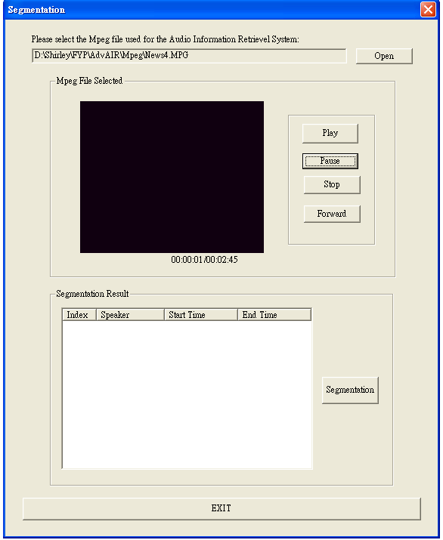
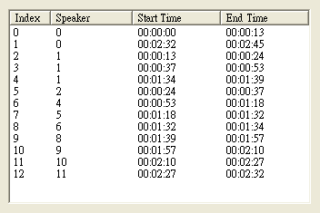
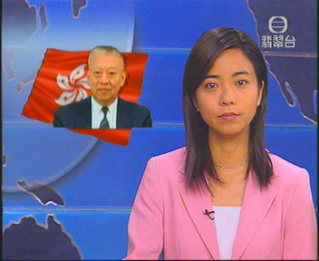

Segmentation Result

Fig. 25 segmentation system GUI

Figure 25 shows the segmentation system. First steps for segmentation is to select an mpeg file. You can watch the video selected by using play, pause, and stop, forward button provided next to the screen for playing of mpeg. The duration and current position of the mpeg file playing is shown just below the screen. Next, press the “Segmentation” button. The result is then shown in the “Segmentation Result” list box.

9.3.3 Recognition engine
The recognition engine can perform speaker recognition, language recognition, and gender recognition. Training needs to be done in prior the use the engine. Before training, enough audio clips need to be collected. The recognition engine use Gaussian Mixture Models for modeling of the model in training set. Both Language recognition engine and gender recognition engine is close set recognition engine. Only speaker recognition engine is an open set recognition engine. Our Recognition engine allows users to select any combination of the recognition, they can select all three recognition at the same time, but of course the time needed is the combination of three engine running time. Users need to specify a time interval for recognition, otherwise, the whole audio file is used for recognition.

9.3.3.1 Speaker Recognition engine
The speaker recognition engine has ten models for ten different speakers and one overall model. First, open the client program and select “Recognition Engine” button, then you can see the graphical user interface shown in figure 26. Secondly, you select an mpeg file for recognition. Next, you can specify a time interval for processing. Furthermore, you need to tick the check box for speaker recognition. You can then play the specified time interval mpeg file by using the mpeg player in the left top part of figure 26. The result is then shown in “Recognition Result” section. A photo will be displayed if the user is one of the people in the speaker training set. The name of the speaker is displayed and also a sound file announcing the name of speaker is played. This makes the system more fancy and user-friendly.
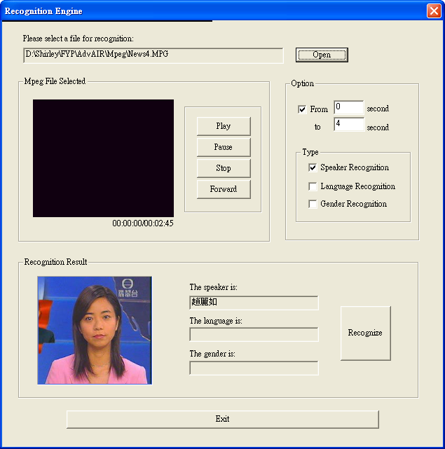
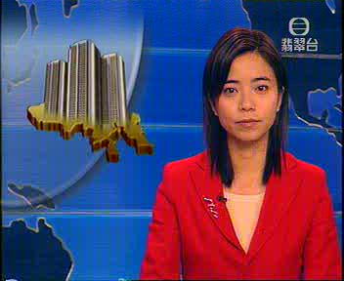
Select the time interval for recognition

Select the type of recognition

Recognition Result

Fig. 26 Recognition engine GUI

9.3.3.2 Language Recognition engine
The language recognition engine has 3 different models (English, Chinese, and Mandarin). First, open the client program and select “Recognition Engine” button, then you can see the graphical user interface shown in figure 27. Next, you select an mpeg file for recognition and specify a time interval for processing. And then, you need to tick the check box for language recognition and press the recognition button. The result is then shown in “Recognition Result” section.
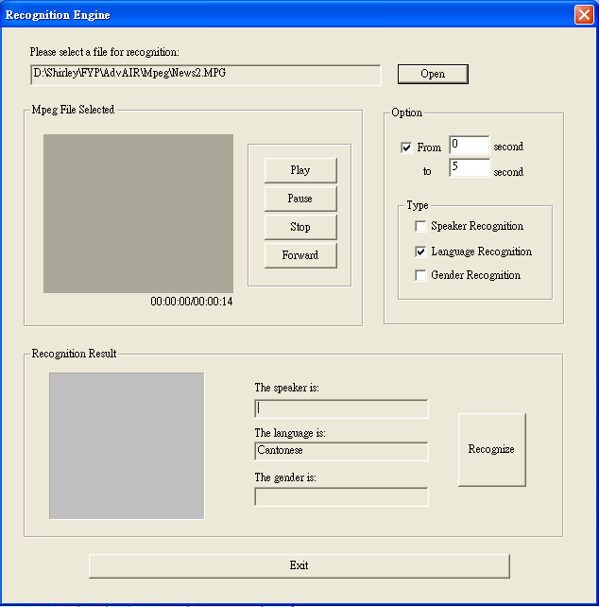
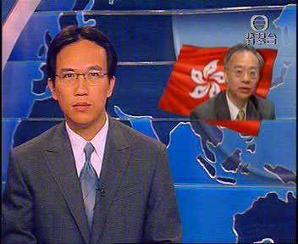
Select the type of recognition
Select the time interval for recognition
Recognition Result

Fig. 27 another capture of recognition engine GUI

9.3.3.3 Gender Recognition engine
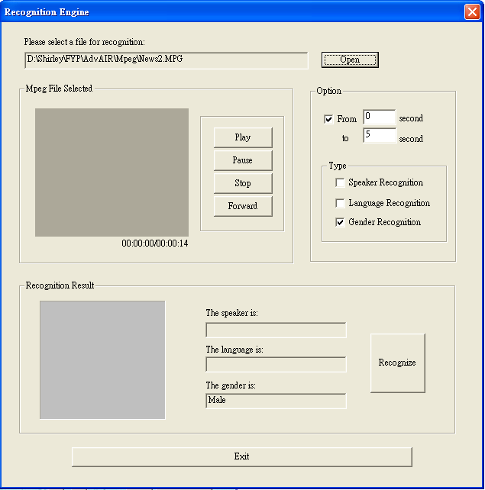
The language recognition engine has 2 different models (male, female). First, open the client program and select “Recognition Engine” button, then you can see the graphical user interface shown in figure 28. Next, you select an mpeg file for recognition and specify a time interval for processing. And then, you need to tick the check box for gender recognition and press the recognition button. The result is then shown in “Recognition Result” section.
Select the type of recognition
Select the time interval for recognition
Recognition Result

Fig. 28 a capture for gender recognition result

9.3.4 Segmentation with Speaker Recognition engine
This engine is an automatic speaker recognition engine with segmentation. It is different from the speaker recognition in recognition engine. The speaker recognition in recognition engine can only recognition one segment specified by the user in the whole input mpeg file while this engine recognize all the speaker of the speech in the whole input mpeg file automatically.

The input of this engine is an mpeg video in .mpeg format. First step is to open the client program and then select “Segmentation with speaker recognition” button. Then the graphical user interface in figure 29 will be shown. Next, you need to select an mpeg file for speaker recognition with segmentation engine and click the “Recognition” button. The recognition result will then be shown in the “Recognition Result” section.

The result shown specifies the speaker name and the interval of speech belong to that speaker. Hierarchical clustering is also done before speaker recognition to group the speech belong to the same speaker together.

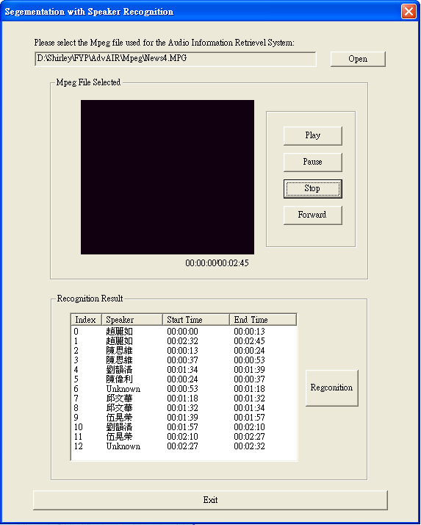
Mpeg player
Speaker recognition Result

Fig. 29 a figure for segmentation with speaker recognition

9.4 Audio Data Searching

9.4.1 Introduction to Audio Data Searching
Audio data searching is to search for audio data in a large audio data set. In the past, multimedia resources such as video and audio are not important resources because the size of multimedia resources is large and there is less demand on multimedia resources. But now multimedia resources such as audio resource become more and more important. Our audio data searching engine help user to search for audio file in a large set of audio data set or audio database.

9.4.2 Pattern Matching on local host
Given a short audio part of an audio file, we can search out the original audio file inside a large audio data set. Another use is in audio indexing. A large set of audio file is difficult to manage. We can extract the most important part from the audio file as the index. The index audio file is similar with the index in table. We can then search by using the index audio file.

First step is to open the client program. The graphical user interface in figure 30 is shown. To do pattern matching, user needed to select an audio file for searching and a folder for searching. Then press the “Start Search” button. The result will be shown in the
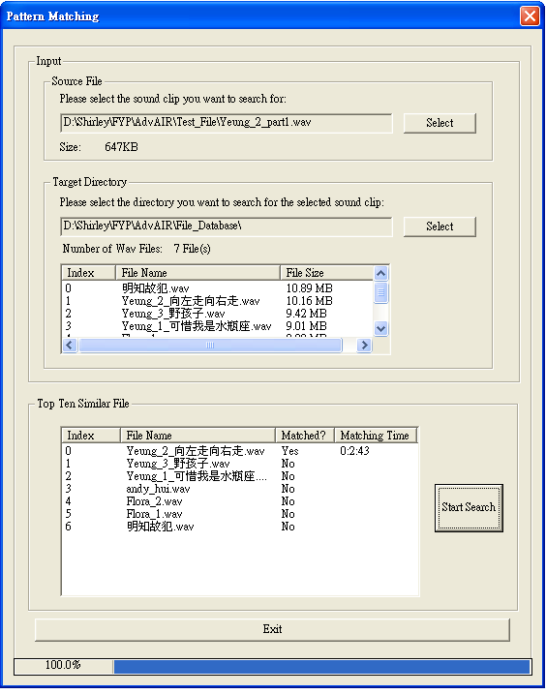
“Top Ten Similar File” section. It shows a list of file with the highest similarity file on the top. In the result, a field “Matched?” show whether the file is a matched file or not. If it is a matched file, the time where the result file match the audio file for searching will also be shown.
Audio file for searching
Target Directory for searching
Fig. 30 Direct audio search GUI capture
Search Result

9.4.3 Pattern Matching on server side
Besides pattern matching for audio data searching on local machine, our system can also perform pattern matching in server side to search the database or data set in server side. Instead of listing a list of ten similar file, this engine only list the most similar file in the result. First step is to open the client program and then graphical user interface in figure 31 will be shown and then you connect to one of the server and select a file on local side for searching. Next click “Upload the file and search” button and wait for the result. The result will then be shown in the “Result” section.
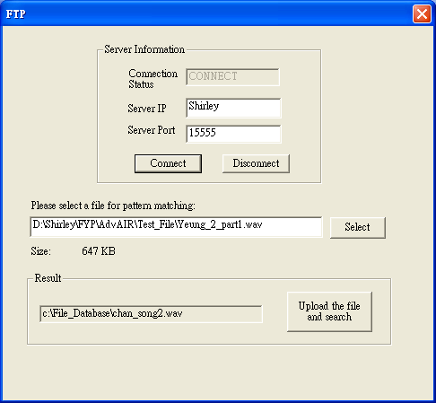
Server status, IP and port number
Local File for searching on server side
Result match file in Server side

Fig. 31 a result of direct audio search request on server

9.4.4 Query by Humming on local host
Query by humming is another way to do audio data searching. It uses a hummed audio file contain human voice singing out the melody of a song or pure tone wav file as input for searching. First, open the client program and then user can see the graphical user interface in figure 32. Next, select the file for searching and the directory for searching. And then, press the “Start Search” button and wait for the result. The result will be shown in the “Top Ten Similar File” section. It is range according to the score calculated by compare two wav file similarity. The highest marks file is put on top of the result. The top most file is the file most similar to the file for searching.

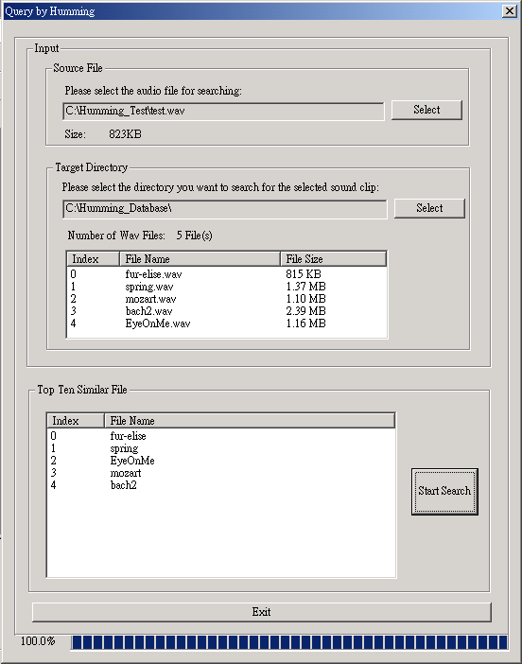
File for searching
Directory for searching
Top Ten Similar Result File

Fig. 32 Query by Humming GUI

Chapter 10 Contribution of Work

10.1 Alex’s contribution

10.1.1 Introduction
In this section, I will go to state the part of contribution that I have done. For the final year project, we mainly divided the project into two parts which is audio data mining and audio information retrieval. For the audio data mining part, it consists of recognition engine, pattern matching (direct audio search). For the audio retrieval part, it consists of scene segmentation, and query by humming. There are also some extra parts like GUI development and network based communication.
I was focused on the latter part, that is the scene segmentation and query by humming and also the network based communication. And my partner has focused on the remaining parts. In the later section, the parts I have contributed will be explained in detail.

10.1.2 Preparation work
Before implementation, we will first need to know about the background knowledge of signal processing and some special technique deal with sound. I have studied the nature of sound, principle of signal processing and also make use of some current library in Visual C++, in addition, MFC programming skills and WINSOCK documentation have been reviewed.

After the enrichment of several fields of programming and background knowledge, we have started to implement the system.

10.1.3 Implementation Detail

10.1.3.1 Scene segmentation
It consists of the problem of segment the video clip into homogenous clips, according to the background information or speaker identity. As stated before, it make use of BIC algorithm to compare two sound clips, seeing it if they belong to same homogenous node. The algorithm works well in small incremental size, and can achieve very high accuracy. However, it runs for very long time.

To improve the performance of the audio scene change segmentation, I had applied dynamic programming and also long time heuristic to boast up the search time. As the result is not prefect, I tired to use the BIC algorithm again in the result of achieve a better accuracy. It shows that the improved algorithm works well as the original one with a much faster speed.

      - Query By Humming
Query by humming is a searching method of next generation of audio database. It is a natural way to query the audio database by humming the tune of a song. Such a system would be useful in any multimedia database containing musical data.

The whole system consists of two main parts: 1. Pitch tracking engine, 2. Intermediate representation matching engine. For the pitch tracking part, famous auto-correlation algorithms plus some error elimination process likes zero-crossing rate and energy level determination have been applied. The speed and accuracy is quite acceptable for pure tones but weak in tracking human voice. For the intermediate representation matching engine, a k mismatch approximate string algorithm has been applied, which consists of technique of dynamic programming. As the result of running time is O (mn), it can be shown that the running speed of the whole query by humming system is quite a little bit fast.

10.1.3.3 Network communication part
In order to enhance the interactive of the system, network is implemented. The network part is implemented solely by WINSOCK package. Multiple servers and multiple clients with fault tolerance have been implemented. In order to achieve security, asymmetric key encryption is being embedded.

10.2 Shirley’s contribution

10.2.1 Introduction
This section is about my contribution in this Final Year Project and the knowledge I have learnt in this project.

Our Final Year Project is mainly divided into two parts. They are the audio data mining and audio data searching. Audio data mining includes the segmentation engine, recognition engine. Audio data searching includes pattern matching and query by humming. And there are extra parts such as network implementation and graphical user interface.

I mainly focus on the recognition engine and the pattern matching while my partner focus on the segmentation engine and query by humming. In the following section, I will states what I have learnt. And my partner focuses on the other parts.

10.2.2 Preparation Work
As I haven’t study any subject that is related to multimedia or audio before I started to do this final year project, so before implementation I have studied the basic knowledge about audio, signal processing. Besides, I only know ANSI C and java before, so I have studied the Visual C++ before start to write the program. As I am in charge of the implementation of the graphical user interface, and it is necessary to write an mpeg player, I studied the MFC and DirectShow in details. After learning the basic knowledge, I start to do the project.

10.2.3 Implementation Details

10.2.3.1 Recognition Engine
The recognition engine consists of two separate parts. One is the training program which takes a set of mpeg file as input and trains the parameters (mean, variance, weight) for the Gaussian Mixture Models. The other is the program read in an mpeg file as input and compares it with the stored pre-processed Gaussian Mixture Model for recognition. Both program take mpeg file as input and then extract the feature in the mpeg file using MFCC feature extraction. Maximum Likelihood parameter estimation is used in the training process to determine the parameters of models. I have tried to use different number of mixture in Gaussian Mixture Model for training and find the most suitable one. Also, for the open set speaker recognition, I have tried to test and find the best threshold for accurate determination of speaker identity.

10.2.3.2 Pattern Matching
A cue-audio search is a fast and efficiency method for audio database retrieval. It can also be used for database indexing. A faster than real-time algorithm is implemented by using AHU algorithm. AHU is a mathematic model of statistic and similarity compare method, not only exact matching, but also similar audio pieces can be found. By this nature, my direct search engine can locate a ranked similarity list of songs which contains exact/similar nature of cue-audio, which is useful for indexing and clustering in audio database.

10.2.3.3 Graphical User Interface
The MFC and DirectShow, DirectX library consists of a lot of classes. For example, for showing of result, I have make use of the List Control, progress bar. And also, I have mad use of the CFileDialog to select a file. Also I know how to make use of the event in the MFC, such as the timer event, initDialog event. In DirectShow, I have make used of the IVideoWindow, IMediaControl, IMediaPosition, etc to control the position, speed and the flow of the mpeg file.

10.2.4 Conclusion
After doing the final year project, I have learnt a lot about signal processing (GMM, AHU), graphical user interface programming, and also object-orientated programming skills. Also, I have learnt about DirectShow which is a very useful tool for writing multimedia applications.

Chapter 11 Conclusion
Our network based AdvAIR system allow user to do audio data mining and audio data searching. It is a system for audio information retrieval. We believe that it aid in applications related to audio data. After doing this final year project, we have learnt a lot about signal processing. Our programming skill has been enriched also.

Reference
[1] S.W. Smoliar and H. Zhang, Content-based video indexing and retrieval, IEEE Multimedia, pp. 62-72, 1994.

[2] M. Flickner, H. Sawhney, and W. Niblack et al., Query by image and video content: The QBIC system, Computer vol.28, no.9 pp.23-32, 1995.

[3] S.F. Chang, W.Chen, and H.J. Meng et al., A fully automated content based video search engine supporting spatio-temporal queries, IEEE Trans. Circuits Syst. Video Technol., vol 8, pp.602-615, 1998.

[4] Eckel, G., Immersive audio-augmented environments: the LISTEN project, Information Visualization, Processing, Fifth International Conference, pp. 571 -573, 2001.

[5] Scott Shaobing Chen, and P.S. Gopalakrishnan, Speaker, Environment and Channel Change Detection and Clustering via the Bayesian Information Criterion, DARPA Broadcast News Transcription and Understanding Workshop, pp. 127-132, 1998.

[6] Hao Jiang, Tong Lin, Hong-Jiang Zhang, Video segmentation with the assistance of audio content analysis, Multimedia and Expo, IEEE International Conference Volume: 3, pp. 1507-1510, 2000.

[7] Zhu Liu, Jincheng Huang, Yao Wang, Tsuhan Chen, Audio feature extraction and analysis for scene classification, Multimedia Signal Processing, IEEE First Workshop, pp. 343-348, 1997.

[8] Wold, E., Blum, T., Keislar, D., Wheaten, J., Content-based classification, search, and retrieval of audio, IEEE Multimedia, Issue 3, Volume 3, pp. 27-36, Fall 1996.

[9] Steve Young, Julian Odell, Dave Ollason, Valtcho Valtchev, Phil Woodland, The HKT Book, Entropic Cambridge Research Laboratory, Version 2.1, pp.72, 1994

[10] G. Schwarz, Estimating the dimension of a model, The Annals of Statistics, vol. 6, pp. 461-464, 1978.

[11] W.S. Wei, Time Series Analysis, Addison-Wesley, 1993.

[12] D. Foster and E. George, `The risk inflation factor in multiple linear regression, Technical Report, Univ. of Texas, 1993.

[13] K. Shinoda et al., Speaker adaptation with autonomous model complexity control by MDL principle, Proceedings of ICASSP, pp. 717-720, 1996.

[14] H. Gish and N. Schmidt, Text-independent speaker identification, IEEE Signal Processing Magazine, pp. 18-21, Oct. 1994.

[15] R.E. Helms, Speaker recognition using linear predictive vector codebooks, Ph.D. thesis, Southern Methodist University, 1981.

[16] Y. Bennani and P. Gallinari, On the use of TDNN-extracted features information in talker identification, Proc. IEEE ICASSP, pp.385-388, May 1991.

[17] L. Rudasi and S. A. Zahorian, Text-independent talker identification with neural netowkrs, Proc. IEEE ICASSP, pp. 389-392, May 1991.

[18] D. A. Renold, and R. C. Rose, Robust text-independent speaker identification using gaussian mixture speaker model, IEEE Trans. Speech and Audio Processing, Vol. 3, pp. 72-83, 1995.

[19] J. Picone, Signal modeling techniques in speech recognition, Proceedings of the
IEEE, Vol. 79, No. 4, April 1991.

[20] S.S.Chen and P.S. Gopalakrishnan , Speaker, Environment and Channel Change Detection and Clustering via the Bayesian Information Criterion, DARPA Broadcast
News Transcription and Understanding Workshop, 127-132, 1998.

[21] D. A. Reynolds and R. C. Rose, Robust Text-Independent Speaker Identification Using Gaussian Mixture Speaker Models, IEEE Trans. on Speech and Audio Processing, vol.3, No.1, pp. 72-83,January 1995.

[22] B. Atal, Automatic recognition of speakers from their voices, Proc. IEEE, vol. 64, pp. 460-475, April 1976.

[23] Douglas A. Reynolds, Robust text-independent speaker identification using Gaussian mixture speaker models, IEEE Transactions on speech and audio processing, pp.312-323, Jan 1995.

[24] S.E. Johnson, P.C. Woodland, A Method for direct audio search with applications to indexing and retrieval, ICASSP’2000, Istanbul, Turkey.

[25] F. Bimbot, L. Mathan, Text-Free Speaker Recognition using an Arithmetic Harmonic Sphericity Measure. Proc. Eurospeech ’93, pp. 169-172, 1993.

[26] Alain de Cheveign, YIN, a fundamental frequency estimator for speech and music, J. Acoust. Soc. Am., Vol. 111 No.4, April 2002.

[27] A. Ghias, et al, Query By Humming – Musical Information Retrieval in an Audio Database. , Proc.s of ACM Multimedia95, pp231-236,1995.

