Department of Computer Science and Engineering The Chinese University of Hong Kong

Final Year Project Report
2001~2002

LYU 1010

Wireless Digital Library on PDA

Superviser

Prof. Michael Lyu

Lam Yee Gordon

Yeung Kam Wah

Abstract

Nowadays the mobile device and wireless communication develop rapidly. The business importance of web-enable phones and PDAs become higher and higher. At the same time, Wireless LANs, Bluetooth, 802.11 and other wireless technologies are rapidly evolving. With powerful handheld device and sufficient wireless bandwidth, we can predict there is a high demand on information and services provide for mobile device. To go with the mobile wireless trend, we propose our project --- Wireless digital Video Library on PDA.

Table of content

Chapter 1 Introduction | P.3

Chapter 2 Summer Work
2.1 Comparison of two main kind of PDA | P.5
2.2 Building our First Application at Pocket PC | P.7
2.3 Architecture of First Application at Pocket PC | P.9
2.4 Bluetooth and 3G technology | P.10
2.5 Problem in our First Application | P.14

Chapter 3 System Design
3.1 Overall Design | P.15
3.2 Network | P.15
3.3 Storage of XML in database | P.16

Chapter 4 Client Side Implementation
4.1 Embedded Visual C++ | P.18
4.2 Win 32 | P.18
4.3 Architecture | P.18
4.4 Customized HTML event on the HTML viewer | P.21
4.5 Screen shots of the Client program | P.22

Chapter 5 Related Technique Studied
5.1 XML | P.26
5.2 XSL and XSLT | P.35
5.3 XHTML and XHTML base | P.42
5.4 Indexing Technique | P.45
Chapter 6 Project Progress | P.49
6.1 Project Progress | P.49
6.2 Difficulty | P.50

6.3 Summary

Chapter 7 Future work
7.1 Continue implement of the Pocket PC client | P.51
7.2 Implement of the server side | P.51
7.3 Study on search technique | P.51
Chapter 8 Bibliography | P.52

Charter 1 Introduction

Nowadays the mobile device and wireless communication develop rapidly [Indro 1]. Handheld mobile devices with access to the Internet and other network application are exploding. The business importance of web-enable phones and PDAs become higher and higher. Moreover, new hardware products such as the Tablet PC and PDA/phone combinations are start to push out to the market. Research also indicates that by 2002 there will be over 1 billion mobile phone owners globally with Internet access. Wireless LANs, Bluetooth, 802.11 and other wireless technologies are rapidly evolving.

With powerful handheld device and sufficient wireless bandwidth, we can predict there is a high demand on information and services provide for mobile device. IBM estimates the overall (both carrier and enterprise classes) market for mobile services alone should equal $30.5 billion by 2003. To go with the mobile wireless trend, we propose our project --- Wireless digital Video Library on PDA.

Wireless digital Video Library on PDA

Our project is to build a PDA application that can searching information in server and support multimedia content. The communication between server and the PDA client is wireless, it can be Bluetooth, Wireless LAN, GSM or even 3G. The searching information is stored in form of generic XML and the presentation format is control by a set of XSL in server. The application is especially suitable of location sensitive content. Below is some example of the usage of our program.

- Shopping guild in a Shopping Mall

When users come to a shopping mall, they can search for the information about the shopping hall. The system can provide information such as description of the shops, what products of the shops sell which and what sales or promotions are running in the shopping hall. This let the users can locate where they want to go before walk around in the shopping mall.

- Information search in an Exhibition

Usually the exhibition center is so large and people are not easy to find the counter want to go. With our system, people can search the location they want to go. The system can provide the business nature of the companies, products the companies provide or demonstrate, etc. This can help the busy businessmen save valuable times.

- Showing vacancy in a Car Park

Using our system, driver can connect to the local server when they go in a car park. They can know where has a space in the car park by using our system. This decreases the time for drivers drive their cars around and find a vacancy,

- Digital video library client

Except location sensitive usage, our system can also in a more general way. User can connect to a video library, user can search for news and other video content in anywhere they want

- Other usage

The usage of the system is not limited, server administrators can provide their own content, and to satisfy user’s need.

With our generic system, people can build their own PDA service in a much more easy way. In the other hand, user can use a common client program to access different server, this save the valuable storage space in mobile devices and eliminate the inconvenient of installing separate client program when he connect to a new server.

Chapter 2 Summer Work:

2.1 Comparison of two main kind of PDA:

Mobile office
 | Feature |  |  |  | Palm OS |  |  |  | Pocket PC
 | Microsoft Word document support |  |  |  | Third-party software available |  |  |  | Pocket Word
 | Microsoft Excel document support |  |  |  | Third-party software available |  |  |  | Pocket Excel
 | Microsoft PowerPoint support |  |  |  | Third-party software available |  |  |  | Third-party software available
 | Adobe Acrobat Support |  |  |  | Third-party software available |  |  |  | Third-party software available
 | Voice recorder |  |  |  | No |  |  |  | Yes

Mobile Internet
 | Feature |  |  |  | Palm OS 4.0 |  |  |  | Pocket PC
 | HTML browser |  |  |  | Third-party software available |  |  |  | Pocket Internet Explorer
 | WAP browser |  |  |  | Third-party software available |  |  |  | Pocket Internet Explorer
 | Offline browsing |  |  |  | Third-party software available (AvantGo) |  |  |  | Pocket Internet Explorer
 | Instant messenger client |  |  |  | Third-party software available |  |  |  | MSN Messenger
 | VPN client (PPTP) |  |  |  | Third-party software available |  |  |  | Yes
 | Terminal client |  |  |  | Third-party software available |  |  |  | Yes
 | Macromedia Flash support |  |  |  | No |  |  |  | Third-party software available

Multi-Media
 | Feature |  |  |  | Palm OS 4.0 |  |  |  | Pocket PC
 | MP3 playback support |  |  |  | No |  |  |  | Windows Media Player
 | Video playback |  |  |  | Third-party software available |  |  |  | Windows Media Player
 | E-book reader |  |  |  | Third-party software available (typically included) |  |  |  | Microsoft Reader

Hardware support
 | Feature |  |  |  | Palm OS 4.0 |  |  |  | Pocket PC
 | 16-bit color support |  |  |  | Yes |  |  |  | Yes
 | Screen resolution |  |  |  | 160x160 pixels |  |  |  | 320x240 pixels
 | Processor |  |  |  | Motorola DragonBall VZ 33MHz |  |  |  | Intel StrongARM SA-1110 206MHz

As show in the above tables, we can see that Pocket PC have better support in (1) internet, which is really important to our FYP (2) Multi-Media, which have better support in video and sound.

Also the processing power of Pocket PC is higher than Palm OS, which give a better performance on both Multi-Media and internet Applications.

More over, the eMbedded Visual C++ which is the programming language to implement programs for Pocket PC, have better support to Multi-Media and Internet Application than the gcc for Palm OS.

So, lastly, we choose Pocket PC to build application on for our FYP.

2.2 Building our First Application at Pocket PC:

Introduction:

Our first application is a Video Digital Video Library on PDA, which supports:
- searching of key word in news report
- Display of the main frame as the search result
- Have a abstracts and key frame of each news report
- Have a news report reading mode
- Have Steaming of Video of news report

Pictures of the First Application at Pocket PC:

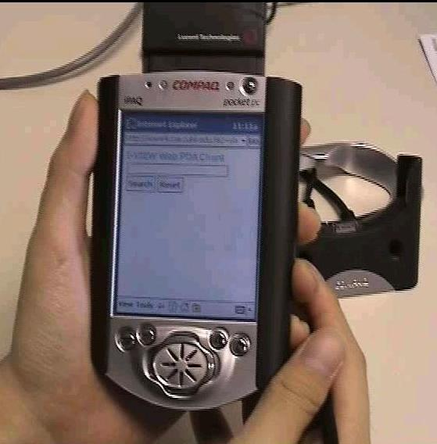 | Search page –  searching of key word in news report

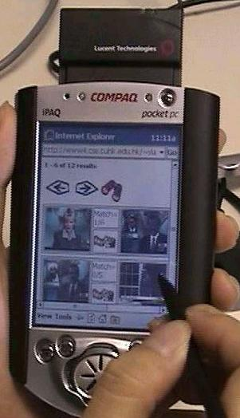 | Result page –  Display of the main frame as the search result | 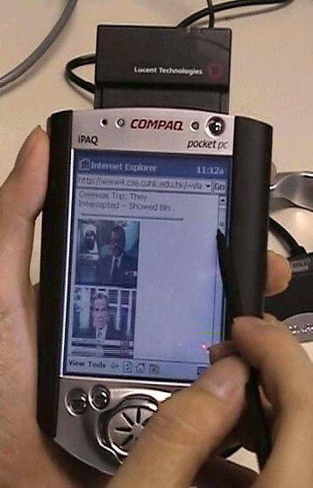 | Abstract –  abstracts and key frame of each news report

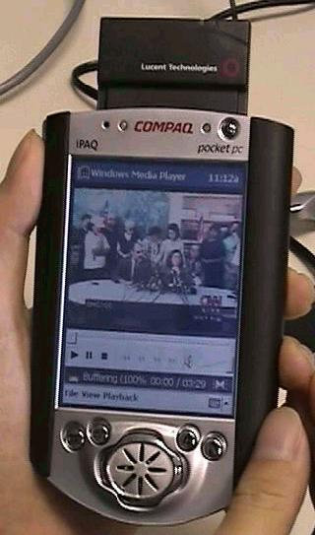 | Video Steaming of news report | 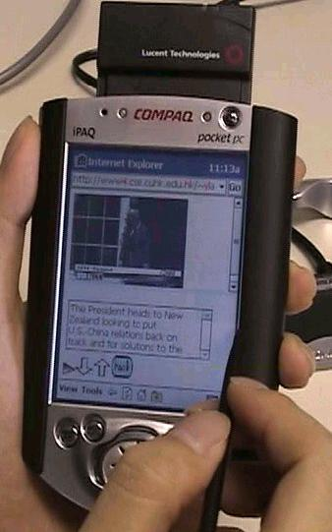 | News report reading mode

2.3 Architecture of First Application at Pocket PC

Video News
mms
request

Front End

Pocket IE
Apache Web server
cgi request

News content and Key frames
html reply

http
request

Pocket IE of Pocket PC:

Due to the powerful functions that already exists in Internet Explore of Microsoft Windows at Desktop, we then study on it. We found that it miss two thing that important to our application (1) Support of Jscript: although Pocket PC claim that it supports Jscript , but it was just a very limit support, as the part of DHTML are totally not supported (2) No ActiveX control: this make the video need to be play outside the Pocket IE, and we can’t control it through out the Pocket IE

2.4 Bluetooth and 3G technology:

As our Application needs to have a wireless support, so we found that both Bluetooth and 3G technology will solve the problem of high power consumption of Wireless LAN card. So we also have a study and test on both of it.

Here is a brief summery on it:

2G | GSM data network 14.4kbps  GSM High-Speed Circuit Switching Data (HSCSD) 43.2kbps  CDMA data network 64kbps
2.5G | General Packet Radio Service (GPRS) 40kbps
3 G | Third Generation wireless where high-speed, broadband mobility, about 64kbps
Bluetooth | low cost, low power consumption ,short distance, about 1 Mbps

Picture on trying of both Technology:

GSM:

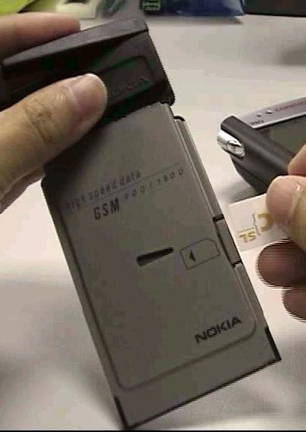 | GSM phone card | 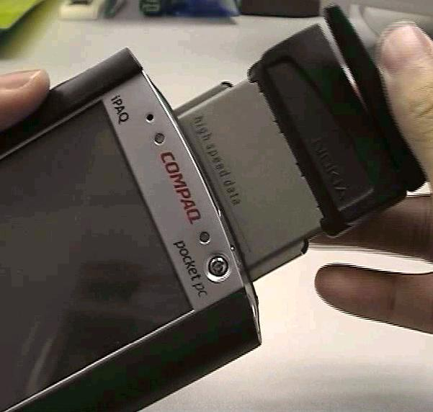 | Using GSM phone card for wireless communication

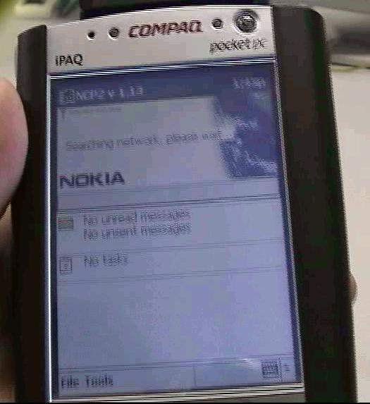 |  | Make communication between the Pocket PC and the GSM card phone |  |  | 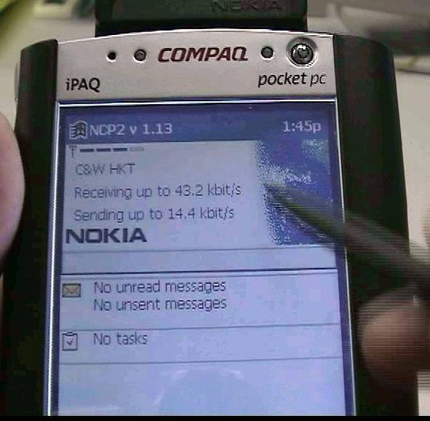 |  | Service available
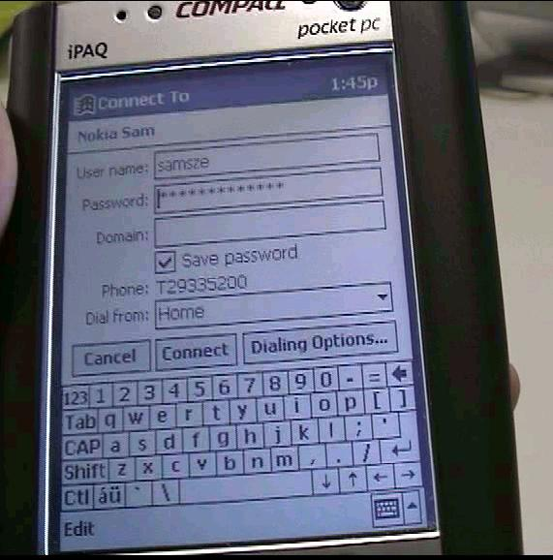 | Prepare to have a dial up connection to internet |  | 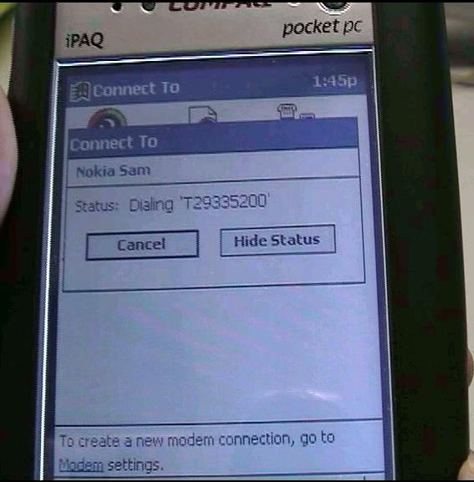 |  |  | Dialing up to the ISP
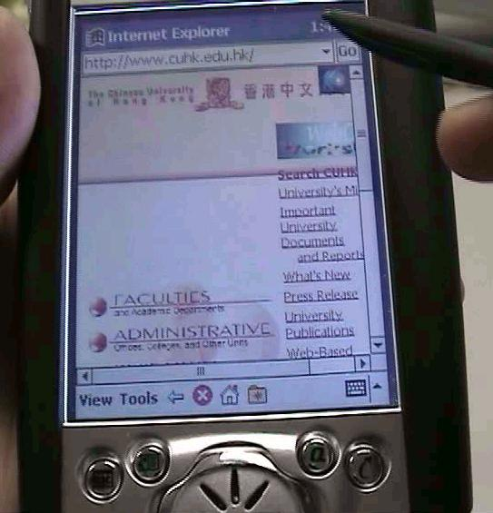 |  |  |  | Trying the internet service with 2G support

Bluetooth mobile phone:
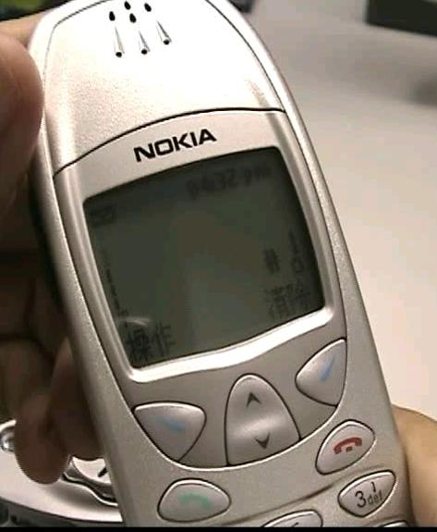 | NOKIA 6120  Mobile phone which support Bluetooth communication | 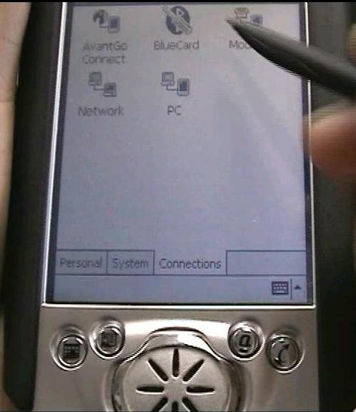 | Pocket PC which also have support on Bluetooth

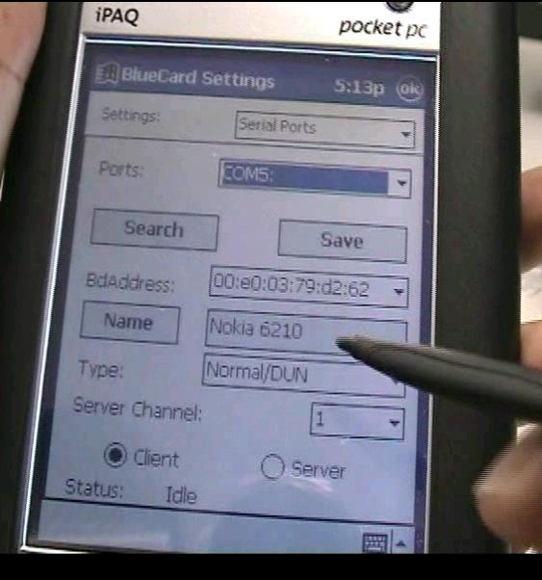 | Two Bluetooth card establish communication with each other, we can then use dial up service of the NOKIA 6120 in order to have Internet service

Bluetooth access point:
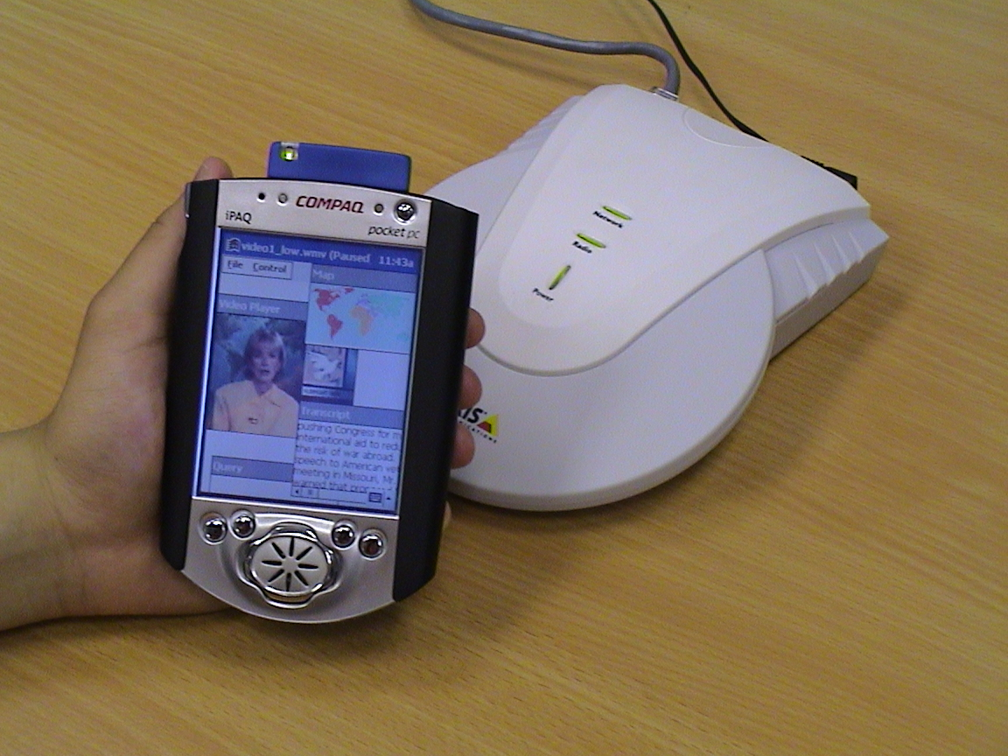
Transcript
Map
Streaming Video
Text query box
Bluetooth Compact Flash (CF) Card
Bluetooth Access Point
2.5 Problem in our First Application

- It is not extensible. The overall application cannot be more than what we have implemented, and a set of CGI program which is difficult to add new things in it. Also our application’s functionality is limit by the power of Pocket IE.

- Playing of video need to jump out our Application, and we can’t control on the playing of it

- Searching of key words in the Web site is just use Sequential search in the files; searching time will be increase as the size of the information growth.

- Changing in format of display for the information needs to have an overall change of Server part. Maintenance on the Application become difficult.

To overcome these problem, new design of our FYP will be taught in the following Chapters.

Chapter 3 System Design

3.1 Overall design

Our system is divide in to two main parts, the server side and the client side. The server is responsible for the data storage, searching and formatting the query result, and the client side responsible for displaying information and playing multimedia content. Below is the diagram showing out system architecture.
Fig 3.1 Architecture of Wireless Digital Video Library

In the server side there is a database store the XML content. Using a Database we can take advantages by the functionality provided by the database manager. These include the concurrent control, storage management, query optimization. After the server obtains the required result form the database, it regenerates the XML and formats it by the XLS. The result HTML is send to the PDA client to display.

3.2 Network

The communication between the server and client are using TCP/IP and HTTP. Using TCP/IP because it is the most success and popular transports protocol in networking, and it is supported by most, nearly all mobile devices and connection protocol now and coming future. This ensure our system can be used on any network environment, such as Bluetooth, Wireless LAN ( 802.11 ) or even using mobile phone to connect to server.

HTTP is chosen as the communication format because HTTP protocol is well developed and widely used nowadays. PDA provide system call to send and receive HTTP content. Also the server can be build above a web server, this simplify the network implementation of our system, and at the same time increase the portability of our server.

3.3 Storage of XML in Database

Reason for convert XML into Database:

- Database provides us many useful services, e.g. building different kinds of indexing on data, concurrency control, recoverability, etc.

- Our application really need an database in order to have fast information retrieve

How to convert XML into Database:

- We can treat an XML Document as a Tree

- Each Tree node will be have (1) attributes, (2) child nodes

- We will assign an unique ID to each Tree node

- A Tree node can be (1) tag, (2) attribute’s name, (3) data (including attribute’s value)

- There will be one main schema in the Database that for store up the XML

- Tree_Node= (Parent ID, NodeID, Type, Value)

- Type can be (1) tag, (2) attribute, (3) data

- Value can be (1) tag name, (2) attribute’s name, (3) attribute’s value, (4) data

Example of converting an XML document into Database

A very simple XML document:

<Shopping Mall>
<Shop shop_no=‘001’>
<name>
aShop
</name>
</Shop>
</Shopping Mall>

Result in Database: Table of Tree Node
ParentID | NodeID | Type | Value
Null | 0 | tag | Shopping Mall
0 | 1 | tag | Shop
1 | 2 | attribute | shop_no
2 | 3 | data | 001
1 | 4 | tag | Name
4 | 5 | data | aShop

Each XML tree node will become one row in the database.

For example, I search for the name of “aShop”, and then we can get the last row of this database and enable to retrieve its, its parent or its children (if any) information.

Notes:
  - Searching (2) Modification or (3) deletion of a tree node and its child nodes can be done by recursion function
  - The NodeID is very helpful in such recursion function

Chapter 4 Client Side Implementation:

In this chapter, we will discuss the design of our Pocket PC client, how is being implemented, and the tools and the technique we used in implementation.

4.1 Embedded Visual C++

Microsoft provides two programming IDE for Window CE and Pocket PC. They are Embedded Visual C++ (EVC) and Embedded Visual Basic (EVB). They are similar to The Visual C++ and Visual Basic on the Desktop Computer. Embedded Visual Basic provides a more visualize way of to build interactive GUI, and suitable for rapid development and testing, but we use Embedded Visual C++ because it provides more low-level programming and access all the low-level system call. Moreover, the development environment nowadays on Pocket PC is not well developed and most of the resources are using C++ only. This makes us have more feasibility to develop features not provided by EVB.

4.2 Win32

Similar to Desktop Visual C++, an application can be developed by using traditional win32 programming or Microsoft Fundamental Class (MFC). We using win32 programming as most of resources about Pocket PC we find are win32 base. Also, similar to using Embedded Visual C++ instead of Embedded Visual Basic, using win32 more feasibility on control the system component such as the HTML viewer and Video viewer.

4.3 Architecture:

Client side is a program run on Pocket PC base on win 32, it provide Different viewer for different kind content and acts as bridge between user and backend server. It contains a HTML viewer, Image viewer, and Video/audio player, which control by a main control.

The HTML viewer will also be an interface for user input event and the main control is responsible for the communication between the server and client. The image viewer is used to display static image with highlights to client. The Video/audio is used to provide multimedia content to user. We will discuss different components in more detail. Below is a figure to show the architecture of the client.

Control
HTML viewer
Image viewer
Video/audio player
Server

Fig. 4.1 Client Architecture

Control component

Control component is the central part of the client of the program, and the client is win32 base. The communication between the control component and different child window (which is different player in our client) are windows messages and function calls, The control component controls different window by sending message, and handles the messages send from different viewers and give corresponding respond. It also responds for the communication with the server.

HTML viewer

The HTML viewer window is the main user interface of the Pocket PC client. It responsible to display text and image content and receive user respond. User respond will pass to and handle by the central control. Use the HTML viewer as main interface because of the benefit provided by the feasibility of HTML. With HTML, the user interface can be adaptive change by server to satisfy the kind of information display.

The HTML viewer used a Dynamic-link Library provided by Pocket Internet Explorer (Pocket IE). As Pocket IE is pre-installed with the Windows CE in every Pocket PC PDA, so it is a system provided function, and no special installation required. The HTML viewer fully supports on standard HTML 2.0 and the action event generated, such as <a></a> and <form></form>, will pass to its parent windows (which is the main client in our client). So we can use this feature to simulate and customize the respond on button event and text field event. In the coming part, there is section to show how to customize the <a></a> and <form></form> event.

This is the system function that related to the HTML viewer.

LoadLibrary
Prototype
HINSTANCE LoadLibrary( LPCTSTR lpLibFileName );
Usage
Load the required DLL to memory. For HTML viewer, corresponding DLL file is “htmlview.dll”.

InitHTMLControl
Prototype
BOOL InitHTMLControl( HINSTANCE hinst );
Usage
Do the required initialization for the HTML viewer. It is necessary for execute this function before execute other functions related to HTML viewer.

SendMessage
Prototype
void SendMessage (g_hwndMain, WM_PUTTEXT, NULL, (LPARAM) lpBufferW);
Usage
Send a message to a window. For HTML viewer, there are three message related to the display of HTML content: WM_SETTEXT, WM_ADDTEXT, WM_ADDTEXTW, which is used to set or append the HTML content displaying on the HTML viewer. In the LPARAM field of the message is the pointer the

HTML viewer will send a WM_NOTIFY message to the parent window, LPARAM field will be pointer to a NM_HTMLVIEW struct. The NM_HTMLVIEW struct contain a field that indicates the kind of message. These are messages that HTML viewer will send to parent window:

NM_INLINE_IMAGE:
This message request the parent window that load the required image, the file location of the image is given by the target field of the NM_HTMLVIEW struct.

NM_HOTSPOT:
This message send to parent window when user action event happen on HTML window, user action event is include user click on a link(<a></a>), or the submit button of a form<form></form>.

Image viewer

Image viewer is a window that can display an image with position highlight. The highlight is a color dot on the top of the image. This can be used a position highlight on a map to indicate the required position. This part is not yet implement in this semester.

Video viewer

The Video viewer window is the interface to provide video/audio content on the Pocket PC client. It is responsible for video or audio playing.

The video viewer used a COM provided by Windows Media Player for Win CE. Same as Pocket IE, Windows Media Player is pre-installed with the Windows CE in every Pocket PC PDA, so it is a system provided function, and no special installation required. By the function provided by the COM library, the client can support all media format support all format support by Windows Media Player and it also support streaming of media content.

There is a series of function that used to control the Video viewer. The control of the video viewer is through a set of interface.
- IGraphBuilder *pGB;
- IMediaControl *pMC;
- IMediaEventEx *pME;
- IVideoWindow *pVW;
- IBasicAudio *pBA;
- IBasicVideo *pBV;
- IMediaSeeking *pMS;

And each interfaces of the video viewer are initialized by following function.

CoCreateInstance(CLSID_FilterGraph, NULL, CLSCTX_INPROC_SERVER, IID_IGraphBuilder, (void **)&pGB);
pGB->RenderFile(wFile, NULL);
pGB->QueryInterface(IID_IMediaControl, (void **)&pMC);
pGB->QueryInterface(IID_IMediaEventEx, (void **)&pME);
pGB->QueryInterface(IID_IMediaSeeking, (void **)&pMS);
pGB->QueryInterface(IID_IVideoWindow, (void **)&pVW);
pGB->QueryInterface(IID_IBasicVideo, (void **)&pBV);
pGB->QueryInterface(IID_IBasicAudio, (void **)&pBA);

After set the size and location of the video window, the video playing can be controlled by following function.

pMC->Run();
pMC->Stop();

4.4 Customized HTML event on the HTML viewer

As we design using the HTML viewer as the main interface, so we need to customize the HTML event to simulate user event. We customize the HREF field of the <a></a> tag and <form></form> tag to satisfy our need. Below are the tables show how we customize the HREF of the <a></a> tag and <form></form> tag.

Format | Action
Video <URL> | Play the video placed at URL in the Video viewer
Video Stop | Stop the video playing on the
Image <URL> <x y> | Display the image placed at URL in Image viewer with highlight at (x,y)
Image Close | Close the Image viewer.
<URL> | Send to server and display server respond on HTML viewer.
Table 4.1 Customize the HREF field of the <a></a> tag.

Format | Action
Login <URL>?name= <username> && password = <password> | Connect and login to the server specified at <URL> with <username> and password
Search <URL>? keyword = <keyword> | Search item <keyword> on the <URL> server
Others | Send to server directly, and display the server respond on HTML viewer.
Table 4.2 Customize the HREF field of the <form></form> tag.

4.5 Screen shots of the Client program

Below are the Screen shots of our PDA Client. In these screen shots, the PDA client is connected to a dummy server, which have very limited function. Our goal is to demonstrate how the client works.

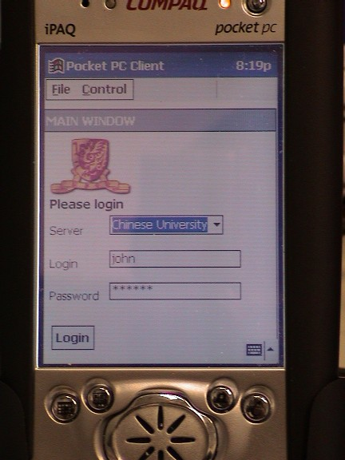 | This is the first screen you will see when starts the PDA client. The window titled as “Main Window” is the HTML viewer.
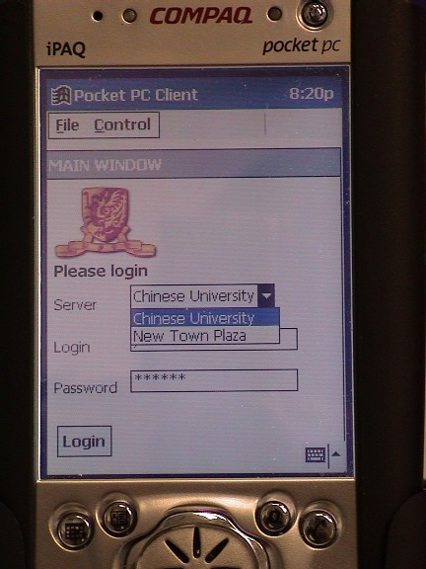 | User can select the server they want to connect to. Before connect to the server, user may need to fill in their user name and password. In this screen shot, we try to connect to a server called “New Town Plaza”
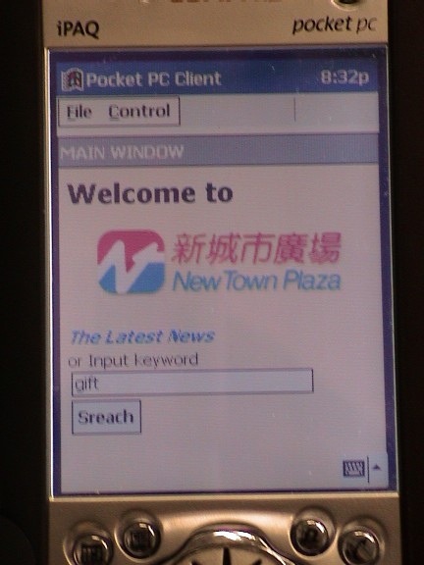 | After connected to the server, The main window changed. From now, the display of the main window is control by the data send from server. In the screen shots we try to find shops related to “gift”
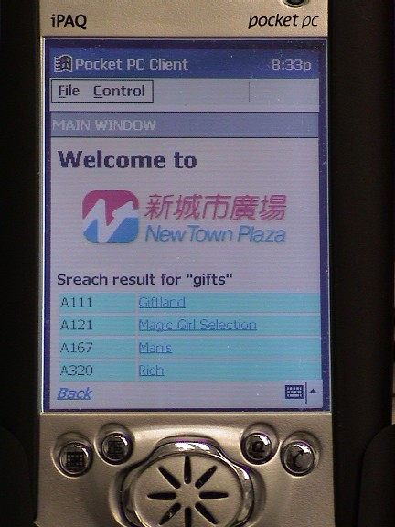 | This is the screen shot that show the result of the search. To know more about the shop, users can click the shop name. In these screen shots, we will select the first shop, “Giftland”.
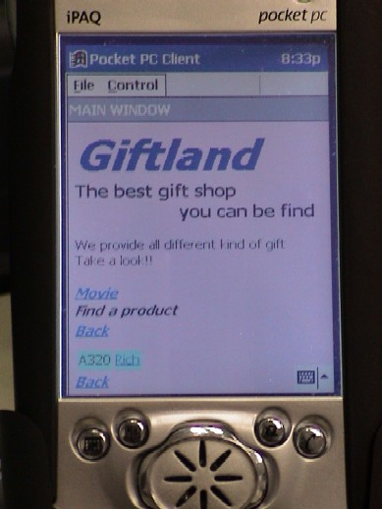 | This is screen shot of description of a shop. Users can get more information by search products in the shop or click the “movie” links
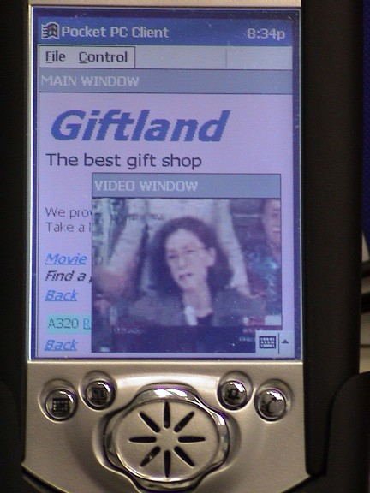 | If the user click “movie” link, a floating window pops up and plays a video about the shop. This is the video window, user can move the video around to satisfy the presentation format of imformation.

Chapter 5 Related Technique Studied:

5.1 XML

Reason of Using XML in our Project:

We use XML as our data format, reason stated in following:

Main Reasons:
- XML support a wide variety of applications. XML is beneficial to a wide variety of diverse applications: authoring, browsing, content analysis, etc. So, we can give our user a feasible and extensible way to design the data structure of their own rich information.
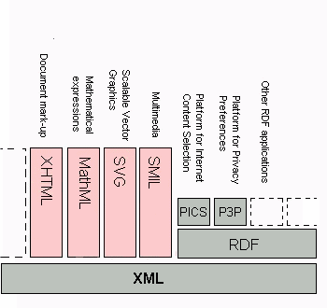

- If the data is in XML format, even our user changes the structure of the data or adds new data, it will not affect our whole system process that reads or writes on the data.

- We can use XML together with XSL and XSLT to generate XHTML, which give the user a feasible way to design the way to present their information in their own ways; on the other end, it will be more extensible on the presentation of the information, any changes will not affect the design of our whole system.

Other Reasons:
- XML documents are easy to process, as it is machine-independent and structural. So it is easy for us to implement our system.

- XML have been well defining in its structure, and it does not specify either semantics or a tag set; in fact XML is really a meta-language for describing markup languages. So XML can provide a facility to define tags and the structural relationships by user. As the result, XML is extendable, and the number of optional features in XML is to be kept to an absolute minimum, ideally zero.

- XML documents are human-legible and reasonably clear. It even easy to understand the content or the meaning of an XML document without using a specific XML browser.

- XML can be easily designed, and can be prepared and developed quickly, also creation of an XML document is easy, as it can be just edit directly in a text editor with simple shell scripts. Standards efforts are notoriously slow.

As the result, user only needs to concentrate on the design of their data and information, and at the same time, with a full control on it. Also, design, creating, modification and updating on the data and presentation method is easy and in a short time, and user don’t need to spend a large effort it. While we provide a efficient and effect way to manage their information which is in XML format, and also provide a fast way to let their client to access their richly structured documents over the LAN or WAN on PDA.

What is XML?

The Extensible Markup Language (XML) is the universal format for structured documents and data on the Web. XML in 10 points explain XML briefly [XML 2]:

1. XML is for structuring data

Structured data includes things like spreadsheets, address books, configuration parameters, financial transactions, and technical drawings. XML is a set of rules (you may also think of them as guidelines or conventions) for designing text formats that let you structure your data. XML is not a programming language, and you don't have to be a programmer to use it or learn it. XML makes it easy for a computer to generate data, read data, and ensure that the data structure is unambiguous. XML avoids common pitfalls in language design: it is extensible, platform-independent, and it supports internationalization and localization. XML is fully Unicode-compliant.

2. XML looks a bit like HTML

Like HTML, XML makes use of tags (words bracketed by '<' and '>') and attributes (of the form name="value"). While HTML specifies what each tag and attribute means, and often how the text between them will look in a browser, XML uses the tags only to delimit pieces of data, and leaves the interpretation of the data completely to the application that reads it. In other words, if you see "<p>" in an XML file, do not assume it is a paragraph. Depending on the context, it may be a price, a parameter, a person, a p... (and who says it has to be a word with a "p"?).

3. XML is text, but isn't meant to be read

Programs that produce spreadsheets, address books, and other structured data often store that data on disk, using either a binary or text format. One advantage of a text format is that it allows people, if necessary, to look at the data without the program that produced it; in a pinch, you can read a text format with your favorite text editor. Text formats also allow developers to more easily debug applications. Like HTML, XML files are text files that people shouldn't have to read, but may when the need arises. Less like HTML, the rules for XML files are strict. A forgotten tag, or an attribute without quotes makes an XML file unusable, while in HTML such practice is tolerated and is often explicitly allowed. The official XML specification forbids applications from trying to second-guess the creator of a broken XML file; if the file is broken, an application has to stop right there and report an error.

4. XML is verbose by design

Since XML is a text format and it uses tags to delimit the data, XML files are nearly always larger than comparable binary formats. That was a conscious decision by the designers of XML. The advantages of a text format are evident (see point 3), and the disadvantages can usually be compensated at a different level. Disk space is less expensive than it used to be, and compression programs like zip and gzip can compress files very well and very fast. In addition, communication protocols such as modem protocols and HTTP/1.1, the core protocol of the Web, can compress data on the fly, saving bandwidth as effectively as a binary format.

5. XML is a family of technologies

XML 1.0 is the specification that defines what "tags" and "attributes" are. Beyond XML 1.0, "the XML family" is a growing set of modules that offer useful services to accomplish important and frequently demanded tasks. Xlink describes a standard way to add hyperlinks to an XML file. XPointer and XFragments are syntaxes in development for pointing to parts of an XML document. An XPointer is a bit like a URL, but instead of pointing to documents on the Web, it points to pieces of data inside an XML file. CSS, the style sheet language, is applicable to XML as it is to HTML. XSL is the advanced language for expressing style sheets. It is based on XSLT, a transformation language used for rearranging, adding and deleting tags and attributes. The DOM is a standard set of function calls for manipulating XML (and HTML) files from a programming language. XML Schemas 1 and 2 help developers to precisely define the structures of their own XML-based formats. There are several more modules and tools available or under development.

6. XML is new, but not that new

Development of XML started in 1996 and has been a W3C Recommendation since February 1998, which may make you suspect that this is rather immature technology. In fact, the technology isn't very new. Before XML there was SGML, developed in the early '80s, an ISO standard since 1986, and widely used for large documentation projects. The development of HTML started in 1990. The designers of XML simply took the best parts of SGML, guided by the experience with HTML, and produced something that is no less powerful than SGML, and vastly more regular and simple to use. Some evolutions, however, are hard to distinguish from revolutions... And it must be said that while SGML is mostly used for technical documentation and much less for other kinds of data, with XML it is exactly the opposite.

7. XML leads HTML to XHTML

There is an important XML application that is a document format: W3C's XHTML, the successor to HTML. XHTML has many of the same elements as HTML. The syntax has been changed slightly to conform to the rules of XML. A document that is "XML-based" inherits the syntax from XML and restricts it in certain ways (e.g, XHTML allows "<p>", but not "<r>"); it also adds meaning to that syntax (XHTML says that "<p>" stands for "paragraph", and not for "price", "person", or anything else).

8. XML is modular

XML allows you to define a new document format by combining and reusing other formats. Since two formats developed independently may have elements or attributes with the same name, care must be taken when combining those formats (does "<p>" mean "paragraph" from this format or "person" from that one?). To eliminate name confusion when combining formats, XML provides a namespace mechanism. XSL and RDF are good examples of XML-based formats that use namespaces. XML Schema [XML Schema 1,2,3,4,5,6] is designed to mirror this support for modularity at the level of defining XML document structures, by making it easy to combine two schemas to produce a third which covers a merged document structure.

9. XML is the basis for RDF and the Semantic Web

XML provides an unambiguous syntax for W3C's RDF, the language for expressing metadata (in fact, for knowledge in general). RDF is like hypertext elevated to the next level. Whereas hypertext links pieces of text and leaves their relation vague, RDF can link anything and everything and assigns names to the relations: "A is the price of B" can be a relation between an object and a sum of money; "A is heavier than B" can be the relation between two sumo wrestlers; "A is the cause of B" can be the relation between a shower and your being wet. To communicate knowledge, whether in XML/RDF or in plain English, both people and machines need to agree on what words to use. A precisely defined set of words to describe a certain area of life (from "shopping" to "mathematical logic") is called an "ontology." RDF, ontologies, and the representation of meaning so that computers can help people do work are all topics of the Semantic Web Activity.

10. XML is license-free, platform-independent and well-supported

By choosing XML as the basis for a project, you gain access to a large and growing community of tools (one of which may already do what you need!) and engineers experienced in the technology. Opting for XML is a bit like choosing SQL for databases: you still have to build your own database and your own programs and procedures that manipulate it, and there are many tools available and many people who can help you. And since XML is license-free, you can build your own software around it without paying anybody anything. The large and growing support means that you are also not tied to a single vendor. XML isn't always the best solution, but it is always worth considering.

The design goals for XML [XML 1] are:

- XML shall be straightforwardly usable over the Internet.

- XML shall support a wide variety of applications.

- XML shall be compatible with SGML.

- It shall be easy to write programs which process XML documents.

- The number of optional features in XML is to be kept to the absolute minimum, ideally zero.

- XML documents should be human-legible and reasonably clear.

- The XML design should be prepared quickly.

- The design of XML shall be formal and concise.

- XML documents shall be easy to create.

- Terseness in XML markup is of minimal importance.

XML will [XML 4]:

- Enable internationalized media-independent electronic publishing.

- Allow industries to define platform-independent protocols for the exchange of data, especially the data of electronic commerce.

- Deliver information to user agents in a form that allows automatic processing after receipt.

- Make it easier to develop software to handle specialized information distributed over the Web.

- Make it easy for people to process data using inexpensive software.

- Allow people to display information the way they want it, under style sheet control.

- Make it easier to provide metadata -- data about information -- that will help people find information and help information producers and consumers find each other.

Logical Structures of XML [XML 1]:

Following will give a brief description on the structure of XML.

Element

[Definition: Each XML document contains one or more elements, the boundaries of which are either delimited by start-tags and end-tags, or, for empty elements, by an empty-element tag. Each element has a type, identified by name, sometimes called its "generic identifier" (GI), and may have a set of attribute specifications.] Each attribute specification has a name and a value.

element ::= EmptyElemTag
| STag content ETag [WFC: Element Type Match]
[VC: Element Valid]

This specification does not constrain the semantics, use, or (beyond syntax) names of the element types and attributes, except that names beginning with a match to (('X'|'x')('M'|'m')('L'|'l')) are reserved for standardization in this or future versions of this specification.

Well-formalness constraint (WFC): Element Type Match

The Name in an element's end-tag must match the element type in the start-tag.

Validity constraint (VC): Element Valid

- An element is valid if there is a declaration matching elementdecl where the Name matches the element type, and one of the following holds:

- The declaration matches EMPTY and the element has no content.

- The declaration matches children and the sequence of child elements belongs to the language generated by the regular expression in the content model, with optional white space (characters matching the nonterminal S) between the start-tag and the first child element, between child elements, or between the last child element and the end-tag. Note that a CDATA section containing only white space does not match the nonterminal S, and hence cannot appear in these positions.

- The declaration matches Mixed and the content consists of character data and child elements whose types match names in the content model.

- The declaration matches ANY, and the types of any child elements have been declared.

White Space

S (white space) consists of one or more space (#x20) characters, carriage returns, line feeds, or tabs.

S ::= (#x20 | #x9 | #xD | #xA)+

Start-Tags

Definition: The beginning of every non-empty XML element is marked by a start-tag.]

Start-tag
STag ::= '<' Name (S Attribute)* S? '>' [WFC: Unique Att Spec]
Attribute ::= Name Eq AttValue [VC: Attribute Value Type]
[WFC: No External Entity References]
[WFC: No < in Attribute Values]

The Name in the start- and end-tags gives the element's type. [Definition: The Name-AttValue pairs are referred to as the attribute specifications of the element], [Definition: with the Name in each pair referred to as the attribute name] and [Definition: the content of the AttValue (the text between the ' or " delimiters) as the attribute value.]Note that the order of attribute specifications in a start-tag or empty-element tag is not significant.

Well-formedness constraint (WFC): Unique Att Spec

No attribute name may appear more than once in the same start-tag or empty-element tag.

Validity constraint (VC): Attribute Value Type

The attribute must have been declared; the value must be of the type declared for it.

Well-formedness constraint (WFC): No External Entity References

Attribute values cannot contain direct or indirect entity references to external entities.

Well-formedness constraint (WFC): No < in Attribute Values

The replacement text of any entity referred to directly or indirectly in an attribute value must not contain a <.

An example of a start-tag:

<termdef id="dt-dog" term="dog">

[Definition: The end of every element that begins with a start-tag must be marked by an end-tag containing a name that echoes the element's type as given in the start-tag:]

End-tag

ETag ::= '</' Name S? '>'

An example of an end-tag:

</termdef>

Content of Elements

[Definition: The text between the start-tag and end-tag is called the element's content:]
content ::= CharData? ((element | Reference | CDSect | PI | Comment) CharData?)* /* */

Overall Example:

<student std_num="99123456">
<name>George Burdell</name>
<age>21</age>
<student>
Start tag
End tag
Attribute
Content

5.2 XSL and XSLT:

Reason of Using XSL and XSLT in our Project:

We use XSL and XSLT as method for translation of information, reason stated in following:

Main Reasons:

- XSL support a wide variety of applications. It provides a standard and powerful way to transform from XML format data to another informative Formal. So, we can give our user a feasible and extensible way to design the presentation of their own data.

- Even our user wants to have changes or have new way to present their data, it will not affect our whole system processing on it, so it is probably easier the to have maintenance.

- As XSL can give user a different transformation of their XML at different node level, so that the transformation results of a XML document can be different depending on how specify of the information that user’s client needs.

We really don’t want to limit the design of the presentation of user’s rich data, so we need to provide a feasible, standardized, and extensible solution to them, here we choose XML together with XSL.

What is XSL and XSLT [XSL 3]?

XSL is a language for expressing style sheets. An XSL style sheet is, like with CSS, a file that describes how to display an XML document of a given type. XSL shares the functionality and is compatible with CSS2 [CSS2](although it uses a different syntax). It also adds:

A transformation language for XML documents: XSLT. Originally intended to perform complex styling operations, like the generation of tables of contents and indexes, it is now used as a general purpose XML processing language. XSLT is thus widely used for purposes other than XSL, like generating HTML web pages from XML data.

Advanced styling features, expressed by an XML document type which defines a set of elements called Formatting Objects, and attributes (in part borrowed from CSS2 properties and adding more complex ones. See also the XSL-FO page.

How Does It Work [XSL 3]?

Styling requires a source XML documents, containing the information that the style sheet will display and the style sheet itself which describes how to display a document of a given type.

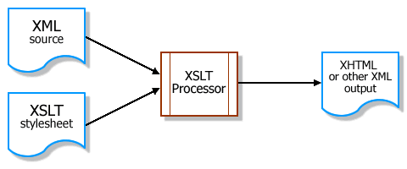

Multiple XSLT style sheets can present a single document in multiple formats. A single style sheet could transform multiple instances of one data type into a standard presentation format, which you could change simply by modifying the style sheet. Or XSLT could transform multiple instances of data into multiple formats. And it is not constrained to presentation: XSLT is a powerful tool for translating one system's data format into another's.

The following shows a sample process of how XSL works, that means how XML file and how it can be transformed and rendered. [XSL 4]

- Get the XSLT processor:

To get started, we need an XSLT processor. There are only a handful of desktop XSLT prototyping tools available, as the majority of such tools are for full-scale production systems.

Recent browsers such as Internet Explorer 5.5 & 6.0, Netscape 6.1, and Mozilla support XSLT processing. They are probably the easiest tools to use but are currently unreliable in their specification support. Also, a browser does not provide the support of a true development tool and won't help much when debugging code. So, in our system, XSLT conversions are done on the server, so browsers will work only for browser the generated HTML.

As we find, Instant Saxon is a simple, command-line server-style XSLT processor for Windows, it provides basic file output and error information and it delivers more solid XSLT support than is available from browsers. Although it do not support a full-blown development environment, Instant Saxon is a great tool on it.

- Example:

order.xml:

<?xml version="1.0" encoding="utf-8"?>
<?xml-stylesheet type="text/xsl" href="./order.xsl"?>

<order number="734" name="Mike">
<line-item>
<description>Cheeseburger</description>
<unit-price>1.59</unit-price>
<quantity>2</quantity>
</line-item>
<line-item>
<description>Large french fries</description>
<unit-price>1.09</unit-price>
<quantity>1</quantity>
</line-item>
<line-item>
<description>Medium Coke</description>
<unit-price>.99</unit-price>
<quantity>1</quantity>
</line-item>
</order>

order.xsl:

<?xml version="1.0" encoding="utf-8"?>
<xsl:stylesheet xmlns:xsl="http://www.w3.org/1999/XSL/Transform" version="1.0">
<xsl:output method="xml" indent="yes" omit-xml-declaration="yes"/>

<xsl:template match="order">

<html>
<head><title>Your order</title></head>
<body>

<xsl:value-of select="@name"/>'s Order (#<b><xsl:value-of select="@number"/></b>): <br/><br/>

<table border="1">
<tr>
<td><b>Item</b></td>
<td><b>Amount</b></td>
<td><b>Cost</b></td>
<td><b>Total</b></td>
</tr>

<xsl:for-each select="line-item">
<tr>
<td><xsl:value-of select="description"/></td>
<td><xsl:value-of select="quantity"/></td>
<td>$<xsl:value-of select="unit-price"/></td>
<td>$<xsl:value-of select="quantity * unit-price"/></td>
</tr>
</xsl:for-each>

</table>
</body>
</html>

</xsl:template>
</xsl:stylesheet>

The XML file is linked to the XSL style sheet, so we can view the XML file in a suitable browser or XSL Transform it in XML Spy. With Instant Saxon, we can execute a command, and translate the XML document into an HTML document:

saxon.exe order.xml order.xsl > order.html

This will write the transformed HTML output into a file called order.html that we can view in our browser.

The results of the example looks like this:
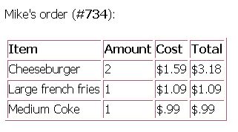

An HTML page with a title showing Mike's order (number 734) and a table of what he ordered, including cost. The XSLT processor took the XML file containing the data and transformed it into the HTML output. The XSLT style sheet defined the HTML tags to place around the XML data using the processing instructions that comprise the XSLT language.

We can also make an XML document have its own default XSLT style sheet rather than normally instructs which style sheet to apply by including the line

<?xml-stylesheet type="text/xsl" href="my.xsl"?>

where my.xsl is a URL to the style sheet. This code is essential for browser-based transforming.

- Sample explanation:

The main ideas of XSLT are build up a context--which is a particular node or set of nodes in an XML document, and output a formatted version of the data that exists within that context. To do this, an XSLT style sheet is separated into discrete templates, each of which handles certain types of tags in the XML document. Within these templates, XSLT utilizes variables, passed parameters, looping constructs, conditionals, and other devices geared toward transforming XML.

The <xsl:stylesheet> element is the outermost element of any XSLT style sheet, assigning it a version and one or more namespaces:

<xsl:stylesheet version="1.0" xmlns:xsl="http://www.w3.org/1999/XSL/Transform>
...
</xsl:stylesheet>

You can set other attributes, but for almost all basic style sheets, you can use these exact <xsl:stylesheet> tags. The template elements are nested within them.

- XSLT templates

The <xsl:template> element defines a context in which to execute along with the resulting output. It has the syntax

<xsl:template
match="expression"
name="name"
priority="number"
mode="mode">
</xsl:template>

An XSLT processor executes a <xsl:template> when it finds either an explicit call in the style sheet or a matching node in the source XML document. The most common cause is matching nodes encountered as the XSLT processor scans the XML. The match attribute takes an XPath expression [XPATH 1], identifying which nodes set off the template.

We can have more than one template matches a node. In this case, fairly complex rules need, e.g. using the mode and priority attributes determine which template will process the node. So a simple style sheets contain only one template to match a given node is better.

There are two usual cases for XSLT, (1) for XML documents that contain mostly marked-up text, such as HTML, XSLT style sheet will contain a template for each tag we might encounter. (2) For XML documents that contain highly structured hierarchical data, our style sheet need to contain templates for only the top-level nodes. These templates will know the data structure and access the subnodes directly, rather than leave them to other templates.

For example, the following sample XML file:

<?xml version="1.0" encoding="UTF-8"?>
<?xml-stylesheet type="text/xsl" href="./sample.xsl"?>
<book>
<title>Stuff Happens</title>
<chapter type="prologue">
<title>How it begins</title>
<paragraph>At first there's nothing going on.</paragraph>
<paragraph>Eventually that all changes.</paragraph>
</chapter>
<chapter>
<title>What transpires</title>
<paragraph>Things occur, one after the other.</paragraph>
<paragraph>Some are simultaneous or overlap.</paragraph>
</chapter>
<chapter type="epilogue">
<title>Where it ends</title>
<paragraph>Everything comes to a stop.</paragraph>
<paragraph>Or at least nothing else happens.</paragraph>
</chapter>
</book>

contains a short, marked-up book. It consists of one <book> node containing a <title> and multiple <chapter> nodes. This template would execute for each <chapter> within the top-level <book>:

<xsl:template match="/book/chapter">
This is chapter <xsl:number/>, entitled "<xsl:value-of select="title"/>"
</xsl:template>

If an XSLT processor do not match any template for a node or its parent nodes, it simply outputs the node's contents, even these can contain subnodes that they have their own templates. So a style sheet with only the preceding template would produce the following result:

<?xml version="1.0" encoding="utf-8"?>
Stuff Happens
This is chapter 1, entitled "How it begins"
This is chapter 2, entitled "What transpires"
This is chapter 3, entitled "Where it ends"

The <paragraph> nodes are skipped because their <chapter> parents were processed, but the first <title>, not being in a <chapter>, just gets printed as is.

e. XPath expressions

XPath have an important role in XSL. XPath is a language for referencing specific parts of an XML document, although it supports a richer feature set than just simply pointing to data. In XSLT style sheets, XPath expressions return four types of values: node-set, Boolean, number, and string. XSLT elements take an XPath expression as an attribute value in order to get the result of the evaluated expression.

The most common use in basic XSLT is to return a node-set or string, depending on the element. For example, <xsl:template match="chapter"> defines a template for <chapter> nodes within the current node context. In this case, the XPath expression chapter returns a node-set as the new context for further XSL functions. Whereas in <xsl:value-of select="title"/>, the XPath expression title returns the raw content of any <title> nodes within the current context as a string.

f. Others

Just like other programming language, XSL also can:
(1) declaring parameters and variables (by xsl:param / xsl:with-param, xsl:variable),
(2) calculation of value (by xsl:value-of, xsl:number),
(3) Looping and sorting (by xsl:for-each, xsl:sort),
(4) Having Conditional statements (by xsl:if, xsl:choose / xsl:when / xsl:otherwise)

More detail examples and explanations can be found at [XSL 1], [XSL 2], [XSL 3], [XSL 4], [XSLT 1], [XPATH 1]

5.3 XHTML and XHTML base:

Reason of Using XHTML and XHTML base in our Project:

We use XHTML and XHTML base as method for presenting information, reason stated in following:

Main Reasons:

- Both of them can be the product after XSLT, and can be just browse on nowadays browsers.
- Parsing of them will be much more efficient than man-made HTML, as the later usually make mistake on the rule of HTML, it makes the browser work smoother.
- Good for future development of the HTML-based browsers, as new features can be standardize by the XSLT

What is XHTML [XHTML 1] ?

XHTML is a reformulation of HTML 4 [HTML 1] as an XML 1.0 application, and three DTDs [XML DTD 1] corresponding to the ones defined by HTML 4. The semantics of the elements and their attributes are defined in the W3C Recommendation for HTML 4. These semantics provide the foundation for future extensibility of XHTML

XHTML is a family of current and future document types and modules that reproduce, subset, and extend HTML 4. XHTML family document types are XML based, and ultimately are designed to work in conjunction with XML-based user agents. The details of this family and its evolution are discussed in more detail in the section on Future Directions.

Developers who migrate their content to XHTML 1.0 will realize the following benefits:

- XHTML documents are XML conforming. As such, they are readily viewed, edited, and validated with standard XML tools.
- XHTML documents can be written to operate as well or better than they did before in existing HTML 4-conforming user agents as well as in new, XHTML 1.0 conforming user agents.
- XHTML documents can utilize applications (e.g. scripts and applets) that rely upon either the HTML Document Object Model or the XML Document Object Model [DOM].
- As the XHTML family evolves, documents conforming to XHTML 1.0 will be more likely to interoperate within and among various XHTML environments.

The XHTML family is the next step in the evolution of the Internet. By migrating to XHTML today, content developers can enter the XML world with all of its attendant benefits, while still remaining confident in their content's backward and future compatibility.

Reasons to write XHTML today [XHTML 3]:

- XHTML 1.0's design is intended to curry good habits among Web page authors. Many of us have taken advantage of the quirks in browser behavior to produce a specific visual result when using nonstandard HTML. The problem with this approach is: First, the result depends on the visitor using the same browser as the designer. This method also let to non-termination of demand for a browser to anticipate and render the author's intention, despite the nonstandard use of HTML.
For example, it is common to find incorrectly nested elements in Web pages produced by authors working in both text editors and some authoring tools. You may see:

<p>I'm going to <b>nest<i>bold and italics</b></i>elements.

Web browsers have long understood this sample to mean that the author wanted to give both bold and italics treatment to the phrase bold and italics, despite the fact that the <b> element is erroneously closed before the <i> element. Many designers would say that since the sample will work in their intended browsers, they don't need to make any corrections. However, in more substantive examples, even the two most popular browsers don't behave in the same manner. Consider the case of a missing </table> tag at the end of a table. Internet Explorer "helpfully" infers the author's intention when it encounters the next block element after the point where the table should have been closed and displays the table as if the closing tag were present. Netscape Navigator, on the other hand, hasn't been programmed to handle such an error and instead refuses to display any of the table content at all, something quite disconcerting when reported to authors who view their work only in IE before publishing.

- Today's commercial Web sites are far more likely to be using dynamic page-generation systems than ever before. Major content sections are retrieved from databases or document storage and delivery systems, and advertising may then be brought in from a third-party site. Each of these pieces needs a solid and dependable place to bind to the template for delivery. A sloppy, miscoded page will complicate matters, not only for proper insertion of dynamic content, but also in the rendering of the page for the end user.

- Web pages that conform with the XHTML Recommendation display faster because the browser has no guesswork to do. It simply parses the document according to the rules of XHTML and finds no place where the author's intent is unclear. Especially for the device with less powerful CPU like PDA, the waiting time for loading a page will be much shorter.

XHTML Base, a subset of HTML [XHTML 2]:

The XHTML Basic document type includes the minimal set of modules required to be an XHTML host language document type, and in addition it includes images, forms, basic tables, and object support. It is designed for Web clients that do not support the full set of XHTML features; for example, Web clients such as mobile phones, PDAs, pagers, and settop boxes. The document type is rich enough for content authoring.

XHTML Basic is designed as a common base that may be extended. For example, an event module that is more generic than the traditional HTML 4 event system could be added or it could be extended by additional modules from XHTML Modularization such as the Scripting Module. The goal of XHTML Basic is to serve as a common language supported by various kinds of user agents.

Information appliances are targeted for particular uses. They support the features they need for the functions they are designed to fulfill. The following are examples of different information appliances:

- Mobile phones
- Televisions
- PDAs
- Vending machines
- Pagers
- Car navigation systems
- Mobile game machines
- Digital book readers
- Smart watches

5.4 Indexing Technique

As sequential text search is really slow if the file size is large. It is necessary to using indexing to speed up the searching speed. Below it is some technique we have studied.

Inverted index

Inverted index is a word-oriented mechanism; it keeps a list of vocabulary and their occurrences. Below is a simple sample of inverted index.

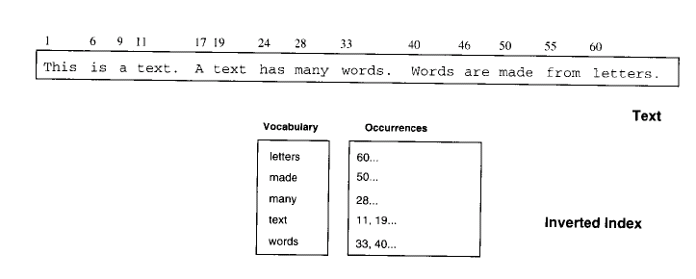
Fig. Inverted index

Occurrence addressing can be done in many ways; character position is used in a small file, and block address in large file. Below is the same sample using block address.

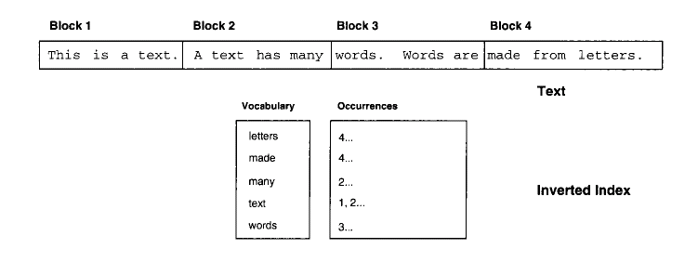
Fig. Inverted index using block addressing

Advantage of block address is to reduce the space requirement, as number of block is less. In the example, the common word “a”, “is”, “are” are not indexed as they have high occurrence and have little meaning on searching.

Trie and PAT tree

To have an effective access of the inverted index, inverted index usually store in a trie or a PAT tree. Trie is a tree that useful for storing strings over an alphabet. Each leaf node stores a string and every inner node represents a common prefix. Below is the trie tree using sample data as the example above.

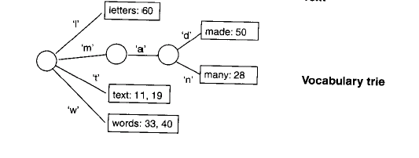
Fig 5.1 a Trie

In the above example, there is a node that has only one child; it is not very effective to keep a node with only one child, both on searching and storage. So a compact representation of trie is needed, and it is called Patricia tree (PAT tree). Patricia tree is a trie that eliminate all nodes that have only one child. As the depth of a node is not indicating which character need to exanimate, a counter is added in each internal node to indicate which is the next character. Below is an example of a Patricia tree.

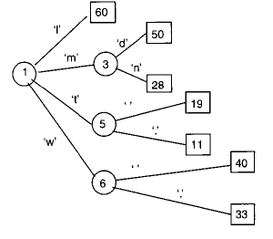
Fig 5.2 a PAT tree.

Signature File

Signature files are word-oriented index structure base on hashing and divide text into text block. We use a hash function to map each vocabulary to a bit pattern with fixed number of bit 1, so a block signature is obtained by bitwise ORing the text in that block. When you do a query, you get the bit pattern of you query try to scan through the block signatures to test if the query word is in a block. If the corresponding bits in a block signature are set even the word is not there, we call it is a false drop. Below is an example of signature generation and comparison.

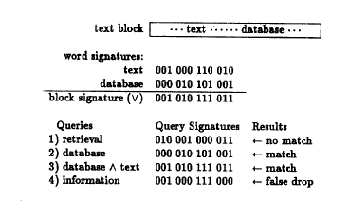
Fig 5.3 Signature generation and comparison

As the search time of a signature file is proportional to the size of the text file. The performance will become unacceptable if the text file is large. So the usage of signature file is limited on small text file.

To alleviate the problem, a multi-level signature files can be introduced [indexing 1]. Under the multilevel signatures there is a different level of signatures organized as a tree structure. The text block represented by a parent signature is the union of text blocks of its child signature.
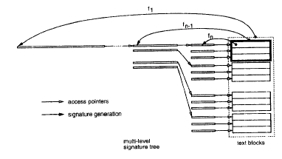
Fig 5.3 Multilevel signature file

As we can apply different signature length and weight (number of one in a signature) on different level, we can optimize the performance by minimize the drop off rate in that level. When we search the required text, we search at a higher level to lower level until we get the required block.
When the text file is updated, the multilevel signature file needs to be updated also. If the update is an insertion, we only need to add the bit pattern in different level of signature related to the position of insertion. But if the update is a deletion, we need to regenerate all the block signature in all different level. This is really performance unacceptable. So a simple method is just update the lowest level signature. This will increase the false drop rate, but since the increase is small, this simplified method is acceptable.

Chapter 6 Project Progress

6.1 Project Progress

Time | Things Done
June 2001 | Study on Palm Programming  Study the technology in wireless communication
July 2001 | Study on XML  Study on Pocket PC programming
August 2001 | Build the first application on Pocket PC
September 2001 | Design the system architecture
October 2001 | Study the searching technique for text file
November 2001 | Build the Pocket PC Client

6.2 Difficulty

Limited functionality on PDA

The function support by the PDA is not clear stated. We need to test by ourselves to find out is the function supported by Pocket PC. This is a time consuming process. Also, we need to change our design when we indicate there is a function that don’t support by Pocket PC.

Limited resource on PDA programming

Compare with desktop programming, the resource that provide information related on Pocket PC programming is limited. So they need to use more time to learn how to write the Pocket PC program.

Difficult to setup compilation environment

To setup the environment for the Embedded Visual C++, we need to setup the path of the include file. Again, it is not clearly stated. We need to use time to try and learn to compilation a PDA program.

6.3 Summary

In these three months, beside the study the knowledge in server side, our focus is on the client side. We try to solve the problem on building the PDA client. At now, we have a Pocket PC client supporting a HTML windows and a Video window that can display the interface control by server and play the video which located at server.

Chapter 7 Future work

7.1 Continue implement of the Pocket PC client

The image viewer function of the Pocket PC client is not yet implement, also the need to improve the control component so it can support more function.

7.2 Implement of the server side

We need to build the server connect with a database connected and using XSL to generate result HTML.

7.3 Study on search technique

To improve the performance of searching in database, we need build index on information store in database. We will try to study different methods and implement one of them.

Chapter 8 Bibliography

[Indro 1]
“Trends Report 2001- Assessing a Wireless Future”
The Software & Information Industry Association, 2001
Available at http://www.trendsreport.net/wireless/1.html

[XML 1]
“Extensible Markup Language (XML) 1.0 (Second Edition)”
W3C Recommendation 6 October 2000
Available at http://www.w3.org/TR/2000/REC-xml-20001006

[XML 2]
“XML in 10 points”
Bert Bos
Revised 13 Nov. 2001 (last update: $Date: 2001/11/21 19:45:05 $)
Created 27 Mar 1999
Available at http://www.w3.org/XML/1999/XML-in-10-points.html

[XML 3]
“Namespaces in XML”
World Wide Web Consortium 14-January-1999
Available at http://www.w3.org/TR/1999/REC-xml-names-19990114/

[XML 4]
“Extensible Markup Language (XML) Activity Statement”
1996-2001 W3C® (MIT, INRIA, Keio)
Available at http://www.w3.org/XML/Activity

[XSL 1]
“The Extensible Stylesheet Language (XSL)”
Max Froumentin, Team Contact for the XSL Working Group
$Id: 2001/07/10 09:53:29 $
Available at http://www.w3.org/Style/XSL/

[XSL 2]
“Extensible Stylesheet Language (XSL) Version 1.0”
W3C Recommendation 15 October 2001
Available at http://www.w3.org/TR/xsl

[XSL 3]
“What is XSL?”
Available at http://www.w3.org/Style/XSL/WhatIsXSL.html

[XSL 4]
“Introduction to XSLT”
Available at http://builder.cnet.com/webbuilding/0-3882-8-7033236-1.html

[XSL 5]
“XSL Transformations”
An excerpt from New Riders Inside XML by Steven Holzner.
Available at http://www.vbxml.com/xsl/articles/xsl_transformations/default12.asp

[XSLT 1]
“XSL Transformations (XSLT) Version 1.0”
W3C Recommendation 16 November 1999
Available at http://www.w3.org/TR/xslt

[XPATH 1]
“XML Path Language (XPath) Version 1.0”
W3C Recommendation 16 November 1999
Available at http://www.w3.org/TR/xpath

[XQuery 1]
“XML Query”
Massimo Marchiori
Created April 2000
$Revision: 1.56 $ $Date: 2001/10/23 08:47:37 $
Available at http://www.w3.org/XML/Query

[XQuery 2]
“XQuery 1.0: An XML Query Language”
W3C Working Draft 07 June 2001
Available at http://www.w3.org/TR/xquery/

[CSS2 1]
“Cascading Style Sheets, level 2 CSS2 Specification”
W3C Recommendation 12-May-1998
Available at http://www.w3.org/TR/REC-CSS2/cover.html

[XHTML 1]
“XHTML™ 1.0: The Extensible HyperText Markup Language”
A Reformulation of HTML 4 in XML 1.0
W3C Recommendation 26 January 2000
Availabe at http://www.w3.org/TR/xhtml1/

[XHTML 2]
“XHTML™ Basic”
W3C Recommendation 19 December 2000
http://www.w3.org/TR/xhtml-basic/

[XHTML 3]
“XHTML: Past, present, and future “
By Ann Navarro (9/12/01)
http://builder.cnet.com/webbuilding/0-3881-8-7080997-1.html?tag=st.bl.3881.edt.3881--7080997-1

[XML Schema 1]
“XML Schema Part 0: Primer “
W3C Recommendation, 2 May 2001
http://www.w3.org/TR/xmlschema-0/

[XML Schema 2]
“XML Schema Part 1: Structures”
W3C Recommendation 2 May 2001
http://www.w3.org/TR/xmlschema-1/

[XML Schema 3]
“XML Schema Part 2: Datatypes”
W3C Recommendation 02 May 2001
http://www.w3.org/TR/xmlschema-2/

[XML Schema 4]
“XML Schema Requirements”
W3C Note 15 February 1999
http://www.w3.org/TR/NOTE-xml-schema-req

[XML Schema 5]
Schema for Object-Oriented XML 2.0
W3C Note 30 July 1999
http://www.w3.org/TR/NOTE-SOX/

[XML Schema 6]
Extensible Markup Language (XML)
Activity Statement
http://www.w3.org/XML/Activity.html

[XML DTD 1]
Datatypes for DTDs (DT4DTD) 1.0
W3C Note 13 January 2000
http://www.w3.org/TR/dt4dtd

[HTML 1]
HTML 4.01 Specification
W3C Recommendation 24 December 1999
http://www.w3.org/TR/html4/

[Indexing 1] Dik Lun Lee, Young Man Kim, Gaurav Patel, “Efficient Signature File Method for Text Retrieval”, IEEE Transaction on knowledge and data engineering, Vol 7, no 3, 1995

