ENGG1100 Introduction to Engineering Design I
Engineering Faculty
The Chinese University of Hong Kong
Laboratory 6 -- Digital Logic with Arduino

Week 8, 2014 Spring

Prepare your lab report sheet before coming to the lab.
After you completed the lab, submit your lab report sheet (with you names and date) to the tutor.

Introduction
Digital logic is the foundation for computers and will be used for controlling your intelligent robot in your course project. In this lab we will learn the basic logic functions and see how they can be implemented using a popular micro-controller board called the Arduino.
In this lab exercise, signals are represented by two logical levels: ‘0’ or ‘1’. In particular level ‘1’ is 5 Volts, and level ‘0’ is 0 Volt. Here, we will study the logic operations (AND, OR, NOT etc.) of these signals and learn how these functions can help you to design your robot.

Objectives and aims
• Learn the basic concepts of digital logic
• Learn how to use the Arduino board to implement digital logic functions

Part 1: Simple logic functions: AND, OR.

Experiment 1.1 (written exercise) : Fill in the truth table of the AND logic function. (No hardware experiment is required for this exercise). Write the truth table on your lab report sheet.

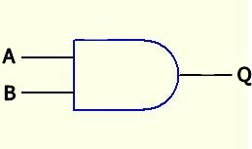  Inputs |  | Output
A | B | Q
0 | 0
0 | 1
1 | 0
1 | 1
Truth table
AND logic circuit

Experiment 1.2 (written exercise): Design and fill in the truth table of the OR logic function using the format similar to the AND logic truth table shown above. (No hardware experiment is required for this exercise). Write the truth table on your lab report sheet.
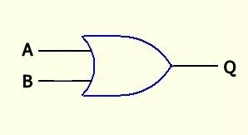
OR logic circuit

Experiment 1.3: (Hardware experiment is required for this and the following exercises). Design and fill in the truth table of the AND logic function after you completed the following procedures.

Connect the USB input of the Arduino board to a PC via a USB cable (to obtain power for the board) as shown in Figure 1a. If a PC is not available, the tutor will instruct you how to obtain the power supply. After you press the Reset-button (see Figure 1b) on the Arduino board, the program (lab6.ino) which implements all the logic functions described in the lab will be run.

You are given: An Arduino computer with the debug board
//program segment in the main loop of Lab6.ino
void loop()
{ // Experiment 1.3 Out1=In1 AND In3
//that means if In1 and In3 are ‘1’, Out1 is ‘1’. Otherwise Out1 is ‘0’
if(Din1() && Din3()) Out1(1); //&& means logic function AND
else Out1(0);
:
}
Procedures:
- Connect the USB input of the Arduino board to a PC via a USB cable (to obtain power for the board) as shown in Figure 1a. If a PC is not available, the tutor will instruct you how to obtain the power supply. Press the Reset button (see Figure 1b) of the Arduino board.
Pins here are all connected to ground (GND)
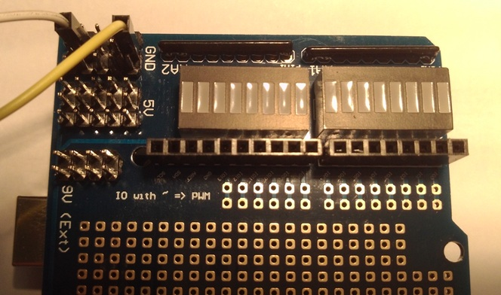
Pins here are all connected to 5 Volts
Out4
Out3
Out2
Out1
In4
In3
In2
In1
Output LEDs
Input LEDs
Connected to a PC via the USB cable

Figure 1a. The Debug board to be placed on top of the Ardunio board

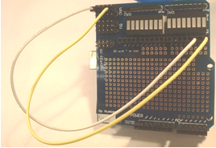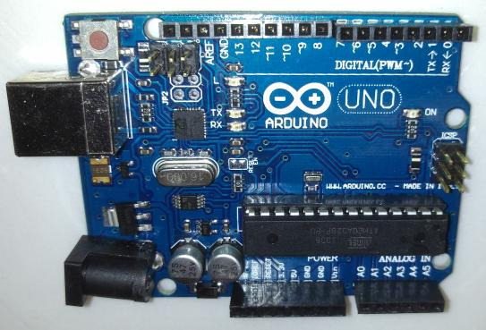
Reset
button s
Figure 1b: (Left) In1 and In3 are connected to the ground (logic level ‘0’). Inputs that are not connected are automatically pulled up to 5 Volts (logic level ‘1’). (Right) The Arudino Board.

A program segment inside the system is written to simulate the AND operation of signals A,B and Q as discussed in experiment 1.1. In here, inputs are represented as In1=A, In3=B and output Out1=Q.
- Examine the logic levels of Out1 for different input combinations of A (In1) and B (In3) by connecting the inputs In1 and In3 to GND using dupont wires as shown in the Figure 1a, 1b. Please see the NOTE_ON_SIGNAL_CONNECTIONS_&_LEDS below for how to connect inputs to constant signals such as GND and 5-Volt pins, and how to interpret the signals of the LEDs. Record the outputs of Out1 for different combinations of In1 and In3.

NOTE_ON_SIGNAL_CONNECTIONS_&_LEDS :
Inputs Ini that are not connected are automatically pulled up to 5Volts (logic level ‘1’.)
When Ini (i=1 or 2 or 3 or 4) is not connecting, it will be at logic level ‘1’ the corresponding LED is off.
When Ini (i=1 or 2 or 3 or 4) is connected to GND , it will be at logic level ‘0’ the corresponding LED is on.
When Outi(i=1 or 2 or 3 or 4) is at logic level ‘0’ the corresponding LED is on.
When Outi(i=1 or 2 or 3 or 4) is at logic level ‘1’ the corresponding LED is off.

- Design and fill in the truth table for this lab based on your observations.

Experiment 1.4: Design and fill in the truth table of the OR logic function. Write the truth table on your lab report sheet.

You are given: An Arduino computer with the debug board

//Program segment in the main loop of Lab6.ino
void loop()
{ :
// Experiment 1.4 Out3=In1 OR In3
if(Din1() || Din3()) Out3(1);
else Out3(0);
:
}
Procedures:

- Connect the USB input of the Arduino board to a PC via a USB cable (to obtain power for the board) as shown in Figure 1a. If a PC is not available, the tutor will instruct you how to obtain the power supply. Press the Reset button (see Figure 1b) of the Arduino board.

A program segment inside the system is written to simulate the OR operation of A,B and Q as discussed in experiment 1.2. In here, inputs are represented as In1=A, In3=B and output Out3=Q.

- Examine the states of Out3 for different input combinations of A (In1) and B (In3) by connecting the inputs to different logic levels using dupont wires. Record the output of Out3. See the NOTE_ON_SIGNAL_CONNECTIONS_&_LEDS above for how to connect inputs to constant signals and how to read the LEDs.

- Design and fill in the truth table for this lab based on your observations.

Part 2: More complex combinational logic

Experiment 2.1: Study a combinational logic function
You are given:. An Arduino computer with the debug board

//Program segment in the main loop of Lab6.ino
void loop()
{ :
// Experiment 2.1 Out2=(NOT(In2) AND In3) AND In4
if((!(Din2()) && Din3()) && Din4()) Out2(1);
else Out2(0);
:
}
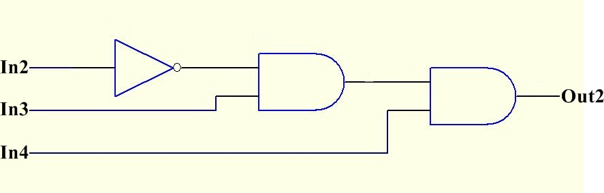
Out2 = (NOT(In2) AND In3) AND In4
Procedures:
- Connect the USB input of the Arduino board to a PC via a USB cable (to obtain power for the board) as shown in Figure 1a. Press the Reset button (see Figure 1b) of the Arduino board.
- Examine the logic levels of Out2 for different input combinations of In2, In3 and In4 by connecting the inputs to different logic levels using dupont wires. See the NOTE_ON_SIGNAL_CONNECTIONS_&_LEDS above for how to connect inputs to constant signals and how to read the LEDs. Record the outputs of Out2 for different combinations of In2, In3 and In4.
- Design and fill in the truth table for this lab based on your observations.

Experiment 2.2: Study another combinational logic function

You are given: an Arduino computer with the debug board

//Program segment in the main loop of Lab6.ino
void loop()
{:
// Experiment 2.2 Out4=(In2 AND In3) OR NOT(In4)
if((Din2() && Din3()) || !(Din4())) Out4(1);
else Out4(0);
}
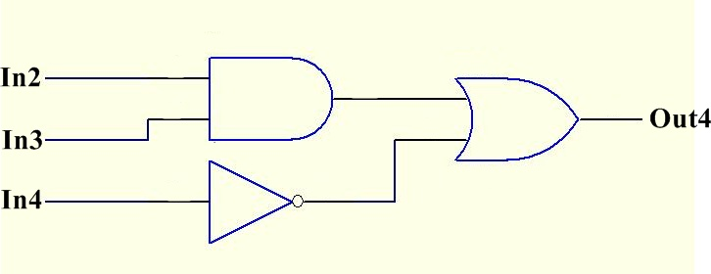
Out4 = (In2 AND In3) OR NOT(In4)

Procedures:
- Connect the USB cable from the Arduino board to the PC as shown in Figure 1a. Press the Reset button (see Figure 1b) of the Arduino board.

- Examine the logic levels of Out4 for different input combinations of In2, In3 and In4 by connecting the inputs to GND using dupont wires. See the NOTE_ON_SIGNAL_CONNECTIONS_&_LEDS above for how to connect inputs to constant signals and how to read the LEDs. Record the outputs of Out4 for different combinations of In2, In3 and In4.

- Enter in your lab report sheet:

  - The truth table of this circuit based on your observations.
  - Explain the operations of the program segment for this experiment in English.

Part 3: Motor control and sensor input

Experiment 3.1: Learn how to use the Arduino board to control a Direct Current D.C. motor

You are given:
1. a DC power supply
2. an Arduino computer with the debug board
3. a motor
5. an L293D
6. a breadboard
7. 3 X 10KΩ resistors

In this experiment we use In1, In2, Out1 and Out2 (see Figure 1a, 1b) to control the motion of a motor. See the NOTE_ON_SIGNAL_CONNECTIONS_&_LEDS above for how to connect inputs to constant signals and how to read the LEDs.

Observe the relations among the logic inputs, logic outputs and the motor operation. See Figure 3b for defining the rotation directions of the motor.

In1 | In2 | Out1 (when LED is on, it is ‘0’) | Out2(when LED is on, it is ‘0’) | Motor operation  (See Figure 3b)
0 | 0
0 | 1
1 | 0
1 | 1
Truth table for experiment 3.1. Copy this table to your lab report sheet and fill in the blanks.
Procedures:
- Construct the motor driver circuit as shown in Figure 3a on a breadboard
- Connect the USB input of the Arduino board to a PC via a USB cable (to obtain power for the board) as shown in Figure 1a. If a PC is not available, the tutor will instruct you how to obtain the power supply. Also setup the whole system with the motor driver circuit as shown in Figure 3b. Remember to connect the +ve connector of the motor to Pin 3 of the H-bridge circuit L293D. And the –ve connector to Pin 6.
- The Arduino computer is powered by the USB bus. However you need to connect a 9V DC power supply to the motor driver. After your setup the circuit, power on the 9V DC power supply.
- Connect In1 and In2 to GND at the same time, that means In1 and In2 are at the ‘0’ logic level (therefore LED for In1 =ON and LED for In2 =ON). Record logic levels of Out1 and Out2 and the motor operation (Stop, Anti-Clockwise or Clockwise). Enter your observations in row1 of the Truth table for experiment 3.1 shown above.
- Fill in Row 2, 3 and 4 of the Truth table for experiment 3.1 shown above.
- Enter in your lab report sheet:
  - Fill in the truth table of this circuit based on your observations.
  - Discuss the results of each row of the truth table.

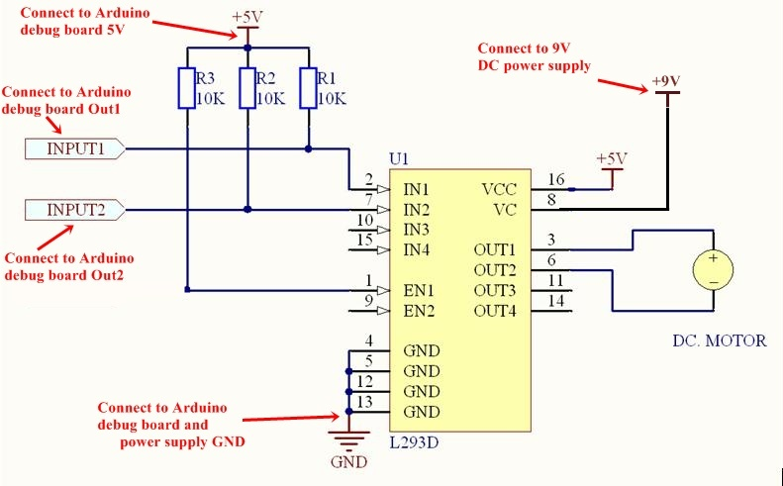
1 16
2 15
3 14
4 13
5 12
6 11
7 (L293D) 10
8 9
This circular marker indicates pin1
Figure 3a: The motor driver circuit
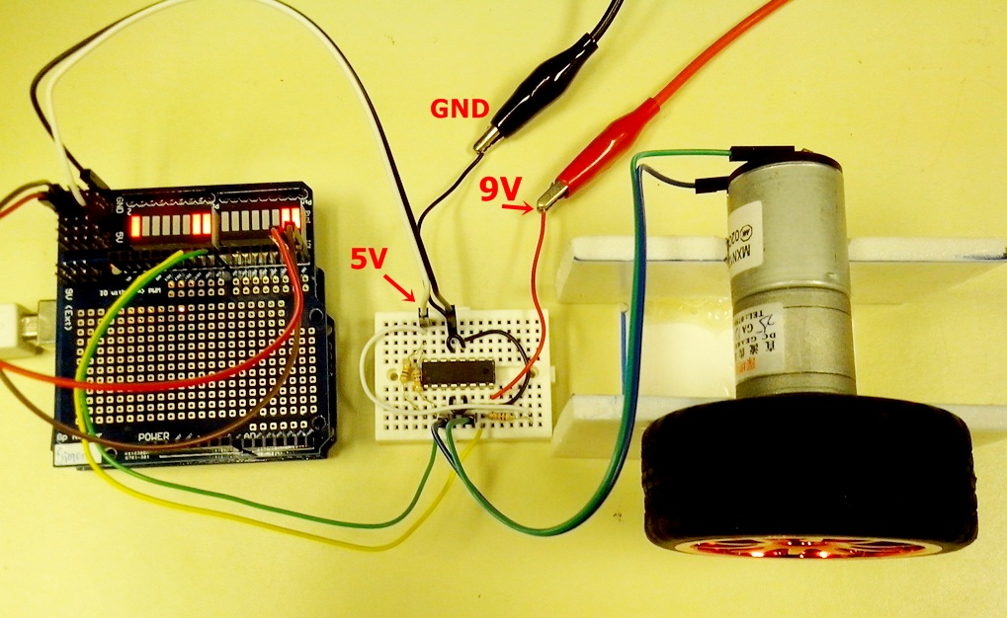
Anti-Clockwise rotation
Figure 3b: The Arduino board (with the debug board) and the motor driver circuit

Experiment 3.2: Learn how to use the magnetic switch to control a motor

You are given:
1. a DC power supply
2. an Arduino computer with the debug board
3. a motor
5. an L293D
6. a breadboard
7. 3 X 10KΩ resistors
8. a magnetic switch
9. a piece of magnetic strip

Use the circuit in experiment 3.1 except for the connections of In1 and In2. For In1, connect anyone pin of the magnetic switch to In1 (the connectors of the magnetic switch have no polarity), and connect the other pin of the magnetic switch to GND as shown in the Figure 3c. In2 is left unconnected.
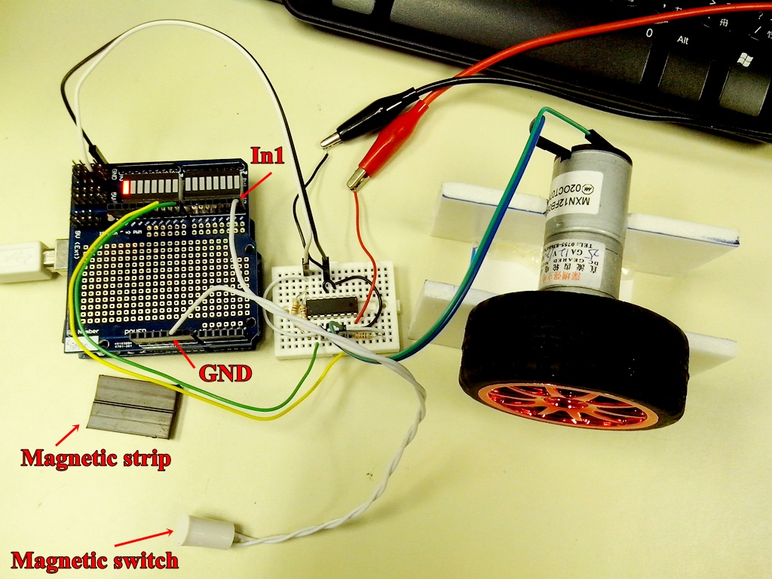
Figure 3c.
Observe the relations among the magnetic switch position (near or away from a magnetic strip), logic inputs (In1), logic outputs (Out1, Out2) and the motor operation (Stop, Anti-Clockwise or Clockwise).
Magnetic switch position | In1 | In2 | Out1(when LED is on, it is ‘0’) | Out2(when LED is on, it is ‘0’) | Motor operation
Away from a magnetic strip
Near a magnetic strip
Truth table for experiment 3.2. Copy this to your lab report sheet and fill in the blanks

Procedures:

- Keep the magnetic switch away from the magnetic strip as shown in the Figure3c. Record the logic levels of In1, In2, Out2, Out1 and motor operation (Stop, Anti-Clockwise or Clockwise).
- Put the magnetic switch near the magnetic strip. Repeat the above procedure.
- Enter in your lab report sheet:
  - Fill in the Truth table for this experiment.
  - Explain the observations for each entry of the truth table.
  - Discuss how you can use this setup to control your robot to follow a path defined by a magnetic strip.
Submit your lab report sheet to the tutor.

- END -
References
  - Introduction to Arduino.pdf (https://elearn.cuhk.edu.hk/webapps/login/)
  - Arduino Language Reference (http://arduino.cc/en/Reference/HomePage)
  - Getting Started w/ Arduino on Windows (http://arduino.cc/en/Guide/Windows)
  - Digital Logic Basic (http://educypedia.karadimov.info/library/ch2_1.pdf)
  - Arduino Tutorial (http://video.mit.edu/watch/arduino-tutorial-1-10950/)
  - Lab6.ino from (https://elearn.cuhk.edu.hk/webapps/login/)

Appendix1
//Program segment in the main loop of Lab6.ino
void loop()
{
// Experiment 1.3 Out1=In1 AND In3
if(Din1() && Din3()) Out1(1);
else Out1(0);

// Experiment 2.1 Out2=(NOT(In2) AND In3) AND In4
if((!(Din2()) && Din3()) && Din4()) Out2(1);
else Out2(0);

// Experiment 1.4 Out3=In1 OR In3
if(Din1() || Din3()) Out3(1);
else Out3(0);

// Experiment 2.2 Out4=(In2 AND In3) OR NOT(In4)
if((Din2() && Din3()) || !(Din4())) Out4(1);
else Out4(0);
}
- END -

