ENGG1100 Introduction to Engineering Design
Faculty of Engineering
The Chinese University of Hong Kong

Project demo 1 and 2
Introduction
In this project, students will learn how to solve problems by integrating technical skills learned from this course. The required task is to ask the robot to navigate itself automatically from the starting position, obtain an object and deliver it to the destination. Each group is required to build the robot and test the program under the supervision of the mentors and tutors.

DEMO1

Required task for DEMO1

Acronyms of various objects, positions and zones used in this specification sheet:
START= The START zone for the robot
CAN1= the empty soft drink CAN 1; CAN2= the empty soft drink CAN 2;
INP1= the initial position of CAN1; INP2= the initial position of CAN2
DST1_ZONE= destination zone for the robot to release CAN1; DST1= center of the edge of DST1_ZONE touches the boundary of the testing board. A similar system applies to DST2_ZONE.

In demo1, your robot should begin at the START zone, runs autonomously to pick up a CAN (an empty soft drink CAN 330ml type) from INP1 and deliver it to the destination at DST1_ZONE.
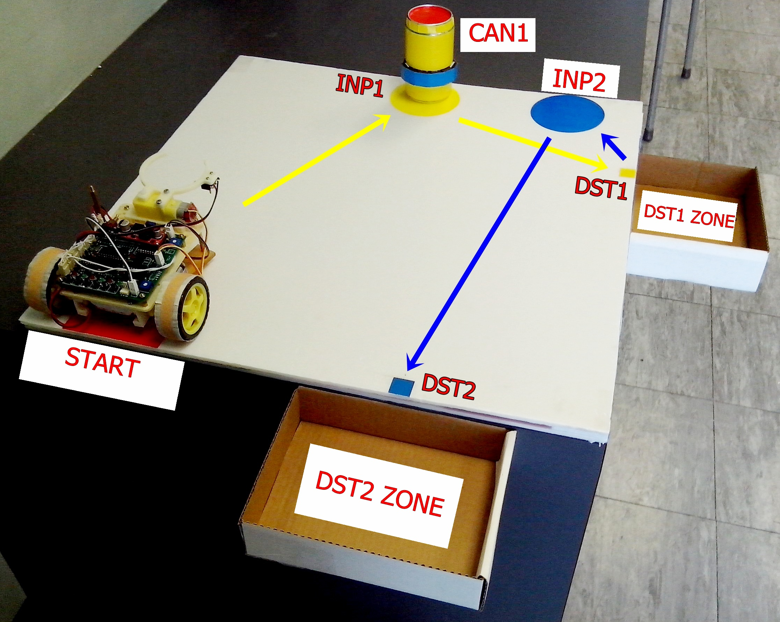 | 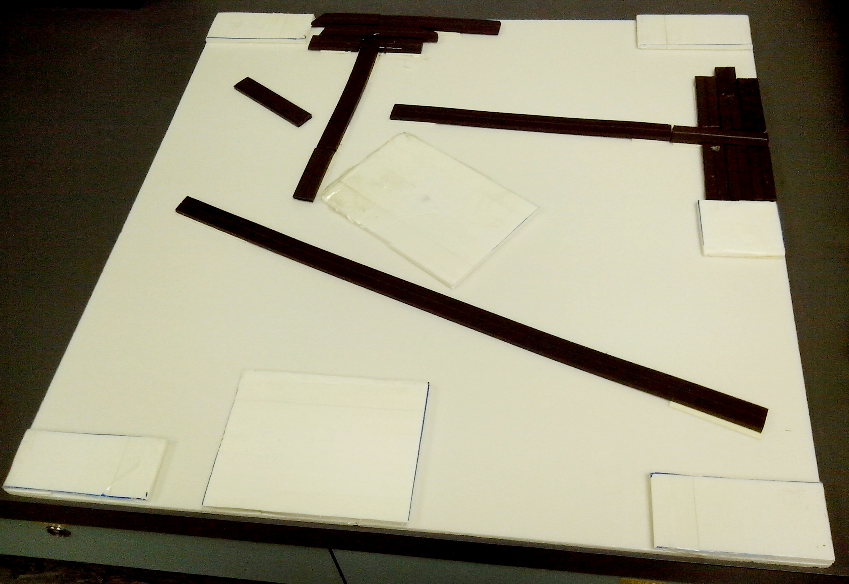 | 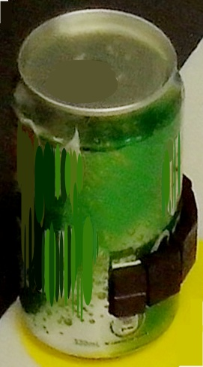
Figure 1a Figure 1b Figure 1c
1a) The testing board with the robot and CAN1
2b) An example of the magnetic strips under the testing board
1c) A CAN with magnetic strips placed on the side;

A demo video can be downloaded from http://www.youtube.com/channel/UCjlkiXFReY2Ubv6WX8m4F8A?feature=watch

The task can be subdivided into the following steps
- The robot should begin at START to find CAN1: To achieve the task, the car can navigate itself using the magnetic strips underneath the board as shown in Figure 1b. Magnetic strips can be placed near INP1, and magnetic strips can be placed on the surface of CAN1. You should program the robot to detect CAN1 and stop at the right position to pick up the object.
- Pick up CAN1 at INP1: You should program the gripper to pick up CAN1. The touch sensor at the gripper can be used to guide the open/close action.
- Move the robot to a position near DST1 and release CAN1 into DST1_ZONE, which is outside the testing board. However, you must make sure that the wheels of the robot are never moved outside the testing board.

Your work for DEMO1
Your robot should have been assembled and tested after the mid-term demo. In this part, you need to complete the followings.
- Prepare CAN1 with magnetic strips placed on the surface. (See Figure 1c).
- Carefully design and build the board with the magnetic strips underneath so that your robot can use them for navigation to complete the required task.
- Develop the program to achieve the task.
- Task (ii) and (III) should be executed alternatively to achieve the best performance.

DEMO2

Required task for DEMO2
Similar to DEMO1, the robot needs to deliver CAN1 to a position fully inside DST1_ZONE. Then the robot should go back to pick up CAN2, and deliver it to DST2_ZONE. Again, you must make sure that the wheels of the robot should never be moved outside the testing board. DST1 and DST2 are predefined and set differently for each group and they can be anywhere in the left/right/bottom regions of the testing board. The whole process should be completed automatically. No user intervention is allowed once the demo is started. The performance of your robot will also be evaluated by how fast your robot can achieve the task.

Specifications

Specifications of the testing board for DEMO1 and DEMO2

- In Demo1, only CAN1 is used.
- In Demo2, both CAN1 and CAN2 are used.
- The initial positions of CAN1 and CAN2 are at INP1 and INP2 respectively. They will be inside the top-region of the board. The distance between the centers of CAN 1 and CAN 2 is fixed at 200 mm. However, their actual positions may vary from group to group.
- The destination zones DST1_ZONE and DST2_ZONE should be inside the left/right/bottom regions of the board.
- Detailed positions of INP1, INP2, DST1 and DST2 for each group will be given to students when they collect their building materials. One example of position details sheet is as shown in Figure 3.

A demonstration video for demo2 can be downloaded from http://www.youtube.com/channel/UCjlkiXFReY2Ubv6WX8m4F8A?feature=watch

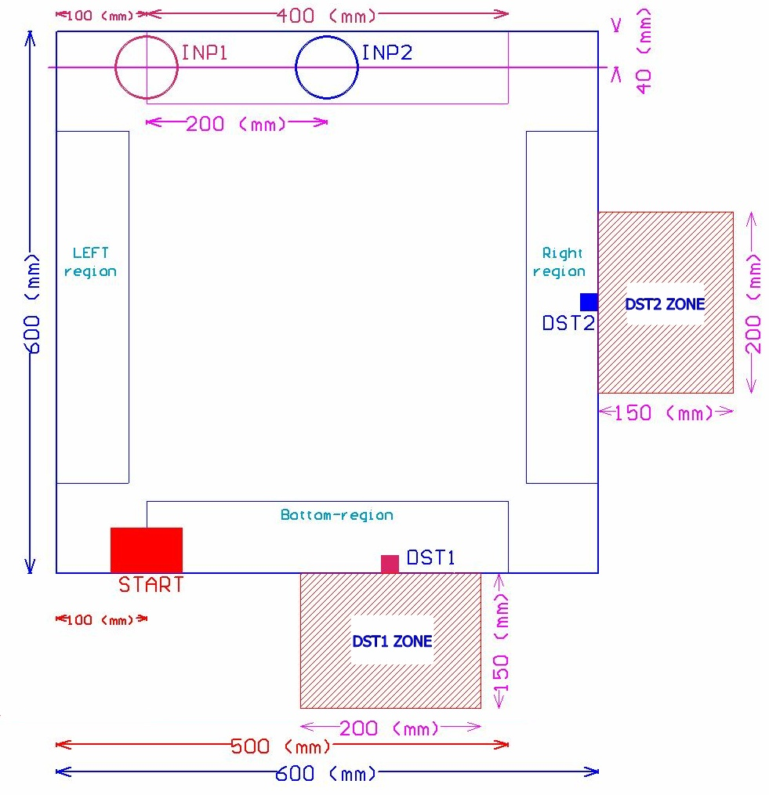

Figure 2: In DEMO1, only CAN1 Is used. In DEMO2, both CAN1 and CAN2 are used. INP1, INP2, DST1, DST2, START, Left-region, Right-region, top-region are bottom-region are shown.

Building materials provided by the lab for each group for DEMO 1 and 2.
- Two 600 mm x 600mm foam boards.
- A total of two meters of magnetic strips will be provided for each project group, you should use the magnetic strip as short as possible to complete the required tasks.
  - Magnetic strip width: 20 mm
  - Magnetic strip thickness: 5 mm
- Soft drink CANs will not be provided, each group should prepare two empty CANs for the test.
The following Tools will be provided for each group:
- Philip screwdriver
- Flat head screwdriver
- Electronic cutter
- Flat nose pliers

Tentative marking scheme (We will finalize these rules when you collect the building materials)
- Assessment/grading policy/Marking scheme
  - The assessment for individual group in each session will be executed on a first-come- first-serve basis. Notify your tutor (TA) once you are ready. After the demonstration, you may continue your project work until the lab session ends.
  - The robot should run autonomously, once you have started a demo (1 or 2), you cannot touch the robot. You are given at most three trials to demonstrate the required functions to your tutor. Each trial lasts not more than 3 minutes.
- The marking scheme is as follows:
  - Demo1 :10 % of the whole course
  - Demo2 :15 % of the whole course

Important dates

- Week 5 (30/9) – Distribution of Smart car board material, including the PCB, MCU and other components.

- Week 6 (7/10) – Distribution of basic project material, including the car chassis, motor mounts, motors with wheels, etc.

- Week 9 (28/10) – Mid-term Demo. Distribution of finished parts for Mechanical Homework 2

- Week 11-13 (11/11 to 25/11) – Mentor meetings (Implementation phase)

- Week 13 (25/11) & (2/12) – Demo 1

- Week 14 (3/12) – Demo 2

Appendix: An example of a testing board

Group # 51 | x (mm) | y (mm)
START | 200 | 0
INP1 | 150 | 560
DST1 | 0 | 460
INP2 | 350 | 560
DST2 | 350 | 0

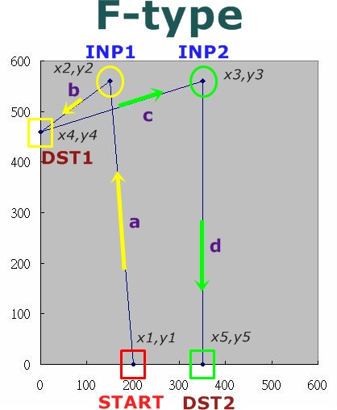

Figure 3. Example of position details sheet (in mm)

-END-

