CMSC5707 (Topics in AI)
- Frame blocking:
  - How many bytes are used in a 22.05 KHz/16-bit signal of 20 seconds?

  - A signal is sampled at 44.1 KHz, the frame size is chosen to be 30 ms and the overlapping region of adjacent frames is 75% of the frame size. Calculate the number of samples in one frame (N), the number of non-overlapping samples (m) and draw the frame-blocking diagram.

  - Repeat the above question when the overlapping region of adjacent frames is 15% of the frame size.

- Vector quantization (assume you use all available samples in building the centroids at all stages of calculations): Given 6 different speech sound signals, each one is described by a 2-D vector (x,y) as (2.1,6.2);(1.1,5.6);(8.1,2.5);(6.1,2.3);(4.6,5.9);(6.5,1.4). Find the code-book of size four using Binary split K-means method with perturbation e=0.01. Show the steps of your calculations.

- A speech signal to be analysed is X= [3 4 9 5 6 1 3 6 8].
  - If the frame size is 6, and the number of non-overlapping samples is 3, write down the signal sequences of the (i) first frame, (ii) second frame.

  - Find the auto-correlation parameters r0, r1, r2 and LPC coefficients of order2 (a1, a2) of the first frame.

- Dynamic Programming: The lpc code representations (a1,a2) against time t of the speech sounds of two commands: S1: “UP”, S(2)=“DOWN” and an unknown input “inp” are shown below. What is the unknown input? Please show your steps of calculation. Note that the error function used is the absolute value between two codes Sx(:,t) and Inp(:,t’) is
dist=|Sx(a1,t)-inp(a1,t’)|+ |Sx(a2,t)-inp(a2,t’)|, Note: “:” means the vector [a1,a2]^{T}
S1(a1,t)= [ 3 2 7 11 2 4 6 5 2]
S1(a2,t)= [ 1 2 4 3 5 2 6 8 4]
S2(a1,t)= [ 7 3 6 8 1 2 5 1 1]
S2(a2,t)= [ 2 6 7 1 3 2 9 6 2]
Inp(a1,t) = [ 8 1 4 3 1 7 2 3 2]
Inp(a2,t) = [ 9 3 1 2 9 0 5 4 2]
(a) Assume all a2s are zero, i.e. Sx(a2, t) =0 for all t=1,2,9 etc.. Complete the following
 |  | Distortion (dist) for S1 and input
S1(:,9)
S1(:,8)
S1(:,7)
S1(:,6)
S1(:,5)
S1(:,4)
S1(:,3)
S1(:,2)
S1(:,1)
 |  |  | Inp(:,1) | Inp(:,2) | Inp(:,3) | Inp(:,4) | Inp(:,5) | Inp(:,6) | Inp(:,7) | Inp(:,8) | Inp(:,9)

 |  | Accumulated Distortion (accumulated score) for S1 and Inp
S1(:,9)
S1(:,8)
S1(:,7)
S1(:,6)
S1(:,5)
S1(:,4)
S1(:,3)
S1(:,2)
S1(:,1)
 |  |  | Inp(:,1) | Inp(:,2) | Inp(:,3) | Inp(:,4) | Inp(:,5) | Inp(:,6) | Inp(:,7) | Inp(:,8) | Inp(:,9)

 |  | Distortion (dist) for S2 and input
S2(:,9)
S2(:,8)
S2(:,7)
S2(:,6)
S2(:,5)
S2(:,4)
S2(:,3)
S2(:,2)
S2(:,1)
 |  |  | Inp(:,1) |  | Inp(:,2) |  | Inp(:,3) |  | Inp(:,4) |  | Inp(:,5) |  | Inp(:,6) |  | Inp(:,7) |  | Inp(:,8) |  | Inp(:,9)
 |  | Accumulated Distortion (accumulated score) for S2 and Inp
S2(:,9)
S2(:,8)
S2(:,7)
S2(:,6)
S2(:,5)
S2(:,4)
S2(:,3)
S2(:,2)
S2(:,1)
 |  |  |  | Inp(:,1) |  | Inp(:,2) |  | Inp(:,3) |  | Inp(:,4) |  | Inp(:,5) |  | Inp(:,6) |  | Inp(:,7) |  | Inp(:,8) |  | Inp(:,9)
- Assume all a1s and a2 s are used, complete the following
 |  | Distortion (dist) for S1 and input
S1(:,9)
S1(:,8)
S1(:,7)
S1(:,6)
S1(:,5)
S1(:,4)
S1(:,3)
S1(:,2)
S1(:,1)
 |  |  |  | Inp(:,1) |  | Inp(:,2) |  | Inp(:,3) |  | Inp(:,4) |  | Inp(:,5) |  | Inp(:,6) |  | Inp(:,7) |  | Inp(:,8) |  | Inp(:,9)
 |  | Accumulated Distortion (accumulated score) for S1 and Inp
S1(:,9)
S1(:,8)
S1(:,7)
S1(:,6)
S1(:,5)
S1(:,4)
S1(:,3)
S1(:,2)
S1(:,1)
 |  |  | Inp(:,1) |  | Inp(:,2) |  | Inp(:,3) |  | Inp(:,4) |  | Inp(:,5) |  | Inp(:,6) |  | Inp(:,7) |  | Inp(:,8) |  | Inp(:,9)

ANSWER: CMSC5707 (Topics in AI)

Part I : Audio processing

- Frame blocking:
  - For a 22.05KHz/16-bit sampling signal, how many bytes are used in 20 seconds.
ANS: 22.05K*2bytes*20seconds=882K bytes
  - A signal is sampled at 44.1 KHz, the frame size is chosen to be 30 ms and the overlapping region of adjacent frames is 75% of the frame size. Calculate the number of samples in one frame (N), and the number of non-overlapping samples (m) and draw the frame-blocking diagram.
ANSWER: N=duration/(Period)=30.2ms/[1/44.1K]= 1323 ; m=(100-75)% of N ==0.25*1323, so m=330.75. Diagram can be found in lecture note
  - Repeat the above question when the overlapping region of adjacent frames is 15% of the frame size.
ANSWER: N=duration/(Period)=30.2ms/[1/44.1K]= 1323 ; m=(100-15)% of N ==0.85*1323, so m=1124.55. Diagram can be found in lecture note
- (10%) Vector quantization (assume you use all available samples in building the centroids at all stages of calculations):

- Given 6 different speech sound signals, each one is described by a 2-D vector (x,y) as :(2.1,6.2);(1.1,2.6);(8.1,7.5);(6.1,2.3);(4.6,5.9);(6.5,1.4).
- Find the code-book of size four using Binary split K-means method with perturbation e=0.01. Show the steps of your calculations.

Ans: \vq_assignment\a5707_vq1_assig1_v2
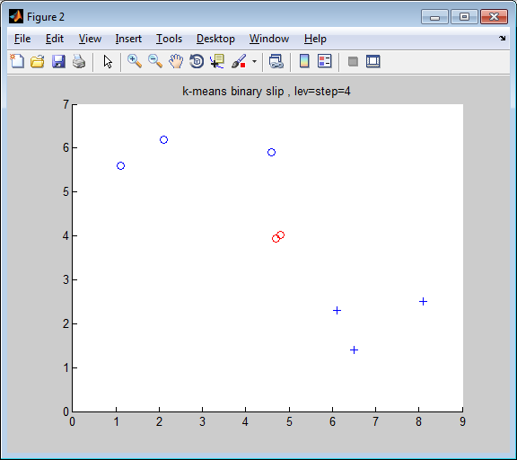
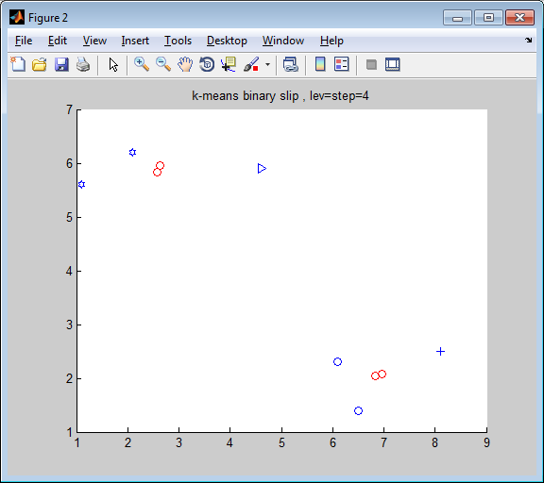
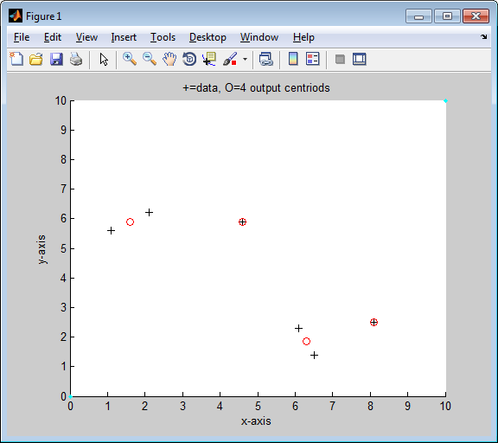

(Question 3) A speech signal to be analysed is X= [3 4 9 5 6 1 3 6 8].
  - Find the auto-correlation parameters r0,r1,r2 of the first frame with window size = 6.
  - Find the LPC coefficients a1,a2.

Ans:
(part a) First frame sequence : s=[3 4 9 5 6 1]
Second frame sequence: [5 6 1 3 6 8]
(partb)
\lpc_assignment\lpc_assign1_v2.m
lpc_order=2
lpc coefficents, a =
0.6905
0.1008

(10%) (question 4) Dynamic Programming:
The code representations of the speech sounds of two commands: s(1): “UP”, s(2)=“DOWN” and an unknown “input” are shown below.
What is the unknown input? Please show your steps of calculation. Note that the error function used is the absolute value between two codes.

s(1)= [ 3 2 7 11 2 4 6 5 2]
s(2)= [ 7 3 6 8 1 2 5 2 1]
input = [ 8 1 4 3 1 7 2 3 2]

The code representations of the speech sounds of the four directions: “North”, “West”, “South”, “East” are shown below. What is the unknown input? Please show your steps of calculation.

Answer (part a) only, students should work out part b themselves:
dp_assign1_1a-2012\dp_assig1_v2a.m

s=zeros(4,9)%init only

s(1,:)= [ 3 2 7 11 2 4 6 5 2]
s(2,:)= [ 7 3 6 8 1 2 5 2 1]
input = [ 8 1 4 3 1 7 2 3 2]

error matrix for index=1

ans =

5 2 1 0 2 4 1 0 1
6 1 2 1 1 5 0 1 0
1 6 3 4 6 0 5 4 5
3 10 7 8 10 4 9 8 9
6 1 2 1 1 5 0 1 0
4 3 0 1 3 3 2 1 2
2 5 2 3 5 1 4 3 4
3 4 1 2 4 2 3 2 3
6 1 2 1 1 5 0 1 0

error matrix for index=2

ans =

1 6 3 4 6 0 5 4 5
5 2 1 0 2 4 1 0 1
2 5 2 3 5 1 4 3 4
0 7 4 5 7 1 6 5 6
7 0 3 2 0 6 1 2 1
6 1 2 1 1 5 0 1 0
3 4 1 2 4 2 3 2 3
6 1 2 1 1 5 0 1 0
7 0 3 2 0 6 1 2 1

accumulated_error matrix for index=1

ans =

5 7 8 8 10 14 15 15 16
11 6 8 9 9 14 14 15 15
12 12 9 12 15 9 14 18 20
15 22 16 17 22 13 18 22 27
21 16 18 17 18 18 13 14 14
25 19 16 17 20 21 15 14 16
27 24 18 19 22 21 19 17 18
30 28 19 20 23 23 22 19 20
36 29 21 20 21 26 22 20 19

accumulated_error matrix for index=2

ans =

1 7 10 14 20 20 25 29 34
6 3 4 4 6 10 11 11 12
8 8 5 7 9 7 11 14 15
8 15 9 10 14 8 13 16 20
15 8 11 11 10 14 9 11 12
21 9 10 11 11 15 9 10 10
24 13 10 12 15 13 12 11 13
30 14 12 11 12 17 12 12 11
37 14 15 13 11 17 13 14 12

Beware! the accumulated matrix view is different from that in the lecture note
it is now up side down

dist =

14 10

dist =

14 10

-- END --

