Using opencv and python
Useful list
opencv_features2d230d.lib opencv_highgui230d.lib opencv_core230d.lib opencv_imgproc230d.lib opencv_ml230d.lib opencv_objdetect230d.lib opencv_video230d.lib opencv_contrib230d.lib opencv_calib3d230d.lib

Installation guide (python2.7+ opencv2.3)+ under vs2008 and win7(or xp) by khwong 8/5/2012 6pm
- I tested opencv2.3rc with python2.7 and they work, I used the following versions
  - From http://opencv.willowgarage.com/wiki/
  - download OpenCV-2.3.0rc-win-src.zip

  - http://www.python.org
  - download python-2.7.1.msi

  - http://sourceforge.net/projects/numpy/
  - Choose the correct versions to support python2.7

  - download numpy-1.5.1-win32-superpack-python2.7.exe
  - download scipy-0.9.0rc5-win32-superpack-python2.7.exe

  - for reference my win7(or WINXP) -search-path is : C:\Python27;C:\OpenCV-2.3.0\vs2008\bin\Debug;C:\OpenCV-2.3.0\vs2008\bin\Release;C:\OpenCV-2.3.0\vs2008\install\lib;C:\OpenCV-2.3.0\vs2008\lib\Debug

====== For opencv2.3 + python2.7 +win7 (or XP)==

- Following the steps below, don’t alter the order otherwise you may have problems.
- Setup python: download and install python , scipy and numpy
  - python2.7, from http://www.python.org/ downalod and install
    - Make sure you have downloaded the numpy andf scipy correct versions for python2.7
    - add path to your computer, in windows:computer(right-click)>>properties environment path append ;c:\python27;
    - It is advisable to reset your machine to make the system recognize your pytjhon27
    - scipy, numpy from http://numpy.scipy.org/
  - Alternatively, you may choose python2.6 , but use the corresponding numpy and scipy tools
- Download opencv2.3 :
  - download opencv2.3 from http://sourceforge.net/projects/opencvlibrary/
  - Download OpenCV-2.3.0rc-win-src.zip
  - unzip and save the source directory to anywhere you like , e.g. C:\OpenCV2.3.
- Setup cmake: download cmake2.8 from http://www.cmake.org/
  - Where is the source code:> : C:/OpenCV2.3/
  - Where build the binaries:> C:/OpenCV2.3/vs2008
  - Check that cmake recognizes python27 , python27/libs/python27/lib, python27/include etc.
  - use default configuration, It should have python detected
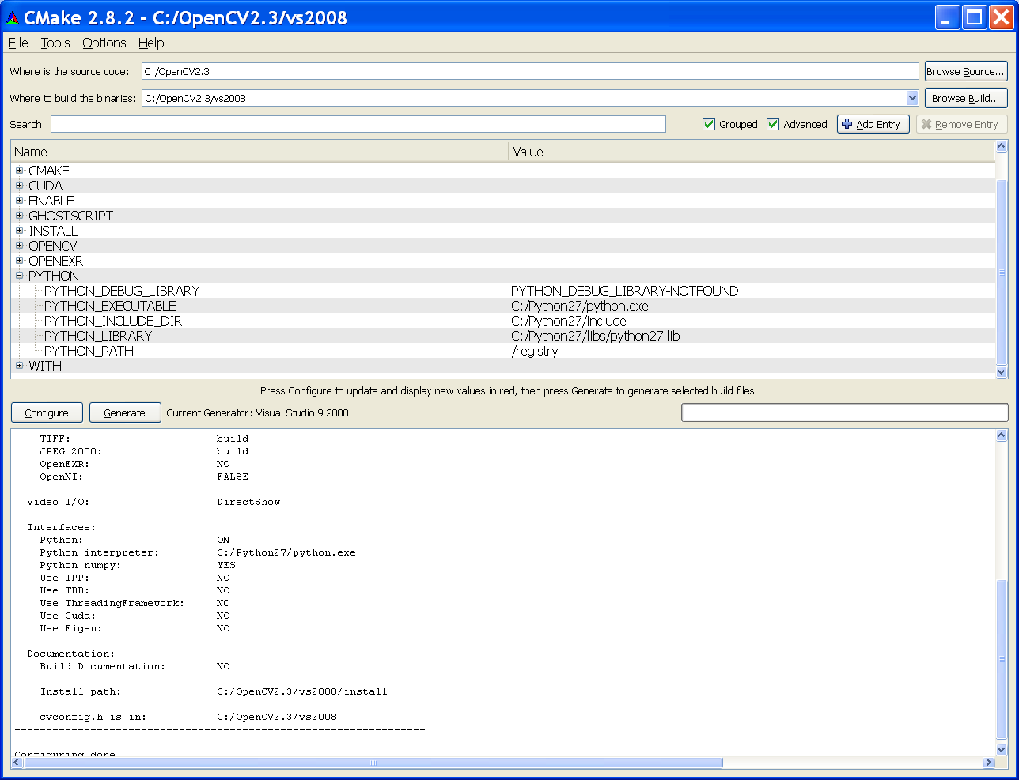
  - If some Python path are not found, double click the “Not found paths” and enter these paths manually except for the PYTHON_DEBUG_LIBRARY (because it is not important). E.g. C:/Python27/Include, C:/Python27/lib/python27.lib.
  - click on “configure” and then “Generate”.
  - done
- compile opencv using vs2008 (visual studio 2008):
open the project opencv.sln using vs2008 at
C:\OpenCV2.3\vs2008\opencv.sln
You need to compile it 4 times using different modes as follows to generate the necessary dlls.

- At Debug mode
  - (1) -Right click "ALL-BUILD" build (or rebuild), will take some time
  - *It is ok if you have two errors: fatal error LNK 1104: cannot open file 'python27_d.lib'. Python has no debug mode, so it doesn’t matter.
  - (2) -Right click "INSTALL" build (or rebuild), will take some time
  - It is normal to have 3 errors, two related to 'python27_d.lib' and one with error code PRJ10019. You system should work with these errors.
- At Release mode
  - (3)-Right click "ALL-BUILD" build (or rebuild), will take some time
    - It should have no compilation error.
  - (4)-Right click "INSTALL" build (or rebuild), will take some time
    - It should have no compilation error.
- Checking: dll files will be generated at C:\OpenCV2.2\bin\debug C:\OpenCV2.2\bin\relesase, check if they are all there and updated.
- Configure vs2008 for developing projects in opencv
  - Start vs2008
  - Copy “C:\OpenCV2.3\include\opencv\*.*” and “C:\OpenCV2.3\include\opencv2\*.*” into “C:\OpenCV2.3\include”. Because some older program assume all .h are in C:\OpenCV2.3\include.
  - In the main menu,
    - Tools>> options>>projects and solution>>VC++_ directories (at the under right-top menu “Show directories for”)
    - (include files ) add :
      - For Opencv2.3
        - C:\OpenCV2.3\vs2008\install\include\
        - C:\OpenCV2.3\include
    - (library files) add :
      - For Opencv2.3
        - C:\OpenCV2.3\vs2008\lib\Release
        - C:\OpenCV2.3\vs2008\lib\Debug
    - You do the above once only. All project use the same figuration
- Python2.7: Setup Opencv2.3 libraries (cv.pyd and pv2.pyd) for Python2.7
  - If you use Opencv2.3
    - Copy the 4 files cv.pyd, cv.lib, cv2.pyd and cv2.lib and from “C:\OpenCV2.3\vs2008\install\Python2.7\Lib\site-packages” to “C:\Python27\Lib\site-packages”
    - These 4 files can also be at C:\OpenCV2.3\vs2008\lib\Release. They are generated by vs2008 using the opencv.sln (sub projects opencv_python and opencv2_python). Make sure you compiled these projects ok using release mode (no need for debug mode)
  - Done
- For writing python programs: If in python, you received the message saying it fails to ‘import cv’, check
  - you set up your correct path in your windows, e.g.
    - c:\opencv2.2\vs2008\bin\debug; c:\opencv2.2\vs2008\bin\release;c:\Python27
  - setup a system variable path in Win7
    - PythonPath: c:\Python27;C:\Python27\Lib;C:\Python27\DLLs;C:\Python27\Lib\lib-tk;C:\other-foolder-on-the-path
    - 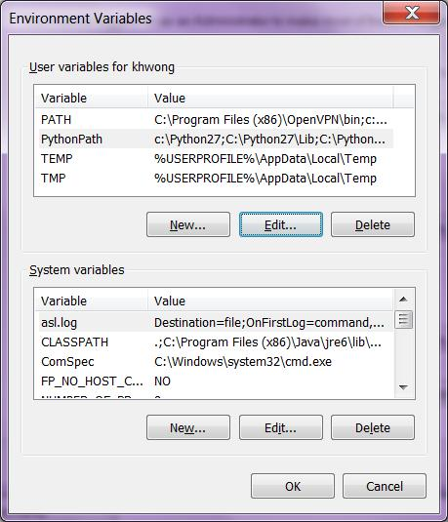
- For developing Opecnv c++ programs: in each project, e.g. open the project file test1.sln by vs2008 .
  - In the source file, add at the beginning of the file: #include "stdafx.h"
  - In debug mode
    - In the window (Solution Explorer - test1)
      - point to the 2nd row item (e.g. test1) , then mouse right click , select properties
      - In (configuration properties>> Linker>>Input>>Additional Dependencies), add the following the entry:
        - opencv_features2d230d.lib opencv_highgui230d.lib opencv_core230d.lib opencv_imgproc230d.lib opencv_ml230d.lib opencv_objdetect230d.lib opencv_video230d.lib opencv_contrib230d.lib opencv_calib3d230d.lib
  - In release mode
    - In the window (Solution Explorer - test1)
      - point to the 2nd row item (e.g.test1) , then mouse right click , select properties
      - In (configuration properties>> Linker>>Input>>Additional Dependencies), add the following the entry:
        - opencv_features2d230.lib opencv_highgui230.lib opencv_core230.lib opencv_imgproc230.lib opencv_ml230.lib opencv_objdetect230.lib opencv_video230.lib opencv_contrib230.lib opencv_calib3d230.lib
  - In the main menu: Build >> rebuild solution, if no error is found, you are have successfully built your program.
  - In the main menu: debug >>start debugging, to start to run your program.

Example of compiling a working opencv program:

Example 1: lkdemo (based on lkdemo.cpp in c:\OpenCV2.3\samples\cpp\lkdemo.cpp etc.)
- Install the system (vs2008 or above and opencv2.3) as described above in the installation guide.
- Start Microsoft studio 2008
- file>>new_project >> visual_C++,>>choose win32
- enter name of your project .e.g. lkdemo2.3.4 >> finish
- left top corner “solution explorer window” , under "source files" you see lkdemo2.3.4cpp, double click it.
- In the editor, remove all content, cut and paste all content of c:\OpenCV2.3\samples\cpp\lkdemo.cpp into lkdemo2.3.4cpp.
- Add #include "stdafx.h" at the beginning of the file.
- VS2008 Dependences setting
  - In debug mode
    - In the window (Solution Explorer -lkdemo2.3.4)
      - point to the 2nd row item (e.g. lkdemo2.3.4) , then mouse right click , select properties
      - In (configuration properties>> Linker>>Input>>Additional Dependencies), add the following the the entry:
        - opencv_features2d230d.lib opencv_highgui230d.lib opencv_core230d.lib opencv_imgproc230d.lib opencv_ml230d.lib opencv_objdetect230d.lib opencv_video230d.lib opencv_contrib230d.lib opencv_calib3d230d.lib
  - In release mode
    - In the window (Solution Explorer – lkdemo2.3.4)
      - point to the 2nd row item (e.g. lkdemo2.3.4) , then mouse right click , select properties
      - In (configuration properties>> Linker>>Input>>Additional Dependencies), add the following the entry:
  - opencv_features2d230.lib opencv_highgui230.lib opencv_core230.lib opencv_imgproc230.lib opencv_ml230.lib opencv_objdetect230.lib
- Then in the main menu: “Build”>>”rebuild lkdemo2.3.4”
- If no error, in “Debug”>>” start debugging F5” to run the program.
- Lkdemo should work, then window will show the features tracked by lkdemo from your web cam (don’t forget to plug in your web cam) .
- You may start other tests. Pick the examples in c:\OpenCV2.3\samples\cpp . Some programs may need extra libs, repeat the step in : VS2008 Dependences setting for adding extra libs to your system.

Example 2: lkdemo (based on demohist.cpp in c:\OpenCV2.3\samples\cpp\demohist.cpp histogram demo etc.)
Similar to lkdemo example, except you need to change the course file to point to the correct image file position . i.e. in main()
int main( int argc, char** argv )
{
// Load the source image. HighGUI use.
- image = imread( argc == 2 ? argv[1] : "c:\\images\\baboon.jpg", 0 );

======older information: For opencv2.2 + python2.7 +win7 (or XP)==
- Following the above procedures, change the directory names from Opencv2.3 to Opencv2.2 etc.
- For the step “For Opecnv c++ developers: in each project, e.g. open the project file test1.sln by vs2008 “.
  - Changed the names of the lib files from xx230.lib to xx220.lib, e.g. opencv_features2d230.lib → opencv_features2d220.lib etc.
- Fix the win7+webcam opencv2.2-bug: Before you execute” compile opencv using vs2008 (visual studio 2008):” complete the instructions in http://blog.qinyujie.net/2011/01/15/440/

