How to Set up OpenGL and GLUT in Visual Studio (C++)
3 Dec 2016
Based on
https://m.youtube.com/watch?v=8p76pJsUP44
download
http://www.mediafire.com/file/cmlnr0pj0pyha5d/Glew+and+Glut.zip
unzip into c:\ Glew and Glut

SETUP, only do it once
Create a win32 console project
IN vs2013>>VIEW>>Property windows>>(lower right corner , select property manager>> >> open Debug|Win32>> double click Microsoft.Cpp.Win32.user>> : in Microsoft.Cpp.Win32.user .property pages, 3 changes
If you cannot see “property manager”. Try
(Vs2013 Root menu)TOOLS>> options>>property manager>> select something etc.
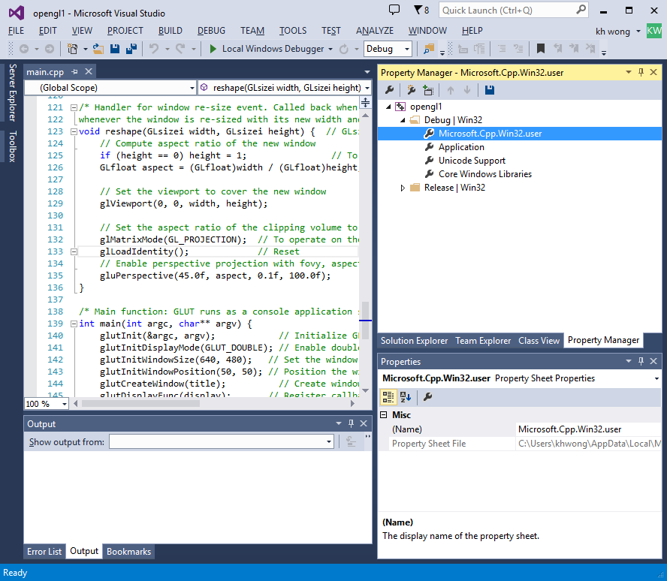
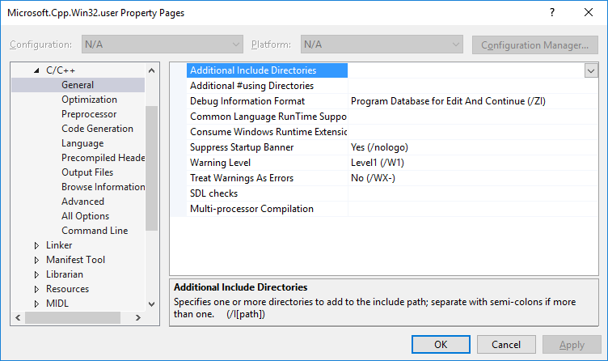
http://www.mediafire.com/file/cmlnr0pj0pyha5d/Glew+and+Glut.zip

- C++ >>general >> Additional Include directories
C:\Glew and Glut\freeglut\include;C:\Glew and Glut\glew-1.11.0\include

- Linker >> General
C:\Glew and Glut\freeglut\lib;C:\Glew and Glut\glew-1.11.0\lib
- Linker>>input>>Additional dependence>>
freeglut.lib;glew32.lib;
*** DO not touch “ VC++ directories”
Make sure

VC++ directories: included directories: $(VC_IncludePath);$(WindowsSDK_IncludePath);
And

VC++ directories: included libraries: $(VC_LibraryPath_x86);$(WindowsSDK_LibraryPath_x86);
Otherisw youa re in trouble

--Now create a project (or using existing project)
Copy
The 2 .dll’s
From C:\Glew and Glut\glew-1.11.0\bin\Release\Win32\glew.dll and
C:\Glew and Glut\freeglut\bin\freeglut.dll
to
C:\Users\khwong\Documents\Visual Studio 2013\Projects\opengl1\opengl1

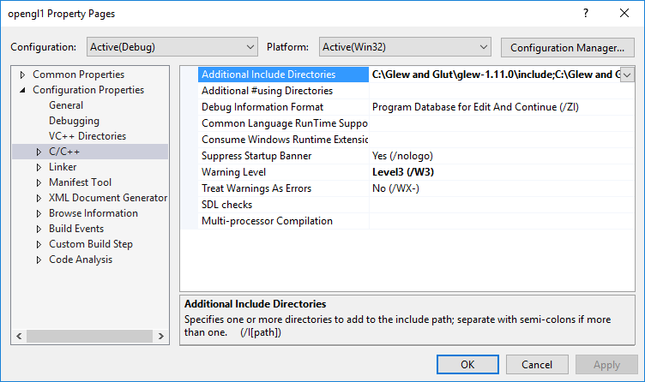
C:\Glew and Glut\freeglut\include
C:\Glew and Glut\glew-1.11.0\include

- Now create a source file main.c , copy the following content to main.c
Then build and run, it should be ok, finish.

//////////////////// end of opengl demo -- main.c
//Jeff Chastine
#include "stdafx.h"
#include <Windows.h>
#include <GL\glew.h>
#include <GL\freeglut.h>
#include <iostream>
/*
* OGL01Shape3D.cpp: 3D Shapes
*/
#include <windows.h> // for MS Windows
#include <GL/glut.h> // GLUT, include glu.h and gl.h

/* Global variables */
char title[] = "3D Shapes";

/* Initialize OpenGL Graphics */
void initGL() {
glClearColor(0.0f, 0.0f, 0.0f, 1.0f); // Set background color to black and opaque
glClearDepth(1.0f); // Set background depth to farthest
glEnable(GL_DEPTH_TEST); // Enable depth testing for z-culling
glDepthFunc(GL_LEQUAL); // Set the type of depth-test
glShadeModel(GL_SMOOTH); // Enable smooth shading
glHint(GL_PERSPECTIVE_CORRECTION_HINT, GL_NICEST); // Nice perspective corrections
}

/* Handler for window-repaint event. Called back when the window first appears and
whenever the window needs to be re-painted. */
void display() {
glClear(GL_COLOR_BUFFER_BIT | GL_DEPTH_BUFFER_BIT); // Clear color and depth buffers
glMatrixMode(GL_MODELVIEW); // To operate on model-view matrix

// Render a color-cube consisting of 6 quads with different colors
glLoadIdentity(); // Reset the model-view matrix
glTranslatef(1.5f, 0.0f, -7.0f); // Move right and into the screen

glBegin(GL_QUADS); // Begin drawing the color cube with 6 quads
// Top face (y = 1.0f)
// Define vertices in counter-clockwise (CCW) order with normal pointing out
glColor3f(0.0f, 1.0f, 0.0f); // Green
glVertex3f(1.0f, 1.0f, -1.0f);
glVertex3f(-1.0f, 1.0f, -1.0f);
glVertex3f(-1.0f, 1.0f, 1.0f);
glVertex3f(1.0f, 1.0f, 1.0f);

// Bottom face (y = -1.0f)
glColor3f(1.0f, 0.5f, 0.0f); // Orange
glVertex3f(1.0f, -1.0f, 1.0f);
glVertex3f(-1.0f, -1.0f, 1.0f);
glVertex3f(-1.0f, -1.0f, -1.0f);
glVertex3f(1.0f, -1.0f, -1.0f);

// Front face (z = 1.0f)
glColor3f(1.0f, 0.0f, 0.0f); // Red
glVertex3f(1.0f, 1.0f, 1.0f);
glVertex3f(-1.0f, 1.0f, 1.0f);
glVertex3f(-1.0f, -1.0f, 1.0f);
glVertex3f(1.0f, -1.0f, 1.0f);

// Back face (z = -1.0f)
glColor3f(1.0f, 1.0f, 0.0f); // Yellow
glVertex3f(1.0f, -1.0f, -1.0f);
glVertex3f(-1.0f, -1.0f, -1.0f);
glVertex3f(-1.0f, 1.0f, -1.0f);
glVertex3f(1.0f, 1.0f, -1.0f);

// Left face (x = -1.0f)
glColor3f(0.0f, 0.0f, 1.0f); // Blue
glVertex3f(-1.0f, 1.0f, 1.0f);
glVertex3f(-1.0f, 1.0f, -1.0f);
glVertex3f(-1.0f, -1.0f, -1.0f);
glVertex3f(-1.0f, -1.0f, 1.0f);

// Right face (x = 1.0f)
glColor3f(1.0f, 0.0f, 1.0f); // Magenta
glVertex3f(1.0f, 1.0f, -1.0f);
glVertex3f(1.0f, 1.0f, 1.0f);
glVertex3f(1.0f, -1.0f, 1.0f);
glVertex3f(1.0f, -1.0f, -1.0f);
glEnd(); // End of drawing color-cube

// Render a pyramid consists of 4 triangles
glLoadIdentity(); // Reset the model-view matrix
glTranslatef(-1.5f, 0.0f, -6.0f); // Move left and into the screen

glBegin(GL_TRIANGLES); // Begin drawing the pyramid with 4 triangles
// Front
glColor3f(1.0f, 0.0f, 0.0f); // Red
glVertex3f(0.0f, 1.0f, 0.0f);
glColor3f(0.0f, 1.0f, 0.0f); // Green
glVertex3f(-1.0f, -1.0f, 1.0f);
glColor3f(0.0f, 0.0f, 1.0f); // Blue
glVertex3f(1.0f, -1.0f, 1.0f);

// Right
glColor3f(1.0f, 0.0f, 0.0f); // Red
glVertex3f(0.0f, 1.0f, 0.0f);
glColor3f(0.0f, 0.0f, 1.0f); // Blue
glVertex3f(1.0f, -1.0f, 1.0f);
glColor3f(0.0f, 1.0f, 0.0f); // Green
glVertex3f(1.0f, -1.0f, -1.0f);

// Back
glColor3f(1.0f, 0.0f, 0.0f); // Red
glVertex3f(0.0f, 1.0f, 0.0f);
glColor3f(0.0f, 1.0f, 0.0f); // Green
glVertex3f(1.0f, -1.0f, -1.0f);
glColor3f(0.0f, 0.0f, 1.0f); // Blue
glVertex3f(-1.0f, -1.0f, -1.0f);

// Left
glColor3f(1.0f, 0.0f, 0.0f); // Red
glVertex3f(0.0f, 1.0f, 0.0f);
glColor3f(0.0f, 0.0f, 1.0f); // Blue
glVertex3f(-1.0f, -1.0f, -1.0f);
glColor3f(0.0f, 1.0f, 0.0f); // Green
glVertex3f(-1.0f, -1.0f, 1.0f);
glEnd(); // Done drawing the pyramid

glutSwapBuffers(); // Swap the front and back frame buffers (double buffering)
}

/* Handler for window re-size event. Called back when the window first appears and
whenever the window is re-sized with its new width and height */
void reshape(GLsizei width, GLsizei height) { // GLsizei for non-negative integer
// Compute aspect ratio of the new window
if (height == 0) height = 1; // To prevent divide by 0
GLfloat aspect = (GLfloat)width / (GLfloat)height;

// Set the viewport to cover the new window
glViewport(0, 0, width, height);

// Set the aspect ratio of the clipping volume to match the viewport
glMatrixMode(GL_PROJECTION); // To operate on the Projection matrix
glLoadIdentity(); // Reset
// Enable perspective projection with fovy, aspect, zNear and zFar
gluPerspective(45.0f, aspect, 0.1f, 100.0f);
}

/* Main function: GLUT runs as a console application starting at main() */
int main(int argc, char** argv) {
glutInit(&argc, argv); // Initialize GLUT
glutInitDisplayMode(GLUT_DOUBLE); // Enable double buffered mode
glutInitWindowSize(640, 480); // Set the window's initial width & height
glutInitWindowPosition(50, 50); // Position the window's initial top-left corner
glutCreateWindow(title); // Create window with the given title
glutDisplayFunc(display); // Register callback handler for window re-paint event
glutReshapeFunc(reshape); // Register callback handler for window re-size event
initGL(); // Our own OpenGL initialization
glutMainLoop(); // Enter the infinite event-processing loop
return 0;
}
//////////////////// end of opengl demo

///////////////////// example 2 begin
//
// File: mycube.c
// Author: Matt Daisley
// Created: 4/25/2012
// Project: Source code for Make a Cube in OpenGL
// Description: Creates an OpenGL window and draws a 3D cube
// That the user can rotate using the arrow keys
//
// Controls: Left Arrow - Rotate Left
// Right Arrow - Rotate Right
// Up Arrow - Rotate Up
// Down Arrow - Rotate Down

// ----------------------------------------------------------
// Includes
// ----------------------------------------------------------
#include "stdafx.h"
#include <stdio.h>
#include <stdarg.h>
#include <math.h>
#define GL_GLEXT_PROTOTYPES
#ifdef __APPLE__
#include <GLUT/glut.h>
#else
#include <GL/glut.h>
#endif

// ----------------------------------------------------------
// Function Prototypes
// ----------------------------------------------------------
void display();
void specialKeys();

// ----------------------------------------------------------
// Global Variables
// ----------------------------------------------------------
double rotate_y = 0;
double rotate_x = 0;

// ----------------------------------------------------------
// display() Callback function
// ----------------------------------------------------------
void display(){

// Clear screen and Z-buffer
glClear(GL_COLOR_BUFFER_BIT | GL_DEPTH_BUFFER_BIT);

// Reset transformations
glLoadIdentity();

// Other Transformations
// glTranslatef( 0.1, 0.0, 0.0 ); // Not included
// glRotatef( 180, 0.0, 1.0, 0.0 ); // Not included

// Rotate when user changes rotate_x and rotate_y
glRotatef(rotate_x, 1.0, 0.0, 0.0);
glRotatef(rotate_y, 0.0, 1.0, 0.0);

// Other Transformations
// glScalef( 2.0, 2.0, 0.0 ); // Not included

//Multi-colored side - FRONT
glBegin(GL_POLYGON);

glColor3f(1.0, 0.0, 0.0); glVertex3f(0.5, -0.5, -0.5); // P1 is red
glColor3f(0.0, 1.0, 0.0); glVertex3f(0.5, 0.5, -0.5); // P2 is green
glColor3f(0.0, 0.0, 1.0); glVertex3f(-0.5, 0.5, -0.5); // P3 is blue
glColor3f(1.0, 0.0, 1.0); glVertex3f(-0.5, -0.5, -0.5); // P4 is purple

glEnd();

// White side - BACK
glBegin(GL_POLYGON);
glColor3f(1.0, 1.0, 1.0);
glVertex3f(0.5, -0.5, 0.5);
glVertex3f(0.5, 0.5, 0.5);
glVertex3f(-0.5, 0.5, 0.5);
glVertex3f(-0.5, -0.5, 0.5);
glEnd();

// Purple side - RIGHT
glBegin(GL_POLYGON);
glColor3f(1.0, 0.0, 1.0);
glVertex3f(0.5, -0.5, -0.5);
glVertex3f(0.5, 0.5, -0.5);
glVertex3f(0.5, 0.5, 0.5);
glVertex3f(0.5, -0.5, 0.5);
glEnd();

// Green side - LEFT
glBegin(GL_POLYGON);
glColor3f(0.0, 1.0, 0.0);
glVertex3f(-0.5, -0.5, 0.5);
glVertex3f(-0.5, 0.5, 0.5);
glVertex3f(-0.5, 0.5, -0.5);
glVertex3f(-0.5, -0.5, -0.5);
glEnd();

// Blue side - TOP
glBegin(GL_POLYGON);
glColor3f(0.0, 0.0, 1.0);
glVertex3f(0.5, 0.5, 0.5);
glVertex3f(0.5, 0.5, -0.5);
glVertex3f(-0.5, 0.5, -0.5);
glVertex3f(-0.5, 0.5, 0.5);
glEnd();

// Red side - BOTTOM
glBegin(GL_POLYGON);
glColor3f(1.0, 0.0, 0.0);
glVertex3f(0.5, -0.5, -0.5);
glVertex3f(0.5, -0.5, 0.5);
glVertex3f(-0.5, -0.5, 0.5);
glVertex3f(-0.5, -0.5, -0.5);
glEnd();

glFlush();
glutSwapBuffers();

}

// ----------------------------------------------------------
// specialKeys() Callback Function
// ----------------------------------------------------------
void specialKeys(int key, int x, int y) {

// Right arrow - increase rotation by 5 degree
if (key == GLUT_KEY_RIGHT)
rotate_y += 5;

// Left arrow - decrease rotation by 5 degree
else if (key == GLUT_KEY_LEFT)
rotate_y -= 5;

else if (key == GLUT_KEY_UP)
rotate_x += 5;

else if (key == GLUT_KEY_DOWN)
rotate_x -= 5;

// Request display update
glutPostRedisplay();

}

// ----------------------------------------------------------
// main() function
// ----------------------------------------------------------
int main(int argc, char* argv[]){

// Initialize GLUT and process user parameters
glutInit(&argc, argv);

// Request double buffered true color window with Z-buffer
glutInitDisplayMode(GLUT_DOUBLE | GLUT_RGB | GLUT_DEPTH);

// Create window
glutCreateWindow("Awesome Cube");

// Enable Z-buffer depth test
glEnable(GL_DEPTH_TEST);

// Callback functions
glutDisplayFunc(display);
glutSpecialFunc(specialKeys);

// Pass control to GLUT for events
glutMainLoop();

// Return to OS
return 0;

}

