Disclaimer:
The instructions and images of making the USB installer are copied from Ubuntu official website.

Instruction for installing Ubuntu on ATOM board:
1. You have download the cd image(ISO).
2. You have to create a USB installer:
If you have a Windows, please go to page 2
If you have an Ubuntu, please go to page 6
MAKE SURE YOU BACKUP YOUR DATA ON THE USB DRIVE.
3. Insert the USB install to ATOM board
4. Connect a keyboad and a mouse.
if you have usb keyboard and mouse. then you should not use mouse because ATOM board only has two USB ports. One for the USB drive, another for the keyboard.
Hint: Use “tab” and “alt” to traversal the install manual
5. Boot the ATOM board. the usb port is bootable by default. If not, you have to change the bios setting.
6. Fill in the necessary information for the installation.
7. After the installation finished, remove the USB installer and reboot.

Create USB installer in Windows
1. Insert a USB stick with at least 2GB of free space
2. Download the Universal USB Installer here
3. Click 'Run' when prompted
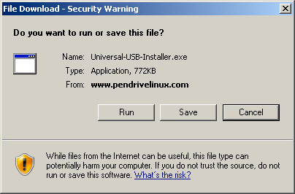
4. If the security dialog appears, confirm by clicking 'Run'
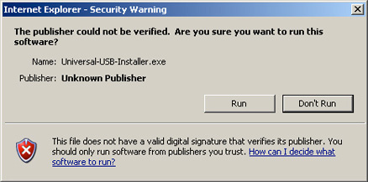
5. Read the licence agreement and choose 'I Agree' to continue
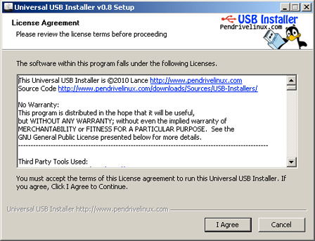
6. Select Ubuntu Desktop Edition from the dropdown list
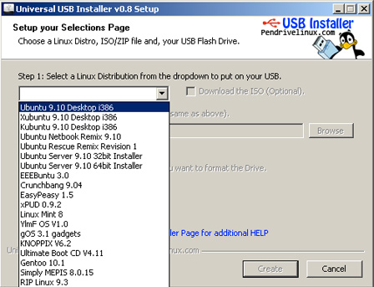
7. Click 'Browse' and open the downloaded ISO file
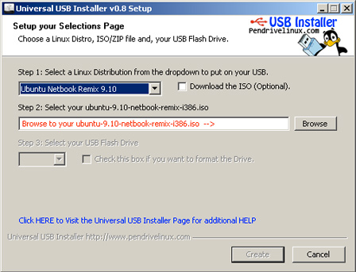
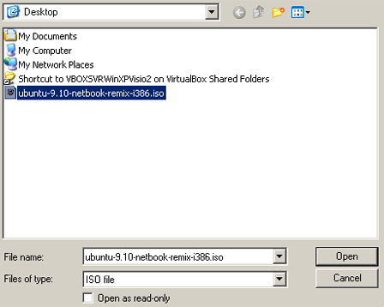

8. Choose the USB drive and click 'Create'
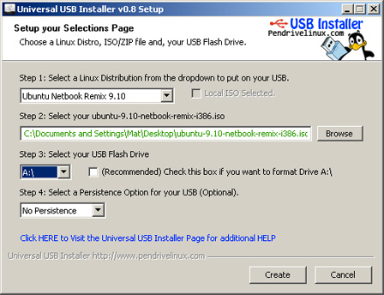

Create USB installer in Ubuntu
1. Insert a USB stick with at least 2GB of free space
2. In the main menu, go to System > Administration and open 'Startup Disk Creator'
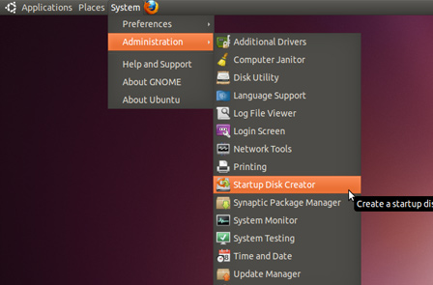
3. Click 'Other' to choose the downloaded ISO file
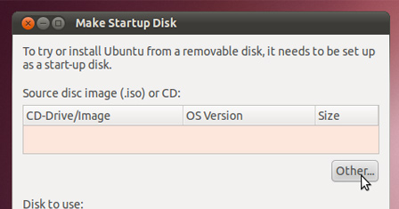

4. Select the file and click 'Open'
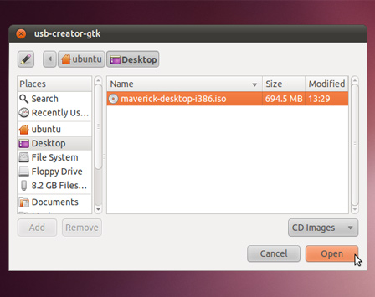

5. Select the USB stick in the bottom box and click 'Make Startup Disk'
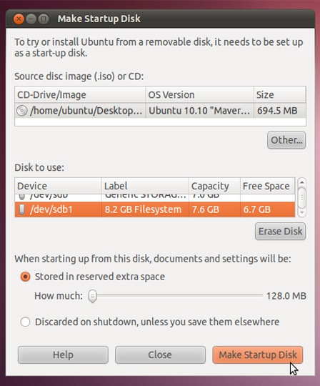
6. That's it! When the process completes, you'll be ready to restart your computer and begin installing Ubuntu.

