CENG4480 Embedded System Development and Applications
Computer Science and Engineering Department
The Chinese University of Hong Kong
Laboratory 6: Arduino Mainboard PCB Soldering
October, 2019
Introduction
In this lab session you will assembly the Arduino mainboard by soldering the components on to the PCB. The Arduino mainboard consists of power supply circuit which will provides sufficient power to 2 servo motors (for Lab 7, Lab 8 self-balancing platform) and 2 DC motors (for Lab 9, Lab10 self-balancing robot).
Objectives
- To practice the soldering technique
- To test circuit on PCB
Introduction
The schematic diagram of the Arduino mainboard circuit is shown on Figure 1:

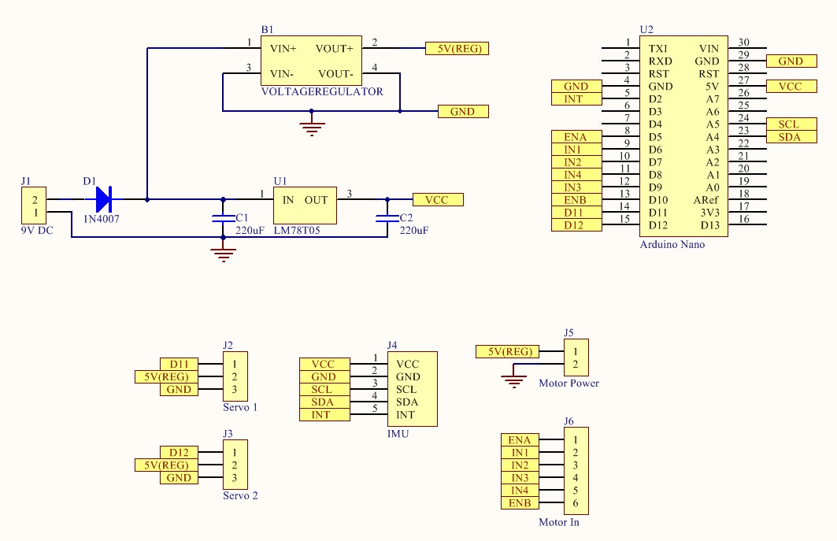
Figure 1. Schematic Diagram of Arduino Mainboard
The PCB layout is shown on Figure 2:

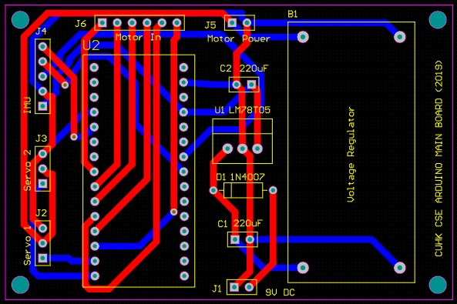

Figure 2. PCB Layout of Arduino Mainboard

The Arduino mainboard consists of an adjustable voltage regulator module which provides power supply (5V(REG)) for 2 servo motors and for 2 DC motors. A fixed 5V regulator 7805 provides stable voltage supply (VCC) for the Arduino Nano and the IMU.

Exercise 1. Solder all the components on to the PCB
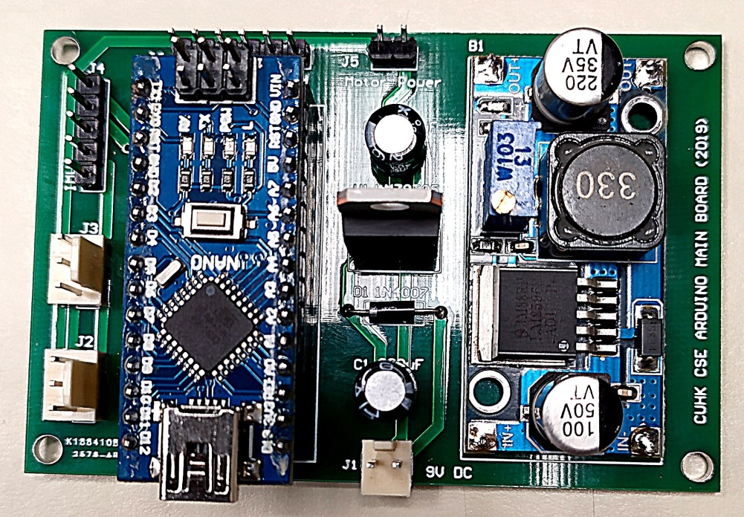
Figure 3. PCB with all components soldered
NOTICE:
- Be careful the polarity of the components
- Diode D1 1N4007
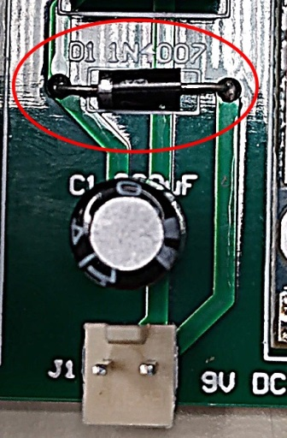

- Voltage regulator module
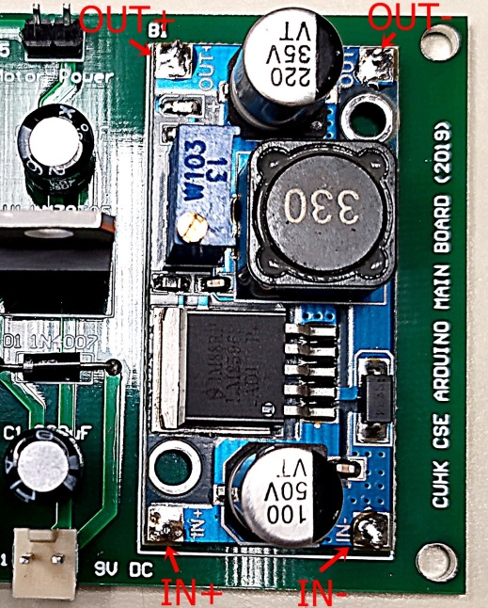

- Capacitors
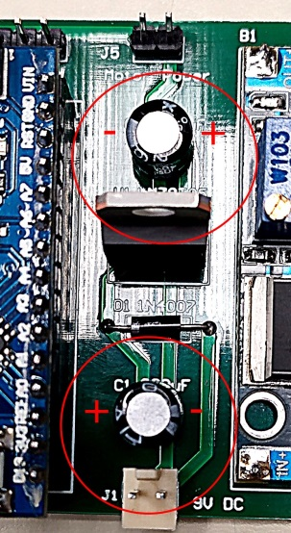
Exercise 2. Testing the circuit and adjust the output voltage of voltage regulator module (5V(REG))
- Connect the 9V power supply to the Arduino mainboard

- The green LED on the Arduno Nano will be ON

- Adjust the VR (Variable Resistor) on the voltage regulator module and measure its output to reach 5V

- Measure the voltage on J2 pin 2, J3 pin 2, J4 pin 1 and J5 pin 1.
Requirements:
- Take a photo for your PCB with all components soldered.
- Take some photos for your measured voltages on J2 pin 2, J3 pin 2, J4 pin 1 and J5 pin 1.
- All photos are submitted to blackboard before the deadline 7 Nov. (No report requirement).
END

