CENG4480 Embedded System Development and Applications
Computer Science and Engineering Department
The Chinese University of Hong Kong
Laboratory 5: Audio Recorder
October, 2019
Introduction
In this lab session you will construct an audio recorder which make up of (1) Microphone amplifier, (2) Arduino, (3) SD card module and (4) Speaker amplifier.
The recording steps of the signal are as follows:
- Capture the audio signal by a microphone.
- Amplify the signal by an operation amplifier (Op-am).
- Feed the amplified signal to the Analog-to-digital input (A0) of the Arduino microcontroller.
- The Arduino performs Analog to Digital conversion and then store the data in the SD card.
The playing steps of the signal are as follows:
- The Arduino read data from SD card and performs Digital to Analog conversion and feed the signal to speaker amplifier.
- The speaker amplifier filter out the high frequency noise and amplify the audio signal to drive the speaker.
Objectives
- To learn how to interface an analogue signal to digital systems
- To learn how to use SD card to store audio signals in an embedded system.
Introduction to hardware part
The following diagram shows the hardware system.

SD card module
SPI
ADC
Arduino ADC input and DAC output
Mic. Amp.

DAC
Speaker Amp.

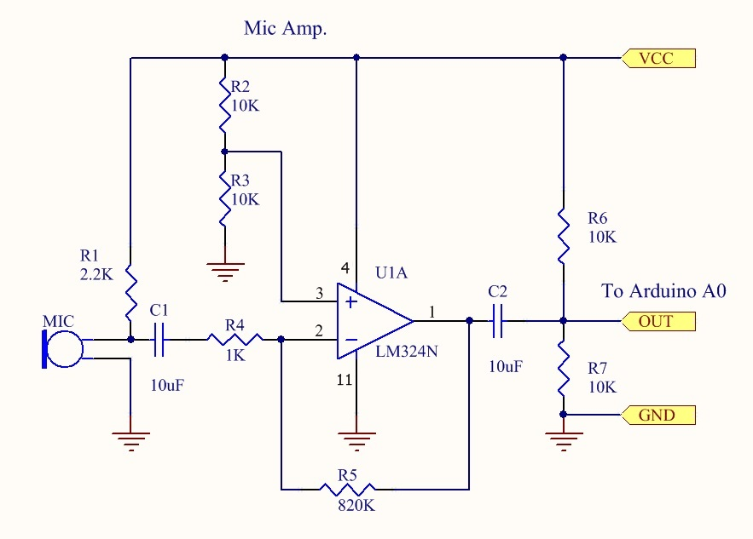

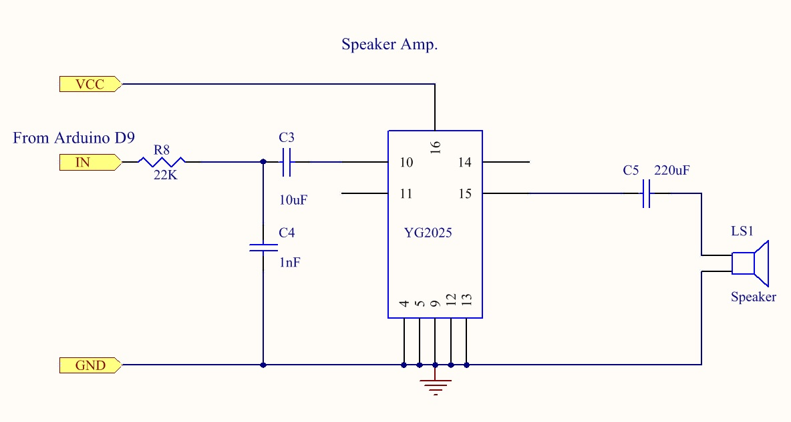

Figure 1. Mic amplifier and speaker amplifier

The audio signal input from the microphone is amplified by a Mic. Amp. Then the amplified signal (0 – 5V) is fed to the ADC input of the Arduino board (A0). The audio signal is then converted into digital data and saved in the SD card. In playing mode, the Arduino read data from SD card and convert to PWM analog signal and output to speaker amp. In the speaker amp a low pass filter remove the high frequency noise and amplify the audio signal to drive the speaker.

Introduction to software part
The given example program Lab5.ino
The example program is using the Arduino TMRpcm library to record and play the audio signal. For detail operation you can refer to the TMRpcm library wiki : https://github.com/TMRh20/TMRpcm/wiki

NOTICE:
- To use the TMRpcm library you have to install the library (TMRpcm-master.zip) on the Arduino IDE. (The TMRpcm library have been installed on all PCs in the lab.)
- You have to uncomment 2 lines, #define buffSize 128 and #define ENABLE_RECORDING inside the pcmConfig.h file. (This have been done on all PCs in the lab.)
Exercise 1. Construction of Microphone amp. and Speaker amp.
You will construct a microphone amplifier, speaker amplifier.
- On provided prototyping breadboard, connect the LM324N with other components by using MM dupont wires to construct microphone amplifier (refer to schematic diagram in Figure 1)

Connect the input channel of oscilloscope to the output of mic amp. (LM324 pin 1, as shown in Figure 3), you can see the amplified audio signal display on the screen (as shown in Figure 2).
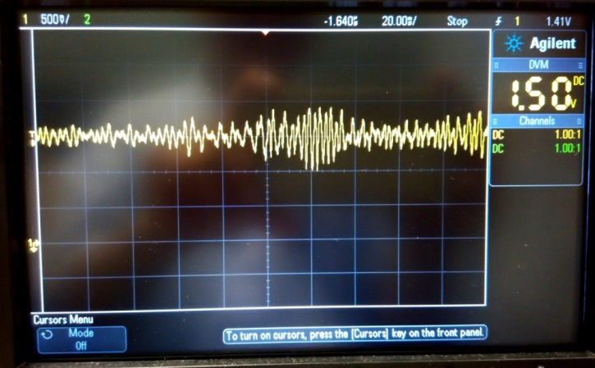
Figure 2. Amplified audio signal
- On provided prototyping breadboard, connect the YG2025 with other components by using MM dupont wires to construct speaker amplifier (refer to schematic diagram in Figure 1)

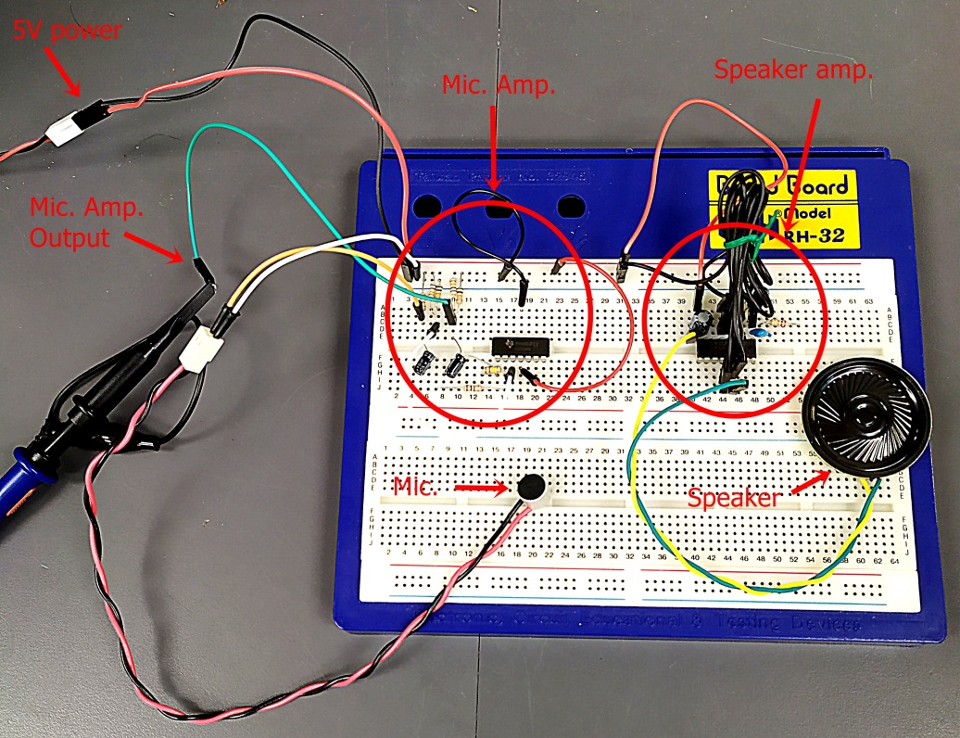
Figure 3. Mic amplifier and speaker amplifier

Exercise 2. Complete the audio recorder
You will build the audio recorder by connecting the Arduino, SD card module, mic. Amp., speaker amp.
- Connect CS, SCK, MOSI, MISO, VCC and GND on SD card module to Arduino pins 4, 13, 11, 12, 5V and GND as shown in following picture.

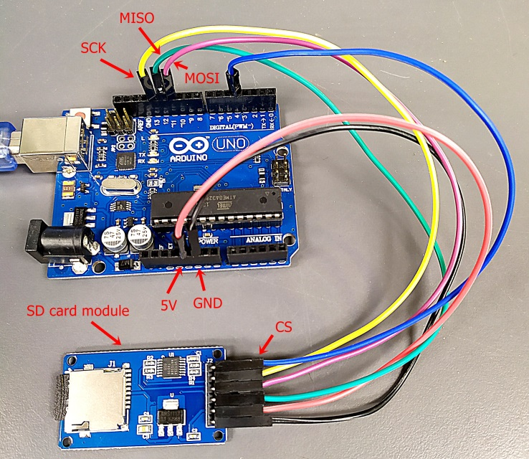
Figure 4. SD card module connection

- Connect the mic amp. and speaker amp. to Arduino. (Mic. amp. Out -> Arduino pin A0, speaker amp. IN -> Arduino pin 9, GND to Arduino GND).

- Connect the USB cable of Arduino to PC. Download the given Lab5.ino program to Arduino.

- Turn on the 5V power of your circuit. Open RealTerm terminal program and configure the Baudrate(115200) and Port number. Reset the Arduino, you should see the SD OK message (as shown in Figure 5.).

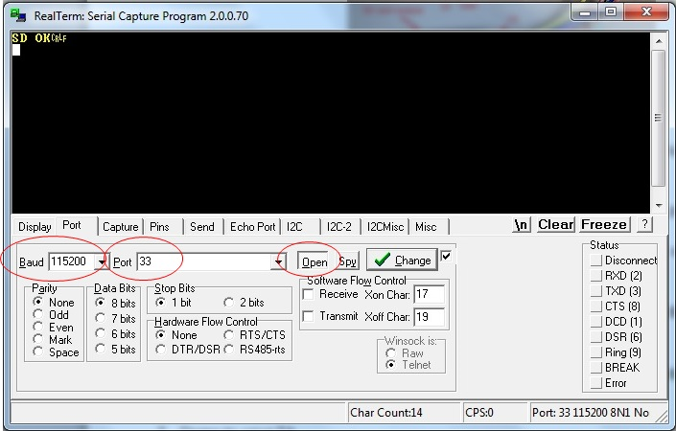
Figure 5. Configure Baud rate and Port number
- Start to record some voice by sending “r” on RealTerm and stop recording by sending “s” on RealTerm.

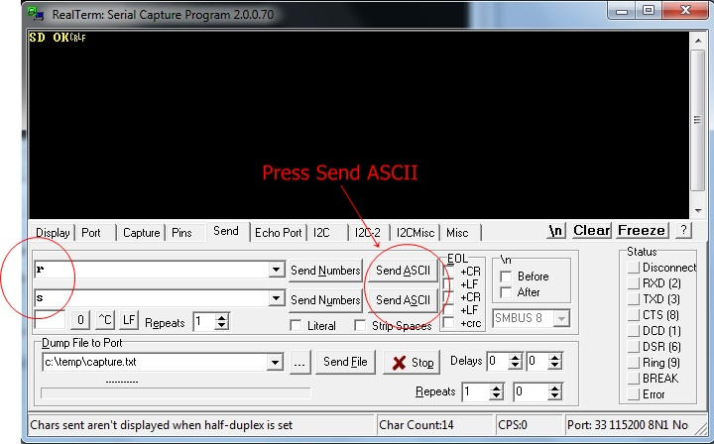

Figure 6. Send “r” to record and “s” to stop

- Play the recorded voice by sending “p” on RealTerm. You should heard the voice on the speaker. To stop playing send “S” ( in uppercase).

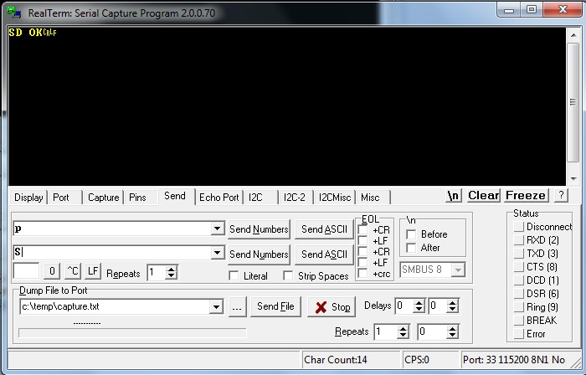

- Record a demo, and answer the questions on the Lab 5 Questions page. You are required to submit both demo and answers to blackboard before deadline (11.59 pm of Oct, 31).
END
Lab 5 Questions
Q1. What type is the op. amp. circuit used in the mic. amplifier ?

Q2. The resisters R2 and R3 in mic. amp. provide a bias voltage on pin 3 of the op. amp. Given VCC = 5V what is this bias voltage value? (Hints: you can obtain the bias voltage value by measurement or by calculation).

Appendix
Lab5.ino
#include <SD.h>
#include <SPI.h>
#include <TMRpcm.h>

//#define SD_ChipSelectPin 53 //example uses hardware SS pin 53 on Mega2560
#define SD_ChipSelectPin 4 //using digital pin 4 on arduino nano 328, can use other pins

TMRpcm audio; // create an object for use in this sketch

void setup() {

// audio.speakerPin = 11; //5,6,11 or 46 on Mega, 9 on Uno, Nano, etc
// pinMode(12,OUTPUT); //Pin pairs: 9,10 Mega: 5-2,6-7,11-12,46-45

audio.speakerPin = 9; //5,6,11 or 46 on Mega, 9 on Uno, Nano, etc
pinMode(10,OUTPUT); //Pin pairs: 9,10 Mega: 5-2,6-7,11-12,46-45

Serial.begin(115200);

if (!SD.begin(SD_ChipSelectPin)) {
return;
}else{
Serial.println("SD OK");
}
// The audio library needs to know which CS pin to use for recording
audio.CSPin = SD_ChipSelectPin;
}

void loop() {

if(Serial.available()){ //Send commands over serial to play
switch(Serial.read()){
case 'r': audio.startRecording("test.wav",16000,A0); break; //Record at 16khz sample rate on pin A0
case 'R': audio.startRecording("test.wav",16000,A0,1); break; //Record, but with passthrough to speaker.
case 't': audio.startRecording("test.wav",16000,A0,2); break; //Do not record. Output direct to speaker
//Note: If samples are dropped before writing, it
// will not be heard in passthrough mode
case 's': audio.stopRecording("test.wav"); break; //Stop recording
case 'p': audio.play("test.wav"); break; //Play the recording
case '=': audio.volume(1); break; //Increase volume by 1. Does not affect recording
case '-': audio.volume(0); break; //Decrease volume by 1. Does not affect recording
case 'S': audio.stopPlayback(); break; //Stop all playback

}
}
}

