CENG4480 Embedded System Development and Applications
Computer Science and Engineering Department
The Chinese University of Hong Kong
Laboratory 8: Self-balancing Robot (1) (hardware)
November, 2017
Introduction
In this lab and the next lab you will build a self-balancing robot by applying knowledge you have studied in previous lectures and labs. You should complete all the hardware knowledges work and test the hardware is working correctly during this Lab 8. The self-balancing robot you are going to build is the same as the one shown in Figure 1.

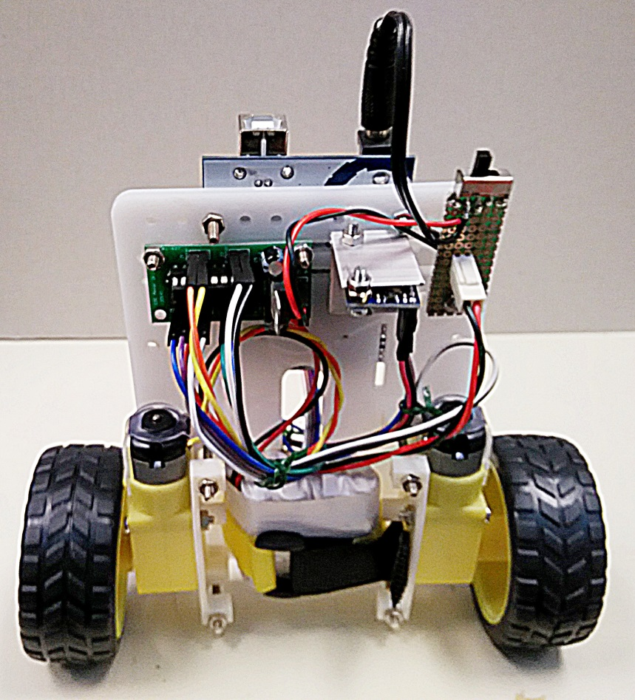
Figure 1. CENG4480 self-balancing robot

Objectives
- To learn how to build an embedded system
- To familiar with the practical work in engineering

The following components will be provided:
1. a plastic base
2. two motors with mounting
3. two wheels
4. an IMU module
5. an Arduino board
6. a piece of prototype board
7. a switch
8. a battery pack

Procedures
- Assembly the power switch board
- On the provided prototype board solder the switch and header as shown in the sample board.

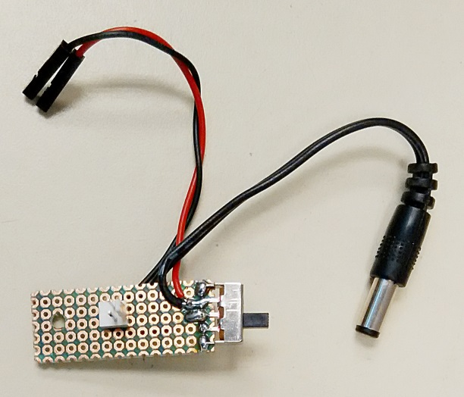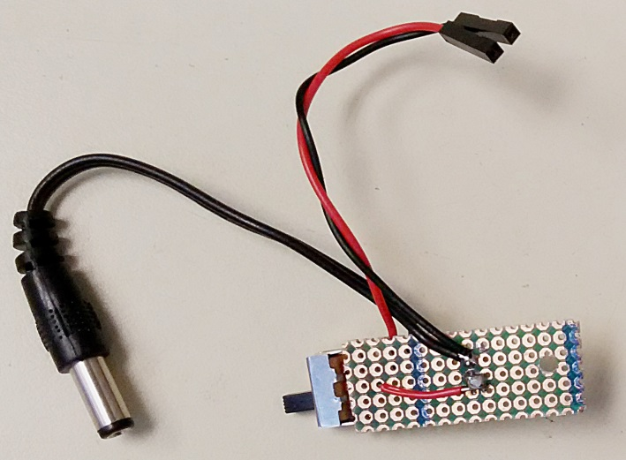

Figure 3. Power switch board
- Assembly all the components on the plastic base
- Be careful all the wires connections. Any wrong connection may causes damage on the components

- Testing the robot
- Use provide Lab8.ino program to test the robot
- The robot should move in the same direction of its skew direction
- If the direction of the wheel is not correct you can just exchange the connections of motor wires
- If you have difficulty in trouble shooting your robot please don’t hesitate to ask our technician for help

- Demo your robot to TAs

END

