CENG4480 Embedded System Development and Applications
Computer Science and Engineering Department
The Chinese University of Hong Kong
Laboratory 7: Motors Control
November, 2017
Introduction
In this exercise you will learn how to implement motors control by using Arduino microcontroller. This technique will be used in the coming two labs Lab 8 and Lab 9.
Figure 1. Block Diagram of Motors Control
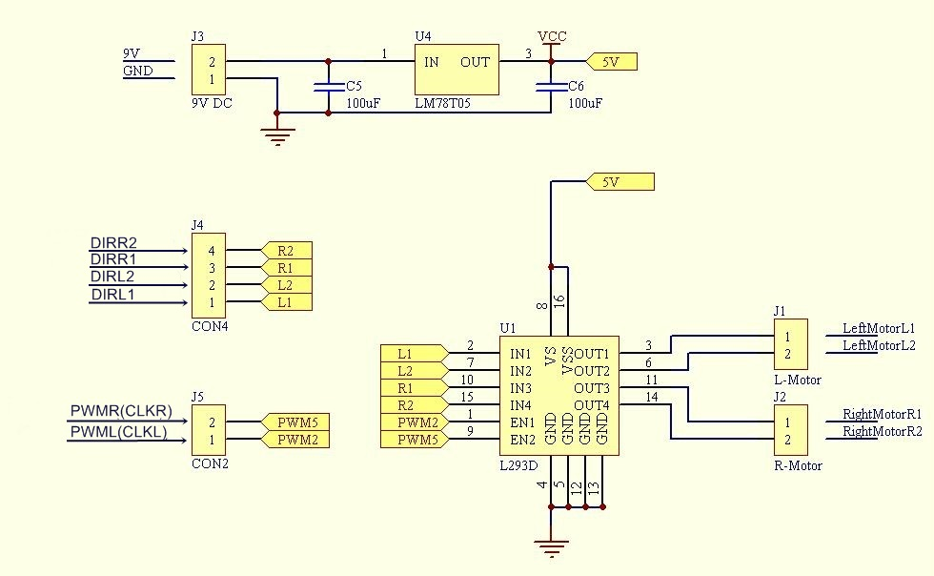
Figure 2. Schematic Diagram of L293D Board
Objectives
- To learn how to use motor driver L293D
- To learn how to use PWM to control motor speed
- To learn how to implement motor speed control by using Arduino microcontroller

Procedures
- Connect the IMU module to Arduino board
- Use dupont wires connect the VCC, GND, SDA, SDC of the IMU module to Arduino board as shown on Figure 3. (refer to sample)

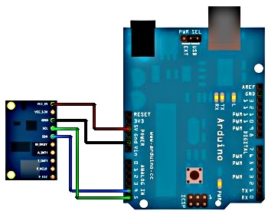

Figure 3. Connection of IMU module

- Attach the IMU module on the platform
- Attach the IMU module on the platform by using plastic tape.
- Make sure it can rotate freely along the x axis.

- Connect the L293D driver to Arduino board
- Use male to female dupont wires connect PWML, PWMR, DIRL1, DIRL2, DIRR1, DIRR2, Vin and GND of L293D driver board to Arduino as shown in Figure 1. (refer to sample)

- Connect motor to L293D driver board
- Connect the two wire of motor to L293D driver board J1-1 and J1-2.

- Connect oscilloscope inputs to L293D driver board
- Connect Channel 1 input of oscilloscope to L293D driver board J2-1
- Connect Channel 2 input of oscilloscope to L293D driver board J2-2

- Connect USB cable from PC to Arduino board

- Connect power adapter to Arduino board

- The whole setup of the experiment is as shown in Figure 4.
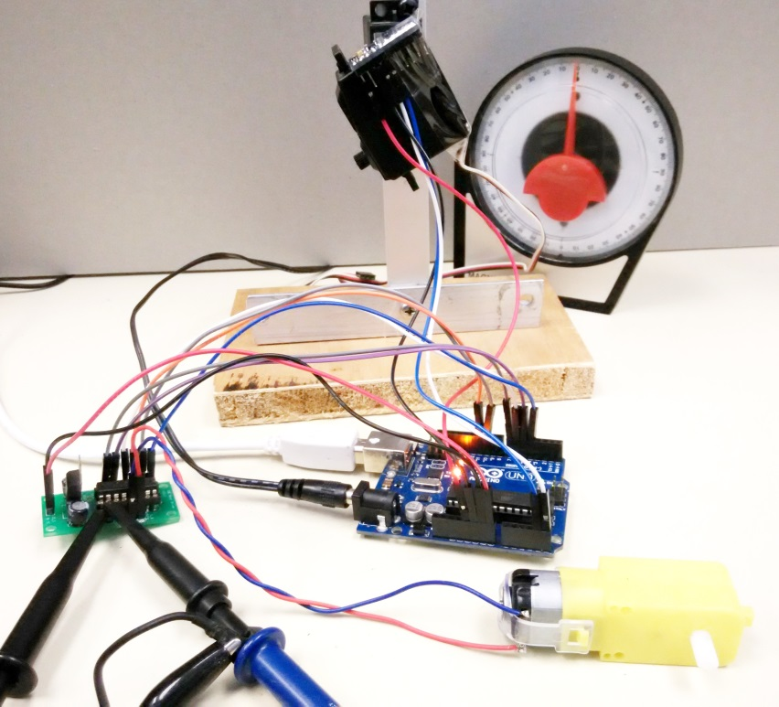
Figure 4. Experiment setup for Lab 7

- Upload the program Lab7.ino to Arduino board
- Double click Lab7.ino
- Observe the COM port number from Device Manager
- On the Arduino IDE Tools, Serial Port select the correct port number
- On the Arduino IDE Tools, Board select the Arduino Uno
- On the Arduino IDE press the Upload button
- Wait for the uploading program finish

- Calibrate the 0 degree of the platform
- Rotate the platform to the 0 degree position (horizontal)
- On the Arduino IDE Tools, select Serial Monitor, you should see the following window
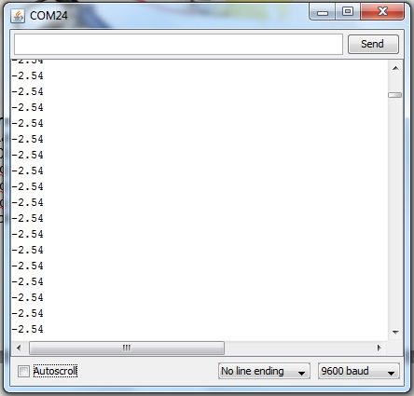

- Use the number displayed on the COM window as the offset value (in this example = -2.54) and change the offset value in the program to this value (for example: #define offset -2.54)
- Upload the program to the Arduino board again
- You should see the value displayed on the COM window is now close to zero

- Rotate the platform to -40 degrees, record the waveform on the oscilloscope screen and measure the duty cycle of the waveform. What is the direction and speed of motor?

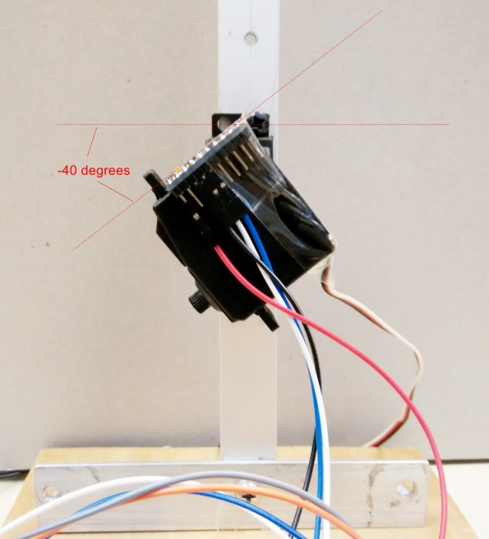
- Repeat step 9 for -30, -20, -10, 0, +10, +20, +30 and +40 degrees. Fill in the following table.

Platform Angle  (Degree) | Picture of waveform on oscilloscope | PWM Duty cycle | Direction  (+ or -) | Speed
-40 | 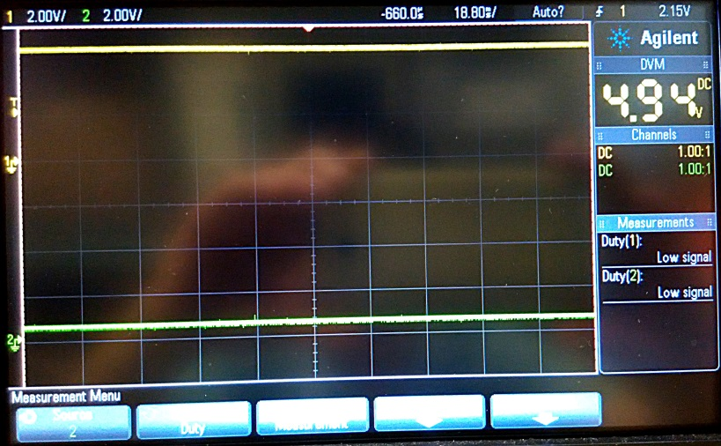 | 100% | + | ++++
-30
-20
-10
0
+10
+20
+30
+40

END

