CENG4480 Embedded System Development and Applications
Computer Science and Engineering Department
The Chinese University of Hong Kong
Laboratory 6: IMU (Inertial Measurement Unit)
November, 2017
Introduction
In this exercise you will learn how to use IMU to measure the angle of an object and how to interface and read the IMU data via I2C channel by using Arduino controller board. In this exercise, we use a low cost IMU GY-801 module (see Figure 1) which based on MEMS (Micro Electro-Mechanical System) technology. GY-801 IMU module consists of 3-axis accelerometer ADXL345, 3-axis gyro L3G4200D, 3-axis compass HMC5883L and barometer BMP180. The Lab 4 platform is used to collect measurements from the accelerometers and gyros (see Figure 2).

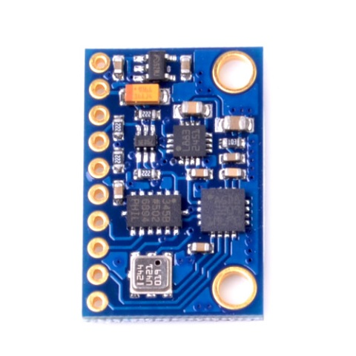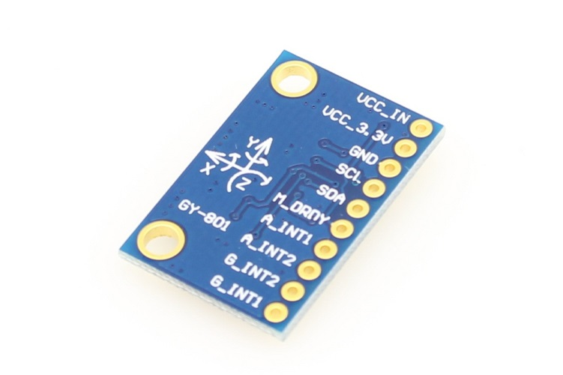

Figure 1. GY-801 IMU module
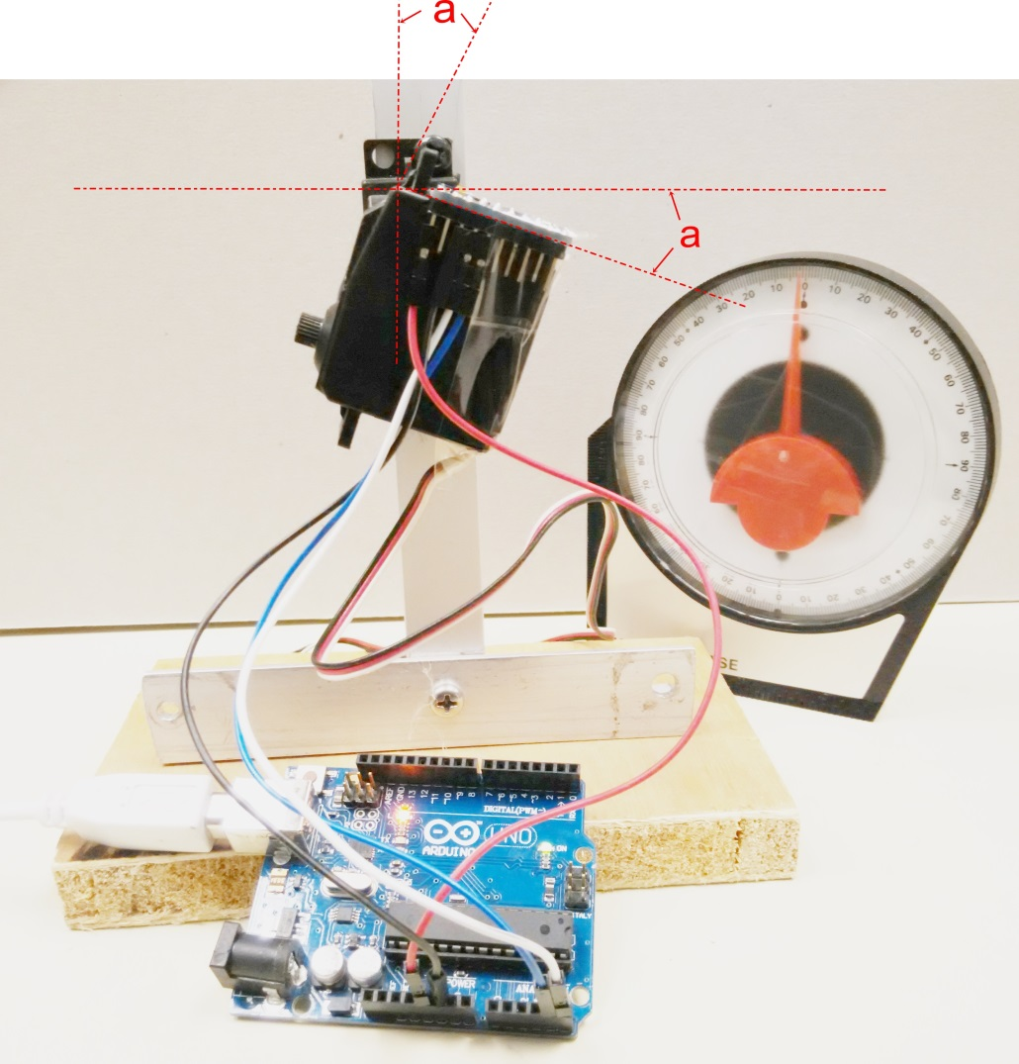
Figure 2. Experiment setup
Objectives
- To learn how to interface IMU module to Arduino microcontroller via I2C
- To learn how to use IMU to measure the angle of an object
- To study the improvement of data stability by using Complement and Kalman filters

Procedures
- Connect the IMU module to Arduino board
- Use dupont wires connect the VCC, GND, SDA, SDC of the IMU module to Arduino board as shown on Figure 3. (refer to sample)

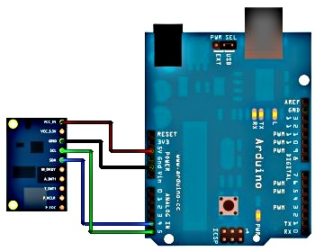

Figure 3. Connection of IMU module

- Attach the IMU module on the platform
- Attach the IMU module on the platform by using plastic tape.
- Make sure it can rotate freely along the x axis.

- Upload the program Lab6.ino to Arduino board
- Double click Lab6.ino
- Connect the USB cable from PC to Arduino board
- Observe the COM port number from Device Manager
- On the Arduino IDE Tools, Serial Port select the correct port number
- On the Arduino IDE Tools, Board select the Arduino Uno
- On the Arduino IDE press the Upload button
- Wait for the uploading program finish
- On the Arduino IDE Tools, select Serial Monitor, you should see the following window
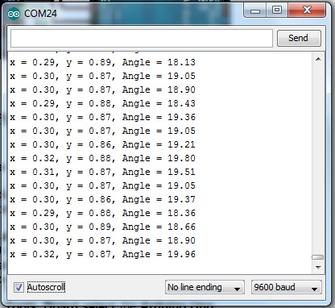
- X is the accelerometer value on x-axis, y is the accelerometer value on y-axis the angle a can be calculated from arctangent of x,y

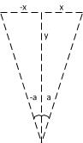

- In Arduino there is an atan2(y,x) function, the angle value shown in the window is the result of atan2(y,x) function

- Record and fill the table for the platform in the different angle

Platform Angle  (Degree) | -50 | -40 | -30 | -20 | -10 | 0 | 10 | 20 | 30 | 40 | 50
X
Y
Angle=atan2(y,x)
(Degree)

Question 1. Find the approximate offset angle of IMU from your results. (The offset of IMU is different from module to module)

- Study the improvement of data stability by using Complement and Kalman filters
Complement and Kalman filters are commonly used in sensor fusion application. Sensor fusion is a set of adaptive algorithms for prediction and filtering. It takes advantage of different and complementary information coming from various sensors, combining it together in a smart way to optimize the performance of the system and enable new amazing applications [1].

For further details in theory of Complement and Kalman filter application in sensor fusion, you can refer to document in reference [1].

Procedures of experiment:
- In Lab5.ino change the code as following:

void loop()
{
float LRspeed;

static unsigned long newMilli; //new timestamp

newMilli = millis(); //save the time when sample is taken
Read_acc();
Read_gyro();
//compute interval since last sampling time in millisecond
interval = newMilli - lastMilli;
lastMilli = newMilli; //save for next loop, please note interval will be invalid in first sample but we don't use it

Ayz=atan2(RwAcc[1],RwAcc[2])*180/PI; //angle measured by accelerometer
Ayz-=offset; //adjust to correct balance point

//delay(500);
//Serial.print("x = ");
//Serial.print(RwAcc[1]); // x-axis accelerometer value
//Serial.print(", y = ");
//Serial.print(RwAcc[2]); // y-axis accelerometer value
//Serial.print(", Angle = ");
Serial.print(Ayz);

Serial.print(", ");
Angy = 0.98*(Angy+GyroIN[0]*interval/1000)+0.02*Ayz;//complement filter
kang = kalmanCalculate(Angy, GyroIN[0],interval); //kalman filter
kang+=0.65; //adjust the offset
Serial.print(kang);

Serial.println(" ");
////////////////////////////

}

- Upload the program to the Arduino board by pressing the Upload button
- Place the platform in horizontal position
- On the Arduino IDE Tools, select Serial Monitor, you should see the following window
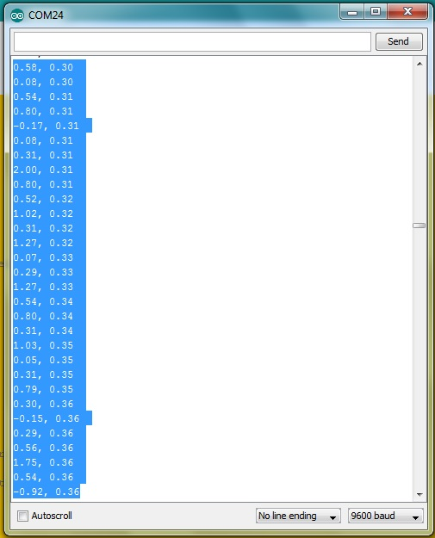
- Wait around one minute to let the data stable
- Uncheck the Autoscroll box to stop the display from scrolling
- Copy 30 lines of data by pressing CTRL C on the keyboard
- Open Microsoft Excel and then paste the 30 lines data on the Excel table
- Press Data, Text to Columns and press Next
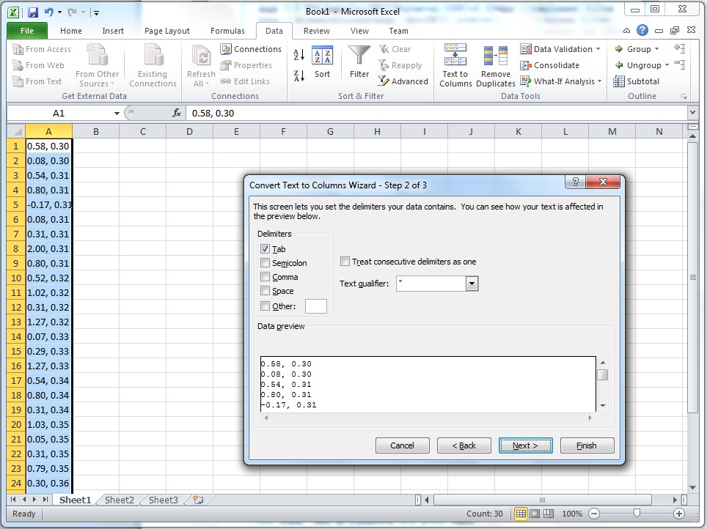

- Check the Comma check box then press Next and Finish
- Select all data in both A, B columns and press Insert, Line

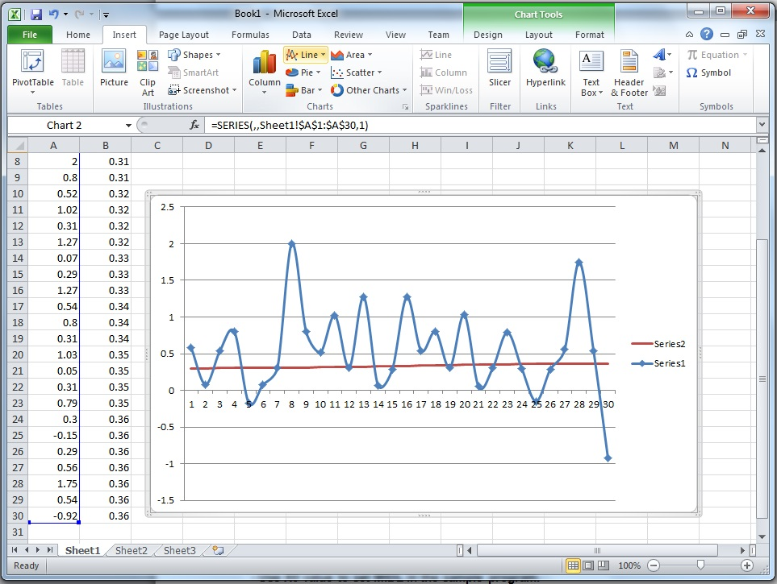
- In your report, explain the effect of applying Complement and Kalman filters on the IMU angle data

END
Refrences:
[1] http://www.mouser.hk/newproducts/applications.aspx?virtualdir=sensor_solutions_mems%2f
[2] http://digitalcommons.calpoly.edu/cgi/viewcontent.cgi?article=1114&context=aerosp
[3] http://www.instructables.com/id/Guide-to-gyro-and-accelerometer-with-Arduino-inclu/
[4] http://ozzmaker.com/2015/01/27/guide-interfacing-gyro-accelerometer-raspberry-pi-kalman-filter/

