CENG4480 Embedded System Development and Applications
Computer Science and Engineering Department
The Chinese University of Hong Kong
Laboratory 5: A self-balancing platform
October, 2017
Introduction
In this exercise you will learn how to develop a self-balancing platform and use the accelerometer as a 2-axis tilt sensor. The theory is described in [1]. The procedures of the development are as follows:
- Connect a 2 channels DC amplifier board which is for signal conditioning of the 2-axis accelerometer inputs to the ARM board.
- Implement a PID controller on the ARM board.
- Fine tune the PID controller constants to reach its optimal state.
- Construct a self-balancing platform by assembling the accelerometer, ARM board and the servos mechanism together.
The following is the block diagram of the self-balancing platform and the 2 channels DC amplifier circuit diagram. A demo video can be found at [2].
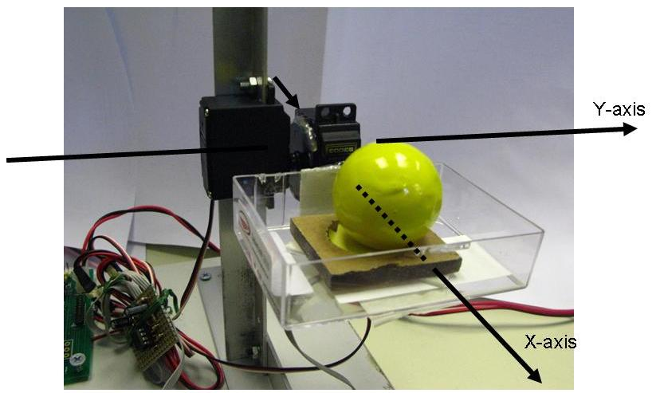
Fig. 1a. The experimental setup: the self-balancing platform holding a ball can be rotated in 2 axes
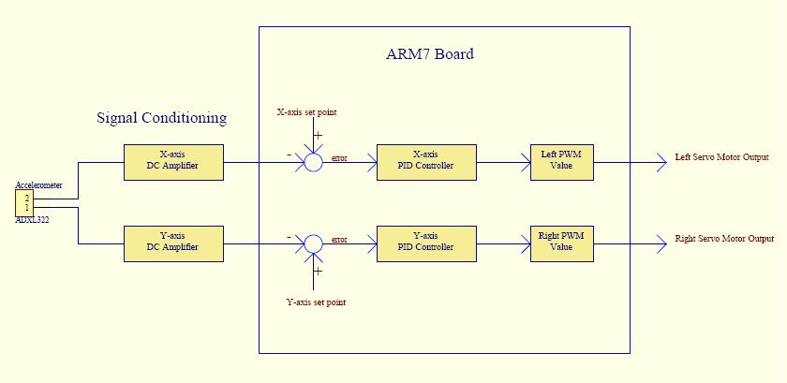
Fig. 1b.Block Diagram of the Self-balancing platform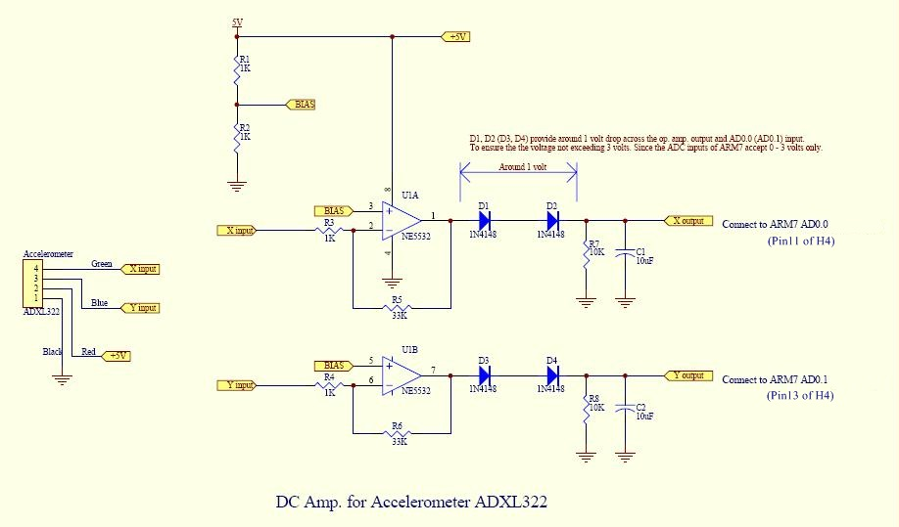
Fig. 2 Two channels DC amplifier circuit
Objectives
- To lean how to interface a direct current (DC) output sensor to a microcontroller
- To learn how to implement a Proportional–Integral–Derivative PID feed back control system.

Procedures and what to submit:
Follow the procedures of each experiment. Submit a lab report sheet with your name and student ID to the tutor after the lab. The lab report sheet should have the measurements or plots of your experiments, and answers of the questions asked in this lab manual. You may prepare the report using a computer document and use a camera to capture the waveforms and insert them in your report.
Experimental procedures
- Connecting two channels DC amplifier circuit
- The circuit diagram of the two-channel DC amplifier is as shown in Fig. 2.
- Connect the accelerometer to the amplifier inputs and connect the amplifier outputs to the ARM board as shown in the figures below. (refer to the sample)
- Attach the accelerometer to the provided platform.
- Connect two servo motors of the platform to the ARM board as shown in the figures below. (refer to the sample)
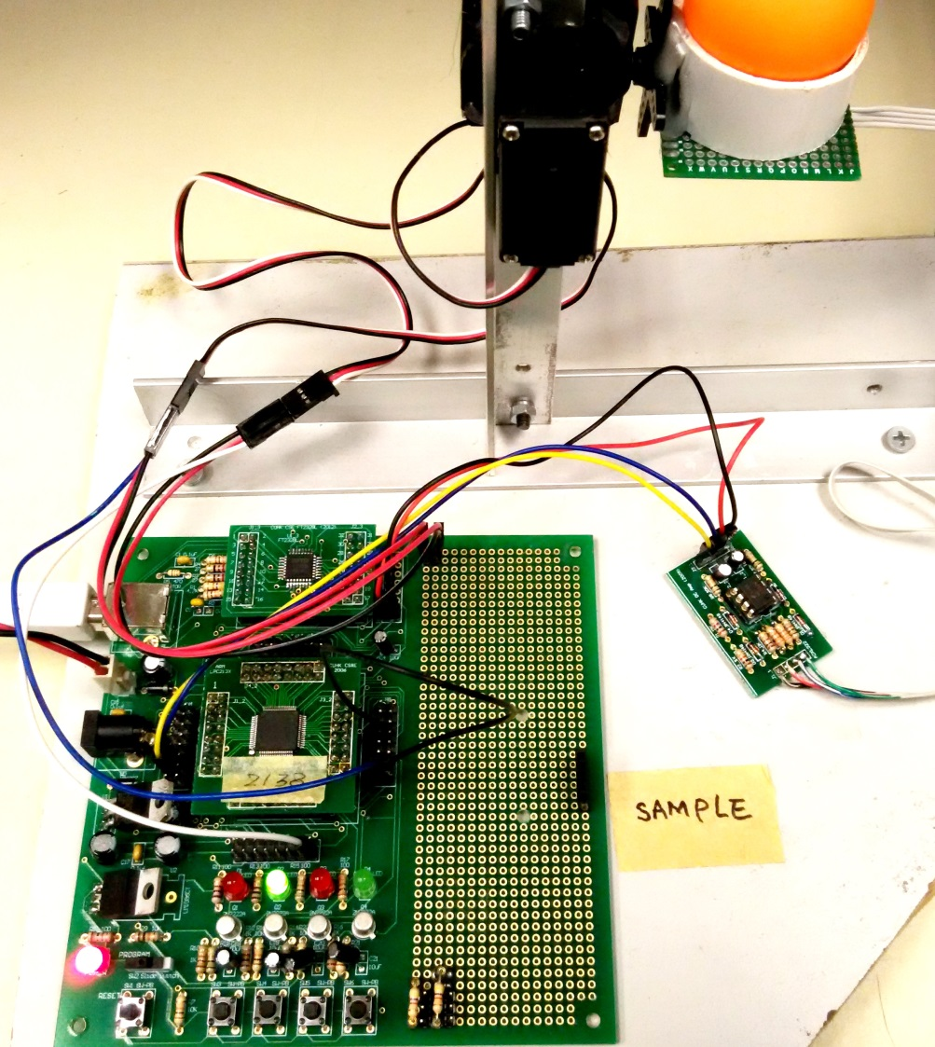
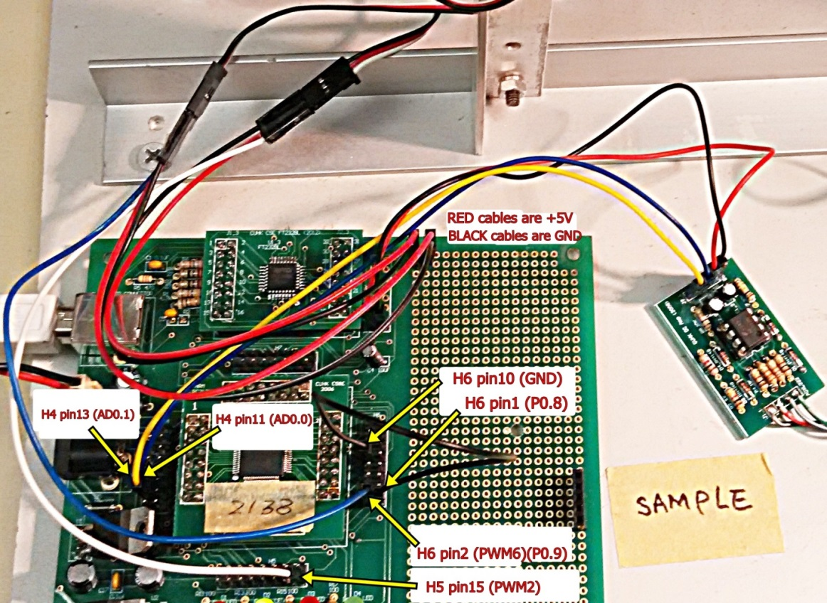
For new accelerometer GY-61, connect VCC to 3.3V (H6 Pin11) as shown on the figure below:
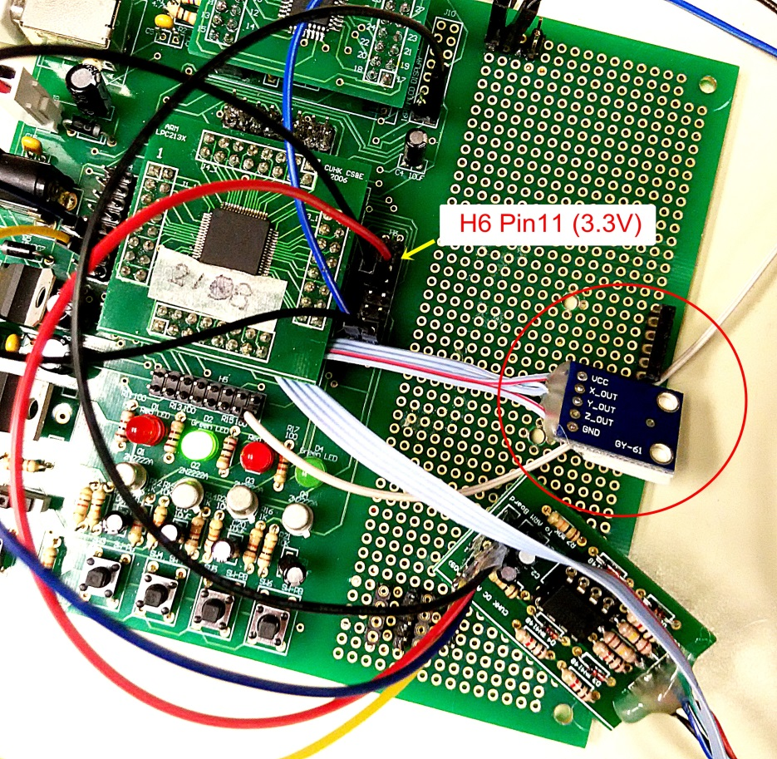

- Measure and record the amplifier output vs the tilt angle, and plot the graph
After finishing procedure 1,
- Connect the power supply and USB cable to the ARM board.
- Download the sample program
- Connect H6 pin1 and H6 pin10 (connect p0.8 to GND).
- Open the Hyper terminal (57600 baud rate).
- Reset the ARM board to run the sample program.
- Manually adjust the platform to the horizontal position.
- Measure the Xoutput (H4 pin13) of the amplifier, record the voltage value (Hints: use digital volt meter DVM function on the oscilloscope to measure the output voltage is more accurate and convenient)
- Press any key and record the ADC reading of Xaxis on the Hyper Terminal.
- Measure the tilt angle of the platform along the x-axis (refer to Fig.3) and record the angle. Change the tilt angle and repeat the measurement.

- In your lab report:
  - Fill in the following table and plot the graph.

y-axis  x-axis | 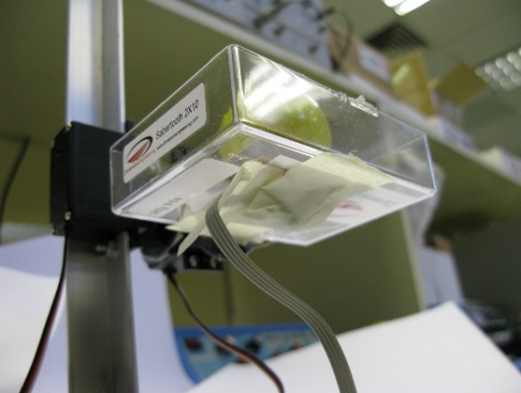
Fig. 3 (a) Top View of the Accelerometer , (b) the sensor attached to the bottom of the platform

X-Tilt Angle  (Degree) | -50 | -40 | -30 | -20 | -10 | 0 | 10 | 20 | 30 | 40 | 50
X-axis Output
(Volts)
X-axis ADC reading

2.5
2.0

Output Voltage (Volts)
1.5
1.0
0.5
0.0
60
50
40
30
20
10
0
-10
-20
-40
-50
-30

Tilt Angle (Degree)

- Question1: Is the output voltage changes linearly with the tilt angle?

- Determine and set the reference point of X-axis and Y-axis
From the measurement results of procedure 2, obtained the X-axis ADC reading (X0) when the tilt angle of the X-axis of the platform is 0 degree. This value (X0) is used for the X-axis set point value of the PID controller (see Fig.1 Block diagram).

- Use X0 value to set MIDL in the sample program.

For example, if X0 = 6830 then define the MIDL in the sample program as follow:
#define MIDL 6830 // The set point value of accelerometer X-axis

if X0 = 6750 then define the MIDL in the sample program as follow:
#define MIDL 6750 // The set point value of accelerometer X-axis

- Repeat the measurement for Y0 of the Y-axis and set the MIDR in the sample program.
- Compile the sample program, download and run the program
- Disconnect the jumper between H6 pin1 and H6 pin 10.
- Run the sample program and test the performance.

- The effect of sampling frequency
The sampling frequency of the sample program is originally set to 500Hz.

- Reduce the sampling frequency to 100Hz by changing the value of TMR0 to 138240 in sample program and recompile it. Then download and run it again.

void init_timer (void) {
T0PR = 0; // set prescaler to 0
T0MR0 =138240; // set interrupt interval to 1mS
// Pclk/500Hz = (11059200 x 5)/(4 x 100)
T0MCR = 3; // Interrupt and Reset on MR0
T0TCR = 1; // Timer0 Enable
VICVectAddr0 = (unsigned long)IRQ_Exception; // set interrupt vector in 0
VICVectCntl0 = 0x20 | 4; // use it for Timer 0 Interrupt
VICIntEnable = 0x00000010; // Enable Timer0 Interrupt
}

Question 2. What is the effect on the performance of the system when the sampling frequency is 100Hz?
- Increase the sampling frequency to 1000Hz by changing the value of TMR0 to 13824 in the sample program and recompile it. Then download and run it again.

Question 3. What is the effect on the performance of the system when the sampling frequency is 1000Hz? Explain your observation.
- Overall tuning of the P, I D constants of the system.

Question 4. The deadband in sensor reading is +/-200. Estimate the deadband in degrees of our system. See [1] for the definition of deadband

Questions 5. You are required to move the platform without dropping the ball from -60 to 60 degrees against the X-axis as fast as you can. Tune the parameters P, I and D constants in the program so you can achieve the maximum of turns (oscillating the platform between -60 degrees to 60 degrees in the X-axis) in 30 seconds. Record the values of P,I and D used and demonstrate your results to the tutor.

END
Refrences:
[1] http://www.cse.cuhk.edu.hk/~byu/CENG4480/slides/L07-PID.pdf
[2] Youtube: A self balancing platform demo http://www.youtube.com/watch?v=Lym2UxUh81Q

