CENG4480 Embedded System Development and Applications
Computer Science and Engineering Department
The Chinese University of Hong Kong
Laboratory 1: Op Amp (I)
September, 2017
Introduction
This lab session introduces some very basic concepts of operational amplifier “op amp” that every engineering student should know about. The op amp IC used in this lab is LM324. LM324 contains 4 op amps, we only use one of them.
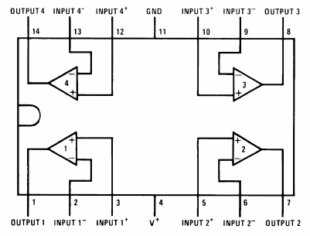
Figure 1. Pinout for the LM324.
Objectives
By completing this lab session, you should know:
1. how to use op amp circuits to interface between sensors and MCU;
2. how to design amplifier circuit using op amp and
3. how to design integrator and differentiator circuit using an op amp.
Procedures:
Follow the procedures of each experiment. Write your result in a report sheet with your name and student ID. Submit the report sheet to the tutor after the lab.
Experiment 1. Inverting Amplifier
In this experiment, you will construct and observe the inverting amplifier. Record the input and output waveforms.
The following apparatus will be provided:
1. a power supply
2. an oscilloscope
3. a breadboard
4. resistors: 2 x 1 KΩ, 1 x 2 KΩ
5. one LM324 IC

Procedures:
- Use pinout diagram for LM324 op amp IC shown in Figure 1 to construct the inverting amplifier circuit as shown in Figure 2.

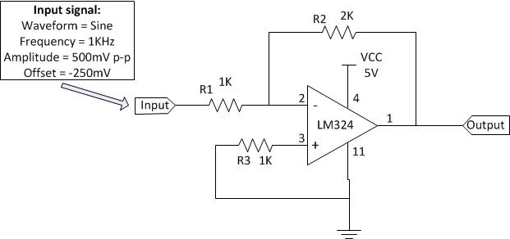
Figure 2. Inverting amplifier

- Configure the waveform generator on the oscilloscope with following settings:
Waveform = Sine
Frequency = 1KHz
Amplitude = 500mV p-p
Offset = -250mV

- Connect the waveform generator output to the input of inverting amplifier.

- Connect channel 1 input (X) of the oscilloscope to the output of inverting amplifier and connect channel 2 (Y) input of the oscilloscope to the input of inverting amplifier.

- Record the input and output waveforms displayed on the oscilloscope.

- In your lab report, give your derivation and compare the calculated with measured output voltages. Why is this called an inverting amp?
Answer:

Experiment 2. Non-inverting Amplifier
In this experiment, you will construct and observe the non-inverting amplifier. Record the input and output waveforms.
The following apparatus will be provided:
1. a power supply
2. an oscilloscope
3. a breadboard
4. resistors: 1 x 1 KΩ, 1 x 2 KΩ
5. one LM324 IC

Procedures:
- Use pinout diagram for LM324 op amp IC shown in Figure 1 to construct the non-inverting amplifier circuit as shown in Figure 3.

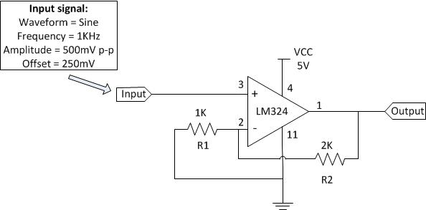
Figure 3. Non-inverting amplifier

- Configure the waveform generator on the oscilloscope with following settings:
Waveform = Sine
Frequency = 1KHz
Amplitude = 500mV p-p
Offset = 250mV

- Connect the waveform generator output to the input of non-inverting amplifier.

- Connect channel 1 input (X) of the oscilloscope to the output of non-inverting amplifier and connect channel 2 (Y) input of the oscilloscope to the input of non-inverting amplifier.

- Record the input and output waveforms displayed on the oscilloscope.

- In your lab report, give your derivation and compare the calculated with measured output voltages. Verify the gain relation of the non-inverting amplifier.

$$\frac{Vo}{Vin}≈1+\frac{R2}{R1}$$
Answer:

Experiment 3. Differential Amplifier
In this experiment, you will construct and observe the differential amplifier. Record the input and output waveforms.
The following apparatus will be provided:
1. a power supply
2. an oscilloscope
3. a breadboard
4. resistors: 2 x 1 KΩ, 2 x 2 KΩ
5. one LM324 IC

Procedures:
- Use pinout diagram for LM324 op amp IC shown in Figure 1 to construct the differential amplifier circuit as shown in Figure 4.

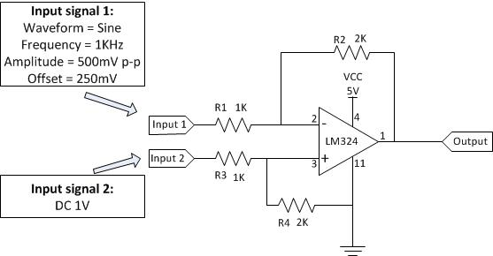
Figure 4. Differential amplifier

- Configure the waveform generator on the oscilloscope with following settings:
Waveform = Sine
Frequency = 1KHz
Amplitude = 500mV p-p
Offset = 250mV

- Connect the waveform generator output to the input 1 of differential amplifier.

- Connect 1 V dc from power supply to the input 2 of differential amplifier.

- Connect channel 1 input (X) of the oscilloscope to the output of differential amplifier and connect channel 2 (Y) input of the oscilloscope to the input 1 of differential amplifier.

- Record the input and output waveforms displayed on the oscilloscope.

- In your lab report, give your derivation and compare the calculated with measured output voltages.
Answer:

Experiment 4. Voltage follower
In this experiment, you will construct and observe the voltage follower. Record the input and output waveforms.
The following apparatus will be provided:
1. a power supply
2. an oscilloscope
3. a breadboard
4. resistors: 1 x 2 KΩ
5. one LM324 IC

Procedures:
- Use pinout diagram for LM324 op amp IC shown in Figure 1 to construct the voltage follower circuit as shown in Figure 5.
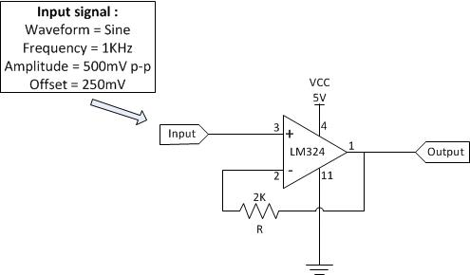

Figure 5. Voltage follower

- Configure the waveform generator on the oscilloscope with following settings:
Waveform = Sine
Frequency = 1KHz
Amplitude = 500mV p-p
Offset = 250mV

- Connect the waveform generator output to the input of voltage follower.

- Connect channel 1 input (X) of the oscilloscope to the output of voltage follower and connect channel 2 (Y) input of the oscilloscope to the input of voltage follower.

- Record the input and output waveforms displayed on the oscilloscope.

- In your lab report, state what is the relation between the output and input voltages of the voltage follower.

Answer:

END

