CENG4480 Embedded System Development and Applications
Computer Science and Engineering Department
The Chinese University of Hong Kong
Laboratory 7: Self-balancing Robot (1) (hardware)
November, 2016
Introduction
In this lab and the next lab you will build a self-balancing robot by applying knowledge you have studied in previous lectures and labs. In this lab, you should assemble the robot hardware and then test the system using the provided testing program to make sure the hardware is working correctly. A picture of the completed self-balancing robot hardware is shown in Figure 1.

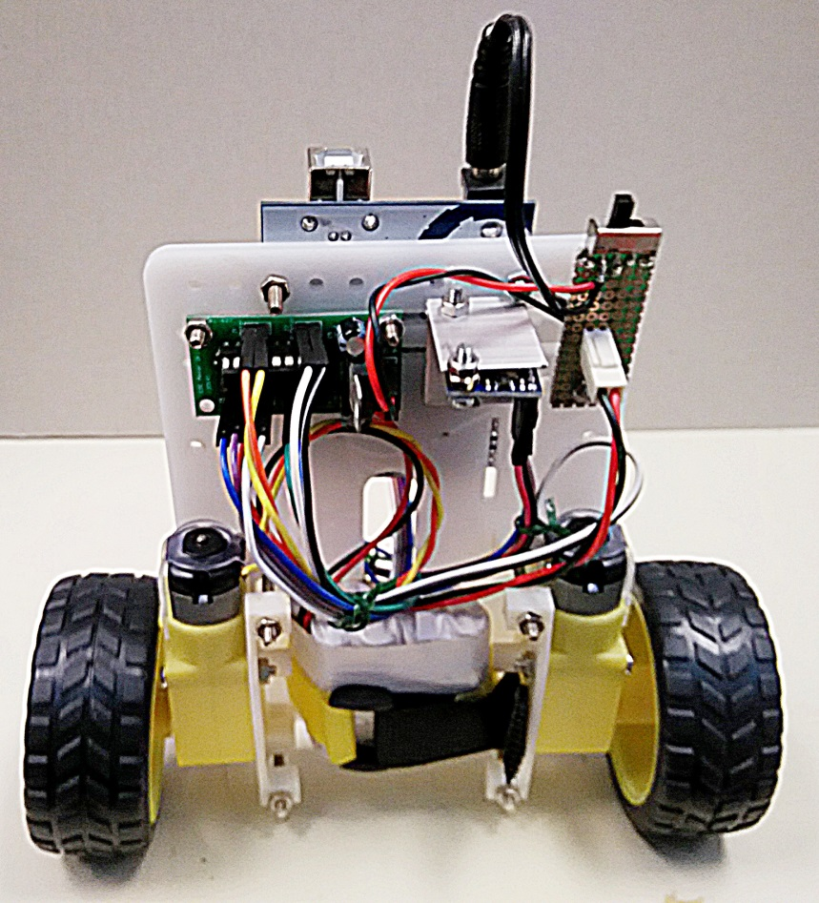
Figure 1. The CENG4480 self-balancing robot

Objectives
- To learn how to build an embedded system
- To familiar with the practical work in engineering

Procedures and what to submit:
Demonstrate your robot hardware to a tutor after your complete the experiment, no need to submit lab report.

The following components will be provided:
1. a plastic base
2. two motors with mounting
3. two wheels
4. an IMU module
5. an Arduino board
6. a piece of prototype board
7. a switch
8. a battery pack

Experimental procedures
- Assembly the power switch board
- On the provided prototype board solder the switch and header as shown in the following diagram or the sample board found in the lab.

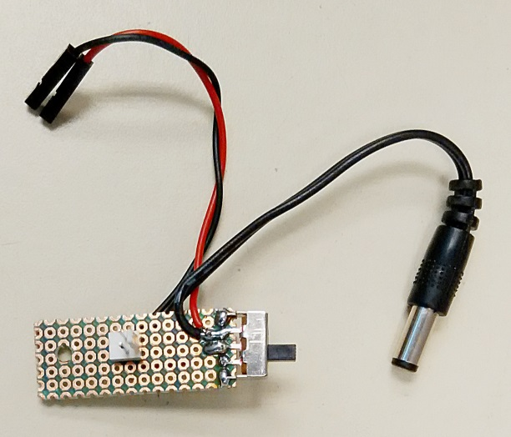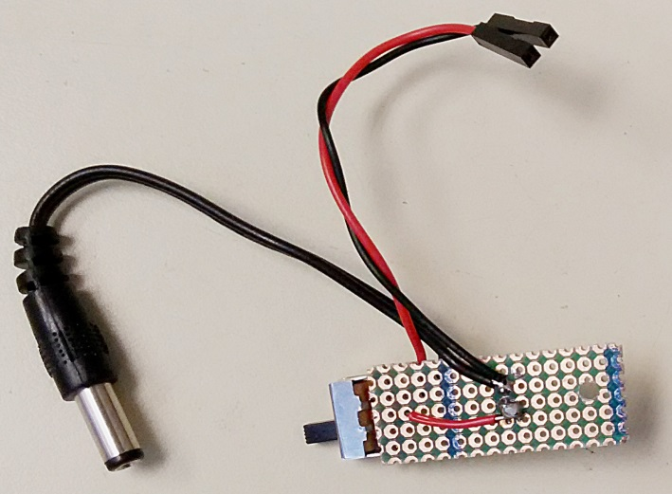

Figure 3. Power switch board
- Assembly all the components on the plastic base
- Double check the connections of the wires to make sure they are correctly soldered. Any wrong connection may cause damage to the system.

- Testing the robot
- Use the provided testing software Lab7.ino to test the robot.
- Test if the motors are correctly connected: If the robot is oriented to one direction, the robot should move in that direction. If the rotation direction of the wheel is not correct you can just swap the 2 terminal connections (positive and negative) of the motor.
- If you have difficulty in trouble shooting your robot please don’t hesitate to ask our tutors TAs or technicians for help.

- Demo your robot to TAs

END

