CENG4480 Embedded System Development and Applications
Computer Science and Engineering Department
The Chinese University of Hong Kong
Laboratory 5: Inertial Measurement Unit (IMU)
October, 2016
Introduction
In this exercise, you will learn how to use an electronic Inertial Measurement Unit (IMU) to measure the orientation angle of an object. In this experiment, we will be using a low cost IMU GY-801 module (see Figure 1) which is based on the MEMS (Micro Electro-Mechanical System) technology. The Gy-801 IMU module consists of a 3-axis accelerometer ADXL345, 3-axis gyro L3G4200D, 3-axis compass HMC5883L and barometer BMP180. We will show how to interface the IMU with an Arduino computer via the I2C channel. The experimental platform used in Lab 4 is also employed to collect the real orientation measurements based on a mechanical orientation meter. And the results will be used to verify the measurements obtained using the electronic accelerometers and gyros (see Figure 2) inside the IMU. Methods of filtering noisy data will also be introduced.

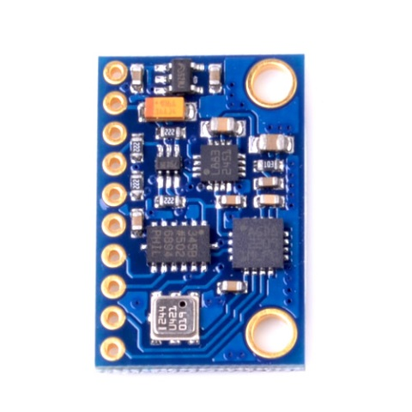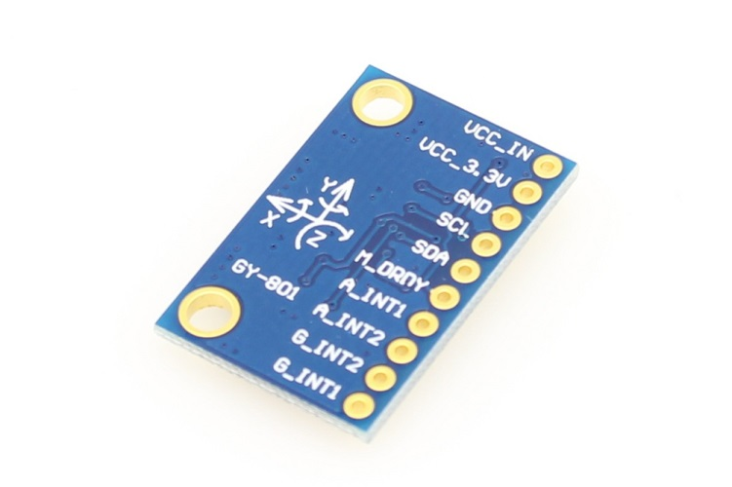

Figure 1. GY-801 IMU module
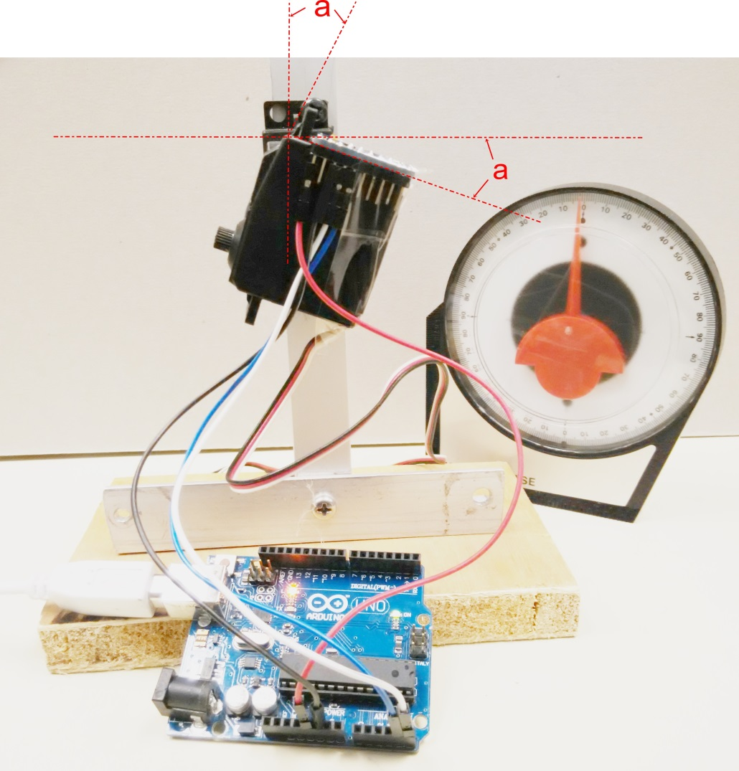
Figure 2. Experiment setup
Objectives
- To lean how to interface the IMU module to Arduino microcontroller via I2C
- To learn how to use IMU to measure the orientation angle of an object
- To study the Complement and Kalman filtering method for noisy data

Procedures and what to submit:
Follow the procedures of each experiment. Submit a lab report sheet with your name and student ID, to the tutor after the lab. The lab report sheet should have the measurements or plots of your experiments, and answers of the questions asked in this lab manual. You may prepare the report using a computer document and use a camera to capture the waveforms and insert them in your report.

Experimental procedures
- Connect the IMU module to Arduino board
- Use dupont wires to connect the VCC, GND, SDA, SDC of the IMU module to the Arduino board as shown on Figure 3. (refer to sample to be found in the lab)

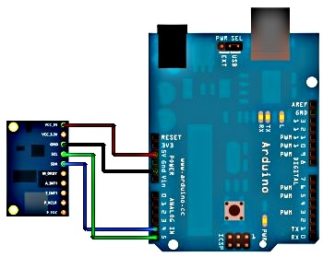

Figure 3. Connection of IMU module

- Attach the IMU module on the platform
- Attach the IMU module on the experimental platform by using plastic tape.
- Make sure it can rotate freely along the rotation (x) axis.

- Upload the program Lab5.ino to Arduino board
- Double click Lab5.ino
- Download two libraries from: https://github.com/manifestinteractive/arduino/tree/master/Libraries
and https://github.com/PaulStoffregen/TimerOne, put L3G4200D and TimerOne in Documents\Arduino directory
- Import these two libraries through Arduino IDE Tools
- Compile and Verify the source program
- Connect the USB cable from PC to Arduino board
- Observe the COM port number from Device Manager
- On the Arduino IDE Tools, Serial Port select the correct port number
- On the Arduino IDE Tools, Board select the Arduino Uno
- On the Arduino IDE press the Upload button
- Wait for the uploading program to finish
- On the Arduino IDE Tools, select Serial Monitor, you should see the following window
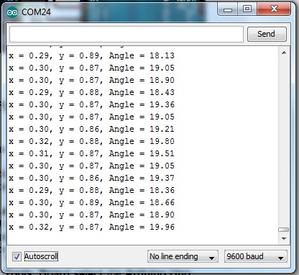
- The value ‘x’ is the accelerometer value on x-axis, ‘y’ is the accelerometer value on y-axis the angle ‘a’ can be calculated from arctangent of x,y

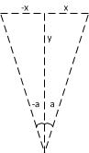

- In Arduino there is an atan2(y,x) function, the angle value shown in the window is the result of the atan2(y,x) function

- Record and fill the table for the platform in the different angle

Platform Angle  (Degree) | -50 | -40 | -30 | -20 | -10 | 0 | 10 | 20 | 30 | 40 | 50
X
Y
Angle=atan2(y,x)
(Degree)

Question 1. Find the approximate average offset angle of the IMU from your results. (The offset of the IMU is different from module to module)

- Study the improvement of data stability by using Complement and Kalman filters
The Complement and Kalman filter is commonly used to stabilize noisy data captured in sensor fusion applications. Sensor fusion is implemented as a set of adaptive algorithms for prediction and filtering using the data collected from different sensors of the same physical phenomenon. That is, it takes advantage of different and complementary information coming from the accelerometer, the gyroscope and the optional magnetometer and combine them a smart way to generate accurate measurement results [1].

For further details of the theory of Complement and Kalman filter and applications can be found in reference [1].

Procedures of the experiment:
- In Lab5.ino change the code as following:

void loop()
{
float LRspeed;

static unsigned long newMilli; //new timestamp

newMilli = millis(); //save the time when sample is taken
Read_acc();
Read_gyro();
//compute interval since last sampling time in millisecond
interval = newMilli - lastMilli;
lastMilli = newMilli; //save for next loop, please note interval will be invalid in first sample but we don't use it

Ayz=atan2(RwAcc[1],RwAcc[2])*180/PI; //angle measured by accelerometer
Ayz-=offset; //adjust to correct balance point

//delay(500);
//Serial.print("x = ");
//Serial.print(RwAcc[1]); // x-axis accelerometer value
//Serial.print(", y = ");
//Serial.print(RwAcc[2]); // y-axis accelerometer value
//Serial.print(", Angle = ");
Serial.print(Ayz);

Serial.print(", ");
Angy = 0.98*(Angy+GyroIN[0]*interval/1000)+0.02*Ayz;//complement filter
kang = kalmanCalculate(Angy, GyroIN[0],interval); //kalman filter
kang+=0.65; //adjust the offset
Serial.print(kang);

Serial.println(" ");
////////////////////////////

}

- Upload the program to the Arduino board by pressing the Upload button
- Place the experimental platform in the horizontal position
- On the Arduino IDE Tools, select Serial Monitor, you should see the following window
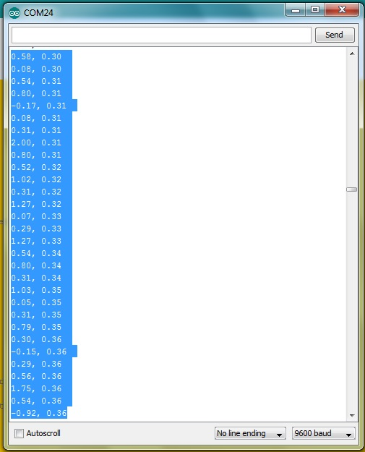
- Wait around one minute to let the data stabilize
- Uncheck the Autoscroll box to stop the display from scrolling
- Copy 30 lines of data by pressing CTRL C on the keyboard
- Open Microsoft Excel and then paste the 30 lines data on the Excel table
- Press Data, Text to Columns and press Next
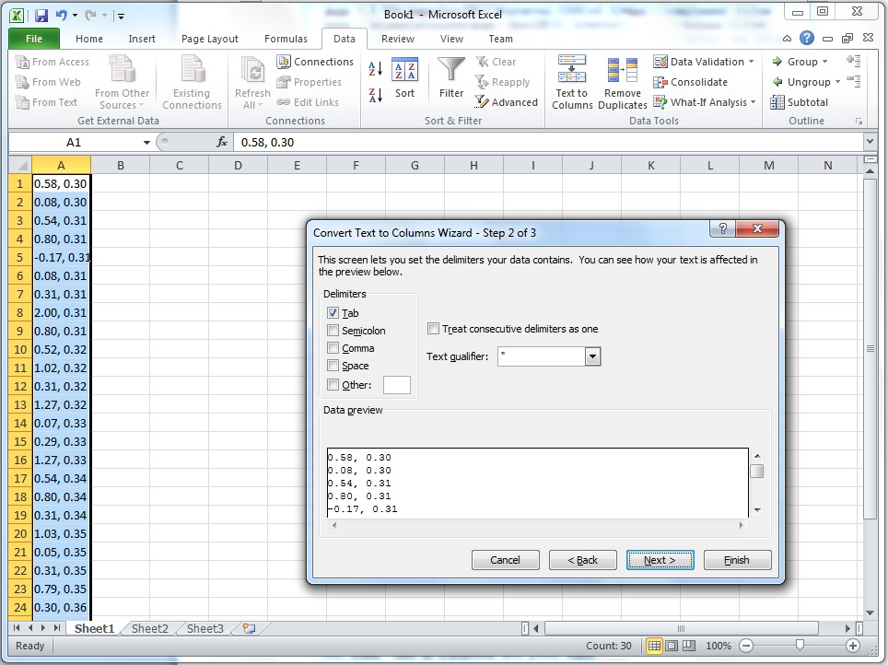

- Check the Comma check box then press Next and Finish
- Select all data in both A, B columns and press Insert, Line

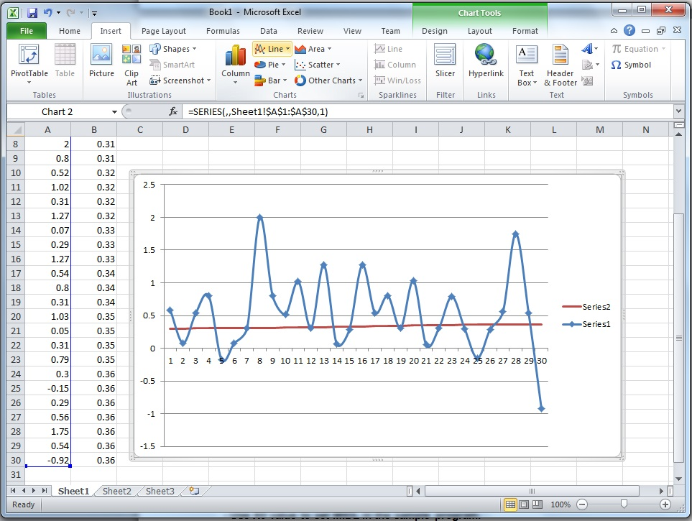

- Question 2: Study reference [1], in your report, write a 100 words summary to explain the difference of series 1 and series 2, and discuss the effect of applying Complement and Kalman filters on the IMU angle data

END
Refrences:
[1] http://www.mouser.hk/newproducts/applications.aspx?virtualdir=sensor_solutions_mems%2f
[2] http://digitalcommons.calpoly.edu/cgi/viewcontent.cgi?article=1114&context=aerosp
[3] http://www.instructables.com/id/Guide-to-gyro-and-accelerometer-with-Arduino-inclu/
[4] http://ozzmaker.com/2015/01/27/guide-interfacing-gyro-accelerometer-raspberry-pi-kalman-filter/

