CENG4480 Embedded System Development and Applications
Computer Science and Engineering Department
The Chinese University of Hong Kong
Lab manual: Laboratory 2: Active Filters
September, 2015
Introduction
This lab session introduces some active filters constructed using op amp. The op amp IC used in this lab is LM324. LM324 contains 4 op amps, we only use one of them.
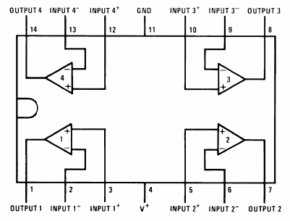
Figure 1. Pinout for the LM324.
Objectives
By completing this lab session, you should know:
1. how to design active filter;
2. how to design low pass, high pass, band stop and band pass filter by using op amp.

Procedures and what to submit:
Follow the procedures of each experiment. Submit a lab report sheet with your name and student ID to the tutor after the lab. The lab report sheet should have the measurements or plots of your experiments, and answers of the questions asked in this lab manual. You may prepare the report using a computer document and use a camera to capture the waveforms and insert them in your report.
Experimental procedures
Experiment 1. One-pole low pass filter
In this experiment, you will construct and observe the low pass filter. Measure the input and output waveforms.
The following apparatus will be provided:
1. a power supply
2. an oscilloscope
3. a breadboard
4. resistors: 3 x 1 KΩ
5. capacitor: 1 x 0.1uF
6. one LM324 IC

Procedures:
- Use pinout diagram for LM324 op amp IC shown in Figure 1 to construct the low pass filter circuit as shown in Figure 2.
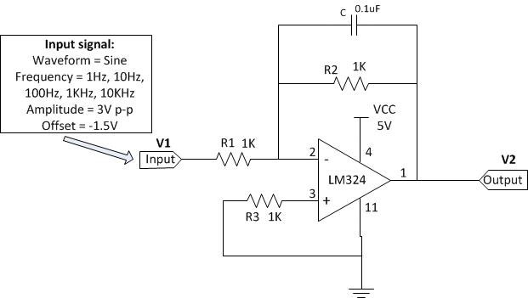
Figure 2. Low pass filter
- Configure the waveform generator on the oscilloscope with following settings:
Waveform = Sine
Frequency = 1Hz, 10Hz, 100Hz, 1KHz and 10KHz
Amplitude = 3V p-p
Offset = -1.5V

- Connect the waveform generator output to the input of low pass filter.

- Connect channel 1 input (X) of the oscilloscope to the output of low pass filter and connect channel 2 input (Y) of the oscilloscope to the input of low pass filter.

- Measure V1 and V2 on the input and output of low pass filter by using the measurement function on the oscilloscope. It is more suitable to use AC RMS-Cyc to measure V1 and V2.

- In your lab report:

  - Fill in the blanks of the table below:

Frequency (Hz) | V1 (Volt) | V2 (Volt) | Gain (dB)  (G = ${20log}_{10}\frac{V_{2}}{V_{1}}$ dB)
1
10
100
1K
10K

  - Plot the Frequency Response curve using semi log graph or use Excel to plot the graph.

  - Adjust the frequency of Wave Gen on the oscilloscope to find out the Corner frequency of the low pass filter. The Corner frequency is defined as the frequency at V2/V1 = 0.707.

  - Measure the Corner frequency of the low pass filter found by measurement. Does it agree with the theoretical corner frequency f_{c} by the formula: $f_{c}=\frac{1}{2πR_{2}C}$ (Hz)?

  - State one of the reasons that causing the difference between Corner frequencies $f_{c}$found by measurement and by calculation.

  - Discuss an application of this circuit.
Experiment 2. Two-pole low pass filter
In this experiment, you will construct and observe the two-pole low pass filter. Measure the input and output waveforms.
The following apparatus will be provided:
1. a power supply
2. an oscilloscope
3. a breadboard
4. resistors: 4 x 1 KΩ
5. capacitor: 2 x 0.1uF
6. one LM324 IC

Procedures:
- Use pinout diagram for LM324 op amp IC shown in Figure 1 to construct the two-pole low pass filter circuit as shown in Figure 3.

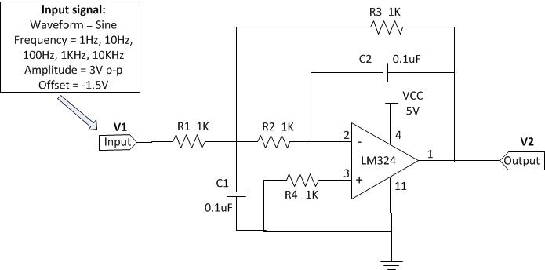
Figure 3. Two-pole low pass filter

- Configure the waveform generator on the oscilloscope with following settings:
Waveform = Sine
Frequency = 1Hz, 10Hz, 100Hz, 1KHz and 10KHz
Amplitude = 3V p-p
Offset = -1.5V

- Connect the waveform generator output to the input of two-pole low pass filter.

- Connect channel 1 input (X) of the oscilloscope to the output of two-pole low pass filter and connect channel 2 input (Y) of the oscilloscope to the input of two-pole low pass filter.

- Measure V1 and V2 on the input and output of two-pole low pass filter by using the measurement function on the oscilloscope. It is more suitable to use AC RMS-Cyc to measure V1 and V2.

- In your lab report,

  - fill the table below:

Frequency (Hz) | V1 (Volt) | V2 (Volt) | Gain (dB)  (G = ${20log}_{10}\frac{V_{2}}{V_{1}}$ dB)
1
10
100
1K
10K

  - Plot the Frequency Response curve using semi log graph paper or use Excel to plot the graph. Compare and write down the differences of the frequency responses the one-pole low pass filter (in experiment 1) and the two-pole low pass filter (experiment 2 here).

  - Adjust the frequency of Wave Gen on the oscilloscope to find out the Corner frequency of this low pass filter. The Corner frequency is defined as the frequency at V2/V1 (-6dB) = 0.5011.

  - Measure the Corner frequency of this low pass filter found by measurement. Does it agree with the theoretical corner frequency f_{c} by the formula:
$f_{c}=\frac{1}{2π\sqrt{R_{2}R_{3}C_{1}C_{2}}}=\frac{1}{2πR_{3}C_{2}}$ (Hz)

(Since R2 = R3, C1 = C2)

Experiment 3. High pass filter
In this experiment, you will construct and observe the high pass filter. Measure the input and output waveforms.
The following apparatus will be provided:
1. a power supply
2. an oscilloscope
3. a breadboard
4. resistors: 2 x 10 KΩ
5. capacitor: 1 x 0.1uF
6. one LM324 IC

Procedures:
- Use pinout diagram for LM324 op amp IC shown in Figure 1 to construct the high pass filter circuit as shown in Figure 4.

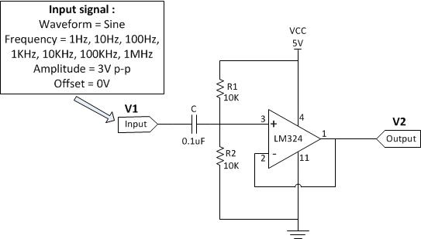
Figure 4. High pass filter
- Configure the waveform generator on the oscilloscope with following settings:
Waveform = Sine
Frequency = 1Hz, 10Hz, 100Hz, 1KHz, 10KHz, 100KHz and 1MHz
Amplitude = 3V p-p
Offset = 0V

- Connect the waveform generator output to the input of high pass filter.

- Connect channel 1 input (X) of the oscilloscope to the output of high pass filter and connect channel 2 input (Y) of the oscilloscope to the input of high pass filter.

- Measure V1 and V2 on the input and output of high pass filter by using the measurement function on the oscilloscope. It is more suitable to use AC RMS-Cyc to measure V1 and V2.

- In your lab report:

  - Fill the table below:
Frequency (Hz) | V1 (Volt) | V2 (Volt) | Gain (dB)  (G = ${20log}_{10}\frac{V_{2}}{V_{1}}$ dB)
1
10
100
1K
10K
100K
1M

  - Plot the Frequency Response curve using semi log graph or use Excel to plot the graph. Explain why the gain of high pass filter drop significantly at very high frequency.
  - Adjust the frequency of Wave Gen on the oscilloscope to find out the Corner frequencies of high pass filter, $f_{cl}$ and $f_{ch}$ . Where $f_{cl}$ is the Corner frequency at lower frequency range and $f_{ch}$ is the Corner frequency at higher frequency range. The Corner frequency is defined as the frequency at V2/V1 = 0.707. Measure the Corner frequency of this high pass filter found by measurement. Does it agree with the theoretical corner frequency $f_{cl}$ by the formula: Corner frequency $f_{cl}=\frac{1}{2πRC}$ (Hz), Where R = R1║R2
  - Discuss an application of this circuit.

Experiment 4. Band stop (notch) filter
In this experiment, you will construct and observe the band stop filter. Measure the input and output waveforms.
The following apparatus will be provided:
1. a power supply, an oscilloscope and a breadboard
2. resistors: 2 x 10 MΩ, 1 x 4.7MΩ
3. capacitor: 1 x 390pF, 2 x 200pF
4. one LM324 IC

Procedures:
- Use pinout diagram for LM324 op amp IC shown in Figure 1 to construct the voltage follower circuit as shown in Figure 5.

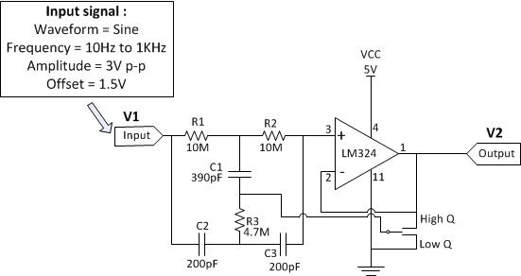
Figure 5. Band stop filter
- Configure the waveform generator on the oscilloscope with following settings:
Waveform = Sine
Frequency = 10Hz to 1KHz
Amplitude = 3V p-p
Offset = 1.5V
- Connect the waveform generator output to the input of band stop filter.

- Connect channel 1 input (X) of the oscilloscope to the output of band stop filter and connect channel 2 input (Y) of the oscilloscope to the input of band stop filter.

- Connect the band stop filter to Low Q, measure V1 and $V_{2l}$ on the input and output of band stop filter by using the measurement function on the oscilloscope. Then connect the band stop filter to High Q, measure $V_{2h}$.

- Repeat the step 5 for different frequencies as listed on the table.

- In your lab report:

  - Fill the table below. (It is more suitable to use AC RMS-Cyc to measure V1 and V2.)

Frequency (Hz) | V1 (Volt) | $V_{2l}$ (Volt) | Low Q Gain (dB)  (G = ${20log}_{10}\frac{V_{2l}}{V_{1}}$ dB) | $V_{2h}$ (Volt) | High Q Gain (dB)  (G = ${20log}_{10}\frac{V_{2h}}{V_{1}}$ dB)
10
20
30
40
50
60
70
80
90
100
150
250
500
1K

  - Plot the both Frequency Response curve of Low Q and High Q band stop filter in the same graph by using semi log graph or using Excel. Compare and comment the Low Q and High Q frequency response curves of the band stop filter.
  - Discuss an application of this circuit.

Experiment 5. Non-inverting Schmitt trigger
In this experiment, you will construct and observe the non-inverting Schmitt trigger. Measure the Hysteresis ($V_{TH}-V_{TL}$) with different value of R1.
The following apparatus will be provided:
1. a power supply, an oscilloscope and a breadboard
2. resistors: 1 x 1KΩ, 3 x 10 KΩ, 1 x 2KΩ, 1 x 3.9KΩ, 1 x 8.2KΩ
3. one LM324 IC
Procedures:
- Use pinout diagram for LM324 op amp IC shown in Figure 1 to construct the current to non-inverting Schmitt trigger circuit as shown in Figure 6. (Use R1 = 2KΩ at first)
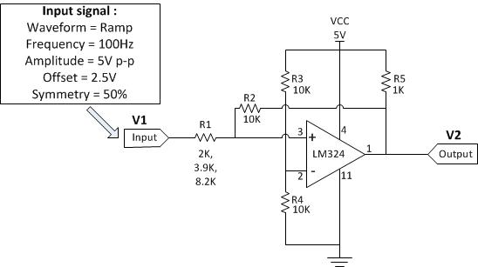
Figure 6. Non-inverting Schmitt trigger

- Configure the waveform generator on the oscilloscope with following settings:
Waveform = Ramp
Frequency = 100Hz
Amplitude = 5V p-p
Offset = 2.5V
Symmetry = 50%

- Connect channel 1 input (X) of the oscilloscope to the input of non-inverting Schmitt trigger and connect channel 2 input (Y) of the oscilloscope to the output of non-inverting Schmitt trigger. The waveform displayed on the oscilloscope should be similar to the following picture.

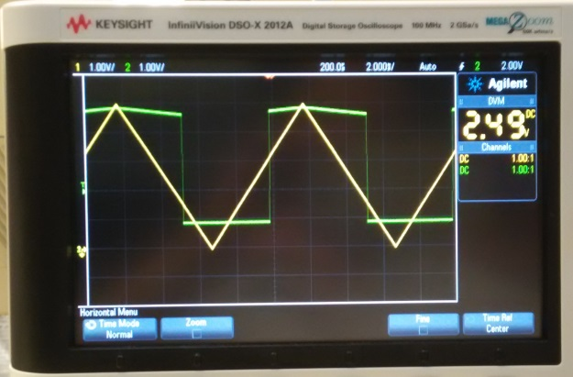
(Sample plot)

- Press the Horiz button (on the top of oscilloscope panel near the Horizontal knob). Select XY Time Mode. The waveform displayed on the oscilloscope should be similar to the following picture.

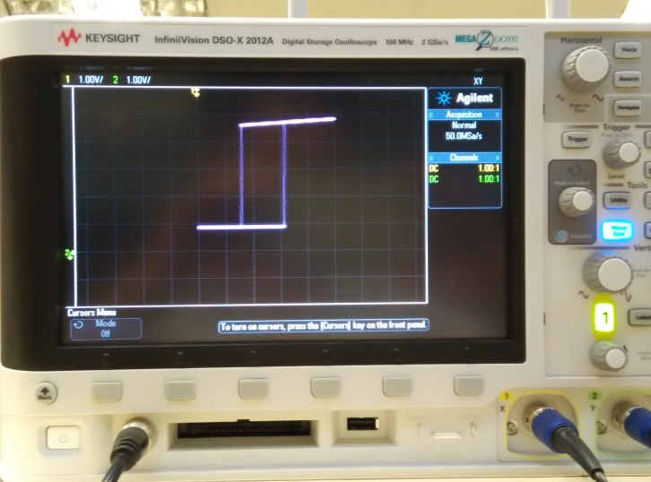
(Sample plot)

- Use cursor measurement on the oscilloscope measure the top value of the curve $V_{ohigh}$, the bottom value of the curve $V_{olow}$ , the right value of the curve $V_{TH}$ and the left value of the curve $V_{TL}$.

- Hence measure the Hysteresis of the Schmitt trigger circuit.

Hysteresis = $V_{TH}$ - $V_{TL}$ = ∆X

- Measure the $V_{ohigh}$ - $V_{olow}$,

$V_{ohigh}$ - $V_{olow}$ = ∆Y(2)

Hence calculate Hysteresis from

Hysteresis = ( $V_{ohigh}$ - $V_{olow}$ )$\frac{R_{1}}{R_{2}}$
= ∆Y(2)($\frac{R_{1}}{R_{2}}$)

- Repeat steps 4 to 6 with R1 = 3.9KΩ and R1 = 8.2KΩ.

- In the lab report sheet:
  - Fill in the table below.
R1 | $$V_{ohigh}$$ | $$V_{olow}$$ | $$V_{TH}$$ | $$V_{TL}$$ | Hysteresis = ∆X | Hysteresis=∆Y($\frac{R_{1}}{R_{2}}$)
2KΩ
3.9 KΩ
8.2 KΩ
- Record and plot the input/output waveforms displayed on the scope.
- Discuss an application of this circuit.
END

