ENGG1100 Introduction to Engineering Design
Faculty of Engineering
The Chinese University of Hong Kong

Laboratory 3: Electronics Basics II

Week _, 2014 Spring

Introduction

Circuits may contain static signals that do not change with time. We can use instruments introduced in previous lab. On the other hand, circuits do not handle static signals only but also signals that change around time (We call that time variant signals). We will need advanced instruments and techniques so that we can observe and measure them. In this Lab session, Oscilloscope is introduced to you that you can observe complex signals.

Assembling circuits is an integral skill in many fields in engineering. It can be for the purpose of building a permanent circuit as a final product, or for the purpose of testing and prototyping, e.g., verifying some circuit ideas by making a temporary circuit. There are at least two ways of circuit assembly: using breadboards, soldering. We have used breadboard in the last lab session and soldering technique will be introduced in this exercise.

Objective
By completing this laboratory session, you should know:

- how to use oscilloscope to perform various kinds of measurements;
- how to solder circuit well

Recording data properly from a laboratory experiment is part of the learning process in this course. As such, you are required to fill in a lab sheet attached at the end of this lab manual. We will provide Lab Sheet templates/examples of Electronics Basics I & II (provided in eLearning system). However, from Lab 5 and onwards, you will be required to prepare your own lab sheets *BEFORE* attending the lab. Without proper preparation, you are not allowed to start your lab.
Please read the lab manual thoroughly before attending the lab!
1. Oscilloscope
Oscilloscope is a widely used instrument. It is used to measure periodically changing signals (unlike the multimeter which measures static signals), like those depicted in Figure 2. With an oscilloscope, you would even be able to observe signal waveforms that change in the order of millions of times per second.

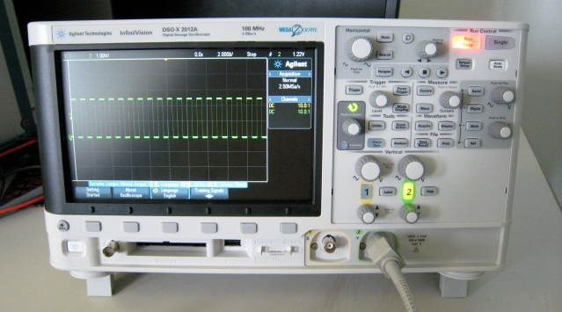 | 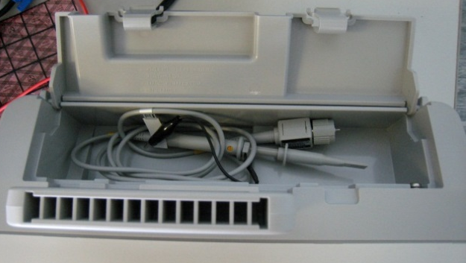
Figure 1a: The oscilloscope on your bench | Figure 15: The probes are stored on top of the oscilloscopes
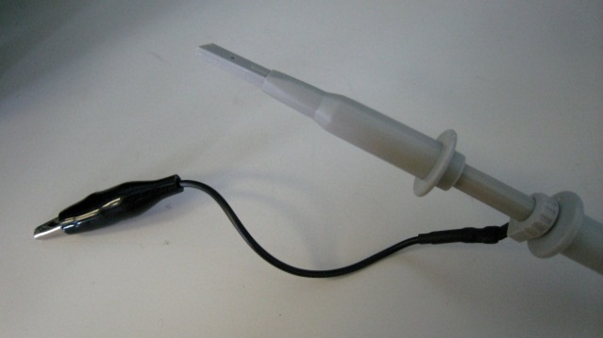 | 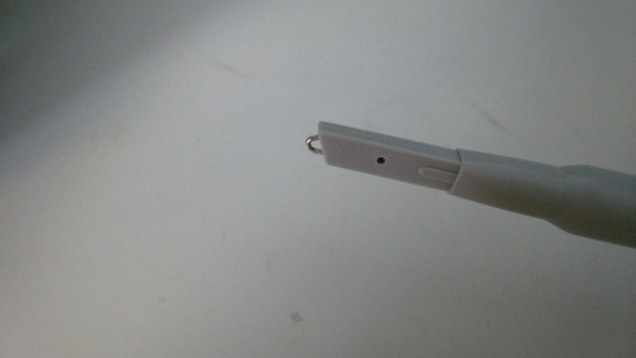
Figure 1c: A probe. Black clips to ground. Press the white cap lightly to get the measurement tip | Figure 1d: The measurement tip as a small hook. Rotate the white cap slightly to cover the tip after use

Figure 2: Some common periodic signals (left: Sine wave, right: Square wave)

General Hints for using the oscilloscope:
- You should be careful about AC and DC coupling mode of operations depends on your application.
- If it is not specified, we will use the DC coupling mode of operation in this laboratory.
- The trigger should be in “Edge” mode and the probe should be at 10x mode. Check before beginning your measurement.
- You may need to adjust the “volt/div” and “sweep-time/div” selectors manually to obtain a better result.
- Try to use different methods to record waveforms.
Time variant signals can be obtained with sensors like microphone; they can be generated by electronic system like computers. There are special machines that generate periodic signals with different forms, shapes and parameter. These machines are called as Signal Generator. They are very useful in educational and design purpose.

Experiment I: Time-domain signal measurement

In this section, you will practice how to use an oscilloscope and generate signals through a simple experiment. Don’t hesitate to ask the TAs if you have any question.

The following apparatus will be provided:
- an oscilloscope with built-in signal generator (Wave Gen)

The signal generator is used to generate periodically changing signals (in form of voltage). (There’s a separate tutorial on the use of oscilloscope) We start out with using the oscilloscope to measure signals (in time-domain, which means measures voltage variation against time) generated by the signal generator.

Procedures:
- Connect the oscilloscope probe to the signal generator output.
- Set the output of the signal generator to: V(pk-pk): 1 V, Frequency: 20 Hz, Waveform: Sine
- Using the oscilloscope, record your observed waveform (make sure the scales and axis are clearly shown), also measure the peak-to-peak voltage and period of the signal.
(Hints: use measuring function of the oscilloscope. Abbreviations: Peak-to-peak voltage = Pk-Pk, Frequency =F)
- Repeat step 2-3 with following settings.
  - Pk-Pk =2 Volts , F = 200Hz, Waveform :Sine, Offset = 0 Volt
  - Pk-Pk= 1 Volt , F = 2KHz, Waveform :Square, Offset = 0 Volt
  - Pk-Pk= 1 Volt , F = 20Hz, Waveform :Square, Offset = 0.5 Volts
- Observe the signals of 4c in both AC and DC coupling mode. State the differences of:
  - Difference between signals recorded in 2 and 4a,b,c respectively.
  - Difference between the observation in 4c with AC and DC coupling mode.

2. Soldering

Soldering is usually the final step in assembling circuits after we have verified that our circuit is working through prototyping on breadboard or with wire-wrapping. Though de-soldering is possible, soldering is generally considered as a permanent process.

Soldering is often done on printed circuit boards (PCBs) or prototype boards.
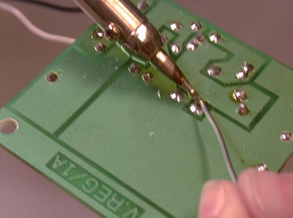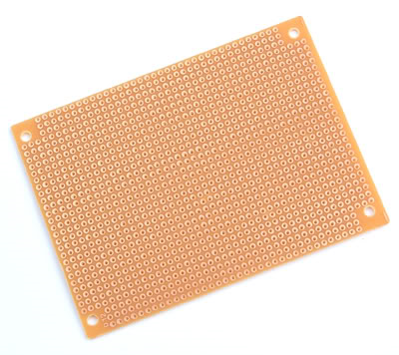
Figure 3: (left) PCB, (right) prototype board

Improper use of the soldering iron can cause serious injuries. A briefing on soldering will be provided before you are allowed to start the following experiment. Please read the precautions listed in the appendix before you go!

You are going to solder a debug board for your project. Be reminded that the debug board soldered will be used for your project. Make sure your board works and keep it as secure as you can. Before you solder the debug board, please demonstrate your soldering skill with prototype board and resistor given to your TA that we ensure you can handle the board.

Experiment II-A: Soldering with Prototyping Board

In this section, you will practice how to solder components on a prototyping board. Don’t hesitate to ask the TAs if you have any question.

The following apparatus will be provided:
- A prototyping board
- Soldering Iron
- Three 5.1 KΩ resistors
- Multimeter

Procedures:
- Place the resistors (5.1 KΩ each) side-by-side on the component side of the board. There should be an empty column between resistors.
- Solder the resistors in order to fix them on the board.
- Bend the pins of each resistor so that all resistors are connected in parallel.
- Solder it. Measure the resistance of the resistor network. It should be 1.7 KΩ if you make every connection correct. Can you explain why it is 1.7 KΩ?
- Show it to your TA.

Experiment II-B: Soldering with Printed Circuit Board (PCB)

In this section, you will solder the debug board which will be used in your project. The PCB given has pre-fabricated circuit on it.

The following apparatus will be provided:
- Soldering Iron
- Component Pack
- Debug board PCB

LED Bar x 2 (D1, D2)
Resistor Array x 2 (RA1, RA2)
The dot represents Pin 1.
Pin Headers with Pin x 4
Debug Board PCB | Components to be soldered

Procedures:
- Placing and soldering the components given. Start with the flattest and smallest components first.
Reminders:
  - The component list is shown above.
  - Make sure you have the correct orientation for Resistor Arrays and LED Bars. (RA1, RA2, D1, D2) Feel free to ask TA if you are not sure.
  - 4 Pin Headers are the black blocks shown on the PCB. 4 Pin Headers are with different number of pins.
  - Those pin headers should be perpendicular to the debug board so that the board can be plugged on another Arduino board as follow. 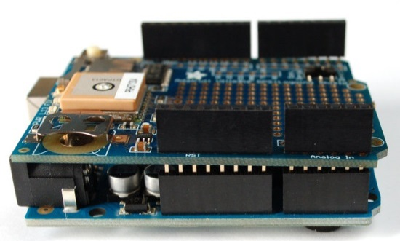
- After soldering the board, the TA will help you to test it. Please follow further instruction.

Appendix

A.1. What are Peak, Peak-to-Peak, and RMS Voltage?

When measuring AC signals, especially using an oscilloscope, you will see measurements like peak voltage, peak-to-peak voltage, and root-mean-squares (RMS) voltage. Their differences are distinguished as follows:
- Peak voltage is the highest level of the signal
- Peak-to-peak voltage is the difference between the peak and trough of the signal. For signals that are symmetric at zero volt (like, the following sine wave), we have.
- RMS voltage is the root mean square value of the signal, defined as, where T is the period and V(t) is a function representing the voltage in time. For sine waves, you can safely assume that

Figure 13: peak, peak-to-peak, and RMS voltages for a sine wave.

Note that different equipment may show you different types of voltage, so figure it out in advance to avoid incorrect measurement.

A.2. Rules for good soldering.

[The soldering iron]

- Make sure the tip is clean. An iron that has been switched on for a while may develop a coating of oxide on the tip. This is usually removed by melting fresh solder onto the tip ("tinning") and wiping with a moist rag or sponge.
- After extensive use, the tip may become pitted. As a result it may be difficult to transfer heat from the tip due to the reduced contact area to the joint. Heavy copper tips may be cleaned with fine emery paper or a file (though this may clog the file), however, the tips used in most electronics laboratories have specially treated long-life surfaces - and these MUST NOT be touched with emery paper or a file. A rub with plain paper or a wet rag will suffice.
- Wait until the iron is sufficiently hot before soldering.
- For big joints, particularly onto a metallic chassis, the tip should be sufficiently large.

[Soldering]

Soldering flux is needed to allow the molten solder to "wet" the surfaces being jointed. It is usually not necessary to apply flux separately as solder wires provide flux in hollow tubes inside the wire.

- Tinning. It is recommended to run solder onto all wires, tags, terminals, pigtails etc., before attempting to form a joint. Components which have been exposed to the atmosphere for a long time develop an oxide layer which may require scraping e.g. with sandpaper.
- Forming the joint. Heat the surfaces to be jointed, and run the solder onto these surfaces. If thermal contact to the iron is poor, better heat conduction may be obtained by running solder onto the iron as well. Make sure the iron heats the surfaces being jointed, and not just the solder. The iron should be removed as soon as the solder has formed a clean wet joint (i.e. with a concave meniscus to the surfaces being jointed).
- For experimental work. Do not twist wires around soldering lugs to obtain greater mechanical strength. It makes stripping down and recovery of components very difficult.
- Soldering aluminum is extremely difficult. Soldering metals other than tin, copper and brass may require specially activated fluxes. Some of these are corrosive and must be completely removed after soldering.

[Dry joints]

It is absolutely essential that no movement occurs while the solder is solidifying otherwise a DRY JOINT could result. A dry joint is one in which the electrical contact may be unreliable even though mechanical bondage appears quite firm. Dry joints may not manifest their presence until after many hours of apparently satisfactory operation. Failure due to dry joints may be intermittent, and therefore difficult, time consuming and frustrating to detect.

Dry Joints may also occur as a result of unsatisfactory or no tinning and incorrect tip temperature. If too cold, solder may not wet the surfaces. If too hot, the flux may be evaporated.

Prolonged heating of the solder evaporates the flux and may result in a dry joint. It is for this reason that the iron must be removed as quickly as possible after a joint has been formed.

Note: If unsatisfied with a joint, do not try to reform it by applying the iron to the same solder. Clean off all the cooked solder with the iron, and start again with fresh solder.

[Heat sensitive components]

  - Solid-state and some devices may be damaged by heat during soldering. The following precautions should be taken.
    - If several leads are being soldered, those from the heat sensitive devices should be soldered last.
    - The heat may be shunted away from the device by gripping the lead in the jaws of a set of pliers.
    - Heat must be applied for the least practicable time. The joint should be reasonably small if possible. Note that transformer leads are often soldered onto the winding. Indiscriminate application of heat may melt this internal Joint.
  - Overheating printed-circuit boards (PCB) may cause lifting of the copper strip. Before proceeding to attempt to desolder a component off a PCB, make sure that there is no risk of damage to the PCB.
  - Note that the plastic insulation on some wires (and especially coaxial cables) melts at a low temperature.
  - Beware of the power on soldering irons. Tips may become overheated if the switch is allowed to remain ON for too long.

