**ENGG1100 Introduction to Engineering Design**

**Faculty of Engineering**

**The Chinese University of Hong Kong**

**Laboratory 2: Electronics Basics I**

Week 4, 2014 Spring

|  |
| --- |
| **Introduction**  The objective of this lab session and the next lab session is to introduce some very basic skills in electronics—which every engineering student should know about. |
| **Objectives**  By completing this lab session, you should know:   1. how to read schematics and construct the corresponding circuits; 2. how to use a multimeter to perform various kinds of measurements; 3. how to use a breadboard to construct circuits. |
| Recording data properly from a laboratory experiment is part of the learning process in this course. As such, you are required to complete a document called a **lab sheet**. **We will provide Lab Sheet templates for Electronics Basics I & II (in eLearning system). However, from Lab 4 and onwards, you will be required to prepare your own lab sheets *BEFORE* attending the lab. Without a properly prepared lab sheet, you will not be allowed to start your lab.** |
| **Please read the lab manual thoroughly before attending the lab!** |

1. **Circuits, Schematics and Electronics**

This section gives an introduction of what circuits and schematics are.

Simply speaking, a **circuit** is something that has **electronic components** connecting together, and a **schematic** is a diagram that provides a symbolic description of a circuit. The figure below shows schematic representation, or symbols, of some commonly used electronic components.



**Figure 1**: Symbols of different electronic components

The properties and utilities of some of the electronic components will be taught later.

There are some basic rules about reading/drawing/implementing a schematic.

There are a few rules about drawing a schematic:

1. A circuit must contain a **closed loop**.
2. A circuit usually contains a **power source**.
3. Connections are treated as **nodes**. Each node is considered as a set of **electrical connections.**

* A circuit must contain a **closed loop**



**Figure 2**: Closed loop circuits

A closed loop means that electricity can flow through the circuit, and return to the position it originates from. Without a closed loop, the circuit is **open** and it will not work.

* A circuit usually contains a **power source.**

A power source can be represented in a number of ways (here, we only show the illustrations for a direct current (**DC**)power source):



**Figure 3**: Different representations of power sources

You may notice that the last representation does not seem to give a closed loop circuit. In fact, it is still describing a closed loop circuit. Moreover, the three circuits shown are the same.

* Connections are treated as **nodes.**

In a schematic, the connections between components are represented using a line. You should bear in mind that these lines serve only one purpose in the diagram, i.e., to make connections. It doesn’t matter how they are drawn; what matters most is that the components are connected to different **nodes**. An example is shown in Figure 4.



**Figure 4**: The three circuits are equivalent in terms of their connections

One can verify that all the three circuits in Figure 4 are the same, despite the fact that they look different from each other. When you are “**implementing**” (or constructing) a circuit according to a schematic, **make sure** that you have **wired together all** **components’ terminals** belonging to that node.

Reading circuits is a skill that needs practice to improve. The simplest way of making connections/assembling a circuit is to use the **crocodile clips**.

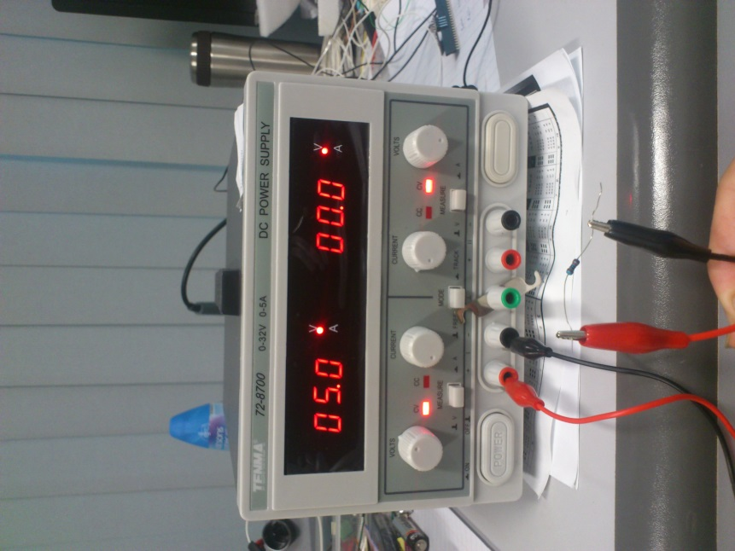

Crocodile Clips

Resistor

Power supply

**Figure 5**: Connecting a simple circuit with crocodile clips

There are more sophisticated ways to build circuits, e.g., soldering, wire-wrapping, and breadboard-prototyping. We will introduce them one by one in the next two lab sessions. In the sequel, we shall focus only on using crocodile clips.

Note: When you assemble a circuit, make sure that the **metal parts** are touching each other in order to have a connection.

1. **Multimeter**

Multimeter is a meter that can take a variety of electrical measurements. It can measure DC voltages, AC voltages, current (both DC and AC), and resistance. It also serves many different test purposes, e.g., checking if a connection between is shorted or broken, testing the operation of diodes and transistors (like, are they faulty or not?), to name a few.

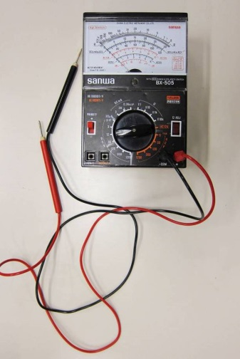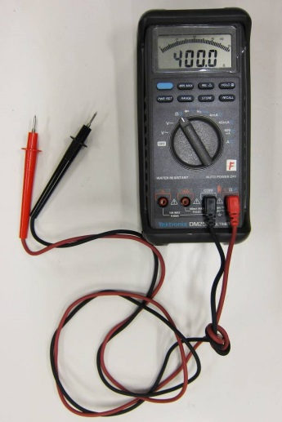

**Figure 6:** Analog and digital multimeters

**2.1. Voltage Measurement using multimeter**

The following figure depicts how to measure the voltage or potential difference across the two points:

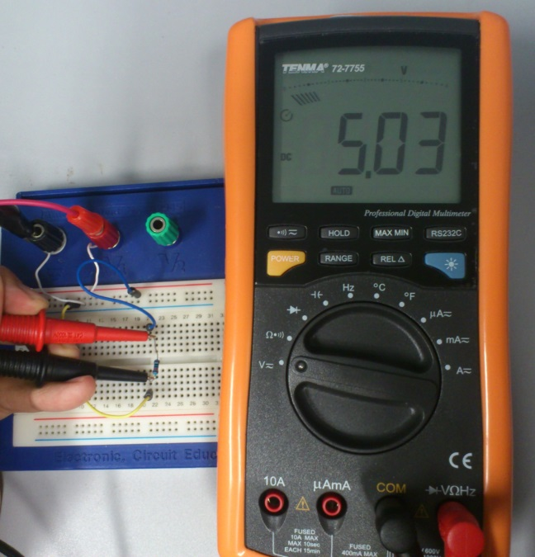

Circuit connected **in parallel**

The voltage reading is 5.03 V

**Figure 7:** Voltage measurement

In the figure above, the rectangular block represents part of a circuit (which, in the simplest case, is a resistor); the notation *V* denotes the voltage or potential difference you desire to measure, the circle with “V” inside is a multimeter configured as a voltmeter. The measurement is done by connecting the probes of the multimeter to the two test points **in a parallel** fashion.

**Important remarks**:

1. Polarity matters. The red probe corresponds to “+”, while the black probe “-”.
2. Dial the function knob to the desired kind of measurement. In voltage measurement, it is “voltage”. Moreover, the function knob allows you to choose the maximum range of the measured value (the range selection would be automatic in digital multimeters). Choose the range that would give you the most accurate reading.

**2.2. Current Measurement using multimeter**

The following figure depicts how we measure the current passing through a point:



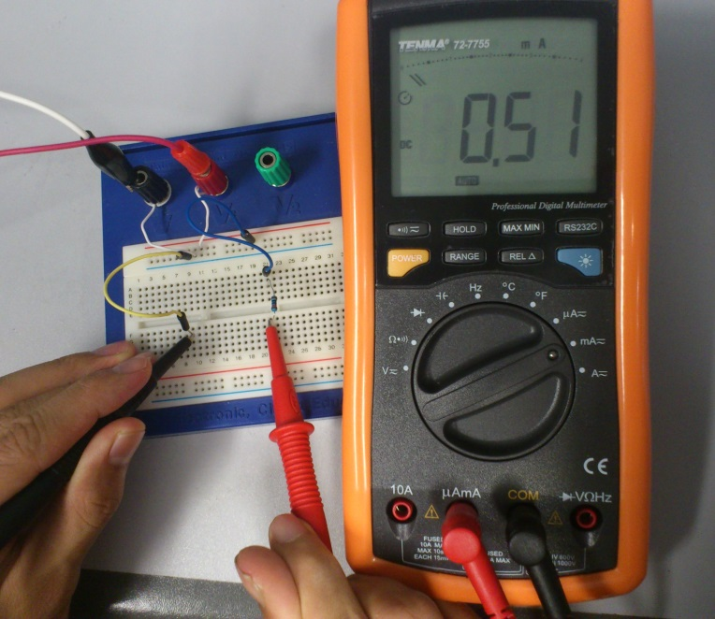

Circuit connected **in series**

The current reading is 0.51 mA

**Figure 8:** Current measurement

In the above figure, the circle with “A” inside represents a multimeter configured as an ammeter, and the notation “I” denotes the current we want to measure.

**Important remarks:**

1. Dial the function knob to “current”.
2. For current measurement, a multimeter should always be connected **IN SERIES** with the circuit as shown in Figure 8.
3. Some digital multimeter may require plugging the +ve probe **in a different socket** from the one used for voltage/resistance measurement.
4. Improper current measurement can damage the multimeter. If the current to be measured is higher than the maximum range of current set in the multimeter, you run the risk of blowing the fuse. Always choose the current range wisely.

**2.3. Resistance Measurement using multimeter**

To measure the resistance between two points, the connection is the same as that for voltage measurement in Figure 7, i.e., **in parallel**. However, you have to switch off ALL the power supplied to the circuit.

1. **Using breadboard for circuit assembly**

As illustrated in Figure 9, breadboard is a circuit board with many **pre-connected** holes in it:

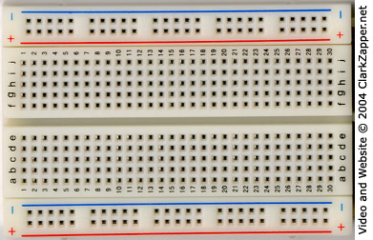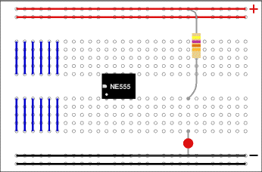

**Figure 9**: A real breadboard (left) and connection assignment of it (right)

Constructing circuits using breadboard is very easy especially if you are familiar with the “**node**” concept which is just introduced. For instance, each connected line (e.g. a blue one or a red one in Figure 9) is seen as a node to which the electronic components are connected.

Let us demonstrate this by showing an example circuit:

To 5V of power supply

To GND of power supply

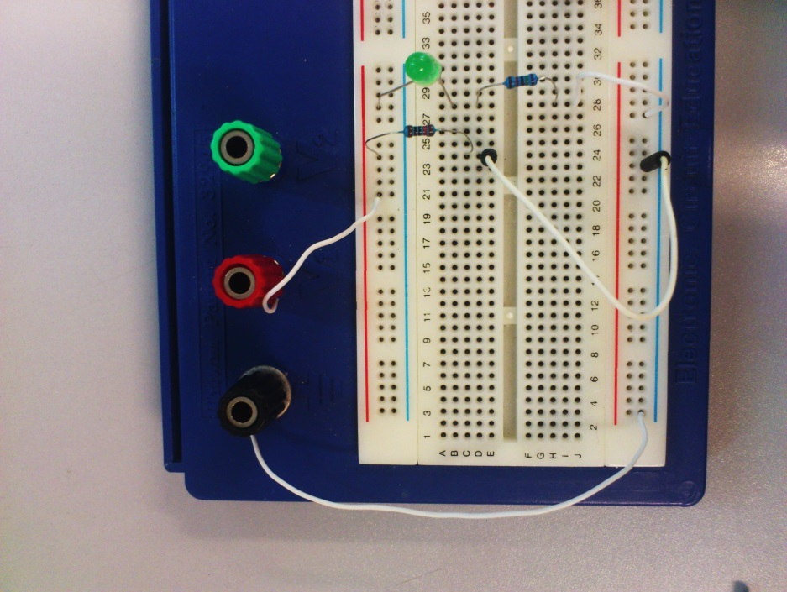

**Figure 10**: Practical example showing how to connect a circuit on breadboard

From the above figure, you can see how the pre-connected holes can help you to connect the circuit. Just imagine how messy would the connection be if you are going to connect the same circuit using crocodile clips.

**4. Elementary component: Resistors**

Resistor is a basic electronic component that appears in every electronic circuit. To begin with, let us see how a resistor looks like:

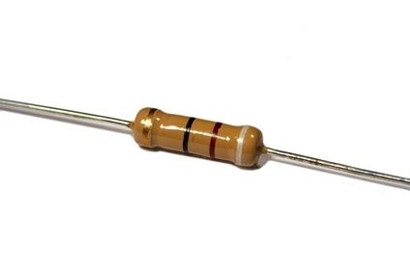



**Figure 11**: Resistor and its equivalent electronic symbol

In practice, we will read the **Color Band Code** marked on the resistor to identify the resistance value of it. At the moment, we will use **multimeter** to measure the value directly. There are plenty of resource on the Internet that teach us how to read those codes; e.g., <http://www.elexp.com/tips/clr_code.gif> from Electronix Express.

Some resistors have their resistance tunable; they are variable resistors and potentiometer. Figure 12 shows the symbol and physical appearance of variable resistors.

 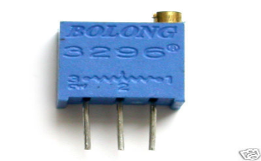

1

3

2

1

2

1 2 3

**Figure 12**: Variable resistor symbols (left) and a potentiometer (right)

**4.1 Voltage divider network – Theory**

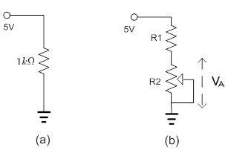

**Figure 13**: Voltage divider circuit

The circuit in Figure 13 demonstrates the principle of **voltage divider**. In particular, the voltage across R2 follows the following equation, which can be deduced from Ohm’s Law:

.

As you can see, the two resistors R1 and R2 divide the voltage provided to the circuit proportionally.

|  |
| --- |
| ***Experiment I: Making Connections and Measurements***  In this experiment, you will practice how to use a multimeter through a simple experiment. Don’t hesitate to ask the TAs if you have any question.  The following apparatus will be provided:   1. a digital multimeter 2. six resistors of different values, and a trimmer pot (0-10k) 3. a power supply 4. a few crocodile clips   In Figure 13(b), the symbol R2 represents a variable resistor. In this experiment, we connect **only two adjacent pins (e.g., either pins 1+2 or pins 2+3)** to form a variable resistor. The resistance can be adjusted using the dial at its top.  **Figure 13**: Voltage divider circuit |
| **Procedures:**   1. Measure the resistance for each of the given resistors and pick both the **1K Ohm** and **2K Ohm** resistors. 2. Connect the circuit in Figure 13(a) using crocodile clips. 3. **Measure the following quantities**:    1. the voltage across the **1K Ohm** resistor.    2. the current flowing through the **1K Ohm** resistor. 4. Now connect the circuit in Figure 13(b) and adjust the resistance of the trimmer pot until $V_{A}$ becomes 0.5V. **R1** should be **2K Ohm**. 5. Take out the trimmer pot and measure the resistance of it (measure the resistance across the two pins you have just used) 6. Plug in the trimmer pot and repeat Step 4-5 with $V_{A}$ being 1V, 2V, 3V, 4V. **Tabulate your result and plot a graph of the resistance R2 versus .** 7. **Calculate the following ratio “A” for each value of $V_{A}$**  in step 6**: $$A=\frac{R_{2}}{R_{2}+2000}$$**   **Does the computed Ratio A match the experiment?**   1. What can you tell about the relationship between the voltage across R2 and the resistance of R2? (Hints: You may plot the relationship and describe it. Is it linear, or reciprocal?) 2. What will be the value of when R2 is very large (say > 100K)? |
| ***Experiment II: Resistor Networks***  In this experiment, a resistor network will be constructed and you have to measure voltages of different nodes. The following apparatus will be provided:   1. a power supply 2. a multimeter 3. a breadboard 4. resistors: 1 x 1 KΩ, 1 x 10 KΩ, 1 x 5.1 KΩ 5. a 0-10 KΩ trimmer pot     **Figure 14**: A resistor network for testing |
| **Procedures:**   1. Connect the circuit in Figure 14 on a breadboard. 2. Adjust the resistance of the trimmer pot to 1.5 KΩ. 3. Measure the **voltages** at Points A, B, C, D while reference to the ground. (The **voltage at a point** is defined as the potential difference between the **point and the ground**.) 4. Measure the **currents** across all resistors and the power supply. (IA, IB, IC,ID,IPower passing through points A,B,C,D and power supply respectively.) 5. *What can you tell about the currents measured across the 1 KΩ, 5.1 KΩ and the variable resistor? (Hint: write a formula to link up the currents.* IB *= ?,* IPower *= ?)* 6. Adjust the resistance of the trimmer pot to *2* KΩ*,* 5KΩ*,* 8KΩ, and measure the corresponding voltages at Point B respectively. (VB 2KΩ, VB 5KΩ, VB 8KΩ respectively.)   **Hint: Be wise and try to use as few jumper wires as possible.** |

**Appendix**

**A.1. Component Symbols**

Some popularly seen electronic components and symbols are shown below:



**Figure 17:** Electronic symbols

* **Resistor** (R): A resistor is a two-terminal electronic component which is governed by Ohm’s law, which states that the voltage across two terminals of the resistor is proportional to the electric current through it. The resistance of a resistor is measured in Ohms, or, symbolically, .
* **Capacitor** (C): A capacitor consists of a pair of conductors separated by an insulator. When a potential difference exists between the two conductors, an electric field presents in the insulator and energy is stored. The capacitance of a capacitor is measured in Farads, or, symbolically, *F*.
* **Inductor** (L): An inductor is a passive electrical component usually in the shape of a coil. It can store energy in a magnetic field created by the electric current passing through it. The inductance of an inductor is measured in Henry, or, symbolically, *H*.
* **Diode**: A diode is a two-terminal semiconductor device whose conducting properties are different in the two possible directions of the current. To be specific, a diode conducts electric current in only one direction.
* **Transistor**: A transistor is a three-terminal semiconductor device which is used to amplify or switch electronic signals. Transistors play a very important role to electronics.