ENGG1100 Introduction to Engineering Design
Faculty of Engineering
The Chinese University of Hong Kong

Workshop 1 and Laboratory 1: Computer Aided Design Using SolidWorks

Week 2 & 3, 2014 Spring

Introduction

The objective of these laboratory sessions is to equip you with geometry concepts and basic mechanical design processes using SolidWorks, a CAD tools for 3D mechanical drawings. In practice, we will teach you different concepts in 3D geometry space and how objects are described in 3D space. Afterward, SolidWorks will be introduced and you will have hands-on experience on this software tool.

There will be two course works especially for mechanical design in this course:
- Homework 1 – Simple object design: tea cup
- Homework 2 – Project components design and assembly (e.g. Sensor holders, component mounts, etc.)

Details and deadlines of these assignments will be released later on. Furthermore, the parts designed in Homework 2 will be fabricated with a rapid prototyping machine, which means you will have a “Real Object” for what you design after inspected by TAs.

Objective
By completing this laboratory session, you should know:

- how to describe 3D objects;
- how to design and construct 3D components / parts with SolidWorks; and
- how to assemble parts with SolidWorks virtually.

Creating Parts
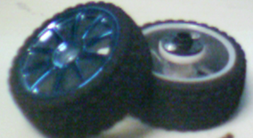
Drawing a 3D part includes two major steps:
- Sketch in 2D plane (sometime 3D space);
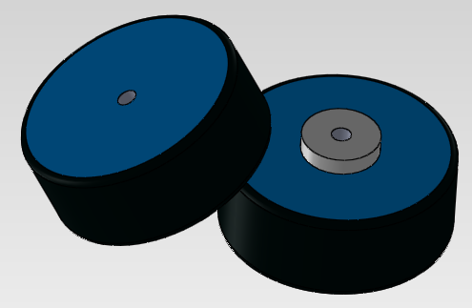
- Create 3D feature
In this lab, we are going to draw a wheel for the car as shown on the right.
1. Opening the program and a part file
Before sketching a part, we have to open a “Part file” for that.
It can be done as follow:

1.1 Click the SolidWorks icon to open the program.
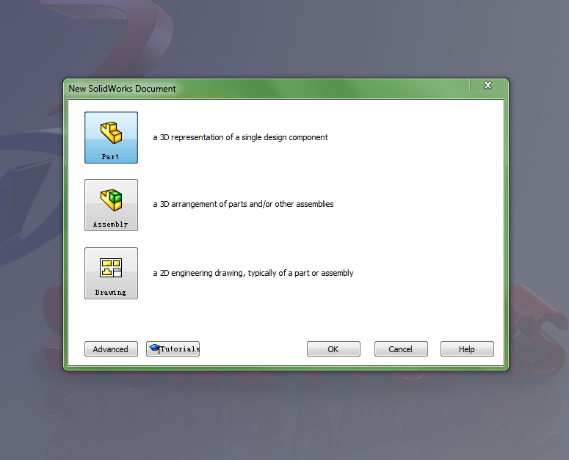
1.2 Open New document with icon located at the top-left and select “Part”
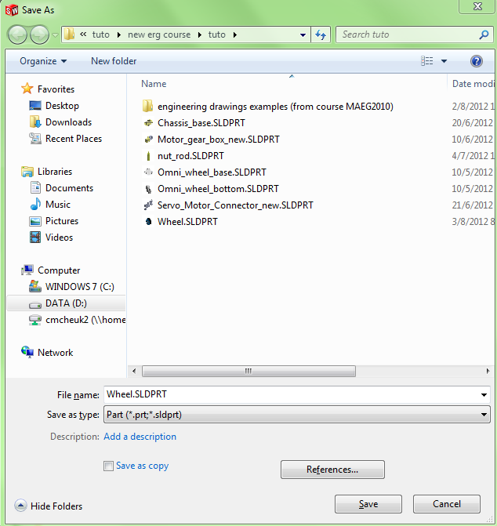
1.3 Press “Ctrl + S” to save the part and name it as “Wheel.SLDPRT”.
You may open a new folder to store the file for better management.

Now you have saved a new part file and ready for drawing new parts.

2. Sketch in 2D plane
After creating the parts, we can start the sketching. Sketching parts include following steps:
- Define the reference plane;
- Sketch with geometric tools;
- Define dimensions and geometry relationships for the sketches.
Normally, you can use a Varnier Caliper to measure the dimensions and assign them to the parts. You may also use a ruler if you don’t have a caliper in low accuracy designs. In this workshop, the dimensions are provided instead.

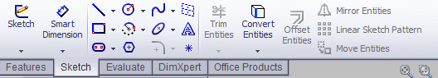
2.1 Click “Sketch” in the sketch tab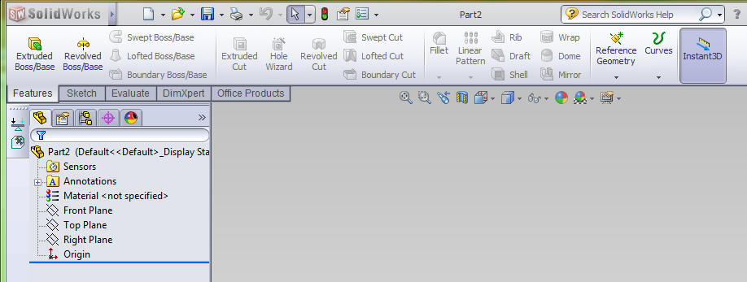
2.2 Define the reference plane by clicking the plane. Click “Front Plane” in this case.
After selecting the reference plane, it will enter the “Sketch Mode”.
Be remarked that you can select any existing plane and click Sketch to enter the sketch mode directly.
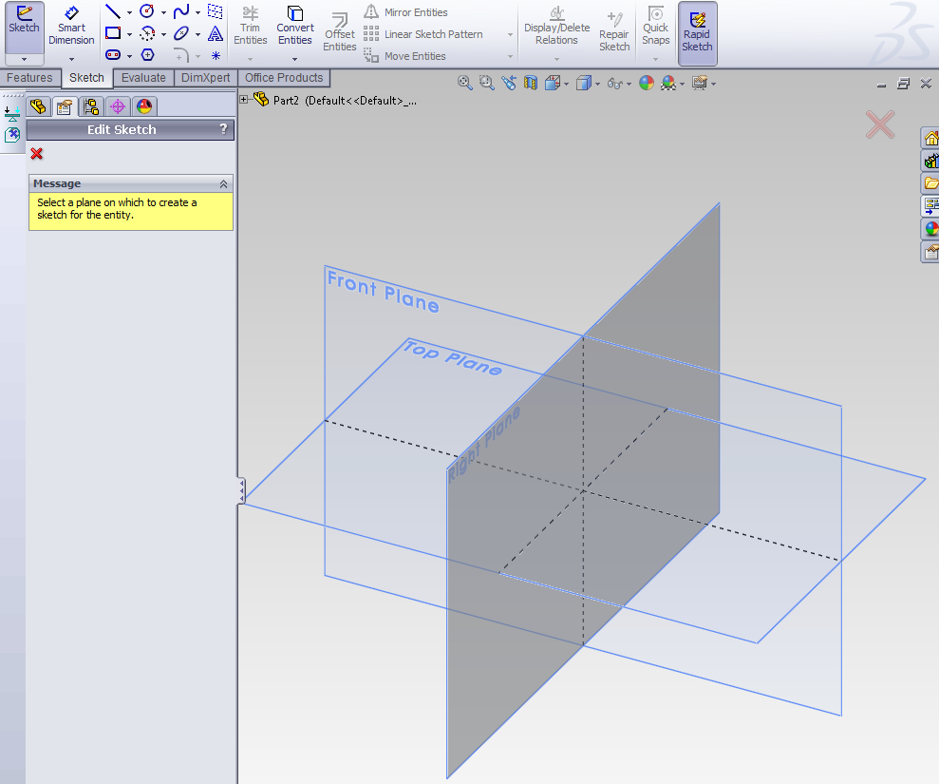
2.3 We will draw a circle on the front plane. Click the “Circle” on the toolbar at the top
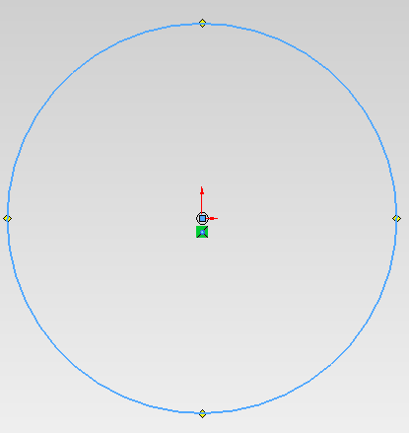
2.4 Define the center of the circle first. Move the cursor to the origin and click on it. The yellow icon with “T-shape” indicates that the center of the circle must be located at the origin.
Click on another point to define the circle. You don’t need to worry about the actual radius at the moment. We will define it later.
Press “ESC” if you want to cancel the previous step. You can also select any drawings and delete them if you wish.
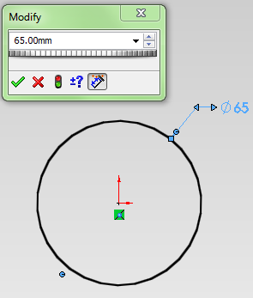
2.5 After definig the circle, it should be shown in blue which means the circle is not well defined (i.e. not all the parameters of the circle are fixed.)
In this case, we have fixed the location by fixing the center to the origin. We need to give the circle a radius / diameter.
Click the “Smart Dimension” icon on the Sketch toolbar and then select the circle.
Further click on the circle we have created. We can define the diameter of the circle by entering a number in the pop-up window now. Let’s enter “65mm” in this case.
At last, click on the transparent icon shown to confirm the dimensioning.

3. Adding 3D features from the sketch to the part
Now, we have sketches to create 3D features. We will try out the following features in this work:
- Extruded base – “Pulling up 2D Sketches”;
- Extruded cut – Cut 3D objects by “Pulling 2D Sketches”;
- Fillet – “Smoothing” the joints and corners.
We can use these featuring tools from the “Features” toolbar:
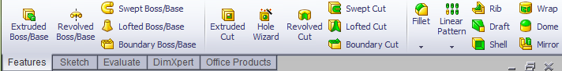
Let us construct a cylinder by extruding the circle sketch we have just constructed.

3.1 Exit Sketch Mode first.
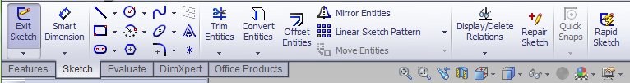

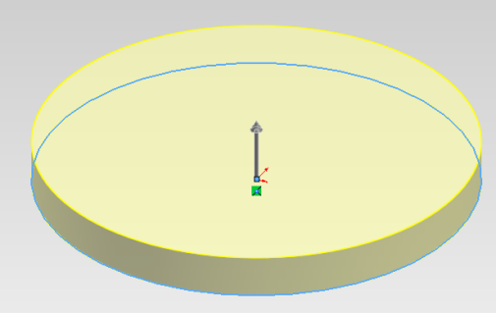
3.2 Select “Extrude Boss/Base” from the Features toolbar and click on the sketch.
The 2D sketch will be transformed into a 3D object as shown. We have to fix parameters for the feature so
DO NOT CLICK the “CONFIRM” button at the moment.
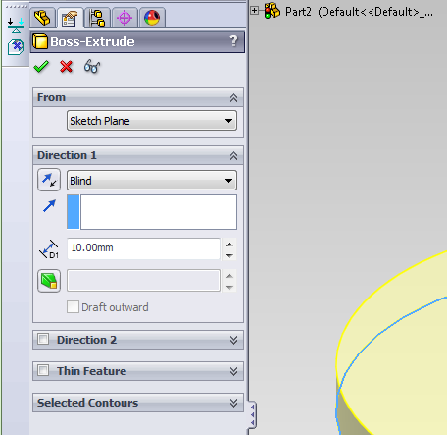
3.3 Assign parameters with the tab on the left. Input the “Direction” and “Dimension” as follow:
Afterward, click the tick to
confirm the changes.
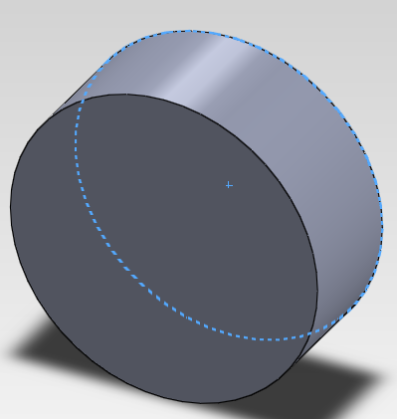
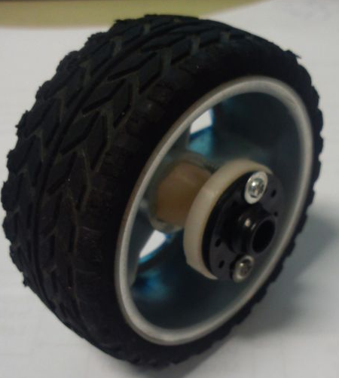
You should get this after confirmation.

4. Adding more features
It is too simple to describe the wheel with a single cylinder (e.g. no screw holes, edge of the cylinder should be smooth). More features should be included by the part such as making holes. We can do this by adding more sketches in different planes and create 3D features.
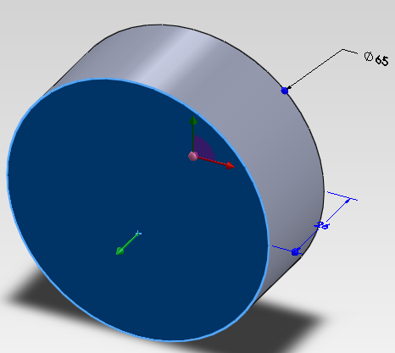
4.1 Define a new reference plane. Select one of the flat surfacs on the cylinder and click “Sketch”.
You may press “Ctrl + 1” and switch to the front view.
4.2 Sketch a “Cirlce” with diameter of “22mm” at the origin. Confirm the new sketch.
4.3 Exit sketch mode and “Extrude” towards outside for “5mm”. You should get something like this.
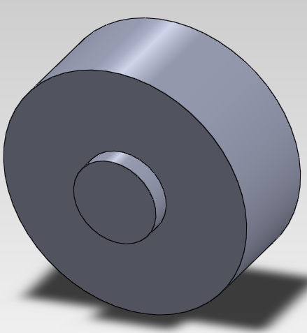
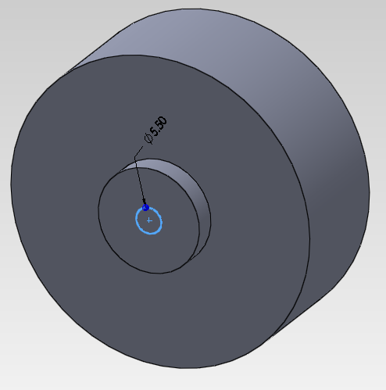
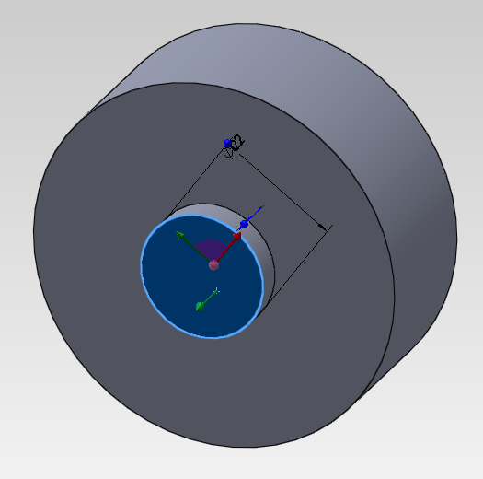
4.4 Further sketch a “Cirlce” with diameter of “5.5mm” on the flat surface of the small cylinder.
4.5 Select “Extrude cut” in the Features tab.
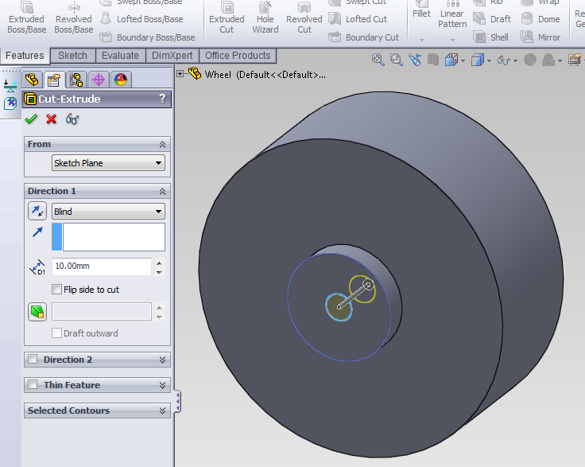
4.6 Use “Through All” for the direction option. It will cut through all 3D features in that direction and create a hole for that.
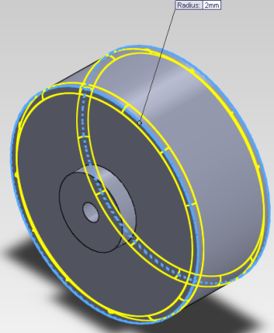
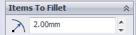
4.7 We will then “smoothen” the rims of the wheel. Click on the “Fillet” feature.
Set the filllet radius to “2mm” and select the two rims of the wheel. 3D wireframe preview will be provided for selected edges.
Click the Tick and confirm the changes.

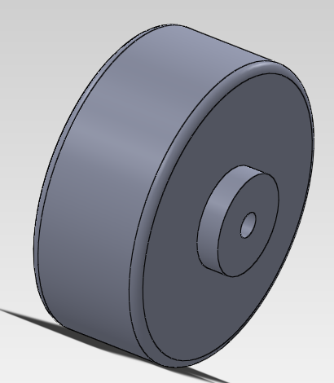
Now we have finished a much detailed wheel for the car and this can be used for assembling your car. You can compare it with the actual wheel we are using.

In actual designs, we have to strike a balance between the time used and the details of the parts. Accuracy should be considered as the “Thumb Rule” that your parts/models are described with accurate dimension and position.
5. Additional useful skill: changing color of the parts.
You may add color on the surfaces of your parts. It can be done as follow:
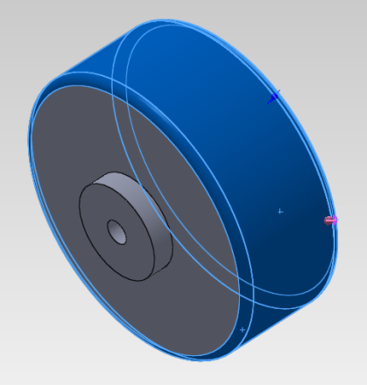
5.1 Select surface to be colored. You may press and hold the “Ctrl” key and select multiple surfaces.
In this case, we select the fillets of the rims and the
side surface of the wheel.
5.2 Right click to open the menu and click “Appearance” icon as shown.
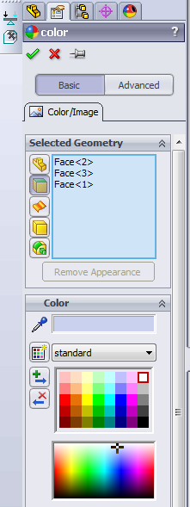
5.3 Click the selected faces: “Face<1> …….” to modify their appearance. The selected geometry will be listed on the left sub-window. You can then change the color of different surfaces and press the tick to confirm.
The laboratory exercise on “Part drawing” is ended here. Remember to press “Ctrl + S” and save your work. Please feel free to practice your skills by instructions given by your TAs. Do not hesitate to ask any questions if needed.

Part Assembly
After creating different parts, we can put them together and form an assembly of your final product. In the project, you are required to design different components and implement the car. In this process we can verify your design by assembling given parts (e.g. wheels, motors, omni-wheels) and preview your design. By this, you may know if your design meets the design requirements and constraints. For example, you may need to check:
- Are the holes for the screws and nuts are well aligned?
- Does a part clash with another part?
- Will the chassis block rotation of the wheels?
- etc.

The basic procedures of assembling parts are as follows:
1. Open a new assembly.
2. Insert necessary parts for assembling.
3. Define mating relationships between parts (e.g. concentric relationship for screws, nuts and the holes)
4. Modify the part if necessary. (If you find any problem.)

We will demonstrate the process by building a half-completed model of the intelligent car.

6. Creating assembly and adding parts
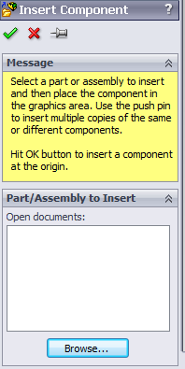
6.1 Create an assembly file and insert the base component. Click on the new document icon and select assembly for the new file first. After that, a new tab called “Insert Component” will be shown on the left.
Press “Browse” and search for “Car_base_universal.SLDPRT”. You don’t need to add other parts at the moment as you will not able to move parts which added in this stage. Press tick to confirm.
6.2 Import more parts as by clicking “Insert Components” in the Assembly toolbar.
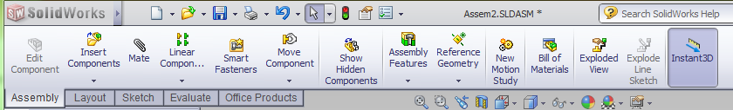
6.3 Click on the “Browse” button as previous and add the partson the right.
Added parts should be placed as shown below.

6.4 Some parts are needed more than once (e.g. we need 2 wheels) and we need to duplicate them. This can be done by selecting the part we want to make copies. Hold “Ctrl” key and Drag it with the mouse. Obtain enough amount of parts by this.
Parts name | number
 | 1
 | 2
 | 1
 | 1
 | 2
 | 1
 | 1
 | 2

7. Defining relationship between parts
We can define relationships between parts to assembly them as a whole in general.
We will introduce “Coincident” and “Concentric” in this exercise. Your TA will give you a simple tutorial on different kinds of geometric relationships. Coincident and concentric can be explained briefly as:

Coincident: Two planar surfaces “stitch” together [note: these planar surfaces are “Infinitely large”]
Concentric: Two cylindrical surfaces / circular features with centers/center-axis align.

Before working on it, let’s have a look at the final assembly (preview) of the car.

We will take the assembly of wheel and motor as an example.
The parts necessary for the assembly are shown in the right picture.

Left: Motor with gearbox;
Right: Wheel;

7.1 Click “Mate” on the “Assembly” toolbar.
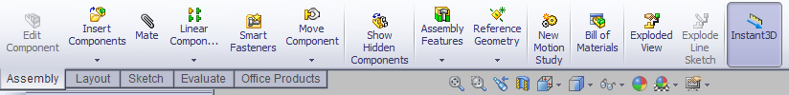
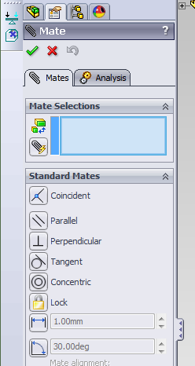
7.2 Select two planes / surfaces / lines in order to define relationships between them with the “Mate Selection”. In this case, we select inner red cylindrical surface on the wheel and then the red curved surface on the motor shaft.
7.3 Temporay mate result is shown after selecting the two surface. Make sure you have selected the correct mate selections and “Concentric” relationship. Sometimes you may click “Mate Alignment” to reverse the directions. You may also click the icon to reverse the direction. The result will be refreshed instantly.
7.4. Click to confirm this mate.
You may assign multiple relationships at single time so don’t close the “Mate” window.
7.5 Without closing the mating window, select 2 more surfaces: the Blue Selected flat surface on the wheel and the tiny Blue Selected flat surface on the base of the motor shaft.
7.6 Define a “coincident” relationship to them and they should be packed together as below. Afterward you can confirm this mate with:

You can further assemble other parts to finish the assembly, and therefore the entire car, by yourself. You may try out different geometry relationships during the assembly. Please work out the full assembly shown as your classwork.
Hint: the mounts pointed by arrows are “Mounting Mount Support” without any features on the inner surface.

