ENGG1100 Introduction to Engineering Design I
Engineering Faculty
The Chinese University of Hong Kong
Laboratory manual 6 – for Digital Logic (2)
Objectives
- Learn the fundamentals of digital logics
- Learn the operations of state machines

You are given the following apparatus:

- a Direct Current (DC) power supply
- a Smart-car board

Introduction
In this lab, we will study digital logic operations using the given Smart-car board. The lab consists of three experiments,

- The truth table approach
- The state machine without branch operation
- The state machine with branch operation

The experiments in this laboratory exercise show you how programs are used to implement digital functions for different applications. Here, you do not need to write the programs, you only need to perform the procedures and observe how the preloaded program generates the results.

At the end of the lab, you should understand
- The use of digital/ input output
- The truth table of a digital logic function
- How to design and implement a logic function with a predefined function (or truth table)
- How to design and implement a digital logic operation using a state diagram
- How a program in an embedded system (Arduino) controls a robot

Experiment 1: The Smart-car control logic by the truth table approach
In this section, you are required to examine the inputs and outputs of the Smart-car control logic by using the truth table approach, which is pre-loaded onto the Smart-car board, and your job is to complete the logic truth table.

The advantage of the truth table approach is that you do not need to know the Boolean functions of the controller for the robot. You only need to know the corresponding input/output relation, then you can construct the truth table using a program as shown below and the system will perform the required functions accordingly.

The disadvantage is that the function you can use is only combinational and the system has no memory of what it has performed previously, so only simple operations can be achieved. This problem will be solved by using a finite state machine approach to be described in experiment 2 and 3.

Experiment 1: The truth table approach
.
Procedures:
  - Connect the DC 9V power to the Smart-car board (no need to connect the Serial COM cable) , then turn on the power supply and turn on the power switch on the board.
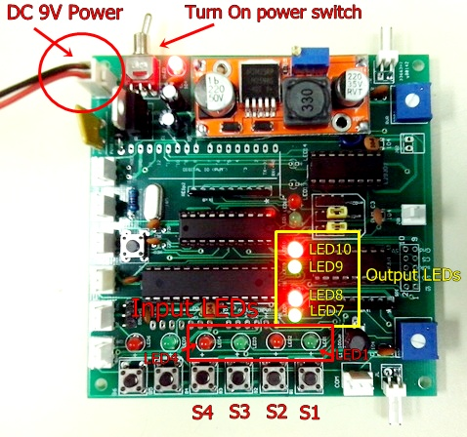
Figure 1.

  - Start to examine the different input combinations of S4 (LED4), S3 (LED3), S2 (LED2) and S1 (LED1) by pressing the corresponding push buttons as shown in the Figure 1, and record the outputs of LM1 (LED7), LM2 (LED8), RM1 (LED9) and RM2 (LED10).

NOTICE:
When you release Si (i=1 or 2 or 3 or 4), it will be at logic level ‘1’ the corresponding LED is off.
When you press Si (i=1 or 2 or 3 or 4), it will be at logic level ‘0’ the corresponding LED is on.
When LM1(or LM2, RM1, RM2) is at logic level ‘0’ the corresponding LED7(or LED8, LED9, LED10) is off.
When LM1(or LM2, RM1, RM2) is at logic level ‘1’ the corresponding LED7(or LED8, LED9, LED10) is on.

  - Record the outputs in the following table, and verify that the outputs agree with the program segment (Program_segment1) shown below.

Inputs |  |  |  | Outputs
S4 | S3 | S2 | S1 | LM1 | LM2 | RM1 | RM2
0 | 0 | 0 | 0
0 | 0 | 0 | 1
0 | 0 | 1 | 0
0 | 0 | 1 | 1
0 | 1 | 0 | 0
0 | 1 | 0 | 1
0 | 1 | 1 | 0
0 | 1 | 1 | 1
1 | 0 | 0 | 0
1 | 0 | 0 | 1
1 | 0 | 1 | 0
1 | 0 | 1 | 1
1 | 1 | 0 | 0
1 | 1 | 0 | 1
1 | 1 | 1 | 0
1 | 1 | 1 | 1
Table 1: Truth Table of Smart-car control logic

The source code of truth table approach (Program_segment1):
/****************************************************************************************
Truth Table approach
****************************************************************************************/
void LogicTable()
{
switch (IN_sensor) // 0b(S4)(S3)(S2)(S1)
{
case 0b1111 : LM1(1);LM2(0);RM1(1);RM2(0);
break;
case 0b1110 : LM1(1);LM2(0);RM1(0);RM2(0);
break;
case 0b1101 : LM1(0);LM2(0);RM1(1);RM2(0);
break;
case 0b0001 : LM1(0);LM2(0);RM1(1);RM2(0);
break;
case 0b0010 : LM1(1);LM2(0);RM1(0);RM2(0);
break;
case 0b0011 : LM1(1);LM2(0);RM1(1);RM2(0);
break;
case 0b0101 : LM1(0);LM2(0);RM1(1);RM2(0);
break;
case 0b0110 : LM1(1);LM2(0);RM1(0);RM2(0);
break;
case 0b0111 : LM1(1);LM2(0);RM1(1);RM2(0);
break;
default : LM1(0);LM2(0);RM1(0);RM2(0);
break;
}
}
Experiment2: State diagram of a state machine
In this section, you are required to study the state diagram of a state machine.

Start

Output: LM1,LM2,RM1,RM2=1010

State1

Move
Forward
After 2 seconds
After 2 seconds
After 2 seconds
After 2 seconds

State2
Turn
Left
State4
Stop

Output: LM1,LM2,RM1,RM2=0010
Output: LM1,LM2,RM1,RM2=0000

State3
Turn
Right

Output: LM1,LM2,RM1,RM2=1000

The advantage of using a state machine is that it is more flexible than a truth table approach and the system has memory. That means what it is doing now depends on what it has done before. In addition, it will affect what it is going to do next. The following experiment will show you that a robot can be controlled to repeat a fixed cycle: move forward for two seconds, turn left for two seconds and then turn right for two seconds, stop for 2 seconds and repeat the cycle again.
A demo video of the robot in action can be found at
http://www.youtube.com/watch?v=iyakbVyoafI&feature=youtu.be

However, this state machine because has no sensor input (no sensor ‘Si’ is used). It performs predefined operations without looking at the sensor inputs received from the environment. You may consider this robot as a blind robot at this stage.
The sample source code (program_segment2) is shown below:
switch(state)
{
case STATE1:
LM1=1;LM2=0;RM1=1;RM2=0;SPEED=200;DELAY_TIME=2000; // move forward for 2 seconds
motors(LM1,LM2,RM1,RM2,SPEED,SPEED,DELAY_TIME);
//
state=STATE2;
break;
case STATE2:
LM1=0;LM2=0;RM1=1;RM2=0;SPEED=200;DELAY_TIME=2000; // trun left for 2 seconds
motors(LM1,LM2,RM1,RM2,SPEED,SPEED,DELAY_TIME);
//
state=STATE3;
break;
case STATE3:
LM1=1;LM2=0;RM1=0; RM2=0;SPEED=200;DELAY_TIME=2000; // turn right for 2 seconds
motors(LM1,LM2,RM1,RM2,SPEED,SPEED,DELAY_TIME);
//
state=STATE4;
break;

case STATE4:
LM1=0;LM2=0;RM1=0;RM2=0;SPEED=200;DELAY_TIME=2000; // stops for 2 seconds
motors(LM1,LM2,RM1,RM2,SPEED,SPEED,DELAY_TIME);
//
state=STATE1; //go back to state 1 and repeat the cycle again
break;
default:
state=STATE4;
break;
}
Experiment2: The operation of a simple state machine
As mentioned above this state machine has no sensor feedback; it performs predefined operations without looking at the sensor inputs received from the environment.

Procedures:
- Connect input S5 to GND by using the dupont wire as shown in the Figure below.
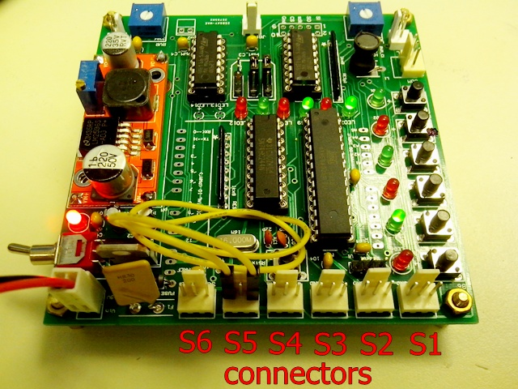
2. Connect the DC 9V power to Smart-car board (no need to connect the Serial COM cable) turn on the power supply and turn on the power switch on the board.

- Press the “Reset” button to start the program and record the outputs. (Press the Reset button when you need to restart the system)
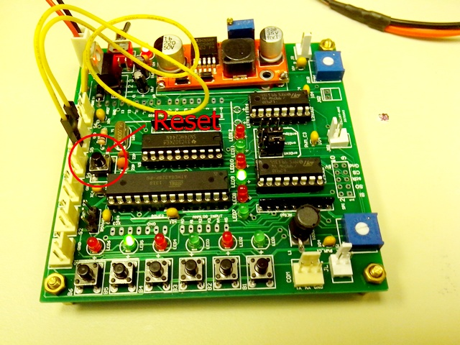

- Record the outputs in the table below.

- Explain the outputs based on program_segment2.

Time  (seconds) | LED Outputs
Time  (seconds) | LM1 | LM2 | RM1 | RM2
Reset
2
4
6
8
10
12
14
Table 2: Function table of state machine without sensor inputs (*LED = Light Emitting Diode)
Experiment3: A state-machine system with sensor inputs
In this section, you will study the state diagram of a state machine with sensor inputs. This state machine has sensor feedback (S1, S2 and S3 are used); the operations depends on predefined procedures as well as what it receives from the sensors outputs. The implementation below is designed for the robot to follow the magnetic strip from the start-point and stops at the end-point. However, the picking up of the obstacle is left as an exercise for students. The Smart-car with 3 sensors S1, S2 and S3, S1 is the left sensor, S2 is the right sensor and S3 is the front sensor. The Smart-car also has 4 output signals for controlling the 2 motors: LM1, LM2, RM1 and RM2, as shown in the Figure below.
S2
S3
S1
Obstacle
End point
RM1,RM2
LM1,LM2
Start point
The Smart-car is required to follow the magnetic stripe and stop if the front sensor S3 detects an obstacle (when S3 =’0’), or both sensors S1 and S2 detect the magnetic stripe at the end-point (when S1=’0’ and S2=’0’). A demo video of the robot in action can be found at
http://www.youtube.com/watch?v=JEQkuax7lKE&feature=youtu.be

The state diagram of the Smart-car logic can be represented by the state diagram below.

Start
Input: S3,S2,S1=111
Output: LM1,LM2,RM1,RM2=1010
Input: S3,S2,S1=111
Input: S3,S2,S1=101
Input: S3,S2,S1=101
Input: S3,S2,S1=110
Input: S3,S2,S1=101
Output: LM1,LM2,RM1,RM2=0000
Input: S3,S2,S1=111

State 1
Move
Forward
Input:
S3=0
OR
S3,S2,S1=100

Input: S3,S2,S1=110

Input: S3,S2,S1=110

State 2
Turn
Left
State 3
Turn
Right
Input:
S3=0
OR
S3,S2,S1=100

S3=0

Output: LM1,LM2,RM1,RM2=0010
Output: LM1,LM2,RM1,RM2=1000

State 4
Stop
Input:
S3=0
OR
S3,S2,S1=100

The sample source code (program_segment3) is shown below:

switch(state)
{
case STATE1:
LM1=1;LM2=0;RM1=1; RM2=0;SPEED=200;DELAY_TIME=10;
motors(LM1,LM2,RM1,RM2,SPEED,DELAY_TIME);
//
if ( S3()==1 && S2()==1 && S1()=0 ) state=STATE2;
else if(S3()==1 && S2()==0 && S1()=1) state=STATE3;
else if((S3==0) || (S3()==1 && S2()==0 && S1()=0)) state=STATE4;
break;

case STATE2:
LM1=0;LM2=0;RM1=1;RM2=0;SPEED=200;DELAY_TIME=10;
motors(LM1,LM2,RM1,RM2,SPEED,DELAY_TIME);
//
if ( S3()==1 && S2()==1 && S1()=1 ) state=STATE1;
else if(S3()==1 && S2()==0 && S1()=1) state=STATE3;
else if((S3==0) || (S3()==1 && S2()==0 && S1()=0)) state=STATE4;
break;

case STATE3:
LM1=1;LM2=0;RM1=0;RM2=0;SPEED=200;DELAY_TIME=10;
motors(LM1,LM2,RM1,RM2,SPEED,DELAY_TIME);
//
if ( S3()==1 && S2()==1 && S1()=1 ) state=STATE1;
else if(S3()==1 && S2()==1 && S1()=0) state=STATE2;
else if((S3==0) || (S3()==1 && S2()==0 && S1()=0)) state=STATE4;
break;

case STATE4:
LM1=0;LM2=0;RM1=0;RM2=0;SPEED=200;DELAY_TIME=10;
motors(LM1,LM2,RM1,RM2,SPEED,DELAY_TIME);
break;
default:
state=STATE4;
LM1=0;LM2=0;RM1=0;RM2=0;SPEED=200;DELAY_TIME=10;
motors(LM1,LM2,RM1,RM2,SPEED,DELAY_TIME);
break;
}

Experiment3: The state diagram of a state machine with sensor inputs

Procedures:
- Connect inputs S6 to GND by using the dupont wires as shown in the Figure below.
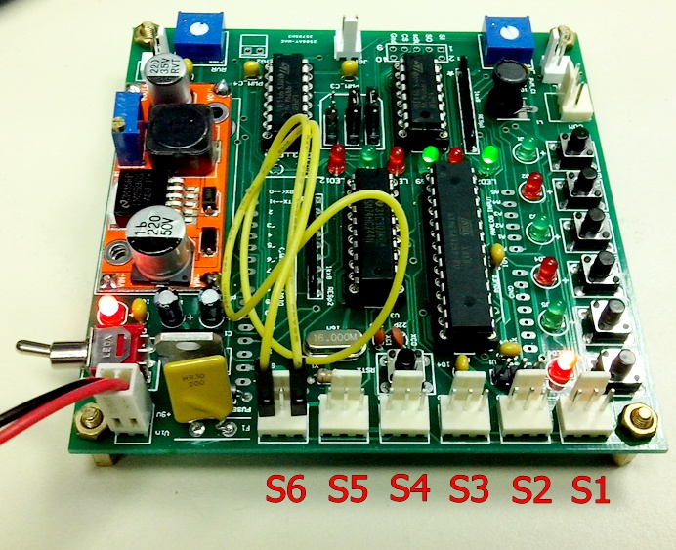
- Connect the DC 9V power to Smart-car board (no need to connect the Serial COM cable) , then turn on the power supply and turn on the power switch on the board.

- Press Reset button to start the program and record the outputs. (Press the Reset button to re-star the system)

- Fill in the table below.

Inputs |  |  | LED Outputs
S3 | S2 | S1 | LM1 | LM2 | RM1 | RM2
0 | 0 | 0
0 | 0 | 1
0 | 1 | 0
0 | 1 | 1
1 | 0 | 0
1 | 0 | 1
1 | 1 | 0
1 | 1 | 1
Table 3: Function table of the state machine with sensor inputs

- END -

