ENGG1100 Introduction to Engineering Design
Faculty of Engineering, The Chinese University of Hong Kong
Laboratory 5: Digital Logic (1)
Laboratory Record Sheet (Report sheet)
Group No: ____________, Date:_______________
Student 1:___________________(SID)_____________ ; Student 2:_____________________(SID)_____________
After your group has completed this lab work, demonstrate your results to the tutor and ask the tutor (TA) to sign below. Submit this sheet to the tutor within one week after this laboratory session finishes.
Name of the tutor/ signature of the tutor: ______________________ /___________________

Part I: Simple logic functions AND OR
Written exercise 1.1: Fill in the truth table of AND logic function. (No hardware experiment is required for this exercise)
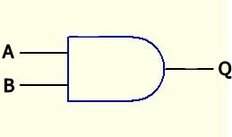  Inputs |  | Output
A | B | Q
0 | 0
0 | 1
1  AND logic | 0
1 | 1

Written exercise 1.2: Fill in the truth table of OR logic function. (No hardware experiment is required for this exercise)
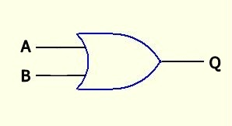  Inputs |  | Output
A | B | Q
0 | 0
0 | 1
1  OR logic | 0
1 | 1

Experiment 1.3: Fill in the truth table of AND logic function by experiment. (Hardware experiment is required for this and the following exercises)
LED_{i} can be “ON “ or “OFF; Out_{i} can be ‘0’ or ‘1’
Inputs |  |  |  | Outputs Q
S3 | S1 | LED3 | LED1 | LED7 | Out1
0 | 0 | ON | ON
0 | 1 | ON | OFF
1 | 0 | OFF | ON
1 | 1 | OFF | OFF

Experiment 1.4: Fill in the truth table of OR logic function by experiment. (Hardware experiment is required for this and the following exercises)
Inputs |  |  |  | Outputs Q
S3 | S1 | LED3 | LED1 | LED9 | Out3
0 | 0 | ON | ON
0 | 1 | ON | OFF
1 | 0 | OFF | ON
1 | 1 | OFF | OFF

Question:

Do the results on experiment 1.3-1.4 agree with exercise 1.1 -1.2?

Part 2: More complex combinational logic
Experiment 2.1: Fill in the truth table of the following complex logic function by experiment.
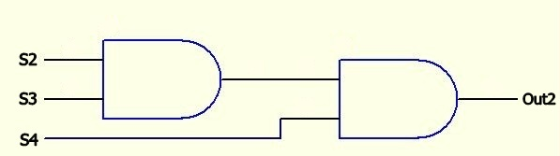
Out2 = (S2 AND S3) AND S4
Inputs |  |  |  |  |  | Output
S4 | S3 | S2 | LED4 | LED3 | LED2 | LED8 | Out2
0 | 0 | 0 | ON | ON | ON
0 | 0 | 1 | ON | ON | OFF
0 | 1 | 0 | ON | OFF | ON
0 | 1 | 1 | ON | OFF | OFF
1 | 0 | 0 | OFF | ON | ON
1 | 0 | 1 | OFF | ON | OFF
1 | 1 | 0 | OFF | OFF | ON
1 | 1 | 1 | OFF | OFF | OFF

Experiment 2.2: Fill in the truth table of the following complex logic function by experiment.
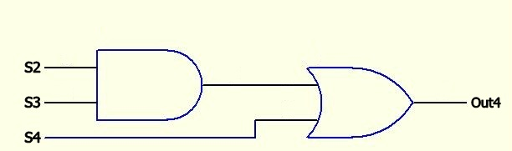
Out4 = (S2 AND S3) OR S4

Inputs |  |  |  |  |  | Outputs
S4 | S3 | S2 | LED4 | LED3 | LED2 | LED10 | Out4
0 | 0 | 0 | ON | ON | ON
0 | 0 | 1 | ON | ON | OFF
0 | 1 | 0 | ON | OFF | ON
0 | 1 | 1 | ON | OFF | OFF
1 | 0 | 0 | OFF | ON | ON
1 | 0 | 1 | OFF | ON | OFF
1 | 1 | 0 | OFF | OFF | ON
1 | 1 | 1 | OFF | OFF | OFF

Part 3: Motor control and sensor input
Experiment 3.1: Learn how to use the Smart Car system board to control motor.
Logic Inputs |  | Logic Outputs |  | Motor Operation
SW2 | SW1 | LED7 | LED8
0 | 0
0 | 1
1 | 0
1 | 1

Question:

Can you conclude from the above experiment, how the motor operation depends on the logic output 1 and logic output 2?

Experiment 3.2: Learn how to use the magnetic sensor to control motor.
Magnetic sensor status | Logic inputs |  | Logic outputs |  | Motor operation
 | SW2 | SW1 | LED7 | LED8
Away from magnetic strip | 1
Over the magnetic strip | 1

Question:

Can you conclude from the above experiment, what is the relation between the magnetic sensor connected on S1 and the switch SW1?

Conclusions and discussions

Write about 100 words on what you have learned from this laboratory exercise.

--END--

