ENGG1100 Introduction to Engineering Design I
Engineering Faculty
The Chinese University of Hong Kong
Document A: Laboratory Manual 5-- Digital Logic (1) ,
Document B: A tutorial of how to use the controller board
Document A: Laboratory Manual 5
Objectives
- Learn the basic concepts of digital logic
- Learn how to use the micro-controller based Smart-car board

Introduction
Logic devices are different from analogue circuits that they only operate on two logical levels: ‘0’ or ‘1’. Depending on hardware implementations, the actual voltage levels for logical levels ‘1’ and ‘0’ may vary from board to board. However, in our lab, level ‘1’ is 5 Volts, and ‘0’ is 0 volt. Here, we will study the logic operations (AND, OR, NOT etc.) of digital signals and see how they can be used for controlling our Smart-car board.

The block diagram of the Smart-car board is shown as on the following picture.
After you press reset, the program Lab5.ino inside the system will be run.

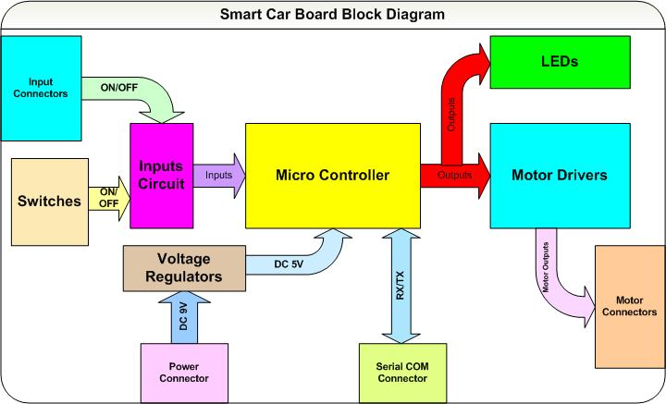
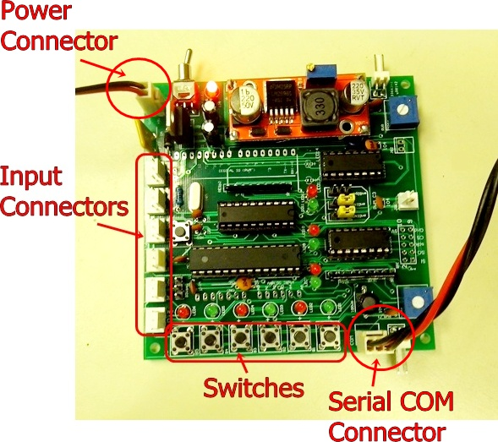
Fill in the truth tables and answer the questions in the lab record and report sheet 5

Part 1: Simple logic functions AND OR.

Written exercise 1.1 : Fill in the truth table of the AND logic function. (No hardware experiment is required for this exercise)
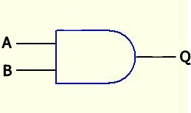
AND logic

Written exercise 1.2: Fill in the truth table of the OR logic function. (No hardware experiment is required for this exercise)

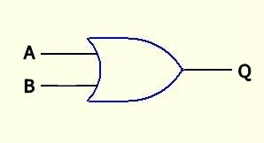
OR logic

Experiment 1.3: Fill in the truth table of the AND logic function after you completed the following procedures. (Hardware experiment is required for this and the following exercises)

//program segment in the main loop of Lab5.ino
void loop()
{ // Experiment 1.3 OUT1=S1 AND S3
if(Din1() && Din3()) Out1(1);
else Out1(0);
:
}

Procedures:

- Connect the DC 9V power to Smart-car board (no need to connect the Serial COM cable) turn on the power supply and turn on the power switch on the board.
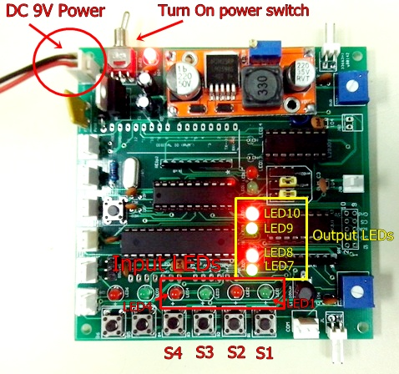
Figure 1.

- A program inside the system is written to simulate the AND operation with input S1=A, S3=B and LED7=Q of the diagram shown in experiment 1.1.

- Start to examine the different input combinations of S1 and S3 by pressing the corresponding push buttons as shown in the Figure 1, and record the output of Q (LED7 or out1)

NOTICE:
When you release Si (i=1 or 2 or 3 or 4), it will be at logic level ‘1’ the corresponding LEDi is off.
When you press Si (i=1 or 2 or 3 or 4), it will be at logic level ‘0’ the corresponding LEDi is on.
When Out1(or Out2, Out3, Out4) is at logic level ‘0’ the corresponding LED7(or LED8, LED9, LED10) is off.
When Out1(or Out2, Out3, Out4) is at logic level ‘1’ the corresponding LED7(or LED8, LED9, LED10) is on.

- Complete the truth table.

Experiment 1.4: Fill in the truth table of OR logic function.
//Program segment in the main loop of Lab5.ino
void loop()
{ :
// Experiment 1.4 OUT3=S1 OR S3
if(Din1() || Din3()) Out3(1);
else Out3(0);
:
}

- Connect the DC 9V power to Smart-car board (no need to connect the Serial COM cable) turn on the power supply and turn on the power switch on the board.
- A program inside the system is written to simulate the OR operation with input S1=A, S3=B and LED9=Q of the diagram shown in experiment 1.2.
- Start to examine the different input combinations of S1 and S3 by pressing the corresponding push buttons as shown in the Figure 1, and record the output of Q (LED9 or out3).
- Complete the truth table.

Part 2: More complex combinational logic

Experiment 2.1: Fill in the truth table of the following complex logic function.
//Program segment in the main loop of Lab5.ino
void loop()
{ :
// Experiment 2.1 OUT2=(S2 AND S3) AND S4
if((Din2() && Din3()) && Din4()) Out2(1);
else Out2(0);
:
}
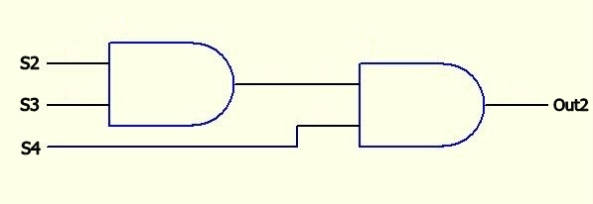
Out2 = (S2 AND S3) AND S4

- Connect the DC 9V power to Smart-car board (no need to connect the Serial COM cable) turn on the power supply and turn on the power switch on the board.

- Start to examine the different input combinations of S2, S3 and S4 by pressing the corresponding push buttons as shown in the Figure 1, and record the output of Out2 (LED8).

- Complete the truth table in the lab record sheet.

Experiment 2.2: Fill in the truth table of the following complex logic function.
//Program segment in the main loop of Lab5.ino
void loop()
{:
// Experiment 2.2 OUT4=(S2 AND S3) OR S4
if((Din2() && Din3()) || Din4()) Out4(1);
else Out4(0);
}

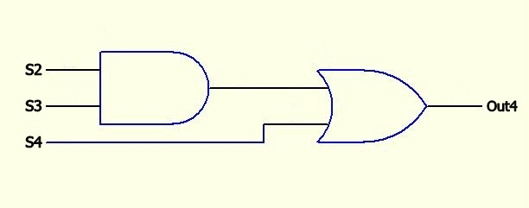
Out4 = (S2 AND S3) OR S4

- Connect the DC 9V power to Smart-car board (no need to connect the Serial COM cable) turn on the power supply and turn on the power switch on the board.

- Start to examine the different input combinations of S2, S3 and S4 by pressing the corresponding push buttons as shown in the Figure 1, and record the output of Out4 (LED10).

- Complete the truth table in the lab record sheet.

Part 3: Motor control and sensor input

Experiment 3.1: Learn how to use the Smart Car system board to control the motor

Connect a motor to the left motor output connector JL as shown in the figure.

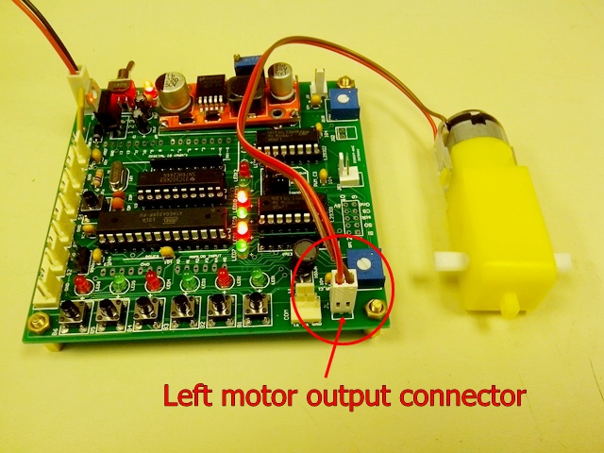
CLOCKWISE
Observe the relation between the logic inputs, logic outputs and the motor operation. Then fill in the table and answer the questions in experiment 3.1 of lab record sheet 5
NOTICE:
When you release Si (i=1 or 2 or 3 or 4), it will be at logic level ‘1’ the corresponding LEDi is off.
When you press Si (i=1 or 2 or 3 or 4), it will be at logic level ‘0’ the corresponding LEDi is on.
When Out1(or Out2, Out3, Out4) is at logic level ‘0’ the corresponding LED7(or LED8, LED9, LED10) is off.
When Out1(or Out2, Out3, Out4) is at logic level ‘1’ the corresponding LED7(or LED8, LED9, LED10) is on.
Procedures:
- Press SW1 and press SW2 at the same time, that means logic input 1 and logic input 2 are both set to “0” ((LED1=ON and LED2=ON).). Record the logic output 1 and logic output 2 in the first line of the table by observing the LED7 and LED8, if the LED is on, that means the logic output is “1” otherwise the logic output is “0”. Record the motor operation whether the motor is moving CLOCKWISE, ANTI-CLOCKWISE or STOP.

- Press SW2 only that means logic input 1 is “1” and logic input 2 is “0” (LED1=OFF and LED2 =ON). Record the logic output 1 and logic output 2 in the 2nd line of the table by observing the LED7 and LED8, if the LED is on, that means the logic output is “1” otherwise the logic output is “0”. Record the motor operation whether the motor is moving CLOCKWISE, ANTI-CLOCKWISE or STOP.

- Press SW1 only that means logic input 1 is “0” and logic input 2 is “1” (LED1=ON and LED2 =OFF). Record the logic output 1 and logic output 2 in the 3rd line of the table by observing the LED7 and LED8, if the LED is on, that means the logic output is “1” otherwise the logic output is “0”. Record the motor operation whether the motor is moving CLOCKWISE, ANTI-CLOCKWISE or STOP.

- Without pressing SW1 and SW2 that means logic input 1 is “1” and logic input 2 is also “1” (LED1=OFF and LED2 =OFF). Record the logic output 1 and logic output 2 in the 4th line of the table by observing the LED7 and LED8, if the LED is on, that means the logic output is “1” otherwise the logic output is “0”. Record the motor operation to see whether the motor is moving CLOCKWISE, ANTI-CLOCKWISE or STOP.

Experiment 3.2: Learn how to use the magnetic sensor input to control the motor

Connect a magnetic sensor to the S1 connector as shown in the figure.
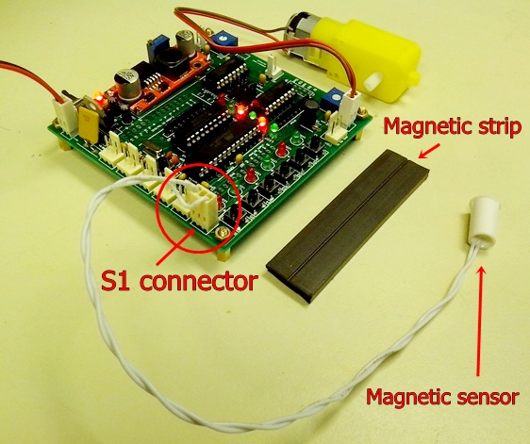

Observe the relation between the magnetic sensor status, logic inputs, logic outputs and the motor operation. Then fill in the table and answer the questions in experiment 3.2 of lab record sheet

Procedures:
- Keep the magnetic sensor away from the magnetic strip as shown in the figure. Record the SW1 and SW2 states by observing LED1 and LED2 (keep in mind that input LED ON means the logic state is “0”, otherwise it means “1”). Record the logic output 1 and logic output 2 in the first line of the table by observing the LED7 and LED8, if the LED is on, that means the logic output is “1” otherwise the logic output is “0”. Record also the motor operation whether the motor is moving CLOCKWISE, ANTI-CLOCKWISE or STOP.

- Put the magnetic sensor over the magnetic strip as shown in the figure. Record the SW1 and SW2 states by observing LED1 and LED2 (keep in mind that input LED ON means the logic state is “0”, otherwise it means “1”). Record the logic output 1 and logic output 2 in the first line of the table by observing the LED7 and LED8, if the LED is on, that means the logic output is “1” otherwise the logic output is “0”. Record also the motor operation to see whether the motor is moving CLOCKWISE, ANTI-CLOCKWISE or STOP.

- END -
Document B: A tutorial of how to use the controller board
Introduction
The above experiments use code provided by your professors. For your project, you need to write your own code using the method introduced in this document.
The system setup of the controller board is shown below.
The demo programs used in our experiments 5 (Lab5.ino) and 6 (Lab6.ino) can be found at the eLearning site. https://elearn.cuhk.edu.hk/webapps/login/
Smart Car Programming Tutorial
In this tutorial, you are going to learn how to program the Smart car board. You have to bring the completed Smart car board to the lab. So, before attending this lab session, please finish your Smart car board soldering and testing.

Tutorial 1: Getting start with Smart car board programming

Procedure:
- Download the Arduino source code lab5.ino from the ENGG1100 home page.
- Open the lab5.ino by double click it. It will be opened in Arduino programming environment.
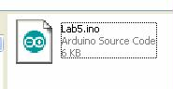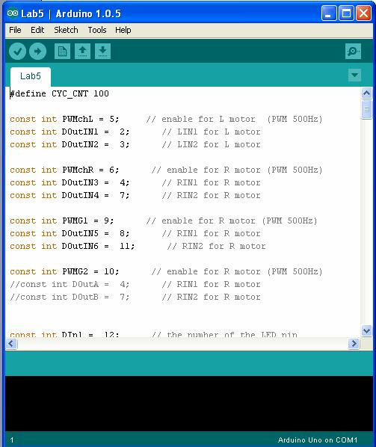
- Make sure the Tools -> Board is set to Arduino Uno and the Tools -> Serial Port is set to correct COM port. (The COM port number for Arduino download cable can be check from the Device Manager.)
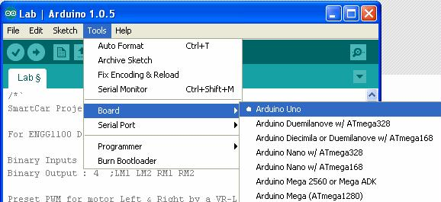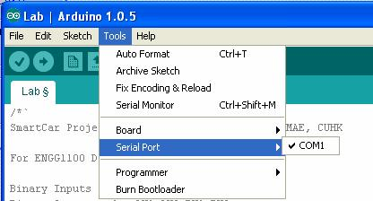

- Connect the DC 9V power and Serial cable to the Smart car board. Turn on the power supply.

- Press the Upload button to compile and up load the source code to Smart car board.
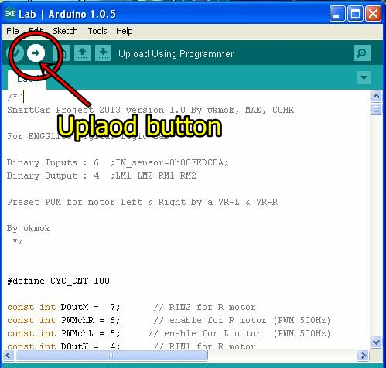
- It starts to compile the source code and the message Compiling sketch…should be displayed on the screen.
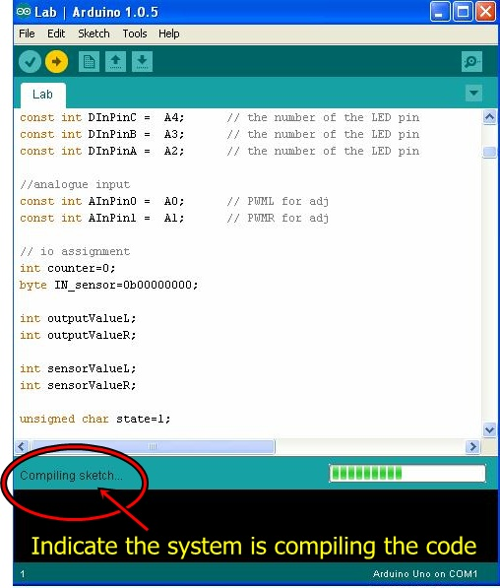
- When the system finishes compiling, it will start to upload the program to the board automatically and the message “Uploading… “ will be shown. Press the “Reset” button immediately on the Smart car board, a long delay in pressing “Reset” may cause error.
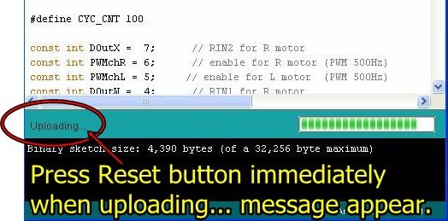

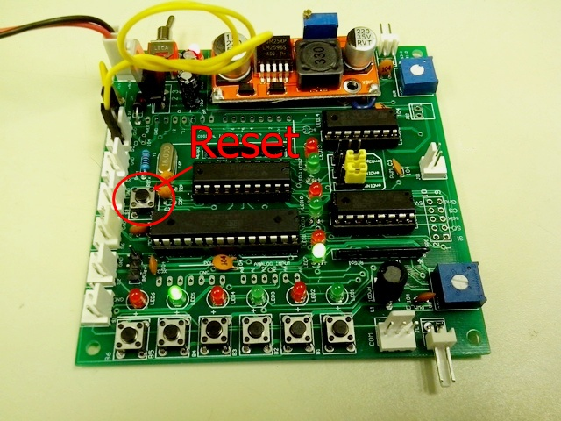
- When uploading is successfully, the following screen will be displayed.

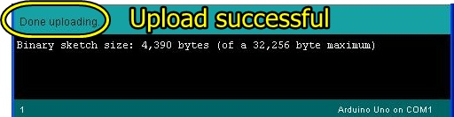
You may run your program by pressing the Reset button.

References
  - Arduino Language Reference (http://arduino.cc/en/Reference/HomePage)
  - Getting Started w/ Arduino on Windows (http://arduino.cc/en/Guide/Windows)
  - Digital Logic Basic (http://educypedia.karadimov.info/library/ch2_1.pdf)
  - Arduino Tutorial (http://video.mit.edu/watch/arduino-tutorial-1-10950/)
  - Lab5.ino from https://elearn.cuhk.edu.hk/webapps/login/
Appendix1
//Program segment in the main loop of Lab5.ino
void loop()
{ // Experiment 1.3 OUT1=S1 AND S3
if(Din1() && Din3()) Out1(1);
else Out1(0);
// Experiment 1.4 OUT3=S1 OR S3
if(Din1() || Din3()) Out3(1);
else Out3(0);
// Experiment 2.1 OUT2=(S2 AND S3) AND S4
if((Din2() && Din3()) && Din4()) Out2(1);
else Out2(0);
// Experiment 2.2 OUT4=(S2 AND S3) OR S4
if((Din2() && Din3()) || Din4()) Out4(1);
else Out4(0);
}

- END -

