ENGG1100 Introduction to Engineering Design I
Faculty of Engineering
The Chinese University of Hong Kong

Laboratory 4: Sensors and Actuators
You have already learnt some basics of electronic circuits. In the first part of this laboratory, you will study magnetic and mechanical switches which will be used in your project. In the second part of this laboratory, you will learn how to drive a DC motor uni-directionally and bi-directionally using a power supply and an H-bridge circuit. In the third part of this laboratory, you will learn to use an electronic device, a motor driver L293D with a built-in H-bridge circuit to control the motor.

Part 4-1. Magnetic and mechanical switches
Switch is a basic electronic device which connects or breaks the circuit. We use the terms “closed” or “open” to name the status between two terminals. Sometimes, a switch has three terminals, namely Common, Normal-open (NO) and Normal-close (NC). The Common terminal connects to either NO or NC as a toggle function.

Experiment 4-1.1 Magnetic switch.
In this experiment, we will use a reed relay (single pole) as the magnetic switch. The product is commonly used for sensing of door open or close, for security purpose. Here, we will use it to sense a magnetic track in the project. The device we used is of normal-open (NO) mode. It means that it will be closed when the device is exposed to a sufficiently strong magnetic field.

In this experiment, we will use one of the sensor parts (Sensor-2) of the experimental board. Parts Sensor-1 and Sensor-2 are of the same circuit.

Apparatus:
1. A DC power supply
2. A wired magnetic switch sensor (normal-open) with a magnet
3. A 10~20mm long magnetic strip
4. L293D experimental board

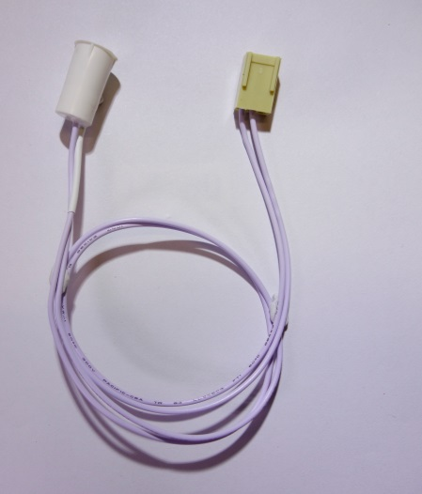  Magnetic sensor | 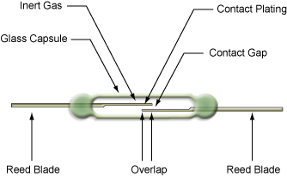  Reed relay structure
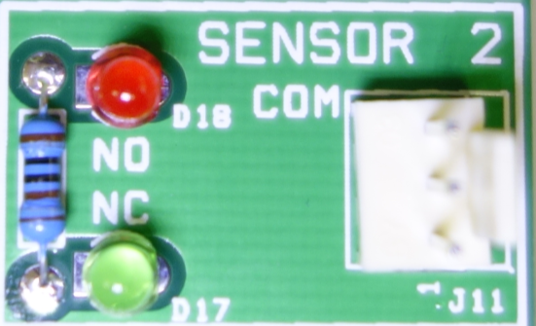  Part Sensor-2 of L293D board | L293D board

Procedures:
- Set the power supply output to 5V with the current limit less than 1Amp.
- Using a pair of DC power cords, connect “GND” (BLACK) and “+” (RED) terminals of the power supply to the screws, named “+GND” and “+5V”, at the top and the bottom corners of the experimental board. Then, power off the power supply or disconnect the DC power cord (RED terminal only) until the whole circuit setup is completed.
- Plug the magnetic sensor to the socket at Part Sensor-2 on the experimental board.
- Power-ON the power supply or reconnect the DC power cord to turn on the whole experimental board.
- Move the magnet (White) from far end toward the magnetic sensor and measure their separation when the sensor is first toggled to “closed” state, which lights up the LED D18 .
- Find the effective and correct position of the sensor.
- Move a magnetic sensor from far end toward the magnetic strip and measure their maximum lateral separation and angular displacement which starts to toggle the sensor into “closed” state. The results will be useful in your project.

Question: What positions you should adopt to detect the magnetic strip and the soft drink can in your project?

Experiment 4-1.2 Micro switch
In this experiment, we will use a micro switch which has three terminals (single pole double throw). One terminal is named “Common” and the other terminals are named “Normal-open, NO” and “Normal-close, NC”. Under normal position, “Common” is connected to “NC”. “Common” will be connected to “NO” when you press the switch handle and change the switching state. You may use this kind of switch for the actuator or other mechanical detections in the project.

Apparatus:
1. A DC power supply
2. A wired micro switch (three terminals)
3. L293D experimental board

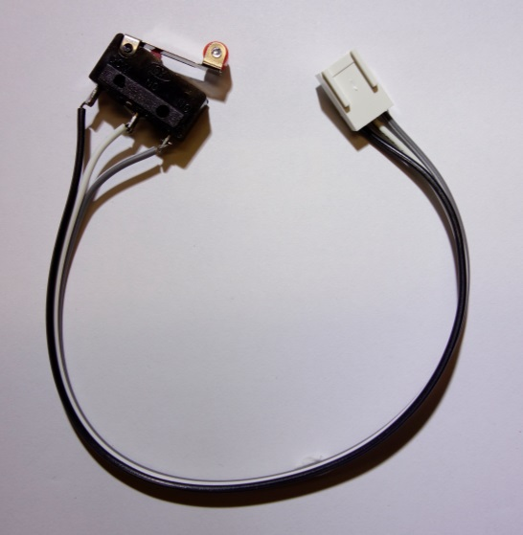Micro switch | 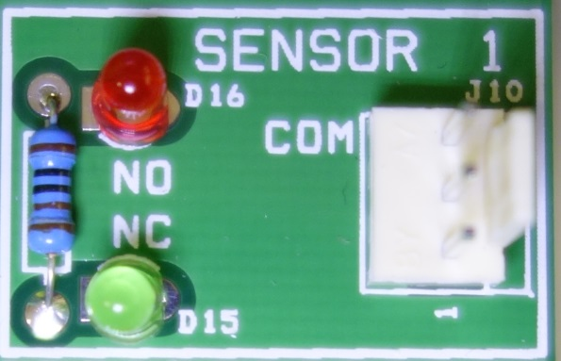  Part Sensor-1 of L293D board.

Procedures:
- Set the power supply output to 5V with the current limit less than 1Amp.
- Using a pair of DC power cords, connect “GND” (BLACK) and “+” (RED) terminals of the power supply to the screws, named “+GND” and “+5V”, at the top and the bottom corners of the experimental board. Then, power off the power supply or disconnect the DC power cord (RED terminal only) until the whole circuit setup is completed.
- Plug the micro switch to the socket at Part Sensor-1 on the experimental board.
- Power On the power supply or reconnect the DC power cord to make the experiment board with power. LED16 (Green) should be lit, which indicates that the terminals “Common” and “NC” are connected at this moment.
- Press the handle of the switch, record the changes of LED15 and LED16.

Question: Describe the implication of this change.

Part 4-2. Driving a DC motor

A DC motor comprises electrical wires wound on a metal holder as an electromagnet. When a DC current passes through the wire, a magnetic force will be generated and makes the holder rotate. You can change the motor’s rotating direction by changing the direction of current flow in the wire.

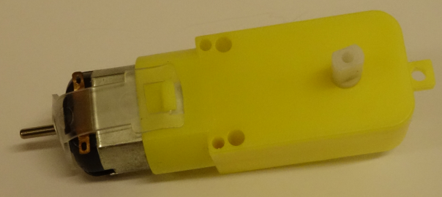

Experiment 4-2.1 Driving a DC motor with a DC power supply directly.
In this experiment, we will drive a motor to rotate in two directions by a DC power supply.

Apparatus:
1. A DC power supply
2. An H-bridge experimental board
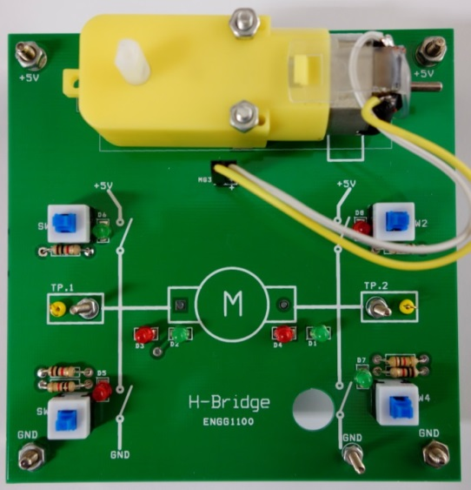  The H-Bridge Board. | The circuit of motor and D1~D4.
Procedures:
- Set the power supply output to 5V with the current limit less than 1Amp.
- Connect “GND” (BLACK) and “+” (RED) terminals of the power supply to the screws, named “TP.1” and “TP.2”, respectively, with a pair of DC power cords. Two of the LEDs D1-D4 should be lit and the motor should rotate.
- Swap the connections of the DC power cords between TP.2 and TP.1. Record and describe the changes to the LEDs and the rotating direction of the motor between Steps 2 and 3.
- Mark down the lighting status of the LEDs (D1-D4), as either “lit” or “off” and the rotating direction of the motor, as “clockwise (CW)” or “counter-clockwise (CCW)”, according to power supply’s polarity.

Input |  | Results
TP1 | TP2 | Motor direction | D1 | D2 | D3 | D4
5V | GND
GND | 5V

Question: Describe the relationship between the rotating direction of the motor and the power supply’s polarity (or direction of current flow).
Experiment 4-2.2 Driving a DC motor by an H-Bridge circuit.
You have learnt how to control the DC motor’s rotating direction, via the control of the polarity of the power supply applied to the motor. It is not feasible and practical to disconnect and reconnect the power cords by human to control the motor’s rotating direction. A circuit named H-bridge, which consists of four switches, is used to control the current flow to the motor.
The individual LEDs D5-D8, next to the switches, will be lit when the respective switch is ON (shorted/closed).
When SW1 or SW2 is closed, TP1 or TP2 will get high voltage (5V).
When SW3 or SW4 is closed, TP1 or TP2 will get low voltage (0V).
Note: Monitor the power supply’s “Constant Current” status. When the CC LED is lit, it means that the output of the power supply is being SHORTED. Therefore, please set the power supply with the current limit less than 1Amp.

The circuit of the H-Bridge board.

Apparatus:
1. A DC power supply
2. An H-bridge experimental board
3. A wheel (yellow color)
4 A two channel oscilloscope

Procedures:
- Set the power supply output to 5V with the current limit less than 1Amp.
- Using a pair of DC power cords, connect “GND” (BLACK) and “+” (RED) terminals of the power supply to the screws, named “+GND” and “+5V”, at the top and the bottom corners of the experimental board.
- Connect the reference points (crocodile clips) of both oscilloscope probes to the “GND” point of the experimental board.
- Connect the probe tip of channel-1 (CH-1) to TP1 and probe tip of channel-2 (CH-2) to TP2.
- Change the status of the switches, SW1 to SW4, on the board. Record the current flow direction and the rotation direction of the motor, together with the on-off state of the CC LED, under different switching state combinations of the switches, SW1-SW4.
- Note the cases when the power supply’s constant current (CC) LED is lit.
If the CC LED of the power supply is on, it means that the switches are shorting the output of the power supply.
- Plug the wheel into the motor’s gear box axis. Use different switching state combinations of the switches to run and stop the wheel.

Sample table for data recording (Use the one provided in Lab Sheets)
Input |  |  |  | Results
SW1 | SW2 | SW3 | SW4 | DC Motor |  | CC LED (on/off)
 |  |  |  | Current flow direction | Rotation direction

Question: Which switching state combination(s) of the switches may be useful in your project.

Experiment 4-2.3 Driving a DC motor bi-directional with an electronic component, motor driver.
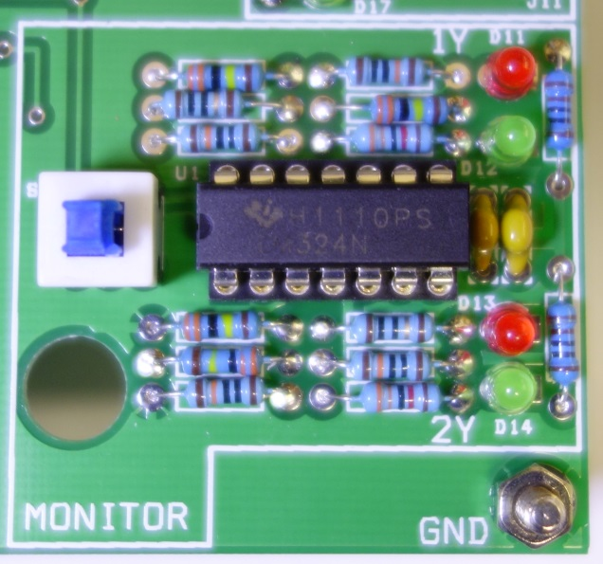  Monitor part of L293D board | 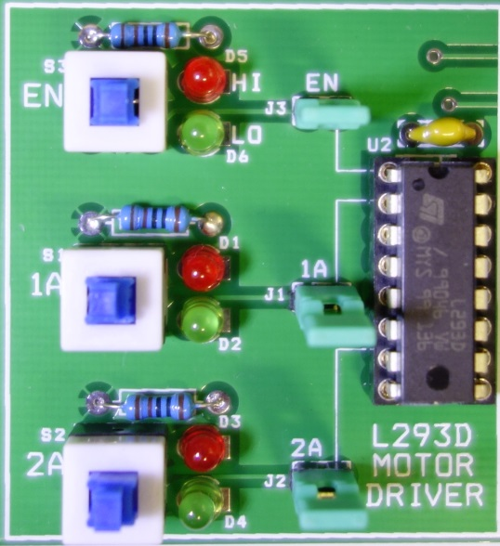  L293D part of L293D board.

It is not desirable to control the on/off and direction of the motor by pressing the mechanical switches. Practically, an electronic component, motor driver (L293D), is used to form an H-bridge so as to control the motor and prevent some prohibited cases.

We have already learnt the logic states, High (H) and Low (L). When a pin in the electronic circuit is idle or disconnected, it is of high impedance (Z). Thus, its logic level may be affected by the environment. We will try this Z case in this experiment.
Extra information: In IEEE-1164 standard, it describes a digital signal with 9 logic levels. ‘U’, ‘X’, ‘0’, ‘1’, ‘Z’, ‘W’, ‘L’, ‘H’ and ‘-‘.

Notes:
- The experimental board is designed for 5V supply only.
- There are five circuits on the board: a Motor part, the L293D part, and a Monitor part and two sensors parts.
- EN1, 1A, 2A, 1Y and 2Y are the terminals of the L293D.
- M1 and M2 are the terminals of the motor.
- LEDs D7 and D8 indicate the current directions of the motor.
- J4 and J5 connect M1 and M2, respectively, to be logic High/Low or connect to the L293D outputs.
- Green LEDs indicate that the logic level of that signal is LOW.
- Red LEDs indicate that the logic level of that signal is HIGH.
- Switch S4 Up means the monitor circuit is connected to M1 and M2. The impedance of M1 and M2 will be slightly affected by the monitor circuit.

Apparatus:
1. A DC power supply
2. An L293D experimental board
3. L293D data sheet

Procedures:
- Set the power supply output to 5V with the current limit less than 1Amp.
- Using a pair of DC power cords, connect “GND” (BLACK) and “+” (RED) terminals of the power supply to the screws, named “GND” and “+5V”, at the top and the bottom corners of the experimental board.
- Connect the reference points (crocodile clips) of both oscilloscope probes to the “GND” point of the experimental board.
- Connect the oscilloscope’s CH-1 and CH-2 probes to screw points, M1 and M2, respectively.
- Set Jumper selectors, J4 and J5, to M-D positions.
- Press the switch S4 and set it be in UP position (connect the monitor circuit to M1 and M2).
- Press the switches, EN1, 1A and 2B, and set them to high. At this moment, all red LEDs of the L293D and the monitor circuits are lit.
- Change the switching state combinations of the switches, EN1, 1A and 2A. Record the outputs of 1Y, 2Y as well as the current flow direction and the rotating direction of the motor. Tabulate your results in the table provided in the Lab Sheet.
- Use the oscilloscope to monitor the voltages at M1 and M2. Describe the current flow direction through LEDs, D7 and D8, when anyone of them is lit.
- Press the switch EN1 down to set it as logic LOW. At this moment, L293D’s 1Y and 2Y are of high impedance (check L293D data sheet). Mark down the logic level of 1Y and 2Y.
- Use your finger to touch the screw, M1 or M2. Record the effect on 1Y and 2Y. Does your finger affect the status of 1Y and 2Y? What are the effects?
- Remove the reference point (the crocodile clips) of the oscilloscope’s probe from the board. Record the effect on 1Y and 2Y. Is there any difference in the results between Step 11 and Step-12?

Questions:
- Describe the relationship between the motor’s current flow, rotation direction and the driver inputs’ combinations. Which input combinations can drive the motor run or stop?
- What is the implication, when EN1= low and we touch the M1 or M2 pin?
Experiment 4-2.4 Driving a DC motor unidirectional with an electronic component- motor driver.

One L293D device contains four drivers. We have learnt how to drive the motor bi-directionally with two drivers (a half of a L293D). In this experiment, we will learn to use one driver (a quad of a L293D) to drive a motor unidirectionally.
Apparatus:
1. A DC power supply
2. An L293D experimental board
3. L293D data sheet

Procedures:
- Set the power supply output to 5V with the current limit less than 1Amp.
- Using a pair of DC power cord, connect “GND” (BLACK) and “+” (RED) terminals of the power supply to the screws which named “GND” and +5V”, at the top and the bottom corners of the experimental board.
- Connect the reference points (crocodile clips) of both oscilloscope probes to the “GND” point of the experimental board.
- Connect oscilloscope’s CH-1 and CH-2 probes to screw points, M1 and M2.
- Set Jumper selector J4 (M1) to H-M position, J5(M2) to D-M position.
- Press the switches, EN1, 1A and 2A. Set them in the UP position and logic HIGH.
- Press the switch S4, set the switch UP (connect the monitor circuit to M1 and M2).
- Press the switches, 1A and 2A, for different combinations. Mark down the motor’s current flow direction, rotation direction and the switching state combinations. Tabulate your results in the table provided in the Lab Sheet.
- Repeat the above steps from Step 5. Set Jumper selector J4 (M1) to L-M , J5(M2) to D-M position. You have to make your own table to tabulate the results.
- Repeat the steps from Step 5. Set Jumper selector J5 (M2) to L-M and H-M positions, J4(M1) to D-M position. Try different switching state combinations and record the results. Tabulate your results in the table provided in the Lab Sheet.

Questions:
- Describe the relationship between the current flow direction and the rotation direction of the motor, as well as the driver inputs’ combinations. Which input combinations can drive the motor run or stop?
- Referring to the project requirements, suggest a solution of using L293D to control the motors in your project. Which motor(s) needs bi-directional motion and which motor(s) needs unidirectional motion only? How to control them to perform the given tasks?
Experiment 4-2.5 Use a motor to do mechanical works.
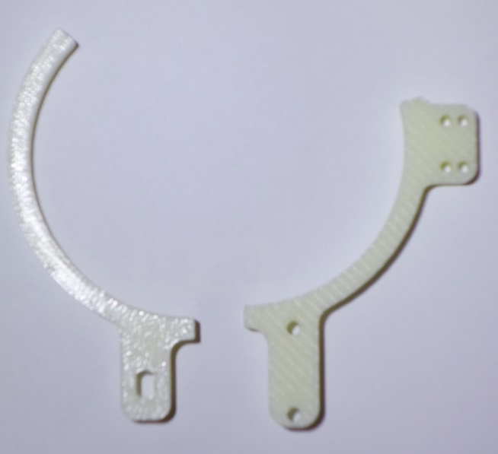
A pair of gripper parts.

We have learnt how to drive a motor with a driver IC (L293D). In this experiment, we will try to grip a soft drink can with a simple gripper. This technique will be useful in your project.

Apparatus:
1. A DC power supply
2. A 5V DC motor with the gear box
3. An L293D experimental board
4. L293D data sheet
5. A wired micro switch
6. A wired magnetic sensor
7. A simple gripper (two mechanical parts)

Procedures:
- Set the power supply output to 5V with the current limit less than 1Amp.
- Using a pair of DC power cords, connect “GND” (BLACK) and “+” (RED) terminals of the power supply to the screws which named “GND” and “+5V”, at the top and the bottom corners of the experimental board.
- Mount the gripper to the motor’s gear box. The parts with one hole should be mounted on the gear box’s axis. The parts with two holes should be mounted on the gear box’s screws.
- Mount the micro switch onto the gripper, which one has two holes with two M2 size screws and nuts.
- Try to control the gripper to grip a soft drink can by controlling the EN, 1A and 2A switches.

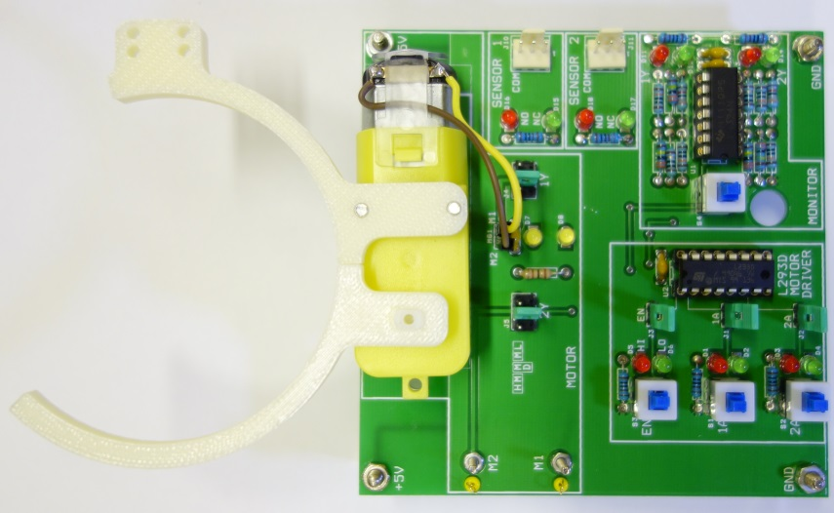
The gripper be mounted on the motor gear box

Question:
Mark down the sequence of the switch setting to grip and release the can. Suggest the solution for your project.

