ENGG1100 Introduction to Engineering Design
Faculty of Engineering
The Chinese University of Hong Kong
Laboratory Manual 3: Electronics Basics II

Objectives and aims:
- To learn how to use electronic testing and analysis equipment
- To learn the techniques of soldering for circuit building

Introduction

Circuits may contain static signals that do not change with time; We can use a multi-meter to measure them. On the other hand, circuits may contain time varying signals that change with time; we then need an oscilloscope to observe these signals. The oscilloscope is a widely used instrument. In this Lab session, you will learn how to use such equipment. The lab exercises also show you how to record and take measurements. Please down load, printout and read the lab manual and lab record sheet (from the eLearning system) before coming to the lab.

Assembling circuits is an integral skill in many fields in engineering. It can be used to build a circuit as a final product, or for the purpose of testing and prototyping a new idea. There are at least two ways of circuit assembly: using the breadboard or soldering. The techniques of using soldering for assembling a circuit will be introduced in this lab exercise.

Please read the lab manual thoroughly before attending the lab!

By completing this laboratory session, you should know:

1. How to use an oscilloscope to perform various kinds of measurements
2. How to solder a circuit well

Laboratory Procedures

Part 1. Oscilloscope

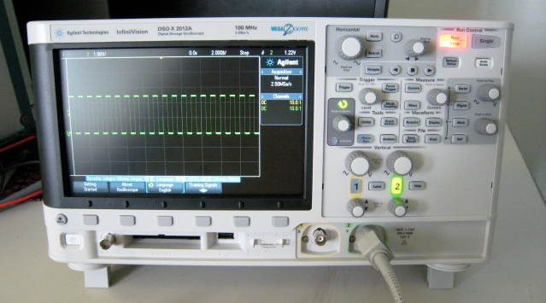 | 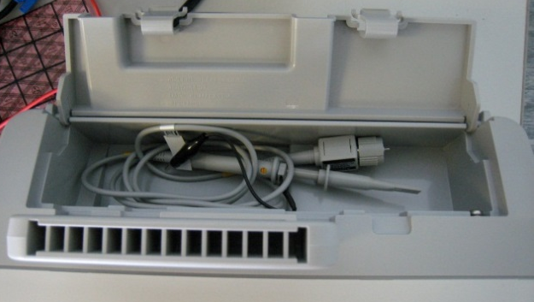
Figure 1a: A typical oscilloscope | Figure 1b: Some probes are stored on top of the oscilloscopes
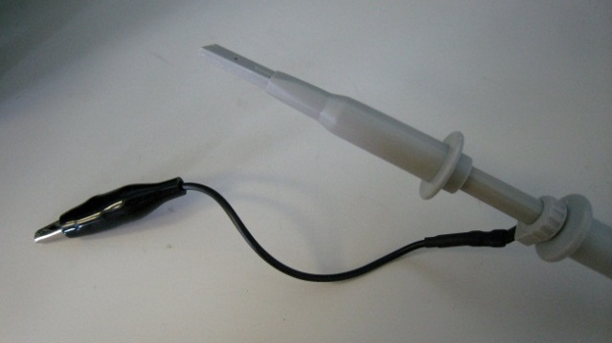 | 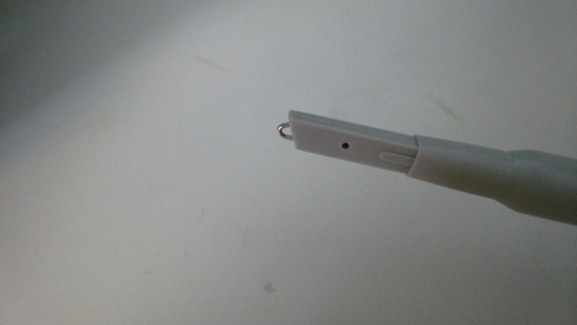
Figure 1c: A probe. The black clip is to be connected to the ground. Press the white cap lightly to expose the measurement tip | Figure 1d: The measurement tip has a small hook. Rotate the white cap slightly to cover the tip after use
Figure 2: Some common periodic signals (left: Sine wave, right: Square wave)

General Hints for using the oscilloscope:
- Depending on your application, you should select the appropriate coupling mode (AC or DC) of operations for your oscilloscope.
- If it is not specified, we will use the DC coupling mode of operation in this laboratory.
- The “trigger selection” of your oscilloscope should be set at the “Edge” mode and the probe should be selecting the “10x” mode. Check these settings before you begin your measurements.
- You may need to adjust the “volt/div” and “sweep-time/div” selectors manually to obtain a better view of the signal.
- Try to use different methods to record the waveforms in order to learn more skills in operating this equipment.
Time variant signals can be obtained with sensors like the microphone; or they can be generated by a computer. The Signal Generator is a specially designed machine for generating periodic signals of different shapes and forms. They are very useful in education, testing and design purposes.

Experiment I: Time-domain signal measurement

In this section, you will practice how to use an oscilloscope and generate signals through a simple experiment. Don’t hesitate to ask the TAs if you have any questions.

The following apparatus will be provided:
- an oscilloscope and a signal generator (Wave Gen)

The signal generator is used to generate periodically voltage-varying signals. If you want to learn more, there is a separate tutorial on the use of the oscilloscope. We will start with using the oscilloscope to measure signals (in time-domain meaning voltage varying against time) generated by the signal generator.

Experiment I, procedures:
- Connect the oscilloscope probe to the signal generator output. Use the oscilloscope to observe the waveforms of the following settings.
- Plot the waveforms and label clearly the axes for each plot (for example, voltage in Volts and time in ms). The required settings are (Note: Peak-to-peak voltage = Pk-Pk, Frequency =F) :
  - Pk-Pk =1 Volt , F = 20Hz, Waveform :Sine, Offset = 0 Volt
  - Pk-Pk =2 Volts , F = 200Hz, Waveform :Sine, Offset = 0 Volt
  - Pk-Pk= 1 Volt , F = 2KHz, Waveform :Square, Offset = 0 Volt
  - Pk-Pk= 1 Volt , F = 20Hz, Waveform :Square, Offset = 0.5 Volts

** You must plot the waveforms by hand, photocopying is not acceptable)

- State the similarities and differences between the waveforms of (2a) and (2b)
- State the similarities and differences between the waveforms of (2a) and (2c)
- State the similarities and differences between the waveforms of (2a) and (2d)

Part 2. Soldering

Soldering is usually the final step in assembling a circuit after it is verified by the method of breadboard or wire wrapping. Soldering is generally considered as a permanent process, although de-soldering (using a solder removal suction pump) is a possibility.

Soldering is often be applied to printed circuit boards (PCBs) or prototype boards.
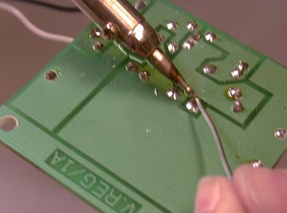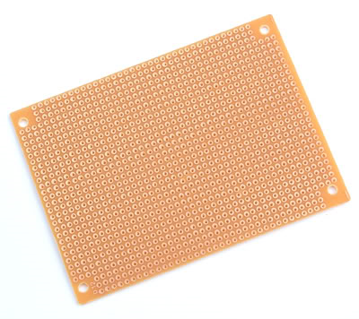
Figure 3: (left) PCB, (right) prototype board

Improper use of the soldering iron can cause serious injuries. A briefing on soldering will be provided before you are allowed to start the following experiment. Please read the precautions listed in the appendix before you start!

You will first be asked to practice your soldering skills using a prototype board in experiment IIA. Then you will be asked to solder your project system board in experiment IIB
Be reminded that the project system board will be used for your project. Make sure you complete the soldering work accurately and nicely. Also you should keep your board in a secure place after it is given to you, because you will be using it for your project for the rest of the term

Experiment II-A: Soldering exercise using the Prototyping Board

In this section, you will practice how to solder components on a prototyping board. Don’t hesitate to ask the TAs if you have any question.

The following apparatus will be provided:
- A prototyping board
- Soldering Iron
- Three 5.1 KΩ resistors
- Multimeter

Procedures:
- Place the resistors (5.1 KΩ each) side-by-side on the component side of the prototyping board. There should be an empty column (of holes) between resistors.
- Solder the resistors to make sure they are firmly fixed on the board.
- Bend the pins of each resistor so that all three resistors are connected in parallel. Solder the circuit.
- Measure the resistance of the resistor network by a multi-meter. It should be 1.7 KΩ if you make every connection correct. Can you explain why it is 1.7 KΩ?

Experiment II-B: Soldering components onto a Printed Circuit Board (PCB)

In this section, you will solder the project system board. The PCB given has pre-fabricated circuit on it.

The following apparatus will be provided:
- Soldering Iron
- Components & system board PCB.
- System board PCB
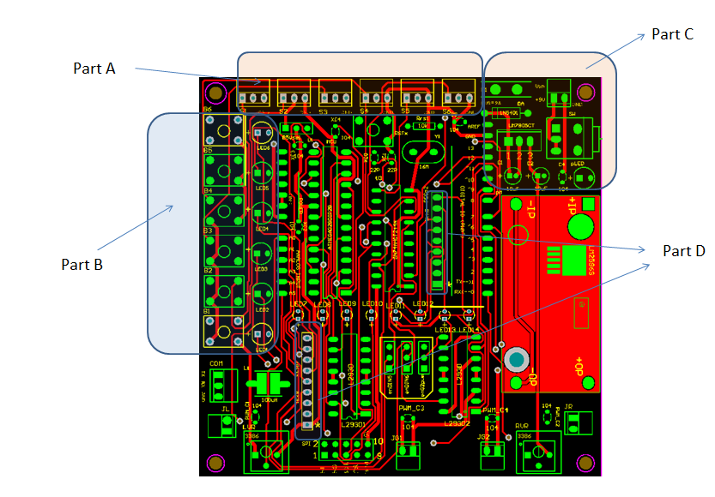
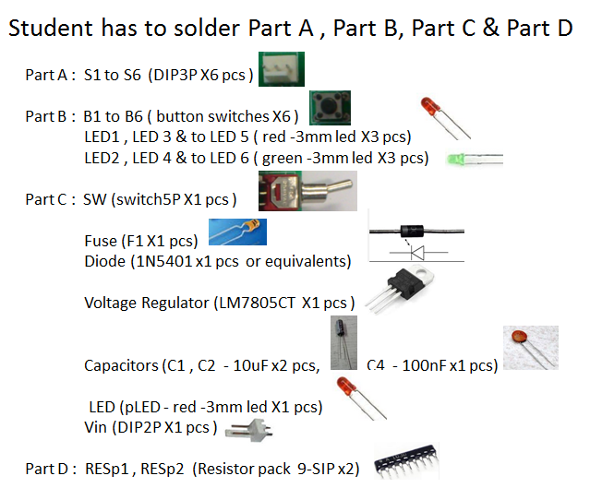

Procedures:
- Place and solder the components given. Start with the flattest and smallest components first.
- Functions of each part,

Part A is the input sensor inlets of the system board,

Part B is for the input buttons with LED indicators,

Part C is the regulated power unit of the system board.

Part D is the resistor networks for limiting currents for LEDs.
- Feel free to ask TAs for help. They will help you to test whether your board is working or not.
- There are still some missing components. They will be provided later in the coming laboratory sessions!

-End-

Appendix

A.1. What are Peak, Peak-to-Peak, and RMS Voltage?

When measuring AC signals, especially using an oscilloscope, you will see measurements like peak voltage, peak-to-peak voltage, and root-mean-squares (RMS) voltage. Their differences are as follows:
- Peak voltage is the highest level of the signal
- Peak-to-peak voltage is the difference between the peak and trough of the signal. For example, in the figure below, a signal is symmetrical at zero volt (like, the following sine wave), we have.
- RMS voltage is the root mean square value of the signal, defined as, where T is the period and V(t) is a function representing the voltage in time. For sine waves, you can assume that

Peak, peak-to-peak, and RMS voltages for a sine wave.

A.2. Rules for good soldering.

[The soldering iron]

- Make sure the tip is clean. After a soldering iron is turned on for a while, it may develop a coating of oxide on the tip. This may lower the efficiency of the equipment. The oxidation can be removed by melting fresh solder onto the tip ("tinning") and then wiping it with a moist rag or sponge.
- After extensive use, the tip may become pitted. Therefore, the contact area from the tip of the soldering iron to the target joint may be reduced. Hence, soldering may become difficult. A rub with plain paper or a wet rag will help to clean the tips. Dirty copper tips may be cleaned with a fine emery paper or a file (though this may clog the file). However, some specially treated tips labeled with long-life surfaces MUST NOT be treated with emery paper or a file. Ask the TAs or techniques to help if your soldering iron is not functioning well.
- Wait until the iron is sufficiently hot before soldering.
- For big joints, particularly onto a metallic chassis, the tip should be sufficiently large.

[Soldering]

Soldering flux (a kind of wax like material) is needed to allow the molten solder to "wet" the surfaces being jointed. It is usually not necessary to apply flux separately as a solder wire already provides flux inside the wire.

- Tinning. It is recommended to run solder onto all wires, tags, terminals, pigtails etc., before attempting to form a joint. Components which have been exposed to the atmosphere for a long time develop an oxide layer which may require scraping e.g. with sandpaper.
- Forming the joint. Heat the surfaces to be jointed, and run the solder onto these surfaces. If thermal contact to the iron is poor, better heat conduction may be obtained by running solder onto the iron as well. Make sure the iron heats the surfaces being jointed, and not just the solder. The iron should be removed as soon as the solder has formed a clean wet joint (i.e. with a concave meniscus to the surfaces being jointed).
- For experimental work. Do not twist wires around soldering lugs to obtain greater mechanical strength. It makes stripping down and recovery of components very difficult.
- Soldering aluminum is extremely difficult. Soldering metals other than tin, copper and brass may require specially activated fluxes. Some of these are corrosive and must be completely removed after soldering.

[Dry joints]

It is absolutely essential that no movement occurs while the solder is solidifying otherwise a DRY JOINT could result. A dry joint is one in which the electrical contact may be unreliable even though mechanical bondage appears quite firm. Dry joints may not manifest their presence until after many hours of apparently satisfactory operation. Failure due to dry joints may be intermittent, and therefore difficult, time consuming and frustrating to detect.

Dry Joints may also occur as a result of unsatisfactory or no tinning and incorrect tip temperature. If too cold, solder may not wet the surfaces. If too hot, the flux may be evaporated.

Prolonged heating of the solder evaporates the flux and may result in a dry joint. It is for this reason that the iron must be removed as quickly as possible after a joint has been formed.

Note: If unsatisfied with a joint, do not try to reform it by applying the iron to the same solder. Clean off all the cooked solder with the iron, and start again with fresh solder.

[Heat sensitive components]

  - Solid-state and some devices may be damaged by heat during soldering. The following precautions should be taken.
    - If several leads are being soldered, those from the heat sensitive devices should be soldered last.
    - The heat may be shunted away from the device by gripping the lead in the jaws of a set of pliers.
    - Heat must be applied for the least practicable time. The joint should be reasonably small if possible. Note that transformer leads are often soldered onto the winding. Indiscriminate application of heat may melt this internal Joint.
  - Overheating printed-circuit boards (PCB) may cause lifting of the copper strip. Before proceeding to attempt to de-solder a component off a PCB, make sure that there is no risk of damage to the PCB.
  - Note that the plastic insulation on some wires (and especially coaxial cables) melts at a low temperature.
  - Beware of the power on soldering irons. Tips may become overheated if the switch is allowed to remain ON for too long.

Reference
http://en.wikipedia.org/wiki/Soldering

