**ENGG1100 Introduction to Engineering Design**

**Faculty of Engineering**

**The Chinese University of Hong Kong**

**Laboratory 2: Electronics Basics I**

Week 4, 2013 Fall

|  |
| --- |
| Welcome to the first electronic lab in this course. As you may have learnt of it last week, the aim of this course is to introduce to you the basic concepts of mechanical engineering, electronic engineering and computer engineering. In particular, electronics will play a very important role here.  The objective of this laboratory session (and the following lab) is to learn basic electronic graphical language and practical skills. We will introduce you how to construct circuit from schematic and how to use various instruments. Your TAs will guide you through the lab in a step-by-step manner.  By completing this laboratory session, you should know: |
| 1. how to read schematic and implement the circuit described; 2. how to use multimeters to perform various kinds of measurements; 3. how to make circuits with breadboard; |
| Recording data properly from a laboratory experiment is part of the learning process in this course. As such, you are required to design and fill in a lab sheet attached at the end of this lab manual. **We will provide Lab Sheet templates/examples of Lab 2 and Lab 3 (provided in eLearning system). However, from Lab 5 and onwards, you will be required to prepare your own lab sheets *BEFORE* attending the lab. Without proper preparation, you are not allowed to start your lab.** |
| **Please read the lab manual thoroughly before attending the lab!** |

1. **Circuits, Schematics and Electronics**

As an engineer, a fundamental skill that you need to master is how to read professional diagrams. In this section, we will learn what a circuit is, how to read schematics of electronic circuits and how to implement them as real circuits.

**Schematics** are made up of **component symbols** and **connections**. You may consult the diagram below for some common examples of the component symbols.



**Figure 1**: Symbols of different electronic components

We will revisit the usage of some of these components in later laboratory sessions.

Schematics are diagrams that describe how electronic components are **connected** to make useful **circuits**. Simply speaking, assembling a circuit is about making **connections** between the components. As such, it is very important to learn how to read schematics. There are some basic rules that you should be aware of while reading/drawing/implementing a schematic.

There are a few rules about drawing a schematic:

1. A circuit must contain a **closed loop** or else there will be no current flow and non-functional.
2. A circuit usually contains a **power source**.
3. Connections are treated as **nodes**. Each node is considered as a set of **Electrical Connection.**

* A circuit must contain a **closed loop**



**Figure 2**: Closed loop circuits

A closed loop means that electricity can flow through the circuit and return to the position that it originates from. Without a closed loop, the circuit is **open** and the circuit cannot function.

* A circuit usually contains a **power source**

A power source can be represented in a number of ways (here, we only show the illustrations for a direct current (**DC**)power source):



**Figure 3**: Different representations of power sources

You may notice that the last representation does not seem to give a closed loop circuit. In fact, it is still describing a closed loop circuit. Moreover, the three circuits shown are essentially the same.

* Connections are treated as **nodes**

In a schematic, the connections between components are represented using a line. You should bear in mind that these lines serve only one purpose in the diagram, i.e., to make connection. It doesn’t matter how they are drawn, what matters most is that the components are connected to different **nodes**. An example is shown on Figure 4 on the next page.



**Figure 4**: The three circuits are equivalent in terms of their connections

One can verify that all the three circuits in Figure 4 are the same, despite the fact that they look different from each other. When you are “**implementing**” (in other words, “Building”) your circuit according to schematics, **make sure** you have **wired all** **components’ terminals** which belong to that node together.

Nevertheless, reading circuits is a skill that needs practice to improve. Through this course you will get plenty of experience on that. The simplest way of making connections/assembling a circuit is to make use of the **crocodile clips** to aid you.

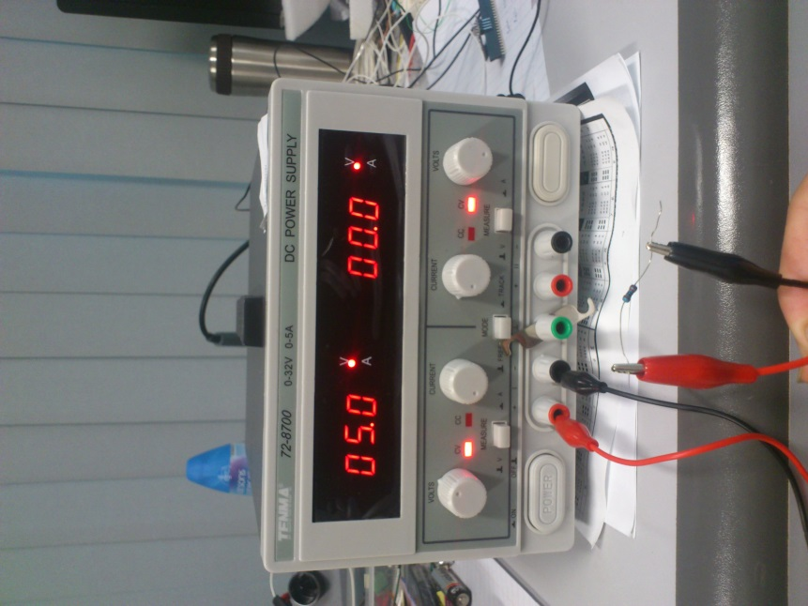

Crocodile Clips

Resistor

Power supply

**Figure 5**: Connecting a simple circuit with crocodile clips

There are more sophisticated ways to build complex circuits, e.g., soldering, wire wrapping or using a breadboard. We will introduce them one by one in the next 2 lab sessions. However, in this lab, we shall focus on using crocodile clips.

When you are constructing a circuit, doing measurements, etc., make sure that the **metal parts** are touching each other whenever you want to make a connection.

1. **Multimeter**

Multimeter is a meter that can take a variety of electrical measurements. It can measure DC voltages, AC voltages, current (both DC and AC), and resistance. It also serves many different test purposes, e.g., checking if a connection between is shorted or broken, testing the operation of diodes and transistors (like, are they faulty or not?), to name a few.

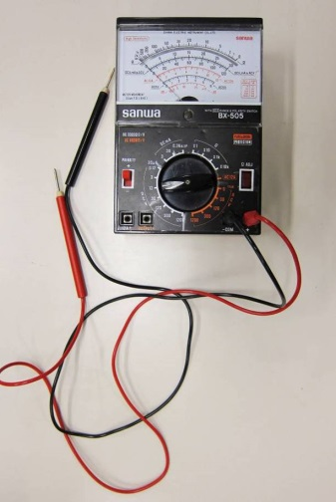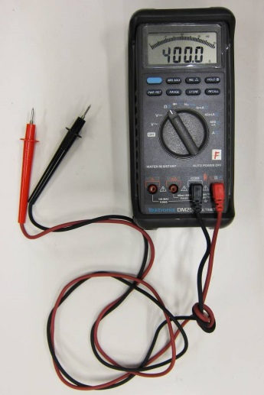

**Figure 6:** Analog and digital multimeters

**2.1. Voltage Measurement using multimeter**

The following figure depicts how to measure the voltage or potential difference across the two points:

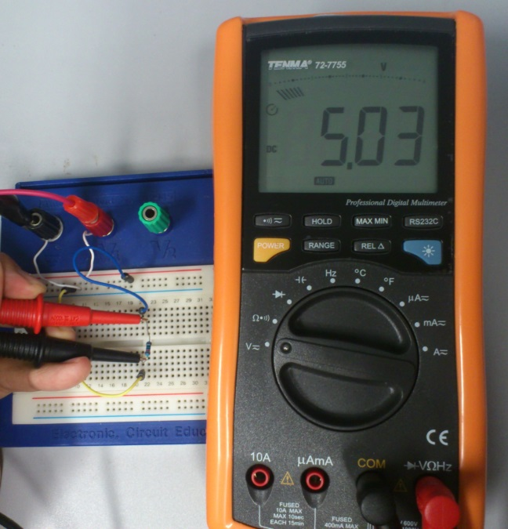

Circuit connected **in parallel**

The voltage reading is 5.03 V

**Figure 7:** Voltage measurement

In the figure above, the rectangular block represents part of a circuit (which, in the simplest case, is a resistor); the notation *V* denotes the voltage or potential difference you desire to measure, the circle with “V” inside is a multimeter configured as a voltmeter. The measurement is done by connecting the probes of the multimeter to the two test points **in a parallel** fashion.

**Important remarks**:

1. Polarity matters. The red probe corresponds to “+”, while the black probe corresponds “-”.
2. Dial the function knob to the desired kind of measurement. In this section, it is voltage. Moreover, the function knob allows you to choose the maximum range of the measured value (the range selection would be automatic in digital multimeters). Choose the range that would give you the most accurate reading possible.

**2.2. Current Measurement using multimeter**

The following figure depicts how we measure the current passing through a point:



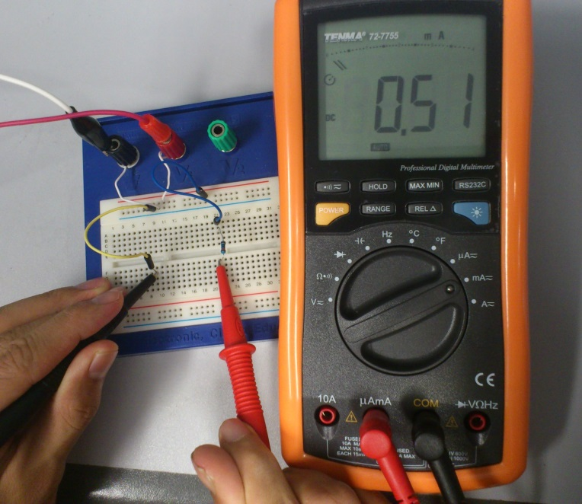

Circuit connected **in series**

The current reading is 0.51 mA

**Figure 8:** Current measurement

In the above figure, the circle with “A” inside represents a multimeter configured as an ammeter, and the notation “I” denotes the current we want to measure.

**Important remarks:**

1. Dial the function knob to current.
2. For current measurement, a multimeter should always be connected **IN SERIES** with the circuit as shown in Figure 8.
3. Some digital multimeter may require plugging the +ve probe **in a different socket** from the one used for voltage/resistance measurement.
4. Improper current measurement can damage the multimeter. If the current to be measured is higher than the maximum range of current set in the multimeter, you run the risk of blowing the fuse. Always choose the current range wisely.

**2.3. Resistance Measurement using multimeter**

To measure the resistance between two points, the connection is the same as that for voltage measurement in Figure 7, i.e., **in parallel**. However, you have to switch off ALL the power supplied to the circuit.

1. **Using breadboard for circuit assembly**

As illustrated in Figure 9, breadboard is a circuit board with many **pre-connected** holes in it:

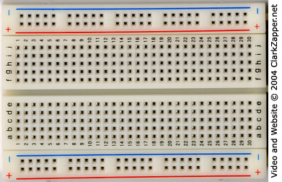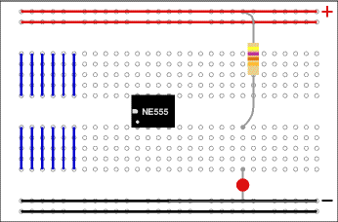

**Figure 9**: A real breadboard (left) and connection assignment of it (right)

Constructing circuits using breadboard is very easy especially if you are familiar with the “**node**” concept which is just introduced. For instance, each connected line (e.g. a blue one or a red one in Figure 9) is seen as a node to which the electronic components are connected.

Let us demonstrate this by showing an example circuit:

To 5V of power supply

To GND of power supply

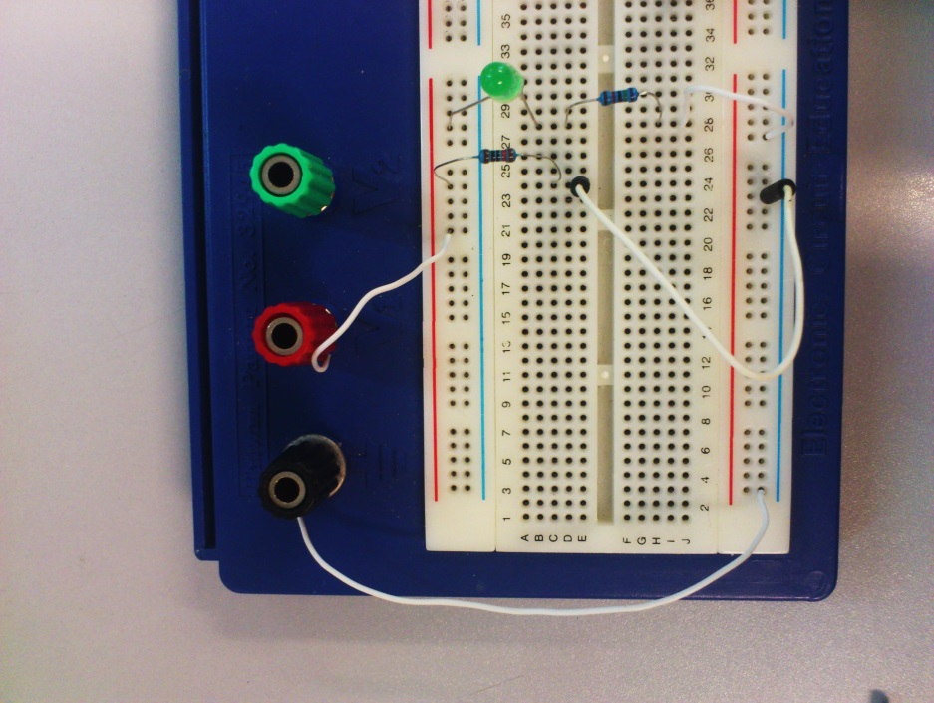

**Figure 10**: Practical example showing how to connect a circuit on breadboard

From the above figure, you can see how the pre-connected holes can help you in connecting the circuit. Just imagine how messy would the connection be if you are going to connect the same circuit using crocodile clips.

**4. Elementary component: Resistors**

Resistor is a basic electronic component that appears in every electronic circuit. To begin with, let us see how a resistor looks like:

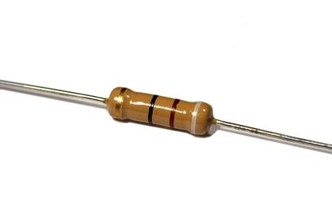



**Figure 11**: Resistor and its equivalent electronic symbol

In practice, we will read the **Color Band Code** marked on the resistor to identify the resistance value of it. At the moment, we will use **multimeter** to measure the value directly. There are plenty of resource on the Internet that teach us how to read those codes. For example: <http://www.elexp.com/tips/clr_code.gif> from Electronix Express.

**4.1 Voltage divider network – the theory**



**Figure 12**: Voltage divider circuit

The circuit in Figure 12 demonstrated the principle of **voltage divider**. In particular, the voltage across R2 follows the following equation, which can be deduced from Ohm’s Law:

.

As you can see, the two resistors R1 and R2 divide the voltage provided to the circuit proportionally. Voltage divider network is often constructed with variable resistors and potentiometer.

 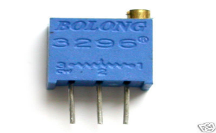

1

3

2

1

2

1 2 3

**Figure 13**: Variable resistor symbols (left) and a potentiometer (right)

|  |
| --- |
| ***Experiment I: Making Connections and Measurements***  In this section, you will practice how to use a multimeter through a simple experiment. Don’t hesitate to ask the TAs if you have any question.  The following apparatus will be provided:   1. a digital multimeter 2. six resistors of different values, and a potentiometer (0-10k) 3. a power supply 4. a few crocodile clips   In Figure 12(b), the symbol R2 represents a variable resistor. In this experiment, we connect **only two adjacent pins (e.g., either pins 1+2 or pins 2+3)** to form a variable resistor. The resistance can be adjusted using the dial at its top. |
| **Procedures:**   1. Measure the resistance for each of the given resistors and pick both the **1K Ohm** and **2K Ohm** resistors. 2. Connect the circuit in Figure 12(a) using crocodile clips. 3. **Measure the following quantities**:    1. the voltage across the **1K Ohm** resistor.    2. the current flowing through the **1K Ohm** resistor. 4. Now connect the circuit in Figure 12(b) and adjust the resistance of the potentiometer until  becomes 0.5V. **R1** should be **2k Ohm**. 5. Take out the potentiometer and measure the resistance of it (measure the resistance across the two pins you have just used) 6. Plug in the potentiometer and repeat Step 4-5 with  being 1V, 2V, 3V, 4V. **Tabulate your result and plot a graph of the resistance versus** **.** 7. **Calculate the following ratio RVA for each value of**  in step 6**:**      1. What can you tell about the relationship between the voltage across R2 and the resistance of R2? (Linear or non-linear) |

|  |
| --- |
| ***Experiment II: Resistor Networks***  In this section, a resistor network will be constructed and you have to measure voltages of different nodes. The following apparatus will be provided:   1. a DC power supply 2. a multimeter 3. a breadboard 4. resistors: 1 x 1 KΩ, 1 x 10 KΩ, 1 x 5.1 KΩ 5. a 0-10 KΩ potentiometer     **Figure 14**: A resistor network for testing |
| **Procedures:**   1. Connect the circuit in Figure 14 on a breadboard. 2. Adjust the resistance of the potentiometer to 1.5 KΩ. 3. Measure the **voltage** at Points A, B, C, D. 4. Measure the **current** across all resistors and the supply. 5. *What can you tell about the currents measured across the 1 KΩ, 5.1 KΩ and the variable resistor?* 6. Adjust the resistance of the potentiometer to *2* KΩ*,* 5KΩ*,* 8KΩ, and measure the corresponding voltages VB*2* KΩ, VB*5* KΩ, VB*8* KΩ, at Point B respectively.   (The **voltage at a point** is defined as the potential difference between the **point and the ground**.)  **Hint: Use your breadboard wisely when connecting the circuit. Try to use as few jumper wires as possible.** |

**Appendix**

**A.1. Component Symbols**

Some popularly seen electronic components and symbols are shown below:



**Figure 17:** Electronic symbols

* **Resistor** (R): A resistor is a two-terminal electronic component which is governed by Ohm’s law, which states that the voltage across two terminals of the resistor is proportional to the electric current through it. The resistance of a resistor is measured in Ohms, or, symbolically, .
* **Capacitor** (C): A capacitor consists of a pair of conductors separated by an insulator. When a potential difference exists between the two conductors, an electric field presents in the insulator and energy is stored. The capacitance of a capacitor is measured in Farads, or, symbolically, *F*.
* **Inductor** (L): An inductor is a passive electrical component usually in the shape of a coil. It can store energy in a magnetic field created by the electric current passing through it. The inductance of an inductor is measured in Henry, or, symbolically, *H*.
* **Diode**: A diode is a two-terminal semiconductor device whose conducting properties are different in the two possible directions of the current. To be specific, a diode conducts electric current in only one direction.
* **Transistor**: A transistor is a three-terminal semiconductor device which is used to amplify or switch electronic signals. Transistors play a very important role to electronics.