=========== Updated 2023 Feb. 5 , if you have problem using the latest opencv (4.4.x.x etc), try to install an older version, follow the following methods
conda> pip uninstall opencv-python
conda> pip uninstall opencv-contrib-python
conda > pip install opencv-python==3.4.16.59,
conda > pip install opencv-contrib-python==3.4.16.59
Inside CSE-CUHK, use :> pip install --proxy http://proxy.cse.cuhk.edu.hk:8000 opencv-python , etc
- =====
- You may try the following samples from
- https://github.com/opencv/opencv/tree/4.x/ (download the zip file and find the sample codes)
- conda> python camshift.py 0 # camshift using camera 0 , use mouse to select area to track
- conda> python lk_track.py 0 # lk tracker for using camera 0 (laptop camera)
- conda> python calibrate.py #using input image files from ..\data, you my use your own images
//////////////////////////////////////////////////////////////////////////
Download the Camshift lk_track etc sample code in zip from OpenCV Github repository ( https://github.com/opencv/opencv ) (C++ or Python),
After unzip , python samples codes are in \opencv-4.x\samples\python
Also download http://www.cse.cuhk.edu.hk/~khwong/www2/cmsc5711/lk_track_save_data.py
And save into \opencv-4.x\samples\python
/////////////// lk_track : Lk_track test: 2022.3.12 ////////////////////////////
cd into sample \opencv-4.x\samples\python, in anaconda>
conda>python lk_track.py 0 #0 is for laptop camera
conda>python lk_track1.py 0 #0 is for laptop camera
conda>python lk_track_save_data.py 0 #can save data into a data file "lk_output.txt"

/////////////// camshift ////////////////////////////
conda> python camshift.py 0

- ======Python ========== For anaconda-python , 2020 Feb 1 ====================
- I recommend you to use anaconda-python , (you may follow the instruction to install anacondas -windows / python: https://www.anaconda.com/distribution/#download-section ), then you can install the latest opencv-python by
- Win10-search (lower-left-bottom) “anaconda-prompt (right-click-Open-location), Right click (run as administrator).
- In anaconda-prompt :>> conda install -c conda-forge opencv
- Now Opencv-python is installed. You may use Anaconda-spyder to edit/test python-opencv programs. For example , try the testing programs in https://sites.google.com/site/hongslinks/opencv-1/opencv
- If you have indentation problem when running python programs, copy and paste your code into Note++ (https://notepad-plus-plus.org/downloads/), at top menu, click-on: View/show symbol/Show white space and tab. Make sure the tabs are replaced by four spaces. Mixing of tabs and spaces may not be allowed for Python, so either use tabs or 4-spaces in your program for indentation.
- Camera Calibration demo/tutorial : https://sites.google.com/site/hongslinks/opencv-1/camera-calibration-opencv-python

======C++ ======= For cpp users through Visual studio , 2022 March 13 =================
- To enter arguments to a program under visual studio IDE
- In the visual studio main window-top bar , select View/solution explorer
- On the right, right click the red elliptical part (console application)
- 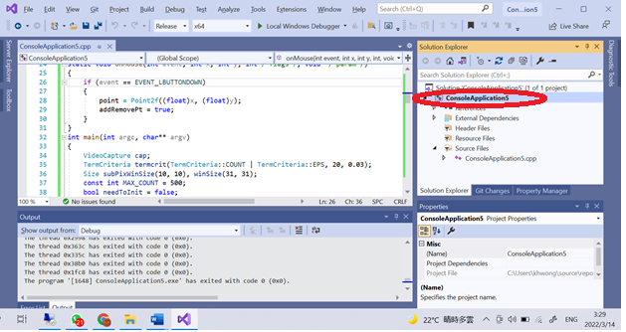
- Select “debugging” enter argument, see the red-elliptical part in the figure
- 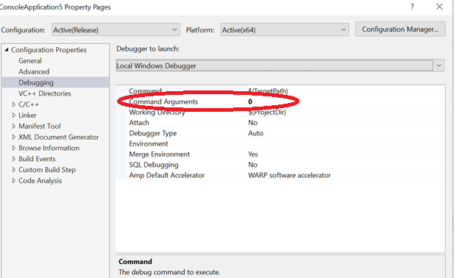

( This document applies to both x32 and x64 project settings, but precompiled vs2019 has no x86/x32)
This document has 3 parts
- Setting up your windows system
- Setting up your visual studio
- Examples
  - Camshift (object tracking)
  - Lkdemo (feature tracking)
  - Camera calibration
2022 March 13, switching to opencv-4.5.5-vc14_vc15 (applies also to a new OPENCV installation)
- if you are using opencv3xx, change opencv3xx to opencv455 in the following passage.
- Download from https://opencv.org/opencv-4-0-0.html , or
- https://sourceforge.net/projects/opencvlibrary/files/latest/download
- download opencv-4.5.5-vc14_vc15.exe ,and run it.
- You will get a directory opencv, rename to c:\opencv455 in my case.
Part A
- For opencv400, Set: windows System Variable (type in win10 start: Edit the system environment) in environment-variables, User variables for YOUR_NAME : OPENCV_DIR should contain “c:\opencv455\build\x64\vc15” not c:\opencv455\build\x64\vc15\ . Then, your system will use opencv455.
Graphical illustration is as follows
Double click “Path” on the right side of the above window (lower part), you will see the following. Assume you use python3.5, add “%OPENCV_DIR%\bin”
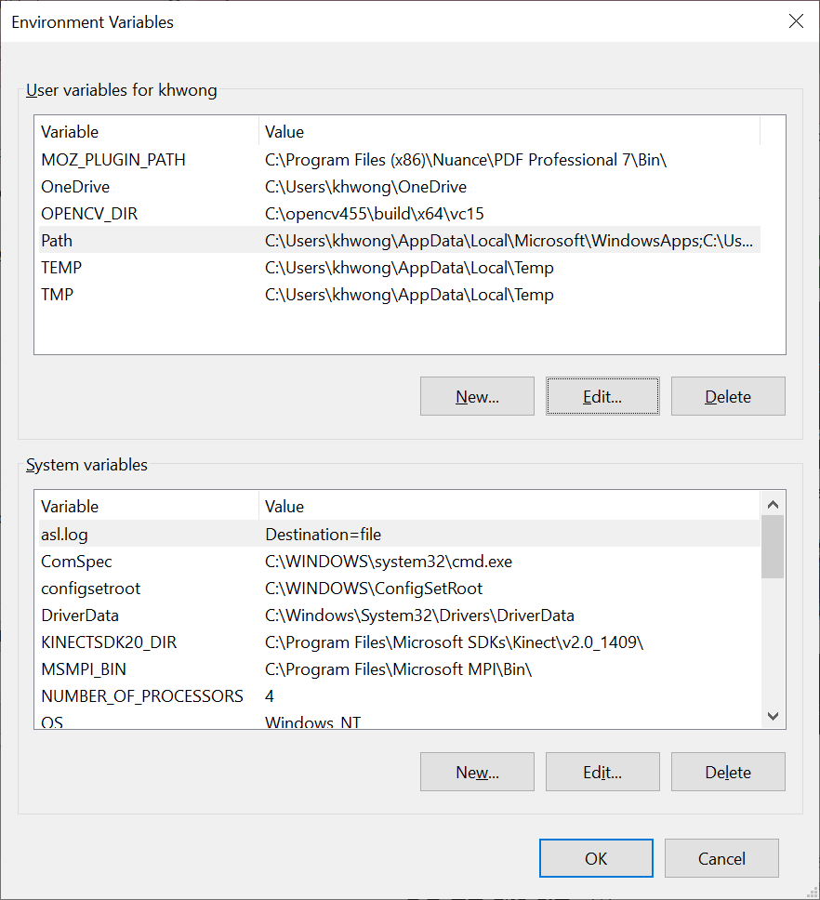
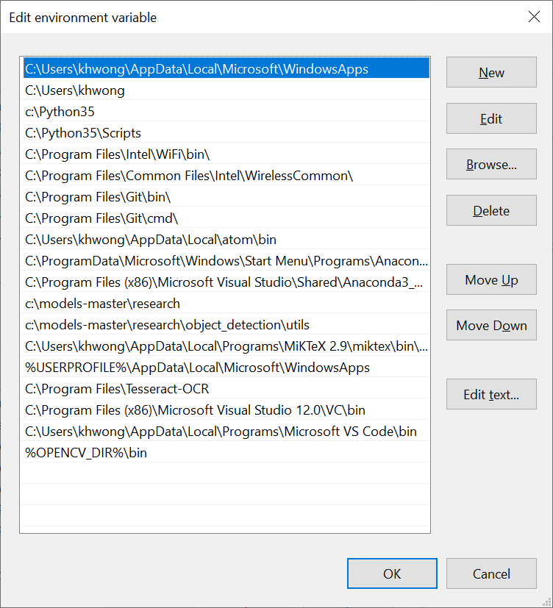

Part B (seems opencv455 has no 32 bit version, only x64)
Setting up your visual studio (2013, 2017, 2018 , 2019 etc)
https://www.tektutorialshub.com/visual-studio/how-to-download-and-install-visual-studio-2019/
You may try the latest visual studio if you prefer. After installation open visual studio, start a “new project”.
From the top Microsoft visual studio menu (top)
select View>>other windows >>Property manager
step B.1:------------------------------ (same for x32, x64 and all versions of opencv):
c/c++ general
$(OPENCV_DIR)\..\..\include\
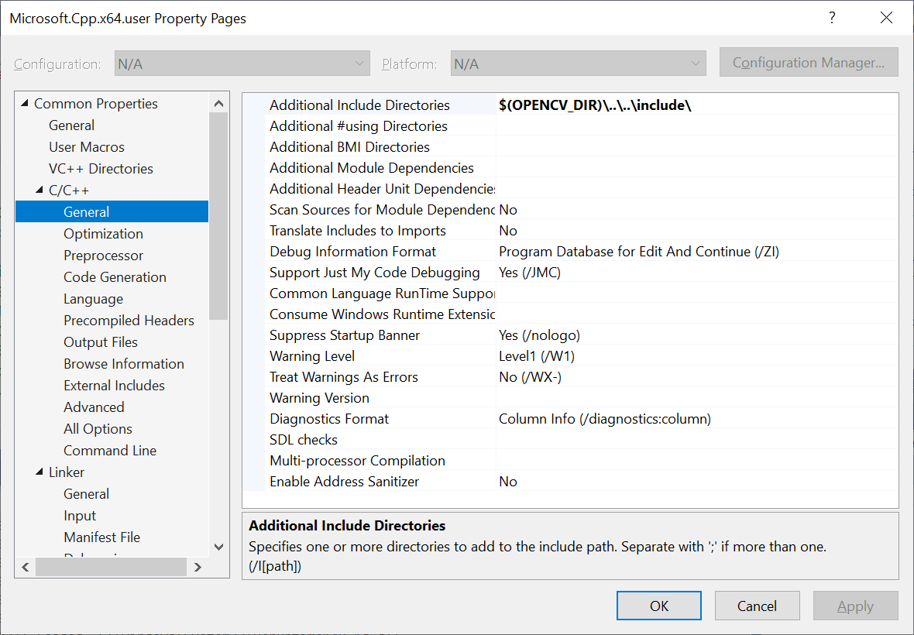
Step B.2:------------------------------- (same for x32, x64 and all versions of opencv):
linker general
Additional library directories: $(OPENCV_DIR)\lib
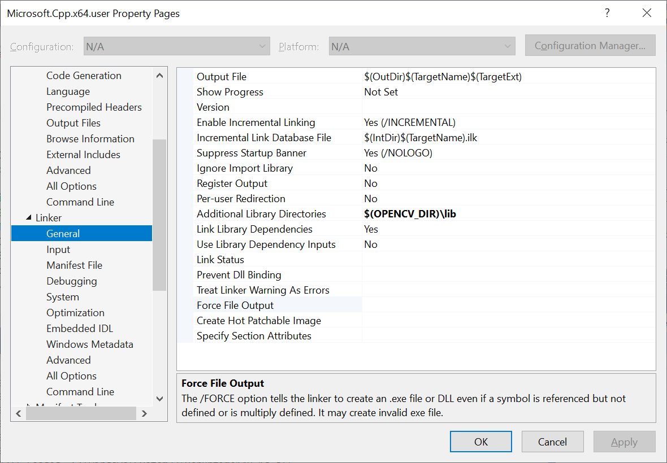
Step B.3:------------------------------- (same for x32, x64 and all versions of opencv):
(change this if you use a new opencv version)
Linker/input/additional dependencies:
opencv_world455d.lib;%(AdditionalDependencies)
For debug mode use opencv_world455d.lib
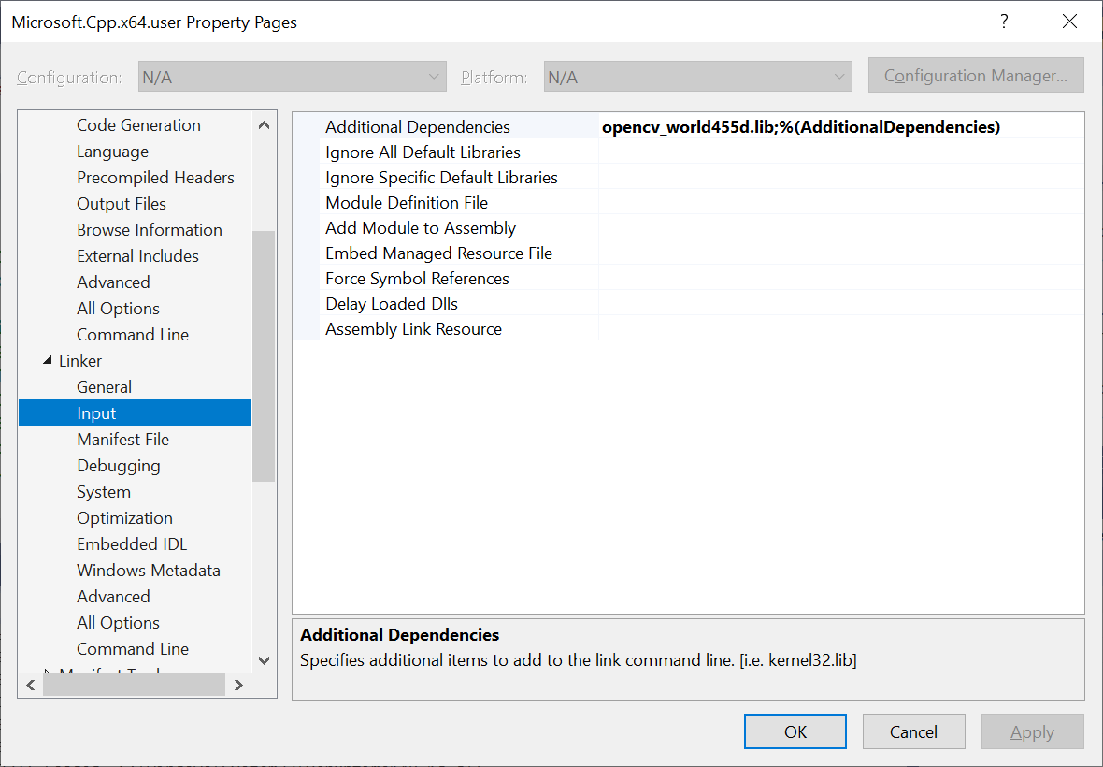

step B.4:------------------------ ( x32, x64 are different).
Check platform is x64 or x32, depending on your system setting. If you set up both x32 x64,
Then you can choose x32 or x64
Step B.5:------------------------(depends on your visual studio version)
make sure first line of the windows opencv cpp program is

#include <iostream>
or
#include "pch.h" // if using vs2017
Or
#include "stdafx.h" //if you are using vs2013 etc.

You may run sample codes from
https://docs.opencv.org/4.x/examples.html
tested
lkdemo.cpp

