///////20220.12.21 khwong////////////////////// Python /////////////////////////////////////////
https://github.com/opencv/opencv/tree/4.x/
Download zip to “opencv-4.x\samples\python” , inside the dir. run >python demo.py to run all demos
/////////////////////////////////////////////////// CPP //////////////////
Sample running report fro cpp
https://docs.opencv.org/4.x/examples.html, or
https://github.com/opencv/opencv/tree/4.x/
// run ok ////////////////
samples/cpp/camshiftdemo.cpp
samples/cpp/connected_components.cpp
samples/cpp/convexhull.cpp
samples/cpp/create_mask.cpp
samples/cpp/demhist.cpp
samples/cpp/distrans.cpp
samples/cpp/edge.cpp
samples/cpp/facedetect.cpp
samples/cpp/tutorial_code/ImgTrans/houghlines.cpp
samples/cpp/falsecolor.cpp
samples/cpp/ffilldemo.cpp
samples/cpp/filestorage.cpp
samples/cpp/fitellipse.cpp
samples/cpp/grabcut.cpp
samples/cpp/image_alignment.cpp
samples/cpp/intersectExample.cpp
samples/cpp/kalman.cpp
samples/cpp/kmeans.cpp
samples/cpp/laplace.cpp
samples/cpp/lkdemo.cpp
samples/cpp/lsd_lines.cpp
samples/cpp/minarea.cpp
samples/cpp/pca.cpp
samples/cpp/peopledetect.cpp
samples/cpp/polar_transforms.cpp
samples/cpp/segment_objects.cpp
samples/cpp/squares.cpp
samples/cpp/stitching.cpp
samples/cpp/stitching_detailed.cpp
samples/cpp/train_HOG.cpp
samples/cpp/tutorial_code/features2D/Homography/decompose_homography.cpp
samples/cpp/tutorial_code/features2D/Homography/homography_from_camera_displacement.cpp
samples/cpp/tutorial_code/features2D/Homography/pose_from_homography.cpp
samples/cpp/tutorial_code/HighGUI/AddingImagesTrackbar.cpp
samples/cpp/tutorial_code/Histograms_Matching/MatchTemplate_Demo.cpp
samples/cpp/tutorial_code/ImgProc/basic_drawing/Drawing_1.cpp
samples/cpp/tutorial_code/ImgProc/basic_drawing/Drawing_2.cpp
samples/cpp/tutorial_code/ImgProc/Morphology_1.cpp
samples/cpp/tutorial_code/ImgProc/Morphology_2.cpp
samples/cpp/tutorial_code/ImgProc/Pyramids/Pyramids.cpp
samples/cpp/tutorial_code/ImgProc/Smoothing/Smoothing.cpp
samples/cpp/tutorial_code/ImgTrans/copyMakeBorder_demo.cpp
samples/cpp/tutorial_code/ImgTrans/houghcircles.cpp
samples/cpp/tutorial_code/ImgTrans/houghlines.cpp
samples/cpp/tutorial_code/ImgTrans/Sobel_Demo.cpp
samples/cpp/tutorial_code/ml/introduction_to_pca/introduction_to_pca.cpp
samples/cpp/tutorial_code/photo/non_photorealistic_rendering/npr_demo.cpp
samples/cpp/tutorial_code/photo/seamless_cloning/cloning_demo.cpp
samples/cpp/tutorial_code/videoio/video-write/video-write.cpp
samples/cpp/videowriter_basic.cpp
samples/cpp/warpPerspective_demo.cpp
samples/cpp/watershed.cpp
samples/dnn/colorization.cpp
samples/dnn/openpose.cpp
samples/dnn/text_detection.cpp
samples/tapi/hog.cpp
samples/tapi/squares.cpp

samples/tapi/hog.cpp
/// run not ok /////////////
fld_lines.cpp
modules/shape/samples/shape_example.cpp

samples/cpp/facedetect.cpp
samples/dnn/classification.cpp
samples/dnn/object_detection.cpp
samples/dnn/segmentation.cpp
- samples/cpp/connected_components.cpp

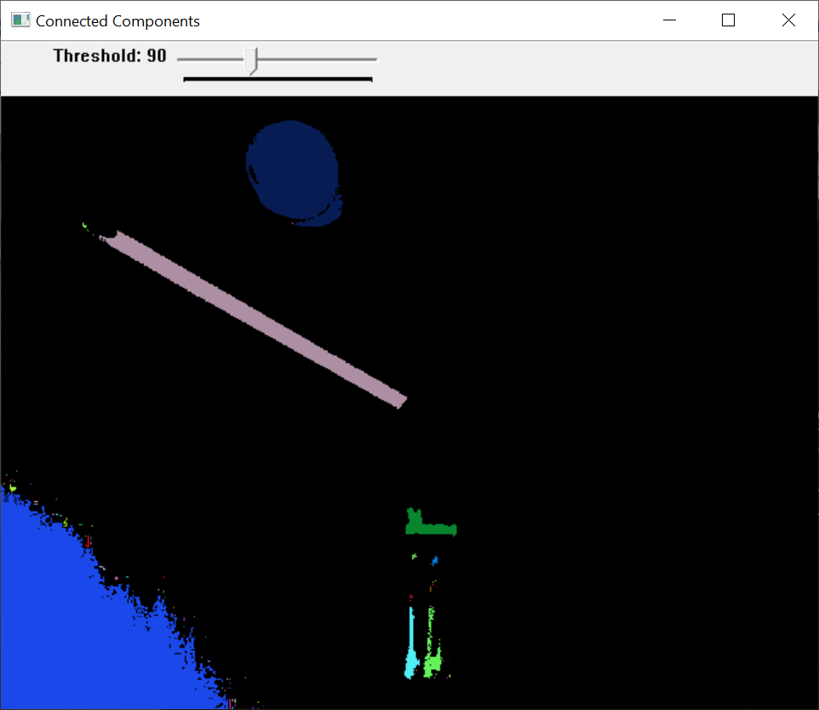
//////////////////////////////////////////////////////////////////////////////////////////////////////
- samples/cpp/contours2.cpp

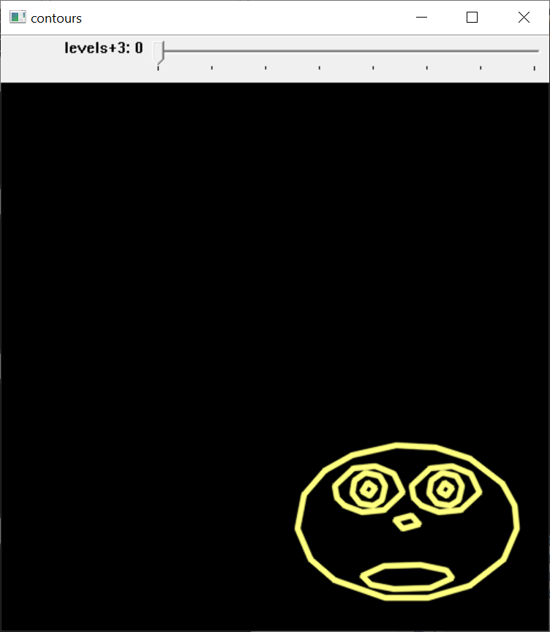
//////////////////////////////////////////////////
- samples/cpp/convexhull.cpp

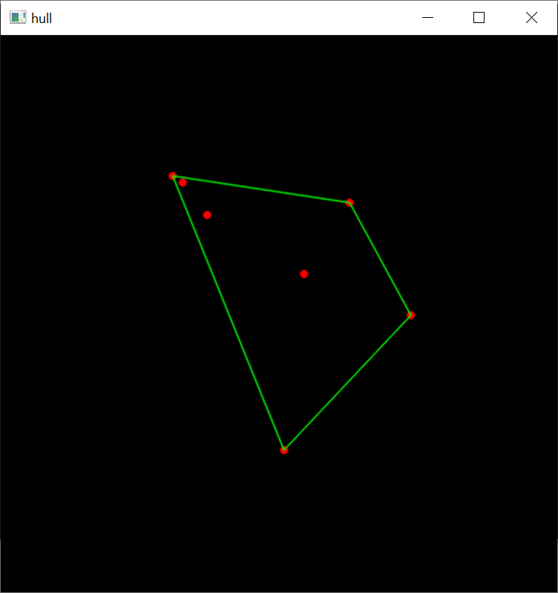

///////////////////////////////////////////////////////////
- samples/cpp/cout_mat.cpp
- ok
- points = [0, 0;
- 5, 1;
- 10, 2;
- 15, 3;
- 20, 4;
- 25, 5;
- 30, 6;
- 35, 0;
- 40, 1;
- 45, 2;
- 50, 3;
- 55, 4;
- 60, 5;
- 65, 6;
- 70, 0;
- 75, 1;
- 80, 2;
- 85, 3;
- 90, 4;
- 95, 5];

- C:\Users\khwong\source\repos\ConsoleApplication5\x64\Release\ConsoleApplication5.exe (process 17784) exited with code 0.To automatically close the console when debugging stops, enable Tools->Options->Debugging->Automatically close the console when debugging stops.
/////////////////////////////////////////////////////////
- samples/cpp/create_mask.cpp

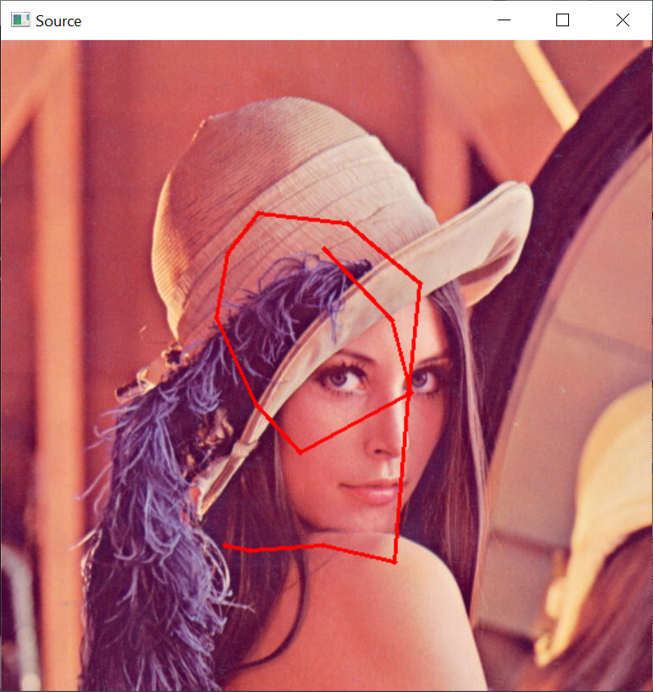
//////////////////////////////////////////////////////////////////////////////////////////////////////
samples/cpp/demhist.cpp

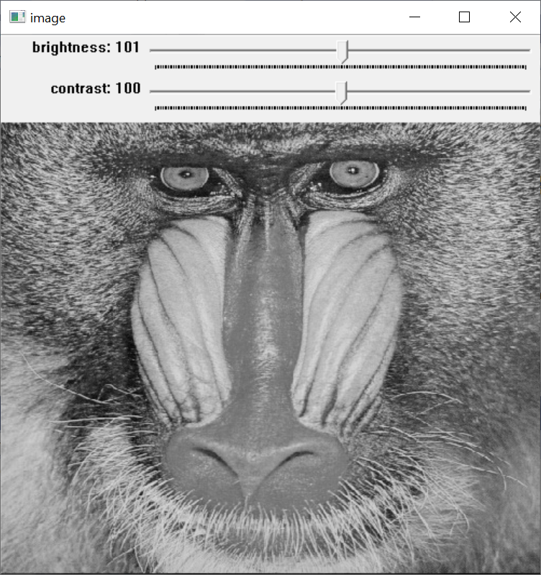
////////////////////////////////////////////////////////////////////////////
- samples/cpp/distrans.cpp

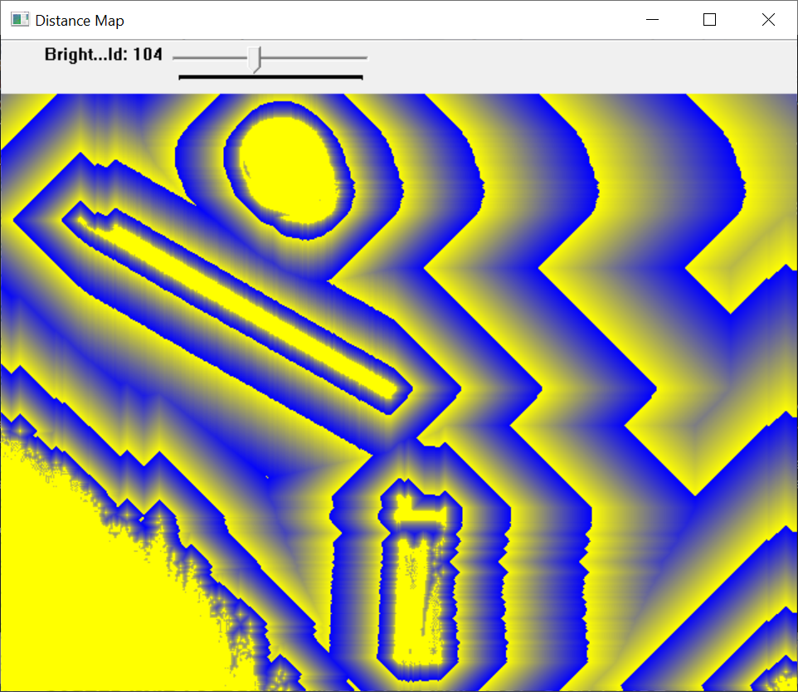

////////////
- samples/cpp/edge.cpp

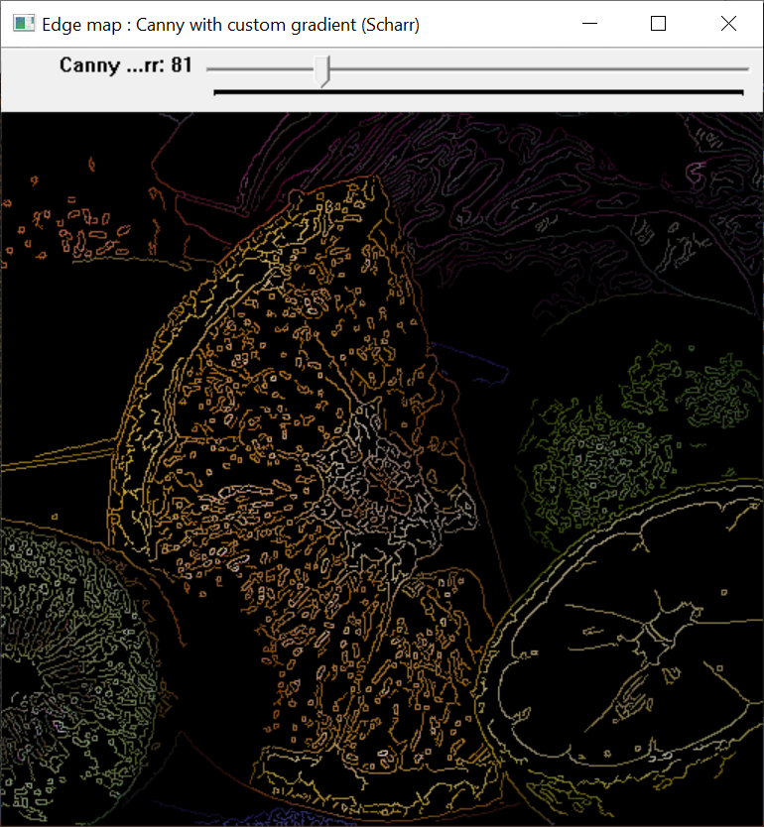

//////////
samples/cpp/falsecolor.cpp
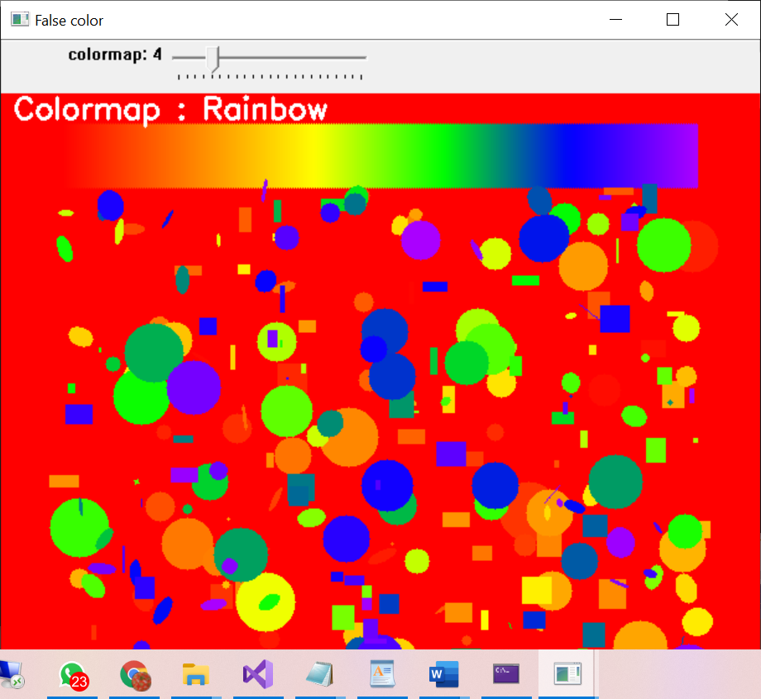

/////////
- samples/cpp/ffilldemo.cpp
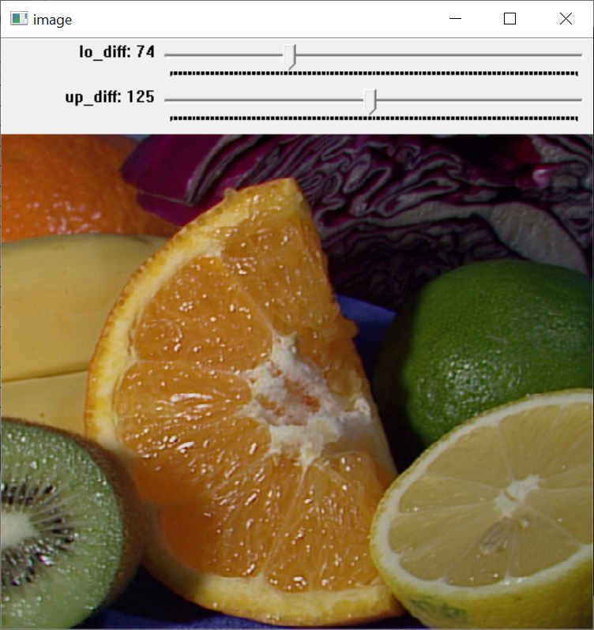
///////////////////////////////////////////////////////

samples/cpp/filestorage.cpp
filestorage_sample demonstrate the usage of the opencv serialization functionality.
usage:
C:\Users\khwong\source\repos\ConsoleApplication5\x64\Release\ConsoleApplication5.exe outputfile.yml.gz

outputfile above can have many different extensions, see below.
This program demonstrates the use of FileStorage for serialization, that is in use << and >> in OpenCV
For example, how to create a class and have it serialize, but also how to use it to read and write matrices.
FileStorage allows you to serialize to various formats specified by the file end type.
You should try using different file extensions.(e.g. yaml yml xml xml.gz yaml.gz etc...)

C:\Users\khwong\source\repos\ConsoleApplication5\x64\Release\ConsoleApplication5.exe (process 19588) exited with code 1.
To automatically close the console when debugging stops, enable Tools->Options->Debugging->Automatically close the console when debugging stops.
Press any key to close this window . .

///////////////////////////////////////////////////////////
samples/cpp/fitellipse.cpp
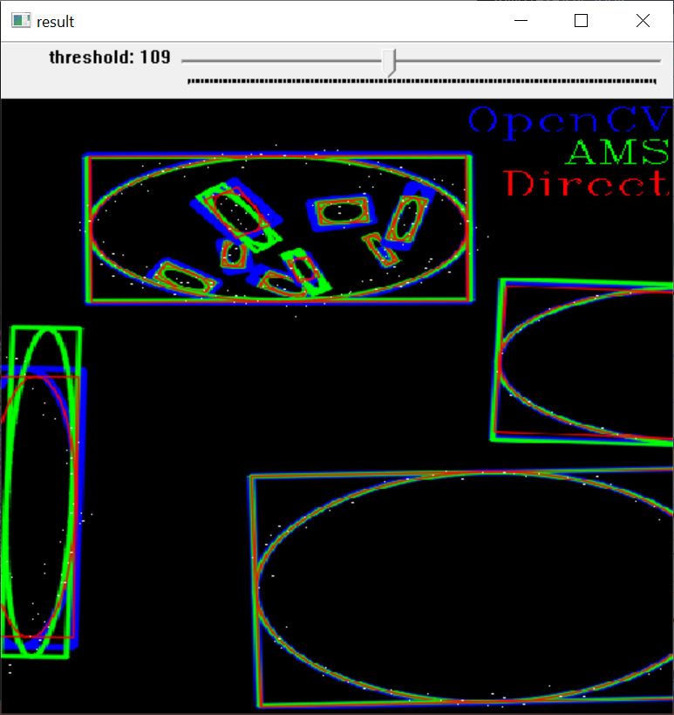
/////////////////////////////////////////////////////////////////////////////////////////
- samples/cpp/grabcut.cpp
- 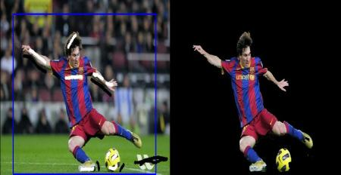
- ///////////////////////////////////////////////////////////////////////////////////////

- samples/cpp/image_alignment.cpp

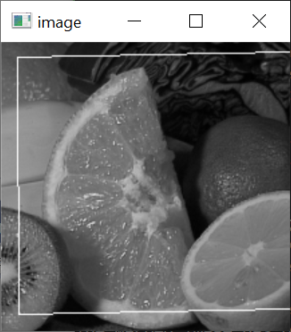
- 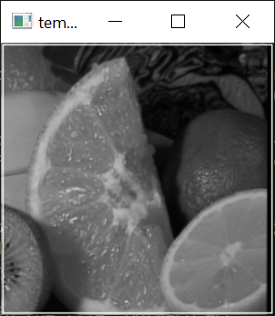/////////////////////////////////////////////////////////////////////
- //samples/cpp/intersectExample.cpp
//
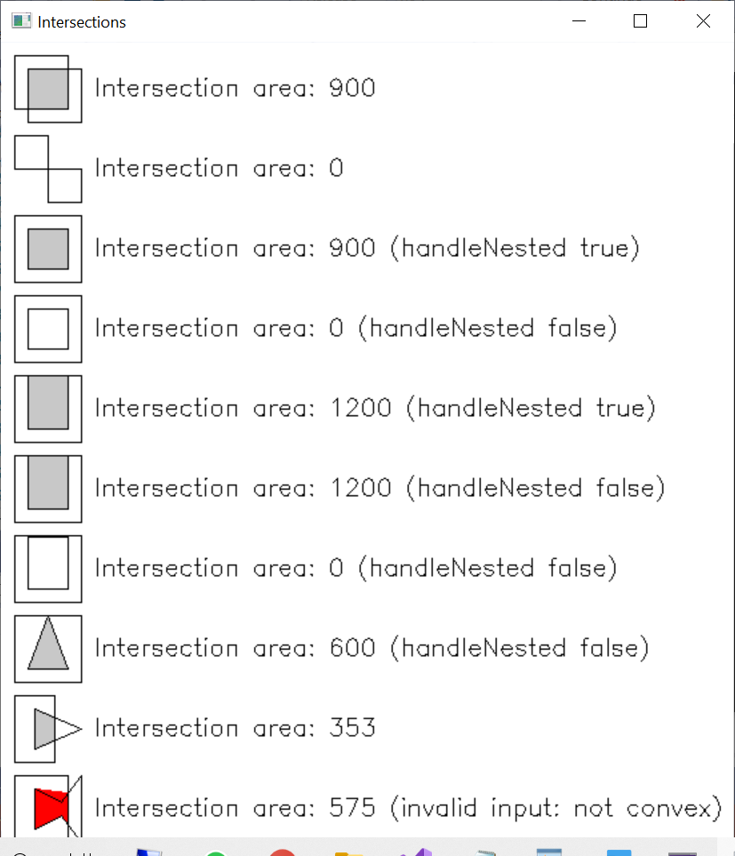
///////////////////////////////////////////////////////////
- samples/cpp/kalman.cpp

Example of c calls to OpenCV's Kalman filter.
Tracking of rotating point.
Point moves in a circle and is characterized by a 1D state.
state_k+1 = state_k + speed + process_noise N(0, 1e-5)
The speed is constant.
Both state and measurements vectors are 1D (a point angle),
Measurement is the real state + gaussian noise N(0, 1e-1).
The real and the measured points are connected with red line segment,
the real and the estimated points are connected with yellow line segment,
the real and the corrected estimated points are connected with green line segment.
(if Kalman filter works correctly,
the yellow segment should be shorter than the red one and
the green segment should be shorter than the yellow one).
Pressing any key (except ESC) will reset the tracking.
Pressing ESC will stop the program.

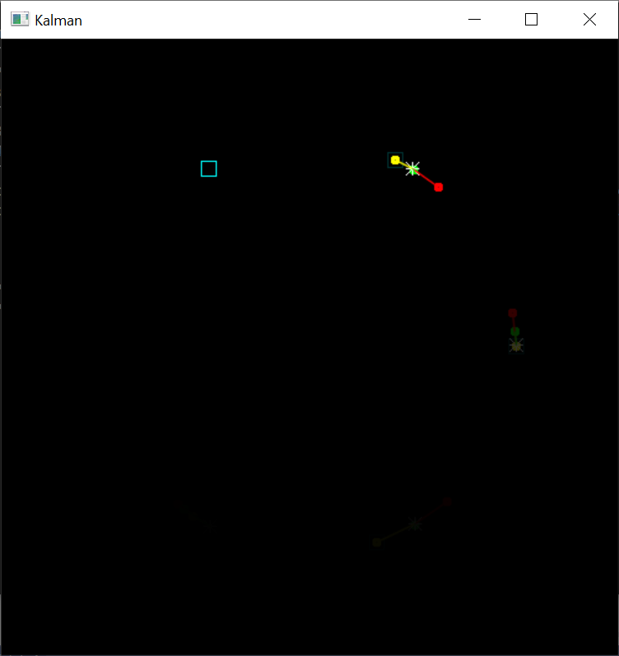
/////////////////////////////////////////////////
- samples/cpp/kmeans.cpp
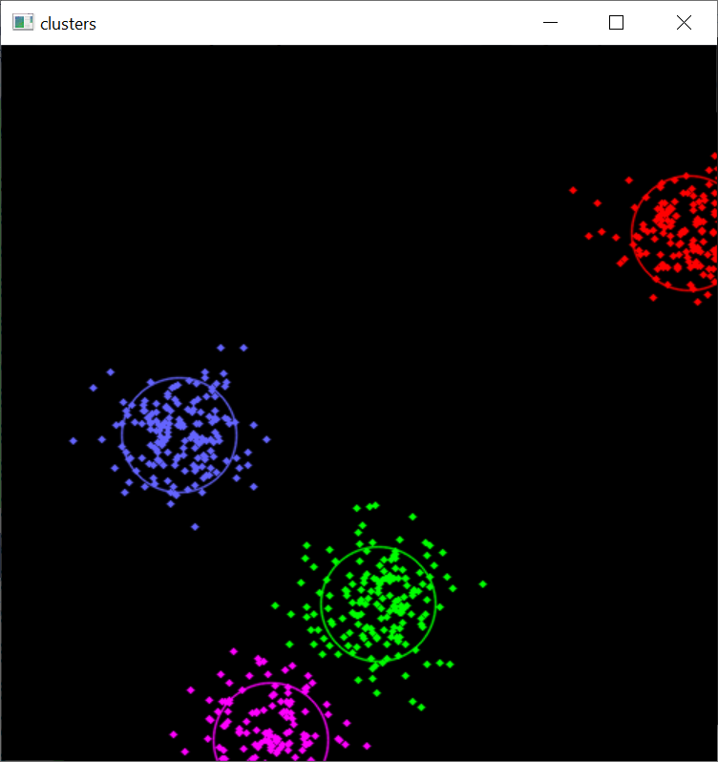
////////////////////////////////////////////////////////
- samples/cpp/laplace.cpp

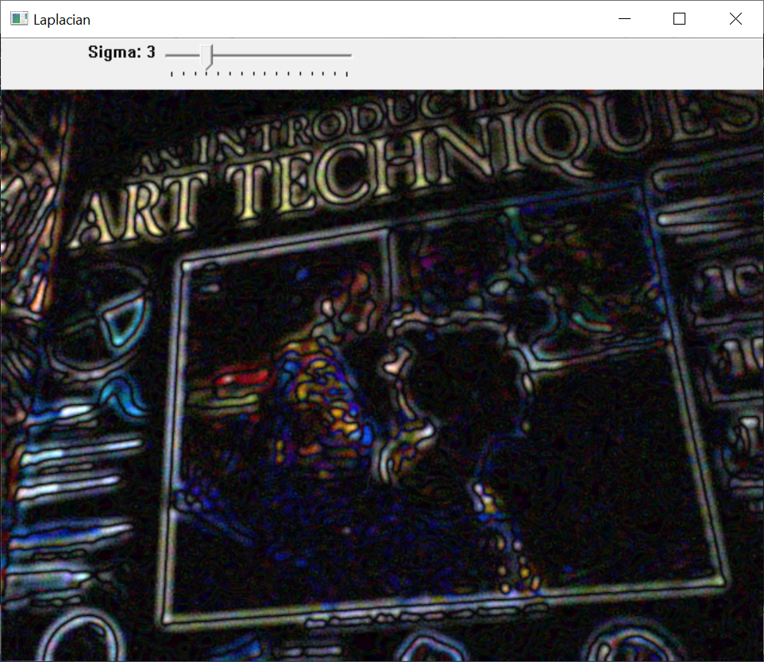
//////////////////////////////////////////////////////
- samples/cpp/lkdemo.cpp

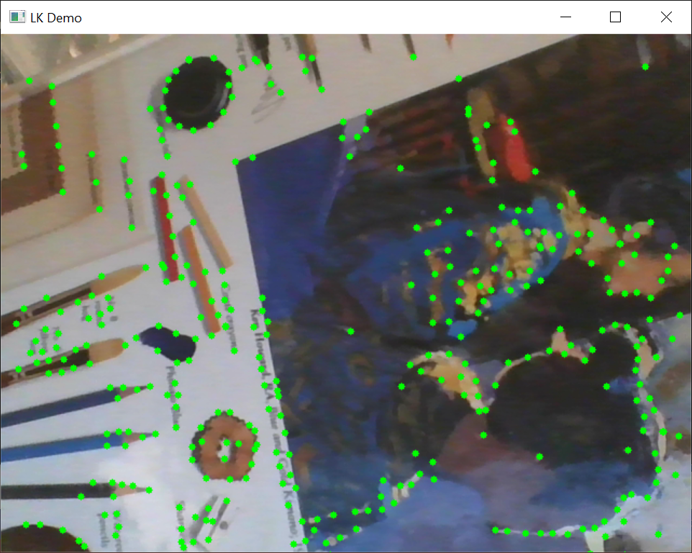
/////////////////////////////////////////////
- samples/cpp/lsd_lines.cpp
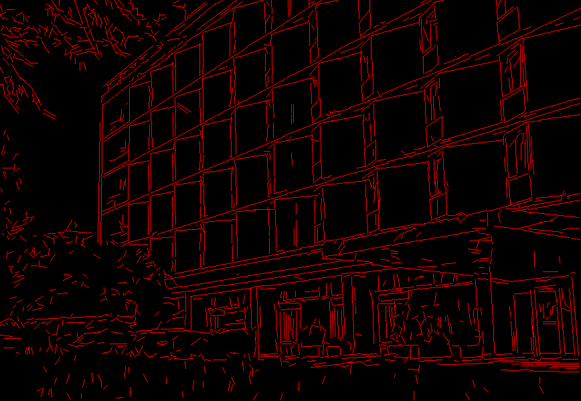
/////////////////////////////////////////////////////////////
samples/cpp/minarea.cpp
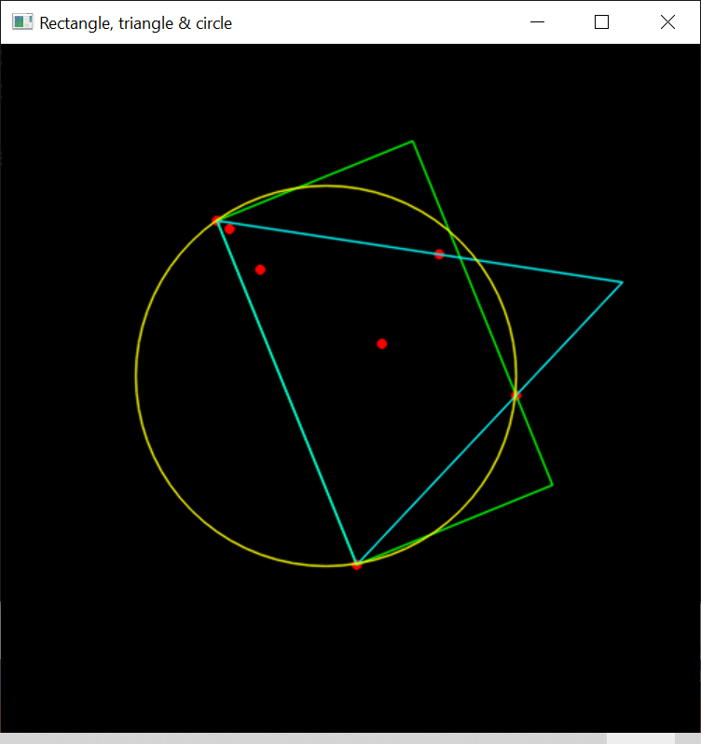
///////////////////////////////
- samples/cpp/pca.cpp
- 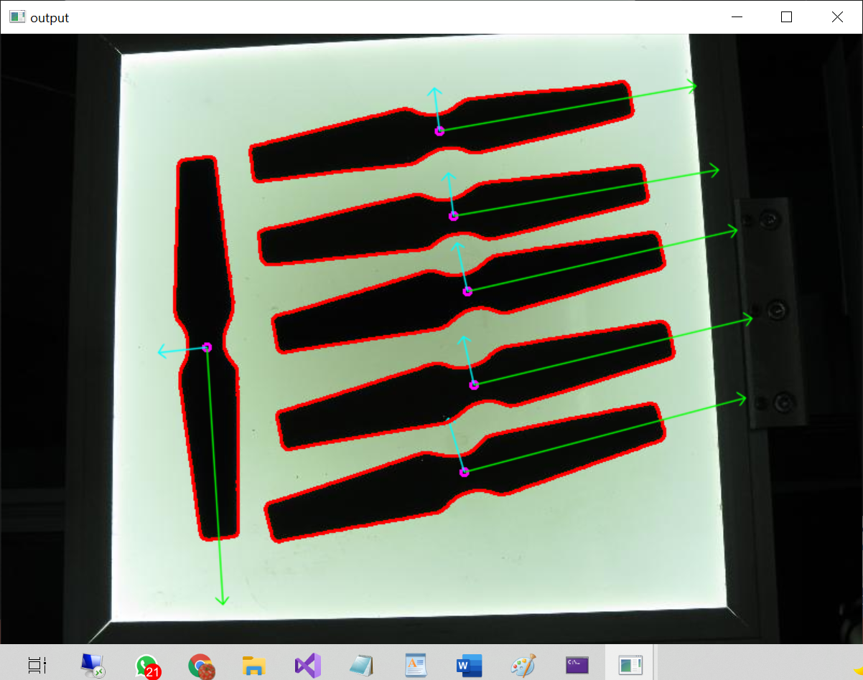

An example using PCA for dimensionality reduction while maintaining an amount of variance
//////////////////////////////////////////////////////
- samples/cpp/peopledetect.cpp

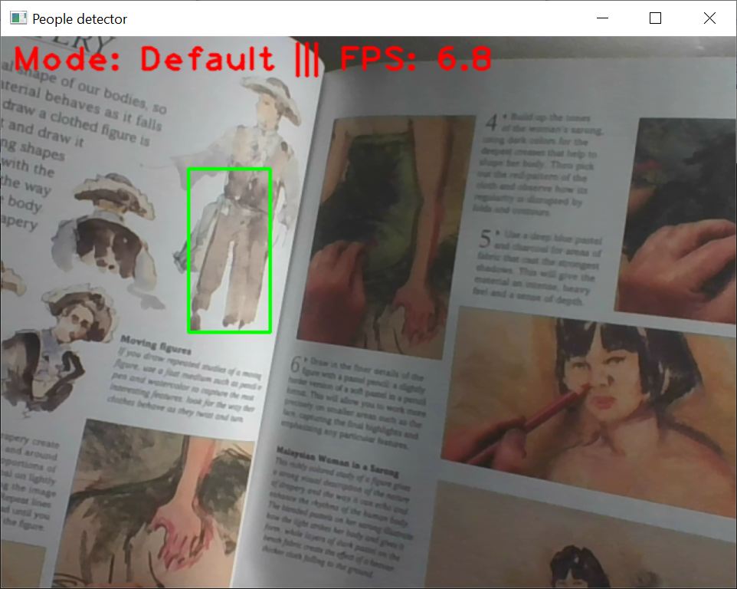
///////////////////////////////////////////////////////
- samples/cpp/polar_transforms.cpp
- runs ok, no display
///////////////////////////////////////////////////////
- samples/cpp/segment_objects.cpp

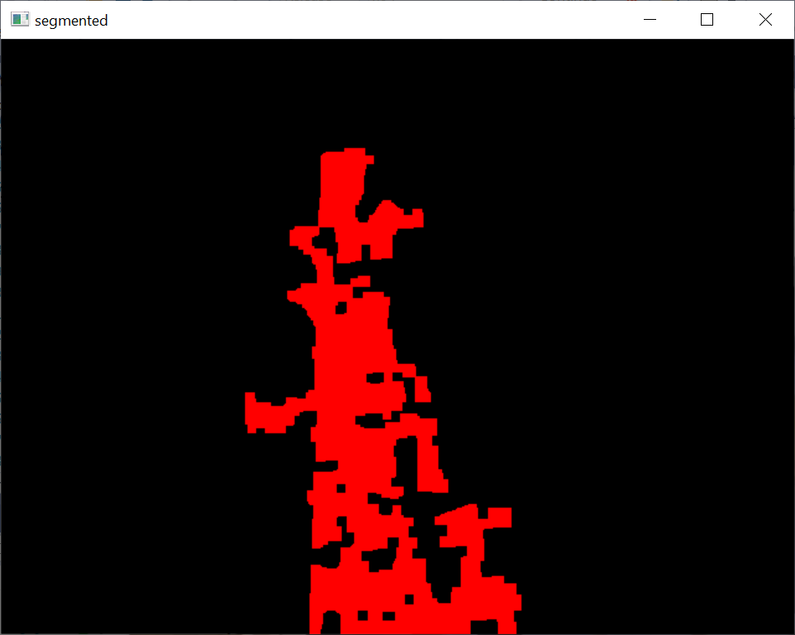
//////////////////////////////////////////

- samples/cpp/squares.cpp
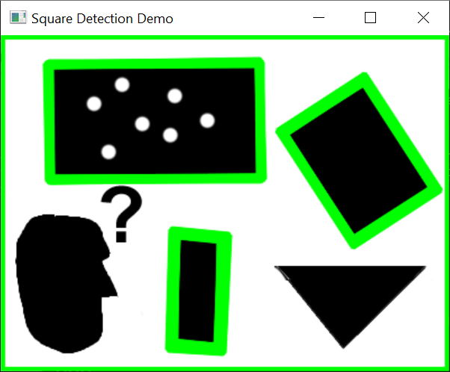
////////////////////////////////////////////////////////
Images stitcher.

Usage :
C:\Users\khwong\source\repos\ConsoleApplication5\x64\Release\ConsoleApplication5.exe [Flags] img1 img2 [...imgN]

Flags:
--d3
internally creates three chunks of each image to increase stitching success
--mode (panorama|scans)
Determines configuration of stitcher. The default is 'panorama',
mode suitable for creating photo panoramas. Option 'scans' is suitable
for stitching materials under affine transformation, such as scans.
--output <result_img>
The default is 'result.jpg'.

Example usage :
C:\Users\khwong\source\repos\ConsoleApplication5\x64\Release\ConsoleApplication5.exe --d3 --mode scans img1.jpg img2.jpg

C:\Users\khwong\source\repos\ConsoleApplication5\x64\Release\ConsoleApplication5.exe (process 6268) exited with code 1.
To automatically close the console when debugging stops, enable Tools->Options->Debugging->Automatically close the console when debugging stops.
Press any key to close this window . . .
////////////////////////////////////////////////////////////////
- samples/cpp/stitching_detailed.cpp

Rotation model images stitcher.

C:\Users\khwong\source\repos\ConsoleApplication5\x64\Release\ConsoleApplication5.exe img1 img2 [...imgN] [flags]

Flags:
--preview
Run stitching in the preview mode. Works faster than usual mode,
but output image will have lower resolution.
--try_cuda (yes|no)
Try to use CUDA. The default value is 'no'. All default values
are for CPU mode.

Motion Estimation Flags:
--work_megapix <float>
Resolution for image registration step. The default is 0.6 Mpx.
--features (surf|orb|sift|akaze)
Type of features used for images matching.
The default is surf if available, orb otherwise.
--matcher (homography|affine)
Matcher used for pairwise image matching.
--estimator (homography|affine)
Type of estimator used for transformation estimation.
--match_conf <float>
Confidence for feature matching step. The default is 0.65 for surf and 0.3 for orb.
--conf_thresh <float>
Threshold for two images are from the same panorama confidence.
The default is 1.0.
--ba (no|reproj|ray|affine)
Bundle adjustment cost function. The default is ray.
--ba_refine_mask (mask)
Set refinement mask for bundle adjustment. It looks like 'x_xxx',
where 'x' means refine respective parameter and '_' means don't
refine one, and has the following format:
<fx><skew><ppx><aspect><ppy>. The default mask is 'xxxxx'. If bundle
adjustment doesn't support estimation of selected parameter then
the respective flag is ignored.
--wave_correct (no|horiz|vert)
Perform wave effect correction. The default is 'horiz'.
--save_graph <file_name>
Save matches graph represented in DOT language to <file_name> file.
Labels description: Nm is number of matches, Ni is number of inliers,
C is confidence.

Compositing Flags:
--warp (affine|plane|cylindrical|spherical|fisheye|stereographic|compressedPlaneA2B1|compressedPlaneA1.5B1|compressedPlanePortraitA2B1|compressedPlanePortraitA1.5B1|paniniA2B1|paniniA1.5B1|paniniPortraitA2B1|paniniPortraitA1.5B1|mercator|transverseMercator)
Warp surface type. The default is 'spherical'.
--seam_megapix <float>
Resolution for seam estimation step. The default is 0.1 Mpx.
--seam (no|voronoi|gc_color|gc_colorgrad)
Seam estimation method. The default is 'gc_color'.
--compose_megapix <float>
Resolution for compositing step. Use -1 for original resolution.
The default is -1.
--expos_comp (no|gain|gain_blocks|channels|channels_blocks)
Exposure compensation method. The default is 'gain_blocks'.
--expos_comp_nr_feeds <int>
Number of exposure compensation feed. The default is 1.
--expos_comp_nr_filtering <int>
Number of filtering iterations of the exposure compensation gains.
Only used when using a block exposure compensation method.
The default is 2.
--expos_comp_block_size <int>
BLock size in pixels used by the exposure compensator.
Only used when using a block exposure compensation method.
The default is 32.
--blend (no|feather|multiband)
Blending method. The default is 'multiband'.
--blend_strength <float>
Blending strength from [0,100] range. The default is 5.
--output <result_img>
The default is 'result.jpg'.
--timelapse (as_is|crop)
Output warped images separately as frames of a time lapse movie, with 'fixed_' prepended to input file names.
--rangewidth <int>
uses range_width to limit number of images to match with.

C:\Users\khwong\source\repos\ConsoleApplication5\x64\Release\ConsoleApplication5.exe (process 18428) exited with code -1.
To automatically close the console when debugging stops, enable Tools->Options->Debugging->Automatically close the console when debugging stops.
Press any key to close this window . . .
////////////////////////////////////////////////////////////////////////////
- samples/cpp/train_HOG.cpp
Usage: ConsoleApplication5.exe [params]

-d (value:false)
train twice
--dh
height of the detector
--dw
width of the detector
-f (value:false)
indicates if the program will generate and use mirrored samples or not
--fn (value:my_detector.yml)
file name of trained SVM
-h, --help
show help message
--nd
path of directory contains negative images
--pd
path of directory contains positive images
-t (value:false)
test a trained detector
--td
path of directory contains test images
--tv
test video file name
-v (value:false)
visualize training steps

Wrong number of parameters.

Example command line:
C:\Users\khwong\source\repos\ConsoleApplication5\x64\Release\ConsoleApplication5.exe -dw=64 -dh=128 -pd=/INRIAPerson/96X160H96/Train/pos -nd=/INRIAPerson/neg -td=/INRIAPerson/Test/pos -fn=HOGpedestrian64x128.xml -d

Example command line for testing trained detector:
C:\Users\khwong\source\repos\ConsoleApplication5\x64\Release\ConsoleApplication5.exe -t -fn=HOGpedestrian64x128.xml -td=/INRIAPerson/Test/pos
C:\Users\khwong\source\repos\ConsoleApplication5\x64\Release\ConsoleApplication5.exe (process 17564) exited with code 1.
To automatically close the console when debugging stops, enable Tools->Options->Debugging->Automatically close the console when debugging stops.
Press any key to close this window . . .//////////////////
//////////////////////////////////////////////////////////////////////////
samples/cpp/tutorial_code/features2D/Homography/decompose_homography.cpp
runs ok, no display
////////////////////////////////////////////////////////////////////////////
- samples/cpp/tutorial_code/features2D/Homography/homography_from_camera_displacement.cpp

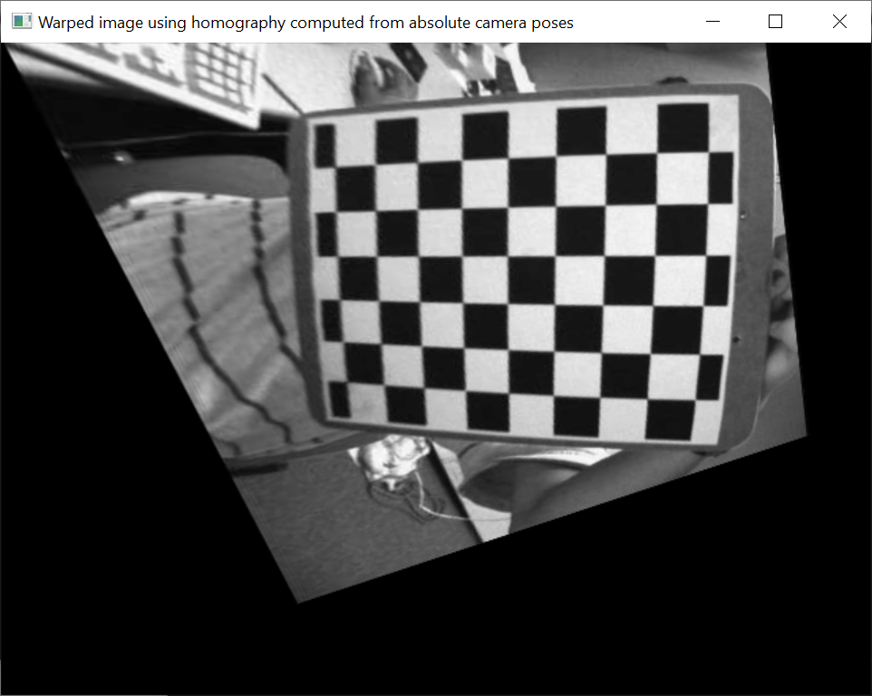
/////////////////////////////////////////////////////////
- samples/cpp/tutorial_code/features2D/Homography/pose_from_homography.cpp
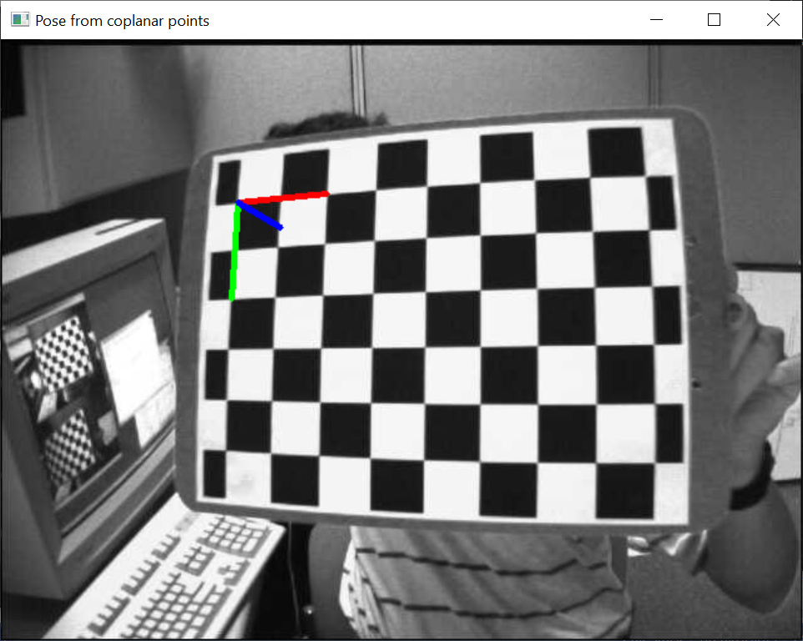

////////////////////////////////////////////
samples/cpp/tutorial_code/HighGUI/AddingImagesTrackbar.cpp
#include <opencv2/imgcodecs.hpp>
#include <opencv2/highgui.hpp>
and remove sprintf
- 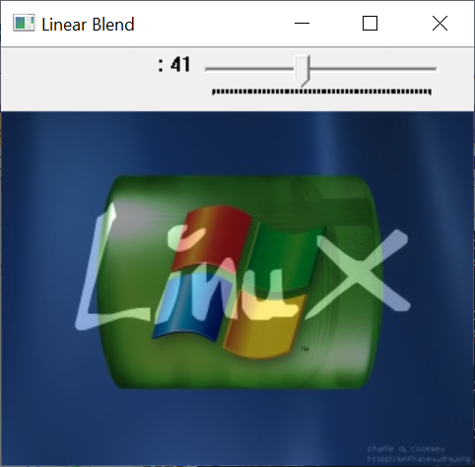

////////////////////////////////////////////////////////////////////////////////

- samples/cpp/tutorial_code/Histograms_Matching/MatchTemplate_Demo.cpp
runs ok, need parameters
/////////////////////////////////////////////////////////
- samples/cpp/tutorial_code/ImgProc/basic_drawing/Drawing_1.cpp
- 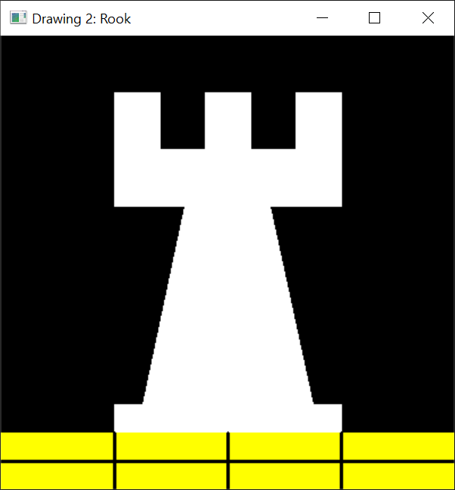////////////////////////////////////////////////////////////////////////////////////////
- samples/cpp/tutorial_code/ImgProc/basic_drawing/Drawing_2.cpp

//////////////////////////////////////////////////////////////////////////////////////////
- 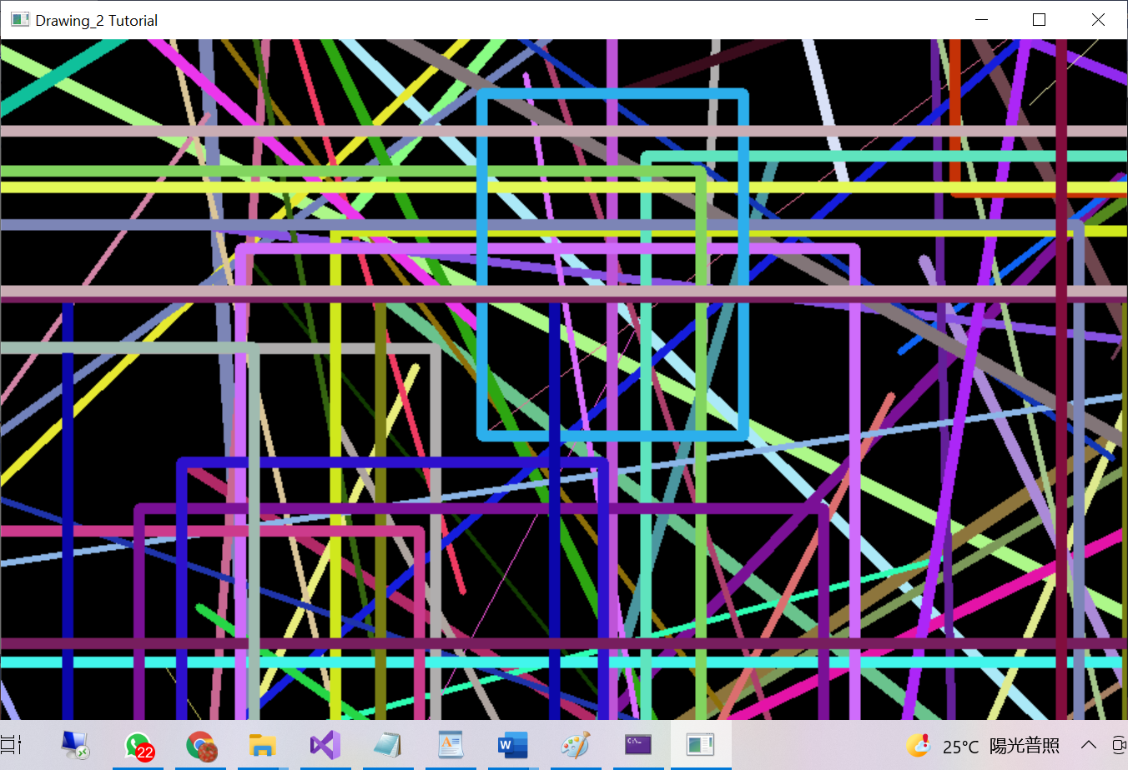
///////////////////////////////////////////////////////////////////////////////////////////
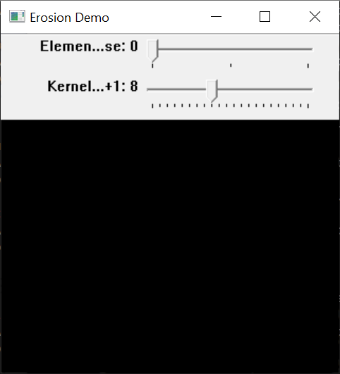
///////////////////////////////////////////////////////////////////////////////////////
samples/cpp/tutorial_code/ImgProc/Morphology_1.cpp
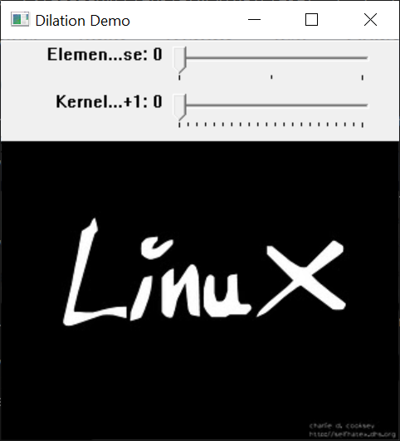
//////////////////////////////////////////////////////////////////////////////
- samples/cpp/tutorial_code/ImgProc/Morphology_2.cpp
- 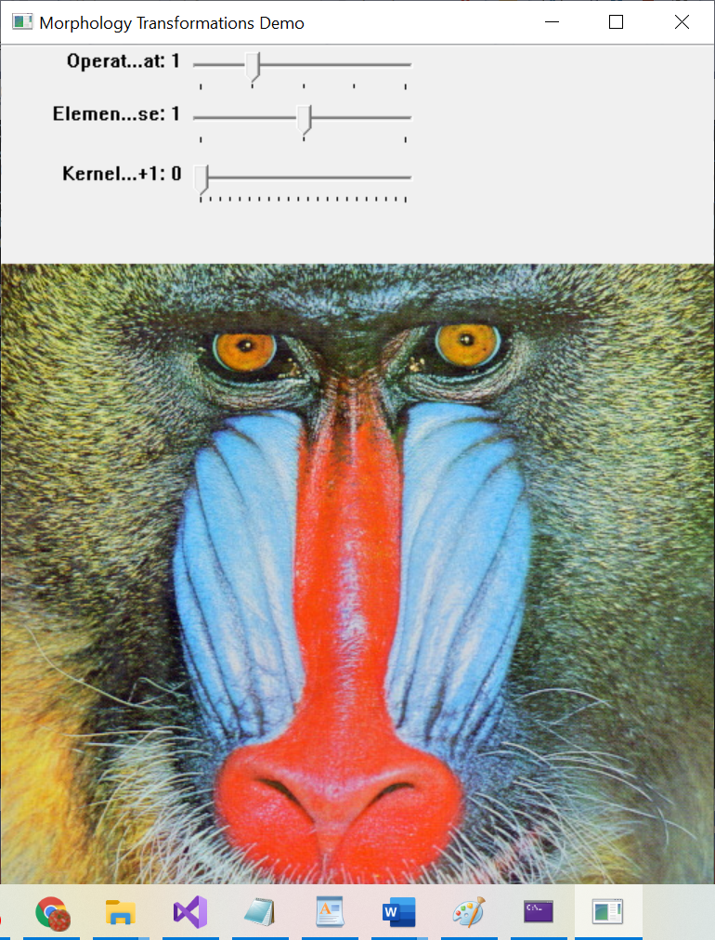
- ///////////////////////////////////////////////////////////////////////////////////////////////////////////////////////////////////////////
- samples/cpp/tutorial_code/ImgProc/Pyramids/Pyramids.cpp

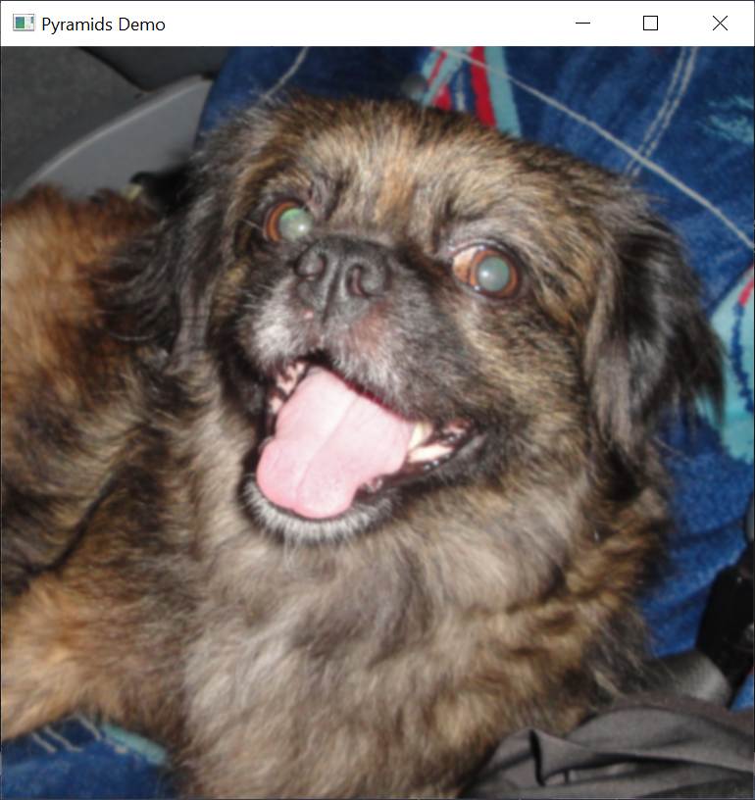

////////////////////////////////////////////////////////////////////////////////////////
- samples/cpp/tutorial_code/ImgProc/Smoothing/Smoothing.cpp

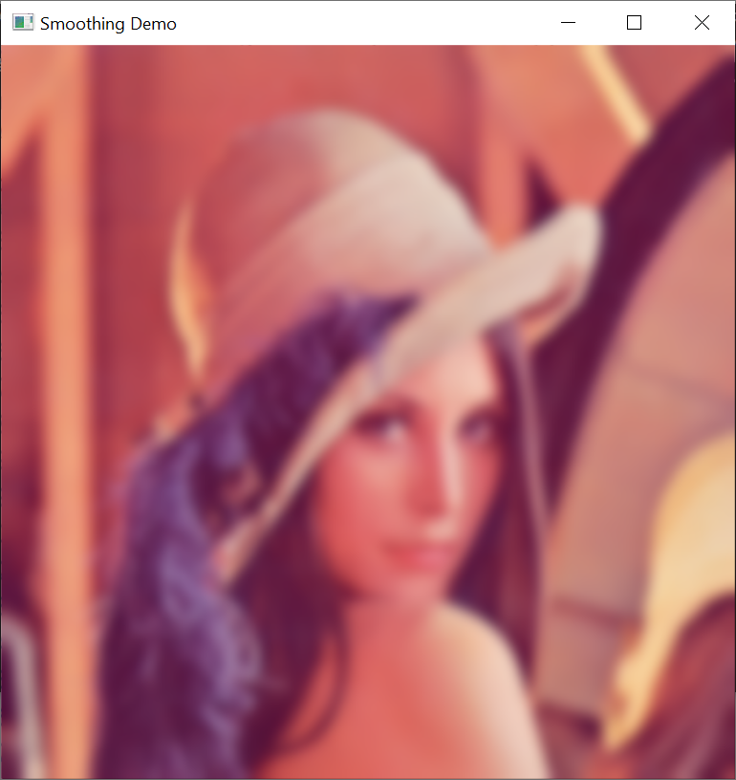
/////////////////////////////////////////////////////////////////////////////////////////////////////
- samples/cpp/tutorial_code/ImgTrans/copyMakeBorder_demo.cpp

/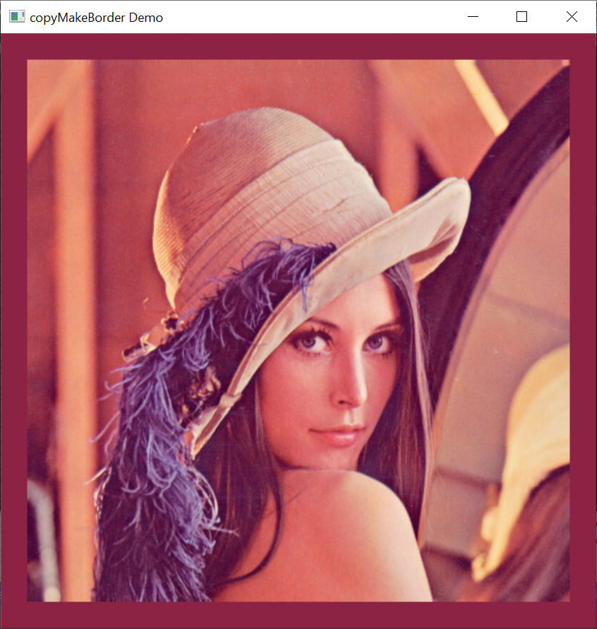
//////////////////////////////////////////////////////////////////////////////////////////////////
- samples/cpp/tutorial_code/ImgTrans/houghcircles.cpp
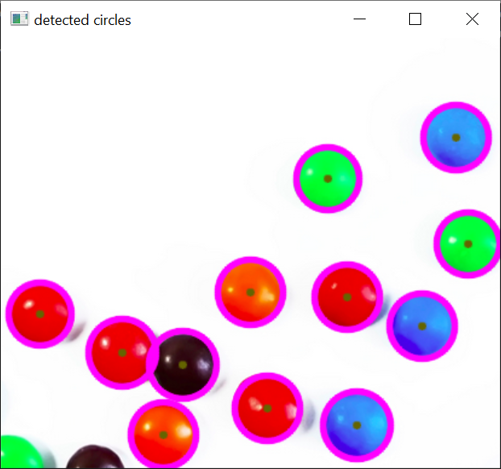
//////////////////////////////////////////////////////////////////////////////////////////////////////
- samples/cpp/tutorial_code/ImgTrans/houghlines.cpp
- 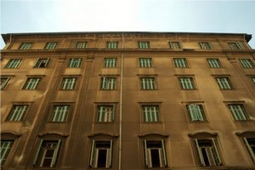
- 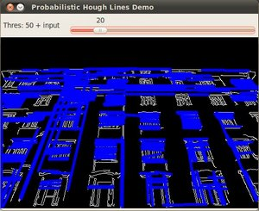
- ///////////////////////////////////////////////////////////////////////////////////
- samples/cpp/tutorial_code/ImgTrans/Sobel_Demo.cpp

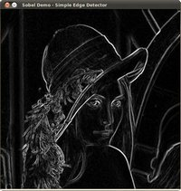

///////////////////////////////////////////////////////////////////////////////
- samples/cpp/tutorial_code/ml/introduction_to_pca/introduction_to_pca.cpp
- 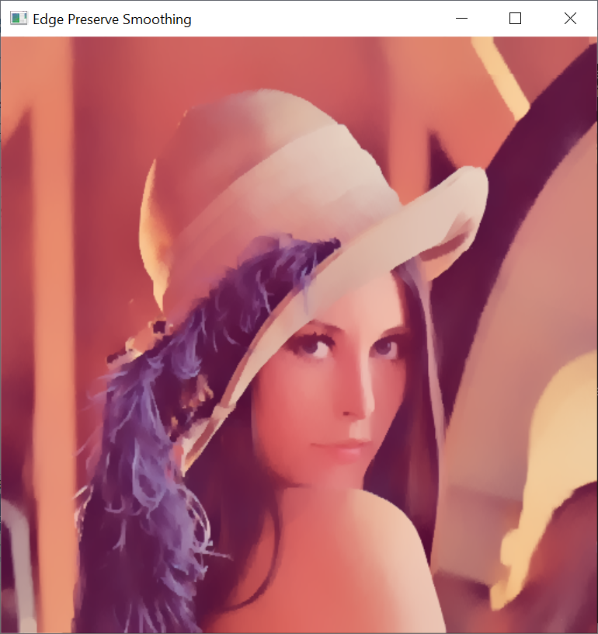
////////////////////////////////////////////////////////////////////////////////////////////////
- samples/cpp/tutorial_code/photo/seamless_cloning/cloning_demo.cpp
Cloning Module
---------------
Options:

1) Normal Cloning
2) Mixed Cloning
3) Monochrome Transfer
4) Local Color Change
5) Local Illumination Change
6) Texture Flattening

Press number 1-6 to choose from above techniques: 4

[ WARN:0@3.879] global C:\build\master_winpack-build-win64-vc15\opencv\modules\imgcodecs\src\loadsave.cpp (239) cv::findDecoder imread_('cloning/Color_Change/source1.png'): can't open/read file: check file path/integrity
[ WARN:0@3.879] global C:\build\master_winpack-build-win64-vc15\opencv\modules\imgcodecs\src\loadsave.cpp (239) cv::findDecoder imread_('cloning/Color_Change/mask.png'): can't open/read file: check file path/integrity
Could not load source image cloning/Color_Change/source1.png

C:\Users\khwong\source\repos\ConsoleApplication5\x64\Release\ConsoleApplication5.exe (process 10744) exited with code 0.
To automatically close the console when debugging stops, enable Tools->Options->Debugging->Automatically close the console when debugging stops.
Press any key to close this window . . .
///////////////////////////////////////////////////////////////////////////////
- samples/cpp/tutorial_code/videoio/video-write/video-write.cpp

------------------------------------------------------------------------------
This program shows how to write video files.
You can extract the R or G or B color channel of the input video.
Usage:
./video-write <input_video_name> [ R | G | B] [Y | N]
------------------------------------------------------------------------------

Not enough parameters

C:\Users\khwong\source\repos\ConsoleApplication5\x64\Release\ConsoleApplication5.exe (process 8220) exited with code -1.
To automatically close the console when debugging stops, enable Tools->Options->Debugging->Automatically close the console when debugging stops.
Press any key to close this window . . .

///////////////////////////////////////////////////////////////////
- samples/cpp/tutorial_code/videoio/video-write/video-write.cpp
no display
//////////////////////////////////////////////////////////////////////////
- samples/cpp/videowriter_basic.cpp
build ok. No display.
////////////////////////////////////////////////////////////////////////////
- samples/cpp/warpPerspective_demo.cpp
compiled ok.
//////////////////////////////////////////////////////////////////////////
- samples/cpp/watershed.cpp
compiled ok.No display.
////////////////////////////////////////////////////////////////////////
- samples/dnn/colorization.cpp
build ok, no display
////////////////////////////////////////////////////////////////////////
/////////////////////////////////////////////////////////////////////////////////
- samples/dnn/openpose.cpp
- compiled ok.
- /////////////////////////////////////////////////////
- samples/dnn/text_detection.cpp
compiled ok.
////////////////////////////////////////////////////////////////
- samples/tapi/hog.cpp
- compiled ok.
////////////////////////////////////////////////////////////////
- samples/tapi/squares.cpp
- compiled ok
- //////////////////////////////

