Installation guide (python2.7+ opencv2.4)+ under vs2010 and win7(or xp) by khwong 23/4/2014,
Important links (depends on version)
Include
c:\opencv\build\include\opencv2;c:\opencv\build\include\opencv;c:\opencv\build\include;

Library
C:\opencv\build\x86\vc10\lib;$(LibraryPath)

Win7 system path
c:\opencv\build\x86\vc10\bin;c:\opencv\build\x86\vc10\staticlib;C:\python27;

c:\opencv\build\;c:\opencv\build\x86\vc10\bin;c:\opencv\build\x86\vc10\staticlib;C:\python27;

For opencv 2.4.8
opencv_core248.lib;opencv_imgproc248d.lib;opencv_highgui248d.lib;opencv_ml248d.lib;opencv_video248d.lib;opencv_features2d248d.lib;opencv_calib3d248d.lib;opencv_objdetect248d.lib;opencv_contrib248d.lib;opencv_legacy248d.lib;opencv_flann248d.lib;%(AdditionalDependencies)

- Install and build opencv: Download opencv248 (http://opencv.org/downloads.html) , use default setting precompiled version for vc2010
  - Run OpenCV-2.4.0.exe, set the destination folder at c:\opencv\ (or some preferred directory)
- Setup Win7 (or win-xp) search path: add (control panel>>systems>edit the system environment>>environment virable>>path>.append the following path to the original path): c:\opencv\build\;c:\opencv\build\x86\vc10\bin;c:\opencv\build\x86\vc10\staticlib;C:\python27;
- Installation done.

- Configure vs2010 opencv2.4.8 (or other opencv versions) “include” and “library” paths, so you only do it once and need not redo it for every new project like vs2010. These properties will be inherited in all new projects. However, you still have to specify the .dll files to be used in each project because each project may use different .dlls.
  - You only need to run the following steps once for all future projects.
    - Create a new project or open an exiting c# project, any project will do.
    - Vs2010 main window>>view (sometimes it may be in ‘other windows’) >>property_manager>>below debug (click on “+” left of debug)>>double click “Microsoft.Cpp.Win32.user”>>commonproperty>>vc++_directories>>
      - Edit Include directories, add: c:\opencv\build\include\opencv2;c:\opencv\build\include\opencv;c:\opencv\build\include;$(IncludePath)
      - Edit Library directories, add:
C:\opencv\build\x86\vc10\lib;$(LibraryPath)
- Create a new project, you need to do this every time you create a new project.
  - File>.New>>project>>Visual C++>>Win32_console_application>>project Name>>test1
  - In the vs2010_main_window>>view>>Solution Explorer, right –click-mouse of your project name (e.g test1)>>property
    - Configuration Linker>>Input>>Additional Dependencies:
      - opencv_calib3d248d.lib;opencv_contrib248d.lib;opencv_core248d.lib;opencv_features2d248d.lib;opencv_flann248d.lib;opencv_gpu248d.lib;opencv_highgui248d.lib;opencv_imgproc248d.lib;opencv_legacy248d.lib;opencv_ml248d.lib;opencv_objdetect248d.lib;opencv_ts248d.lib;opencv_video248d.lib;%(AdditionalDependencies)
    - In the Solution Explorer, you should see the source files icon>> test1.cpp
    - Edit the test1.cpp file. You may cut and paste a .cpp file in C:\opencv\samples\cpp\ under to test1.cpp
    - Add #include "stdafx.h" at the beginning of test1.cpp (first line).
    - In Solution Explorer>>the yellow icon test1 (right click) >> rebuild
    - Debug>>Start Debugging (or click on the “>” icon at the top center of the vs2010 main window)
    - If the project test.sln runs ok and you are successful.

Older files -----------------------------------------------

Installation guide (python2.7+ opencv2.4)+ under vs2010 and win7(or xp) by khwong march/2014,

Important links (depends on version)
Include
c:\opencv2.4.8\build\include\opencv2;c:\opencv2.4.8\build\include\opencv;c:\opencv2.4.8\build\include
or
c:\opencv\build\include\opencv2;c:\opencv\build\include\opencv;c:\opencv\build\include;

Library
C:\opencv2.4.8\build\x86\vc10\lib;$(LibraryPath)
or
C:\opencv\build\x86\vc10\lib;$(LibraryPath)

For opencv 2.4.8
opencv_core248.lib;opencv_imgproc248d.lib;opencv_highgui248d.lib;opencv_ml248d.lib;opencv_video248d.lib;opencv_features2d248d.lib;opencv_calib3d248d.lib;opencv_objdetect248d.lib;opencv_contrib248d.lib;opencv_legacy248d.lib;opencv_flann248d.lib;%(AdditionalDependencies)

older:
opencv_calib3d240d.lib;opencv_contrib240d.lib;opencv_core240d.lib;opencv_features2d240d.lib;opencv_flann240d.lib;opencv_gpu240d.lib;opencv_highgui240d.lib;opencv_imgproc240d.lib;opencv_legacy240d.lib;opencv_ml240d.lib;opencv_objdetect240d.lib;opencv_ts240d.lib;opencv_video240d.lib;%(AdditionalDependencies)

Installation of cmake and opencv (in fact vs2010 and vs2008 can coexist and run opencv2.3 opencv2.4 libraries, just following the instruction to install all these tools.
- Download
  - Download opencv2.4 (OpenCV-2.4.0.exe)
    - http://sourceforge.net/projects/opencvlibrary/files/opencv-win/2.4.0/
    - See also http://opencv.willowgarage.com/wiki/InstallGuide
  - Download cmake
    - Cmake 2.8.8 from http://www.cmake.org/ and install it, enable samples if you need them.
- Install and build opencv
  - Run OpenCV-2.4.0.exe, set the destination folder at c:\opencv2.4\ (or some preferred directory)
  - (optional, you may skip this step and use the precompiled version downloaded from the above step, if it fails, you may consider to use these cmake steps )
    - Got to Setup Win7 (or win-xp) search path ), otherwise run Cmake steps as follows:
      - Run cmake (e.g. cmake2.8.8 GUI version): destination folder is c:\opencv2.4\ vs2010. (need to create it if asked)
      - In “BUILD>>BUILD_EXAMPLE, value-click>>yes” so examples will be generated, they are quite useful for beginners.
      - Run Configure, and then Genrate. It is a quick process, after complete quit.
      - Run visual studio vs2010, open the project file at c:\opencv2.4\vs2010\openc.sln
      - In the solution explore>> (main window center-top, select Debug) right_click_mouse>> ALL_BUILD>>rebuild all (may have one error but is ok)
      - In the solution explore>> (main window center-top, select Release) right_click_mouse>> ALL_BUILD>>rebuild all (should has no error)
      - In the solution explore >>Repeat the above two steps for opencv_python instead of ALL_BUILD
  - Setup Win7 (or win-xp) search path: add (control panel>>systems>edit the system environment>>environment virable>>path>.append the following path to the original path): c:\opencv2.4\build\x86\vc10\bin;c:\opencv2.4\build\common\tbb\ia32\vc10;
  - Installation done.

- Configure vs2010 opencv2.4 (or other opencv versions) “include” and “library” paths, so you only do it once and need not redo it for every new project like vs2008. These properties will be inherited in all new projects. However, you still have to specify the .dll files to be used in each project because each project may use different .dlls.
  - You only need to run the following steps once for all future projects.
    - Create a new project or open an exiting c# project, any project will do.
    - Vs2010 main window>>view (sometimes it may be in ‘other windows’) >>property_manager>>below debug (click on “+” left of debug)>>double click “Microsoft.Cpp.Win32.user”>>commonproperty>>vc++_directories>>
      - Edit Include directories, add: c:\opencv2.4\build\include\opencv2;c:\opencv2.4\build\include\opencv;c:\opencv2.4\build\include;$(IncludePath)
      - Edit Library directories, add:
C:\opencv2.4\build\x86\vc10\lib;$(LibraryPath)
- Create a new project, you need to do this every time you create a new project.
  - File>.New>>project>>Visual C++>>Win32_console_application>>project Name>>test1
  - In the vs2010_main_window>>view>>Solution Explorer, right –click-mouse of your project name (e.g test1)>>property
    - Configuration Linker>>Input>>Additional Dependencies:
      - opencv_calib3d240d.lib;opencv_contrib240d.lib;opencv_core240d.lib;opencv_features2d240d.lib;opencv_flann240d.lib;opencv_gpu240d.lib;opencv_highgui240d.lib;opencv_imgproc240d.lib;opencv_legacy240d.lib;opencv_ml240d.lib;opencv_objdetect240d.lib;opencv_ts240d.lib;opencv_video240d.lib;%(AdditionalDependencies)
    - In the Solution Explorer, you should see the source files icon>> test1.cpp
    - Edit the test1.cpp file. You may cut and paste a .cpp file in C:\opencv2.4\samples\cpp\ under to test1.cpp
    - Add #include "stdafx.h" at the beginning of test1.cpp (first line).
    - In Solution Explorer>>the yellow icon test1 (right click) >> rebuild
    - Debug>>Start Debugging (or click on the “>” icon at the top center of the vs2010 main window)
    - If the project test.sln runs ok and you are successful.
- Testing your program
  - After a project is created, it will generate a .sln file, you can always double click it in the windows-explorer to start your vs2010 project development.
  - Use debug to run your program.
  - Click on the left side of the editor window of your .cpp program, you can set the break points.
    - F11 is step into (single step)
    - F5 is debug, etc
  - How to input argument to your program?:
    - In Solution Explorer, right –click-mouse of your project name (e.g test1)>>property
    - Configuration property>>debugging>>Command argument, edit the space: e.g. -w 4 -h 5 -s 0.025 -o camera.yml -op –oe, it is needed in C:\opencv2.4\samples\cpp\calibration.cpp.
- Bug fixes:
  - For vs2010, vs2008 etc, in you .cpp file, add #include "stdafx.h" at the beginning.
  - Webcam problem in win7, x64: Uninstall Nero (if your webcam cannot be started during debug (after it loaded an nero file-Nero 8 essential video editing in my case) , the problem is certainly caused by Nero ). Nero crashes with my opencv programs in Win7, 64-bit OS.

======older versions: opencv2.2,2.3 , on vs2008======

Using opencv and python
Useful list
opencv_features2d230d.lib opencv_highgui230d.lib opencv_core230d.lib opencv_imgproc230d.lib opencv_ml230d.lib opencv_objdetect230d.lib opencv_video230d.lib opencv_contrib230d.lib opencv_calib3d230d.lib

Installation guide (python2.7+ opencv2.3)+ under vs2008 and win7(or xp) by khwong 8/5/2012 6pm
- I tested opencv2.3rc with python2.7 and they work, I used the following versions
  - From http://opencv.willowgarage.com/wiki/
  - download OpenCV-2.3.0rc-win-src.zip

  - http://www.python.org
  - download python-2.7.1.msi

  - http://sourceforge.net/projects/numpy/
  - Choose the correct versions to support python2.7

  - download numpy-1.5.1-win32-superpack-python2.7.exe
  - download scipy-0.9.0rc5-win32-superpack-python2.7.exe

  - for reference my win7(or WINXP) -search-path is : C:\Python27;C:\OpenCV-2.3.0\vs2008\bin\Debug;C:\OpenCV-2.3.0\vs2008\bin\Release;C:\OpenCV-2.3.0\vs2008\install\lib;C:\OpenCV-2.3.0\vs2008\lib\Debug

====== For opencv2.3 + python2.7 +win7 (or XP)==

- Following the steps below, don’t alter the order otherwise you may have problems.
- Setup python: download and install python , scipy and numpy
  - python2.7, from http://www.python.org/ downalod and install
    - Make sure you have downloaded the numpy andf scipy correct versions for python2.7
    - add path to your computer, in windows:computer(right-click)>>properties environment path append ;c:\python27;
    - It is advisable to reset your machine to make the system recognize your pytjhon27
    - scipy, numpy from http://numpy.scipy.org/
  - Alternatively, you may choose python2.6 , but use the corresponding numpy and scipy tools
- Download opencv2.3 :
  - download opencv2.3 from http://sourceforge.net/projects/opencvlibrary/
  - Download OpenCV-2.3.0rc-win-src.zip
  - unzip and save the source directory to anywhere you like , e.g. C:\OpenCV2.3.
- Setup cmake: download cmake2.8 from http://www.cmake.org/
  - Where is the source code:> : C:/OpenCV2.3/
  - Where build the binaries:> C:/OpenCV2.3/vs2008
  - Check that cmake recognizes python27 , python27/libs/python27/lib, python27/include etc.
  - use default configuration, It should have python detected
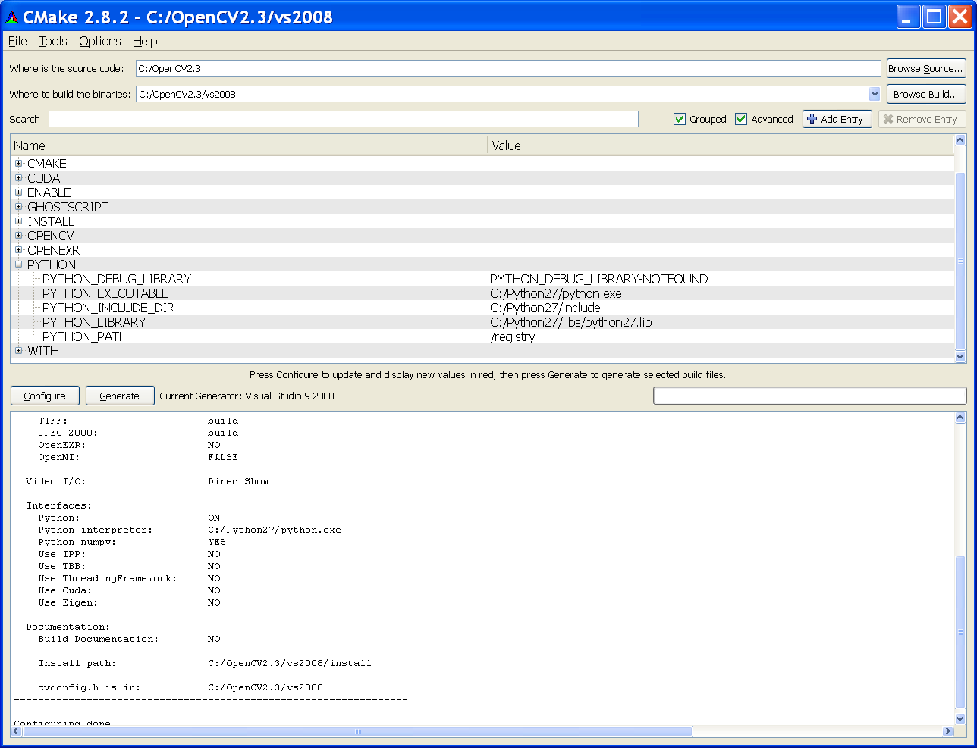
  - If some Python path are not found, double click the “Not found paths” and enter these paths manually except for the PYTHON_DEBUG_LIBRARY (because it is not important). E.g. C:/Python27/Include, C:/Python27/lib/python27.lib.
  - click on “configure” and then “Generate”.
  - done
- compile opencv using vs2008 (visual studio 2008):
open the project opencv.sln using vs2008 at
C:\OpenCV2.3\vs2008\opencv.sln
You need to compile it 4 times using different modes as follows to generate the necessary dlls.

- At Debug mode
  - (1) -Right click "ALL-BUILD" build (or rebuild), will take some time
  - *It is ok if you have two errors: fatal error LNK 1104: cannot open file 'python27_d.lib'. Python has no debug mode, so it doesn’t matter.
  - (2) -Right click "INSTALL" build (or rebuild), will take some time
  - It is normal to have 3 errors, two related to 'python27_d.lib' and one with error code PRJ10019. You system should work with these errors.
- At Release mode
  - (3)-Right click "ALL-BUILD" build (or rebuild), will take some time
    - It should have no compilation error.
  - (4)-Right click "INSTALL" build (or rebuild), will take some time
    - It should have no compilation error.
- Checking: dll files will be generated at C:\OpenCV2.2\bin\debug C:\OpenCV2.2\bin\relesase, check if they are all there and updated.
- Configure vs2008 for developing projects in opencv
  - Start vs2008
  - Copy “C:\OpenCV2.3\include\opencv\*.*” and “C:\OpenCV2.3\include\opencv2\*.*” into “C:\OpenCV2.3\include”. Because some older program assume all .h are in C:\OpenCV2.3\include.
  - In the main menu,
    - Tools>> options>>projects and solution>>VC++_ directories (at the under right-top menu “Show directories for”)
    - (include files ) add :
      - For Opencv2.3
        - C:\OpenCV2.3\vs2008\install\include\
        - C:\OpenCV2.3\include
    - (library files) add :
      - For Opencv2.3
        - C:\OpenCV2.3\vs2008\lib\Release
        - C:\OpenCV2.3\vs2008\lib\Debug
    - You do the above once only. All project use the same figuration
- Python2.7: Setup Opencv2.3 libraries (cv.pyd and pv2.pyd) for Python2.7
  - If you use Opencv2.3
    - Copy the 4 files cv.pyd, cv.lib, cv2.pyd and cv2.lib and from “C:\OpenCV2.3\vs2008\install\Python2.7\Lib\site-packages” to “C:\Python27\Lib\site-packages”
    - These 4 files can also be at C:\OpenCV2.3\vs2008\lib\Release. They are generated by vs2008 using the opencv.sln (sub projects opencv_python and opencv2_python). Make sure you compiled these projects ok using release mode (no need for debug mode)
  - Done
- For writing python programs: If in python, you received the message saying it fails to ‘import cv’, check
  - you set up your correct path in your windows, e.g.
    - c:\opencv2.2\vs2008\bin\debug; c:\opencv2.2\vs2008\bin\release;c:\Python27
  - setup a system variable path in Win7
    - PythonPath: c:\Python27;C:\Python27\Lib;C:\Python27\DLLs;C:\Python27\Lib\lib-tk;C:\other-foolder-on-the-path
    - 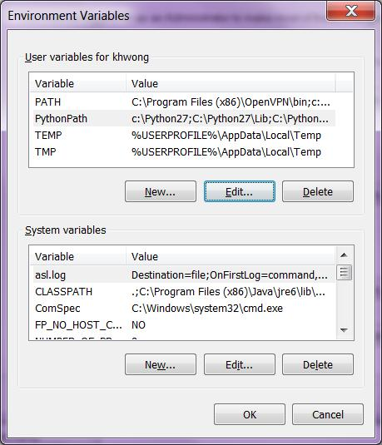
- For developing Opecnv c++ programs: in each project, e.g. open the project file test1.sln by vs2008 .
  - In the source file, add at the beginning of the file: #include "stdafx.h"
  - In debug mode
    - In the window (Solution Explorer - test1)
      - point to the 2nd row item (e.g. test1) , then mouse right click , select properties
      - In (configuration properties>> Linker>>Input>>Additional Dependencies), add the following the entry:
        - opencv_features2d230d.lib opencv_highgui230d.lib opencv_core230d.lib opencv_imgproc230d.lib opencv_ml230d.lib opencv_objdetect230d.lib opencv_video230d.lib opencv_contrib230d.lib opencv_calib3d230d.lib
  - In release mode
    - In the window (Solution Explorer - test1)
      - point to the 2nd row item (e.g.test1) , then mouse right click , select properties
      - In (configuration properties>> Linker>>Input>>Additional Dependencies), add the following the entry:
        - opencv_features2d230.lib opencv_highgui230.lib opencv_core230.lib opencv_imgproc230.lib opencv_ml230.lib opencv_objdetect230.lib opencv_video230.lib opencv_contrib230.lib opencv_calib3d230.lib
  - In the main menu: Build >> rebuild solution, if no error is found, you are have successfully built your program.
  - In the main menu: debug >>start debugging, to start to run your program.

Example of compiling a working opencv program:

Example 1: lkdemo (based on lkdemo.cpp in c:\OpenCV2.3\samples\cpp\lkdemo.cpp etc.)
- Install the system (vs2008 or above and opencv2.3) as described above in the installation guide.
- Start Microsoft studio 2008
- file>>new_project >> visual_C++,>>choose win32
- enter name of your project .e.g. lkdemo2.3.4 >> finish
- left top corner “solution explorer window” , under "source files" you see lkdemo2.3.4cpp, double click it.
- In the editor, remove all content, cut and paste all content of c:\OpenCV2.3\samples\cpp\lkdemo.cpp into lkdemo2.3.4cpp.
- Add #include "stdafx.h" at the beginning of the file.
- VS2008 Dependences setting
  - In debug mode
    - In the window (Solution Explorer -lkdemo2.3.4)
      - point to the 2nd row item (e.g. lkdemo2.3.4) , then mouse right click , select properties
      - In (configuration properties>> Linker>>Input>>Additional Dependencies), add the following the the entry:
        - opencv_features2d230d.lib opencv_highgui230d.lib opencv_core230d.lib opencv_imgproc230d.lib opencv_ml230d.lib opencv_objdetect230d.lib opencv_video230d.lib opencv_contrib230d.lib opencv_calib3d230d.lib
  - In release mode
    - In the window (Solution Explorer – lkdemo2.3.4)
      - point to the 2nd row item (e.g. lkdemo2.3.4) , then mouse right click , select properties
      - In (configuration properties>> Linker>>Input>>Additional Dependencies), add the following the entry:
  - opencv_features2d230.lib opencv_highgui230.lib opencv_core230.lib opencv_imgproc230.lib opencv_ml230.lib opencv_objdetect230.lib
- Then in the main menu: “Build”>>”rebuild lkdemo2.3.4”
- If no error, in “Debug”>>” start debugging F5” to run the program.
- Lkdemo should work, then window will show the features tracked by lkdemo from your web cam (don’t forget to plug in your web cam) .
- You may start other tests. Pick the examples in c:\OpenCV2.3\samples\cpp . Some programs may need extra libs, repeat the step in : VS2008 Dependences setting for adding extra libs to your system.

Example 2: lkdemo (based on demohist.cpp in c:\OpenCV2.3\samples\cpp\demohist.cpp histogram demo etc.)
Similar to lkdemo example, except you need to change the course file to point to the correct image file position . i.e. in main()
int main( int argc, char** argv )
{
// Load the source image. HighGUI use.
- image = imread( argc == 2 ? argv[1] : "c:\\images\\baboon.jpg", 0 );

======older information: For opencv2.2 + python2.7 +win7 (or XP)==
- Following the above procedures, change the directory names from Opencv2.3 to Opencv2.2 etc.
- For the step “For Opecnv c++ developers: in each project, e.g. open the project file test1.sln by vs2008 “.
  - Changed the names of the lib files from xx230.lib to xx220.lib, e.g. opencv_features2d230.lib → opencv_features2d220.lib etc.
- Fix the win7+webcam opencv2.2-bug: Before you execute” compile opencv using vs2008 (visual studio 2008):” complete the instructions in http://blog.qinyujie.net/2011/01/15/440/

