Installation guide (opencv3.1.0 vs2013, win10) 4 dec 2016/ modified 18 Oct 2018
Assume you have installed opencv3.1.0 (see part 2)

PART 1

http://opencv-python-tutroals.readthedocs.io/en/latest/py_tutorials/py_setup/py_setup_in_windows/py_setup_in_windows.html

Install OpenCV-Python in Windows

Goals
In this tutorial
- We will learn to setup OpenCV-Python in your Windows system.
Below steps are tested in a Windows 7-64 bit machine with Visual Studio 2010 and Visual Studio 2012. The screenshots shows VS2012.

Installing OpenCV from prebuilt binaries
- Below Python packages are to be downloaded and installed to their default locations.
  - Install Python-2.7.x. (tested 32-bit, python 2.7.12 ) in c:\python2.7
After this python2.7 is installed , put c:\python2.7 in win10 path. Install all packages into their default locations. Python will be installed to C:\Python27\.

  - install Numpy. 1.9 Must be 1.9 not 1.7 use the following link
https://sourceforge.net/projects/numpy/files/NumPy/1.9.1/numpy-1.9.1-win32-superpack-python2.7.exe/download
  - install Matplotlib (Matplotlib is optional, but recommended since we use it a lot in our tutorials). Need to install this (dateutil) for matplotlib
  - http://stackoverflow.com/questions/879156/how-to-install-python-dateutil-on-windows

1.4 install scipy from
https://sourceforge.net/projects/scipy/files/scipy/0.16.1/scipy-0.16.1-win32-superpack-python2.7.exe/download

- After installation, open Python IDLE. Enter import numpy and make sure Numpy is working fine.
- Download latest OpenCV release from sourceforge site and double-click to extract it.
- Goto opencv/build/python/2.7 folder.
- Copy cv2.pyd to C:/Python27/lib/site-packeges.
- Open Python IDLE and type following codes in Python terminal.
IDLE means it is the UI of python, type python at Ask me anything in win10, you should see it
Testing

>>> import cv2
>>> print cv2.__version__
3.1.0 is what I get

import numpy
print numpy.__version__
1.9.1 is what I get

import scipy
print numpy.__version__
0.16.1 is what I get

Import
You can check the library, they are at
C:\Python27\Lib\site-packages

If the results are printed out without any errors, congratulations !!! You have installed OpenCV-Python successfully.
# opencv_test1.py begin, a testing file ##########################
Test opencv3.1.0 in python 2.7
Ave this script in a test file
import cv2
import numpy as np

cap = cv2.VideoCapture(0)

while(1):

# Take each frame
_, frame = cap.read()

# Convert BGR to HSV
hsv = cv2.cvtColor(frame, cv2.COLOR_BGR2HSV)

# define range of blue color in HSV
lower_blue = np.array([110,50,50])
upper_blue = np.array([130,255,255])

# Threshold the HSV image to get only blue colors
mask = cv2.inRange(hsv, lower_blue, upper_blue)

# Bitwise-AND mask and original image
res = cv2.bitwise_and(frame,frame, mask= mask)

cv2.imshow('frame',frame)
cv2.imshow('mask',mask)
cv2.imshow('res',res)
k = cv2.waitKey(5) & 0xFF
if k == 27:
break

cv2.destroyAllWindows()
# opencv_test1.py end, a testing file ##########################
Save it in d:\\python_test\\opencv_test1.py
In the IDLE window , run this
File >> open >> opencv_test1.py>> run module, (escape to exit)
You may run script by using
But not very user friendly
execfile('d:\\0vision\\python_test\\opencv_test1.py')
(not tested)

#>>>>>>>>>>>>>>>>>>>>>>>>>>>>>>>>>>>>>>>>>>>

# opencv_test1.py begin, a testing file ##########################
#make sure you have 'c:\\images\\lena.jpg'
# harris1.py begin, a testing file ##########################

You may try harris.py
import cv2
import numpy as np

#filename = 'c:\\images\\lena\\chessboard.jpg'
filename = 'c:\\images\\lena.jpg'

img = cv2.imread(filename)
gray = cv2.cvtColor(img,cv2.COLOR_BGR2GRAY)

gray = np.float32(gray)
dst = cv2.cornerHarris(gray,2,3,0.04)

#result is dilated for marking the corners, not important
dst = cv2.dilate(dst,None)

# Threshold for an optimal value, it may vary depending on the image.
img[dst>0.01*dst.max()]=[0,0,255]

cv2.imshow('dst',img)
if cv2.waitKey(0) & 0xff == 27:
cv2.destroyAllWindows()
# harris1.py ends , a testing file ##########################
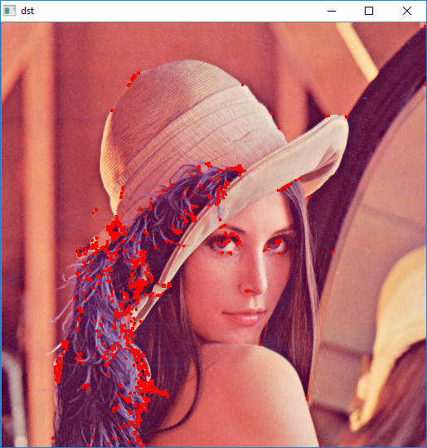

More tests can be found at
https://opencv-python-tutroals.readthedocs.io/en/latest/py_tutorials/py_tutorials.html

PART 2

Updated 3 Dec 2016. Ver.161203c
Test only debug mode forget release mode, because if you use the wrong lib, it crashes
Link only to opencv_world310d.lib, do not link to opencv_world310d.lib
Ok opencv3.1.0, vs2013, win10
https://jugaadjump.wordpress.com/2016/03/06/install-opencv3-1-0-on-windows10/
- Download OpenCV and VisualStudioExpress (or use vs2013)
- Install Visual Studio Express, Extract OpenCV (e.g. opencv310)
- In PC. , Edit System Environment Variables
  - Add OPENCV_DIR with the address C:\opencv\build\x64\vc12
  - (according to where you have extracted), add to path
%OPENCV_DIR%\bin
- Make a new project in Visual Studio
Create a project (win32 console application), then change it to x64 as follows

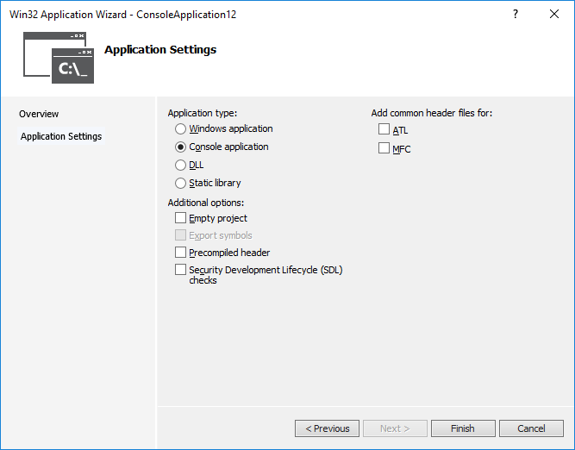

- Right click the project name>>select property>> and add a new property sheet under the Debug | x64 folder, In configuration manager
- Add active solution
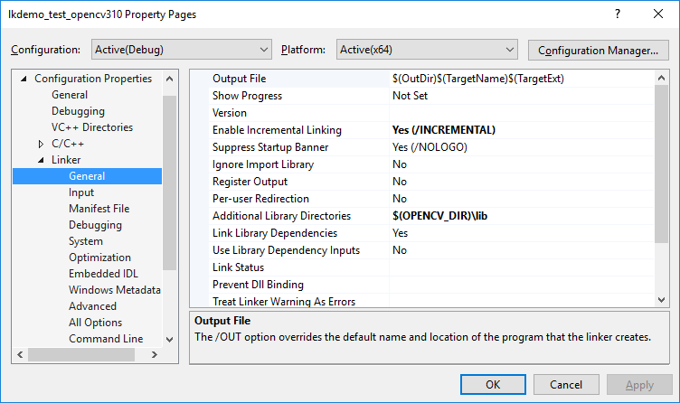
- Active solution >>select New >>select x64 (copy from win32)

- 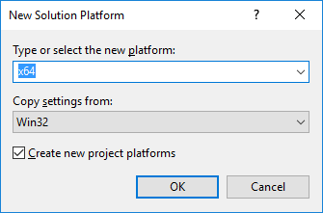
- 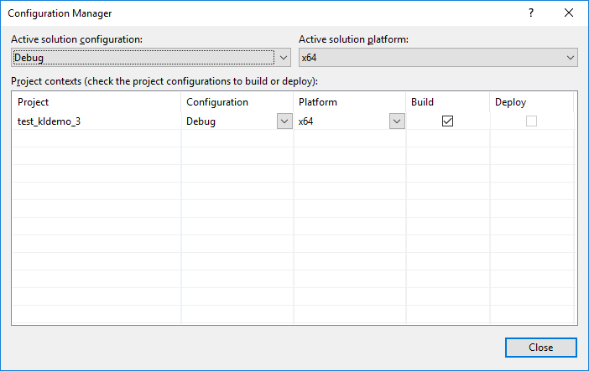

Now change the properties of all projects you will create later
- From the top Microsoft visual studio menu (top) select VIEW>>other windows >>property manager,
- Then, the right top window will show a window with Debug x64>> open Debug x64>> right-click Microsoft.Cpp.x64.user, do the followings.
- Make 3 changes in the property sheet
  - C/C++->General->Additional Include Directories-> Add
$(OPENCV_DIR)\..\..\include
If using opencv300
$(OPENCV_DIR300)\..\..\include

  - Linker->Input->Additional Dependencies option->Add
opencv_world310d.lib
If using opencv300: opencv_world300d.lib
Better not add opencv_world310d.lib and keep debug mode always. If you really do need release mode, add this with care. If you debug and use the release lib (opencv_world310d.lib) , system may crash.
  - Linker->General->Addition.Lib.Directories-> add $(OPENCV_DIR)\lib
** warning : Do not touch VC++ Directories
- Now you can create a new project with the above properties. Then after the project is created, in the view/solution window:
- Test and Display an image
  - Select the project, and add a new C++ file (some examples are shown below) under the source files option
  - Paste the following code.
  - Add #include "stdafx.h" to source
  - Change the solution platform to x64 and select Build Solution
- Open the Project2/x64/Debug folder and add an image
- Open command prompt and change to the above folder and run it as Project2.exe image_name.jpg
To compile and debug: At the top menu of visual studio
BUILD >> CLEAN SOLUTION>> REBUILD SOLUTION.
Then, Select the “Local window debug” icon to run
Or simply type F5.

http://docs.opencv.org/3.0-beta/doc/tutorials/introduction/windows_visual_studio_Opencv/windows_visual_studio_Opencv.html

//////////////////////////////////////////////////////////////////////////////////////////////////////
// example 1 begins--------------------------------------------------------
//display1.cpp
#include "stdafx.h"
#include <opencv2/core/core.hpp>
#include <opencv2/highgui/highgui.hpp>
#include <iostream>

using namespace cv;
using namespace std;

int main(int argc, char** argv)
{

Mat image;
image = imread("c:\\images\\lena.jpg"); // Read the file

if (!image.data) // Check for invalid input
{
cout << "Could not open or find the image" << std::endl;
return -1;
}

namedWindow("Display window", WINDOW_AUTOSIZE); // Create a window for display.
imshow("Display window", image); // Show our image inside it.

waitKey(0); // Wait for a keystroke in the window
return 0;
}
// example 1 ends--------------------------------------------------------

//////////////////////////////////////////////////////////////////////////////////////////////////////
// example 2 begins--------------------------------------------------------
//====test program display a picture
//display2.cpp
#include "stdafx.h"
#include <opencv2/core.hpp>
#include <opencv2/imgcodecs.hpp>
#include <opencv2/highgui.hpp>
#include <iostream>

using namespace cv;
using namespace std;

int main(int argc, char** argv)
{

Mat image;
image = imread("C:\\opencv-3\\abc.jpg", IMREAD_COLOR); // Read the file
// image = imread("C:\\opencv-3\\abc.jpg", IMREAD_COLOR); // Read the file
image = imread("C:\\images\\lena.jpg"); // Read the file

if (image.empty()) // Check for invalid input
{
cout << "Could not open or find the image" << std::endl;
return -1;
}

namedWindow("Display window", WINDOW_AUTOSIZE); // Create a window for display.
imshow("Display window", image); // Show our image inside it.

waitKey(0); // Wait for a keystroke in the window
return 0;
}
// example 2 ends--------------------------------------------------------

//////////////////////////////////////////////////////////////////////////////////////////////////////
// example 3 begins--------------------------------------------------------
//Lkemo.cpp
// test31.cpp : Defines the entry point for the console application.
//
#include "stdafx.h"
#include "opencv2/video/tracking.hpp"
#include "opencv2/imgproc/imgproc.hpp"
#include "opencv2/highgui/highgui.hpp"

#include <iostream>
#include <ctype.h>

using namespace cv;
using namespace std;

void help()
{
// print a welcome message, and the OpenCV version
cout << "\nThis is a demo of Lukas-Kanade optical flow lkdemo(),\n"
"Using OpenCV version %s\n" << CV_VERSION << "\n"
<< endl;

cout << "\nHot keys: \n"
"\tESC - quit the program\n"
"\tr - auto-initialize tracking\n"
"\tc - delete all the points\n"
"\tn - switch the \"night\" mode on/off\n"
"To add/remove a feature point click it\n" << endl;
}

Point2f pt;
bool addRemovePt = false;

void onMouse(int event, int x, int y, int flags, void* param)
{
if (event == CV_EVENT_LBUTTONDOWN)
{
pt = Point2f((float)x, (float)y);
addRemovePt = true;
}
}

int main(int argc, char** argv)
{
VideoCapture cap;
TermCriteria termcrit(CV_TERMCRIT_ITER | CV_TERMCRIT_EPS, 20, 0.03);
Size winSize(10, 10);

const int MAX_COUNT = 500;
bool needToInit = false;
bool nightMode = false;

if (argc == 1 || (argc == 2 && strlen(argv[1]) == 1 && isdigit(argv[1][0])))
cap.open(argc == 2 ? argv[1][0] - '0' : 0);
else if (argc == 2)
cap.open(argv[1]);

if (!cap.isOpened())
{
cout << "Could not initialize capturing...\n";
return 0;
}

help();

namedWindow("LK Demo", 1);
setMouseCallback("LK Demo", onMouse, 0);

Mat gray, prevGray, image;
vector<Point2f> points[2];

for (;;)
{
Mat frame;
cap >> frame;
if (frame.empty())
break;

frame.copyTo(image);
cvtColor(image, gray, CV_BGR2GRAY);

if (nightMode)
image = Scalar::all(0);

if (needToInit)
{
// automatic initialization
goodFeaturesToTrack(gray, points[1], MAX_COUNT, 0.01, 10, Mat(), 3, 0, 0.04);
cornerSubPix(gray, points[1], winSize, Size(-1, -1), termcrit);
addRemovePt = false;
}
else if (!points[0].empty())
{
vector<uchar> status;
vector<float> err;
if (prevGray.empty())
gray.copyTo(prevGray);
calcOpticalFlowPyrLK(prevGray, gray, points[0], points[1], status, err, winSize,
3, termcrit, 0);
size_t i, k;
for (i = k = 0; i < points[1].size(); i++)
{
if (addRemovePt)
{
if (norm(pt - points[1][i]) <= 5)
{
addRemovePt = false;
continue;
}
}

if (!status[i])
continue;

points[1][k++] = points[1][i];
circle(image, points[1][i], 3, Scalar(0, 255, 0), -1, 8);
}
points[1].resize(k);
}

if (addRemovePt && points[1].size() < (size_t)MAX_COUNT)
{
vector<Point2f> tmp;
tmp.push_back(pt);
cornerSubPix(gray, tmp, winSize, cvSize(-1, -1), termcrit);
points[1].push_back(tmp[0]);
addRemovePt = false;
}

needToInit = false;
imshow("LK Demo", image);

char c = (char)waitKey(10);
if (c == 27)
break;
switch (c)
{
case 'r':
needToInit = true;
break;
case 'c':
points[1].clear();
break;
case 'n':
nightMode = !nightMode;
break;
default:
;
}

std::swap(points[1], points[0]);
swap(prevGray, gray);
}

return 0;
}

//////////////////////////////////////////////////////////////////////////////////////////////////////
// example 4 begins--------------------------------------------------------
///////camshift.cpp camshift-demo from openc3.1-sample
#include "stdafx.h"
#include <opencv2/core/utility.hpp>
#include "opencv2/video/tracking.hpp"
#include "opencv2/imgproc.hpp"
#include "opencv2/videoio.hpp"
#include "opencv2/highgui.hpp"

#include <iostream>
#include <ctype.h>

using namespace cv;
using namespace std;

Mat image;

bool backprojMode = false;
bool selectObject = false;
int trackObject = 0;
bool showHist = true;
Point origin;
Rect selection;
int vmin = 10, vmax = 256, smin = 30;

static void onMouse(int event, int x, int y, int, void*)
{
if (selectObject)
{
selection.x = MIN(x, origin.x);
selection.y = MIN(y, origin.y);
selection.width = std::abs(x - origin.x);
selection.height = std::abs(y - origin.y);

selection &= Rect(0, 0, image.cols, image.rows);
}

switch (event)
{
case EVENT_LBUTTONDOWN:
origin = Point(x, y);
selection = Rect(x, y, 0, 0);
selectObject = true;
break;
case EVENT_LBUTTONUP:
selectObject = false;
if (selection.width > 0 && selection.height > 0)
trackObject = -1;
break;
}
}

static void help()
{
cout << "\nThis is a demo that shows mean-shift based tracking\n"
"You select a color objects such as your face and it tracks it.\n"
"This reads from video camera (0 by default, or the camera number the user enters\n"
"Usage: \n"
" ./camshiftdemo [camera number]\n";

cout << "\n\nHot keys: \n"
"\tESC - quit the program\n"
"\tc - stop the tracking\n"
"\tb - switch to/from backprojection view\n"
"\th - show/hide object histogram\n"
"\tp - pause video\n"
"To initialize tracking, select the object with mouse\n";
}

const char* keys =
{
"{@camera_number| 0 | camera number}"
};

int main(int argc, const char** argv)
{
help();

VideoCapture cap;
Rect trackWindow;
int hsize = 16;
float hranges[] = { 0, 180 };
const float* phranges = hranges;
CommandLineParser parser(argc, argv, keys);
int camNum = parser.get<int>(0);

cap.open(camNum);

if (!cap.isOpened())
{
help();
cout << "***Could not initialize capturing...***\n";
cout << "Current parameter's value: \n";
parser.printMessage();
return -1;
}

namedWindow("Histogram", 0);
namedWindow("CamShift Demo", 0);
setMouseCallback("CamShift Demo", onMouse, 0);
createTrackbar("Vmin", "CamShift Demo", &vmin, 256, 0);
createTrackbar("Vmax", "CamShift Demo", &vmax, 256, 0);
createTrackbar("Smin", "CamShift Demo", &smin, 256, 0);

Mat frame, hsv, hue, mask, hist, histimg = Mat::zeros(200, 320, CV_8UC3), backproj;
bool paused = false;

for (;;)
{
if (!paused)
{
cap >> frame;
if (frame.empty())
break;
}

frame.copyTo(image);

if (!paused)
{
cvtColor(image, hsv, COLOR_BGR2HSV);

if (trackObject)
{
int _vmin = vmin, _vmax = vmax;

inRange(hsv, Scalar(0, smin, MIN(_vmin, _vmax)),
Scalar(180, 256, MAX(_vmin, _vmax)), mask);
int ch[] = { 0, 0 };
hue.create(hsv.size(), hsv.depth());
mixChannels(&hsv, 1, &hue, 1, ch, 1);

if (trackObject < 0)
{
Mat roi(hue, selection), maskroi(mask, selection);
calcHist(&roi, 1, 0, maskroi, hist, 1, &hsize, &phranges);
normalize(hist, hist, 0, 255, NORM_MINMAX);

trackWindow = selection;
trackObject = 1;

histimg = Scalar::all(0);
int binW = histimg.cols / hsize;
Mat buf(1, hsize, CV_8UC3);
for (int i = 0; i < hsize; i++)
buf.at<Vec3b>(i) = Vec3b(saturate_cast<uchar>(i*180. / hsize), 255, 255);
cvtColor(buf, buf, COLOR_HSV2BGR);

for (int i = 0; i < hsize; i++)
{
int val = saturate_cast<int>(hist.at<float>(i)*histimg.rows / 255);
rectangle(histimg, Point(i*binW, histimg.rows),
Point((i + 1)*binW, histimg.rows - val),
Scalar(buf.at<Vec3b>(i)), -1, 8);
}
}

calcBackProject(&hue, 1, 0, hist, backproj, &phranges);
backproj &= mask;
RotatedRect trackBox = CamShift(backproj, trackWindow,
TermCriteria(TermCriteria::EPS | TermCriteria::COUNT, 10, 1));
if (trackWindow.area() <= 1)
{
int cols = backproj.cols, rows = backproj.rows, r = (MIN(cols, rows) + 5) / 6;
trackWindow = Rect(trackWindow.x - r, trackWindow.y - r,
trackWindow.x + r, trackWindow.y + r) &
Rect(0, 0, cols, rows);
}

if (backprojMode)
cvtColor(backproj, image, COLOR_GRAY2BGR);
ellipse(image, trackBox, Scalar(0, 0, 255), 3, LINE_AA);
}
}
else if (trackObject < 0)
paused = false;

if (selectObject && selection.width > 0 && selection.height > 0)
{
Mat roi(image, selection);
bitwise_not(roi, roi);
}

imshow("CamShift Demo", image);
imshow("Histogram", histimg);

char c = (char)waitKey(10);
if (c == 27)
break;
switch (c)
{
case 'b':
backprojMode = !backprojMode;
break;
case 'c':
trackObject = 0;
histimg = Scalar::all(0);
break;
case 'h':
showHist = !showHist;
if (!showHist)
destroyWindow("Histogram");
else
namedWindow("Histogram", 1);
break;
case 'p':
paused = !paused;
break;
default:
;
}
}

return 0;
}
// example 4 ends--------------------------------------------------------
/////////////////////////////////////////////////////////////////////
Additional information
From https://msdn.microsoft.com/en-us/library/9yb4317s.aspx

set up C++ applications to target 64-bit platforms
- Open the C++ project that you want to configure.
- Open the property pages for that project. For more information, see How to: Open Project Property Pages.
Note
For .NET projects, make sure that the Configuration Properties node, or one of its child nodes, is selected in the <Projectname> Property Pages dialog box; otherwise, the Configuration Manager button remains unavailable.
- Choose the Configuration Manager button to open the Configuration Manager dialog box.
- In the Active Solution Platform drop-down list, select the <New…> option to open the New Solution Platform dialog box.
- In the Type or select the new platform drop-down list, select a 64-bit platform.
Note
In the New Solution Platform dialog box, you can use the Copy settings from option to copy existing project settings into the new 64-bit project configuration.
- Choose the OK button. The platform that you selected in the preceding step appears under Active Solution Platform in the Configuration Manager dialog box.
- Choose the Close button in the Configuration Manager dialog box, and then choose the OK button in the <Projectname> Property Pages dialog box.

To copy Win32 project settings into a 64-bit project configuration
- When the New Solution Platform dialog box is open while you set up a project to target a 64-bit platform, in the Copy settings from drop-down list, select Win32. These project settings are automatically updated on the project level:
  - The /MACHINE linker option is set to /MACHINE:X64.
  - Register Output is turned OFF. For more information, see Linker Property Pages.
  - Target Environment is set to /env x64. For more information, see MIDL Property Pages: General.
  - Validate Parameters is cleared and reset to the default value. For more information, see MIDL Property Pages: Advanced.
  - If Debug Information Format was set to /ZI in the Win32 project configuration, then it is set to /Zi in the 64-bit project configuration. For more information, see /Z7, /Zi, /ZI (Debug Information Format).

