- To enter arguments to a program under visual studio IDE (2022.3.14, using vs2019)
- In the visual studio main window-top bar , select View/solution explorer
- On the right, right click the red elliptical part (console application)
- 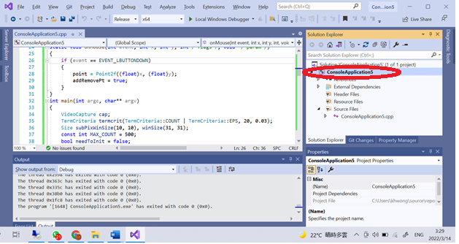
- Select “debugging” enter argument in red-ellipse part
- 